The Mathematics Tower, Volume 1: The Lower Floors
Storeys 1–12: From Arithmetic to Calculus

by Lothar J. Musiol

Copyright © 2026 Lothar J. Musiol. All rights reserved.

Table of Contents
Table of Contents 3
Preface 7
On Storeys and Rooms 9
Storey 1: Something Countable 10
Room 1.1: Why Numbers Exist (And Why We Pretend They Don't) 11
Room 1.2: The Natural Numbers: Humanity's First Great Abstraction 15
Room 1.3: Zero: The Number That Almost Didn't Happen 19
Room 1.4: Integers: Taking Subtraction Seriously 22
Room 1.5: Divisibility, Primes, and the Stubborn Atoms of Arithmetic 26
Room 1.6: The Fundamental Theorem of Arithmetic 29
Room 1.7: Modular Arithmetic: Clocks, Remainders, and Secret Codes 33
Room 1.8: Diophantine Equations: When Whole Numbers Refuse to Cooperate 37
Room 1.9: Infinity, Size, and the Strange Hierarchies of Countable Sets 41
Room 1.10: Looking Ahead: From Arithmetic to Everything Else 44
Storey 2: The Algebra of Almost 47
Room 2.1: What Algebra Actually Is 48
Room 2.2: Linear Equations 51
Room 2.3: Systems of Linear Equations 55
Room 2.4: Factoring 59
Room 2.5: Quadratic Equations 63
Room 2.6: Higher-Degree Polynomials 67
Room 2.7: Inequalities 71
Room 2.8: Absolute Value 75
Room 2.9: Looking Ahead 80
Storey 3: Functions, Graphs & Graph Analysis 83
Room 3.1: What a Function Actually Is 84
Room 3.2: Domain, Range, and the Vertical-Line Test 87
Room 3.3: Linear and Quadratic Functions 90
Room 3.4: Polynomials, Rationals, and Their Graphs 94
Room 3.5: Transformations: Shifts, Stretches, and Reflections 98
Room 3.6: Composition and Inverse Functions 101
Room 3.7: Exponential and Logarithmic Functions 104
Room 3.8: Reading Graphs: Intercepts, Asymptotes, and Qualitative Behaviour 108
Room 3.9: Looking Ahead: From Graphs to Calculus and Beyond 112
Storey 4: Coordinate Systems 115
Room 4.1: What a Coordinate System Actually Is 116
Room 4.2: The Cartesian Plane: Two Axes and an Origin 119
Room 4.3: Distance, Midpoints, and the Algebra of Segments 122
Room 4.4: Polar Coordinates: When Direction Matters More Than Axes 125
Room 4.5: Three Dimensions: Cartesian, Cylindrical, and Spherical 129
Room 4.6: Changing Coordinates: Translation, Rotation, and Scaling 133
Room 4.7: Homogeneous Coordinates and Points at Infinity 136
Room 4.8: Why the Choice of Coordinates Matters 140
Room 4.9: Looking Ahead: From Coordinates to Geometry and Beyond 144
Storey 5: Euclidean Geometry 146
Room 5.1: What Euclidean Geometry Actually Is 147
Room 5.2: Points, Lines, Planes, and the Parallel Postulate 151
Room 5.3: Angles, Triangles, and the Sum of 180° 155
Room 5.4: Congruence: When Two Figures Are the Same 158
Room 5.5: The Pythagorean Theorem and Its Consequences 162
Room 5.6: Similarity: Same Shape, Different Size 165
Room 5.7: Circles and Their Theorems 168
Room 5.8: Constructions, Area, and the Limits of the Ruler and Compass 171
Room 5.9: Looking Ahead: From Euclidean Geometry to Trigonometry and Beyond 175
Storey 6: Trigonometry 178
Room 6.1: What Trigonometry Actually Is 179
Room 6.2: Right Triangles and the Basic Ratios 182
Room 6.3: The Unit Circle and Extension to All Angles 186
Room 6.4: Graphs, Periodicity, and the Shape of the Waves 189
Room 6.5: Identities: The Algebra of the Ratios 192
Room 6.6: Solving Triangles: Right and Oblique 195
Room 6.7: Inverse Functions and the Ambiguity of Angles 199
Room 6.8: Applications: From Surveying to Oscillations 202
Room 6.9: Looking Ahead: From Trigonometry to Logarithms, Vectors, and Waves 205
Storey 7: Logarithms & Potencies 209
Room 7.1: What Exponents and Logarithms Actually Are 210
Room 7.2: Integer and Rational Exponents 214
Room 7.3: The Laws of Exponents 218
Room 7.4: Logarithms as Inverse Exponents 222
Room 7.5: The Laws of Logarithms 226
Room 7.6: The Natural Base e and the Natural Logarithm 229
Room 7.7: Exponential and Logarithmic Functions and Their Graphs 233
Room 7.8: Applications: Growth, Decay, Scales, and Solving Equations 237
Room 7.9: Looking Ahead: From Logarithms to Systems, Vectors, and Analysis 241
Storey 8: Systems of Equations 245
Room 8.1: What a System of Equations Actually Is 246
Room 8.2: Linear Systems in Two Variables 250
Room 8.3: Linear Systems in Three or More Variables 254
Room 8.4: Matrices and the Systematic Solution of Linear Systems 259
Room 8.5: Consistency, Independence, and the Geometry of Solution Sets 262
Room 8.6: Nonlinear Systems: When Curves Meet 266
Room 8.7: Methods for Nonlinear Systems 273
Room 8.8: Applications and Modeling with Systems 278
Room 8.9: Looking Ahead: From Systems to Vectors, Linear Algebra, and Beyond 282
Storey 9: Vectors & Vector Algebra 286
Room 9.1: What a Vector Actually Is 287
Room 9.2: Vector Addition and Scalar Multiplication 290
Room 9.3: Components and the Coordinate Representation 294
Room 9.4: The Dot Product: Angles and Projections 297
Room 9.5: The Cross Product: Perpendicularity and Area 300
Room 9.6: Lines and Planes in Vector Form 304
Room 9.7: Linear Combinations, Span, and Dependence 308
Room 9.8: Applications: Physics, Geometry, and Beyond 311
Room 9.9: Looking Ahead: From Vectors to Linear Algebra and Calculus 315
Storey 10: Limits 318
Room 10.1: What a Limit Actually Is 319
Room 10.2: Informal Limits and Numerical Exploration 324
Room 10.3: The Precise Definition: ε and δ 328
Room 10.4: Limit Laws and Algebraic Computation 332
Room 10.5: One-Sided Limits and Continuity 336
Room 10.6: Limits Involving Infinity 340
Room 10.7: Special Limits and the Squeeze Theorem 344
Room 10.8: Limits of Sequences 348
Room 10.9: Looking Ahead: From Limits to Derivatives and Integrals 352
Storey 11: Differential 357
Room 11.1: What the Derivative Actually Is 358
Room 11.2: The Derivative as a Limit 362
Room 11.3: Differentiation Rules: Linearity, Product, Quotient, Chain 366
Room 11.4: Derivatives of the Elementary Functions 370
Room 11.5: Implicit Differentiation and Related Rates 375
Room 11.6: Higher-Order Derivatives and Linear Approximation 379
Room 11.7: The Mean Value Theorem and Its Consequences 383
Room 11.8: Optimization and Curve Sketching 387
Room 11.9: Looking Ahead: From Derivatives to Integrals and Differential Equations 391
Storey 12: Integral 396
Room 12.1: What the Integral Actually Is 397
Room 12.2: Riemann Sums and the Definite Integral 400
Room 12.3: The Fundamental Theorem of Calculus 404
Room 12.4: Antiderivatives and Indefinite Integrals 407
Room 12.5: Techniques of Integration 410
Room 12.6: Applications: Area, Volume, Arc Length, Work 414
Room 12.7: Improper Integrals 417
Room 12.8: Numerical Integration and Approximation 420
Room 12.9: Looking Ahead: From Integrals to Series, Multivariable Calculus, and Differential Equations 423

Preface
Welcome, then, to the Tower. You are standing in the lobby of a building that has no business existing in the form it now takes — fifty separate volumes, each once perfectly content to stand alone on a shelf with its own spine, its own index, its own faintly apologetic preface, have been knocked through, floor by floor, into a single continuous structure. The walls between them have been removed. The plumbing has been unified. Where one book used to end with a modest full stop and a wave goodbye, there is now a landing, a staircase, and the sound of the next subject already warming up overhead. I make no claim that this was architecturally necessary. I make only the claim that it is, on the whole, more honest: mathematics was never really fifty separate rooms in the first place, and pretending otherwise for the sake of fifty separate marketing budgets was a small, forgivable lie that has now been tidied up.
The reason the Tower exists — the actual reason, not the one that will fit on a dust jacket — is that mathematics is a single connected structure pretending, for administrative convenience, to be several hundred unconnected ones. You cannot do calculus without algebra underneath it; you cannot do functional analysis without calculus, linear algebra, and a worrying amount of measure theory bolted on beneath that. Splitting these into fifty standalone books was good for the shelf and bad for the truth. A tower, at least, gets the physics right: everything above rests on everything below, whether either party consents to the arrangement or not.
How you read it is, refreshingly, entirely up to you, and I say this as someone who has spent an unreasonable fraction of one career telling undergraduates precisely how to read things. You may start in the lobby, at Storey 1, with arithmetic — genuinely, properly, from the bottom, counting on your fingers if it comes to that — and climb, storey by storey, all the way to the mathematical physics and applied modelling near the roof. This is the recommended route for anyone with the patience of a saint, several free years, and no pressing deadline; it is also, not coincidentally, the route that actually makes each new storey easy, because nothing up here is asked of you before its foundations have been poured somewhere beneath your feet.
Alternatively — and this is the route most people will actually take, so let us not pretend otherwise — you may treat the Tower as a building with a lift, and go directly to the storey you need. Revising trigonometry before an exam? Sixth floor. Trying to remember what a Fourier transform is actually for, as opposed to what it is? Seventeenth. Wandered in from an engineering problem and need control theory by Tuesday? Forty-fifth, and Godspeed. Every storey is written to be enterable on its own terms, with the understairs cupboard of prerequisite ideas either explained in passing or clearly signposted below, so that dipping in does not feel like arriving at a dinner party mid-argument about something you were never told the beginning of.
A word on the architecture itself, since I promised you a metaphor and intend to get my money's worth from it. Each storey is one broad mathematical territory — arithmetic, geometry, topology, and so on — and within each storey the rooms are the individual ideas: a room for factoring, a room for the chain rule, a room for compactness, numbered tidily as Storey.Room so that Room 11.4 always means the fourth room of the eleventh storey and never anything more mysterious than that. Some rooms are small and get you in and out in a few paragraphs. Others — measure theory, I am looking at you, and you know exactly what you did — sprawl rather further than their listing suggested, and I can only apologise on behalf of the subject, not the author.
I should confess, in the interests of full disclosure before you have paid for the privilege of finding out yourselves, that the higher storeys of this Tower contain ideas that took the human species several centuries and a fair number of nervous breakdowns to work out, and that I have compressed this achievement into rooms you can read over a cup of tea. This is either a great service to civilisation or a mild insult to the mathematicians who did the actual suffering, and I have chosen, as one does, not to dwell on which. Infinity in particular gets a great deal of attention on the upper floors, and I will say now what I will say again later at greater length: it does not behave, it does not apologise, and it has outlasted every mathematician who has ever tried to tame it, myself very much included, on current form.
You will find, at regular intervals, worked examples — proper ones, with real numbers where real numbers will do, and honest concrete instances where the idea is too structural for arithmetic to touch. This is not decoration. I have long held the view, formed over many years of watching very clever people nod along to a definition and then fail spectacularly to apply it, that an idea you cannot compute with is an idea you do not yet own, however elegantly you can recite it at a dinner party. Every one of these examples has been checked, by hand, more than once, because a mathematics book that gets its own arithmetic wrong is a special and particular kind of disgrace, and I intend to avoid it if it is the last thing I do — which, at this rate, it may well be.
So: welcome to the building. Mind the gap between the elementary storeys and the ones that assume you were paying attention on the elementary storeys — it is not large, but it is real. Take the stairs if you have the time and the temperament, take the lift if you have neither, and do not feel obliged to visit every room merely because the door is open; nobody, least of all the person who wrote them, has read every room of this Tower in one sitting and come out entirely unscathed. What follows is not a shortcut through mathematics — there isn't one, whatever the adverts for certain revision guides may imply — but it is, I hope, an honest staircase, with the handrails fitted at every landing and the worst of the draughts kept out. Up we go, then. Storey 1 awaits, and it starts, appropriately enough, with counting.

On Storeys and Rooms
A brief note is owed on why perfectly good words like 'book' and 'chapter' have been evicted from this text and replaced with 'storey' and 'room', since I am aware this is the sort of decision that can look, from the outside, like whimsy that has got badly out of hand. The honest answer is that it has, rather, but let me at least make the case for the defence before you reach for a refund.
The trouble with 'book' is that this is no longer fifty of them; it is one, and a text that keeps referring to itself as 'this book' while also gesturing at 'the next book in the series' is not being quaint, it is being confused about its own word count. 'Storey' does the same job — a bounded, coherent stretch of related material — while also admitting, honestly, that the thing you are standing in only makes sense as one level of something larger. It is a small change of noun that happens to fix a structural lie, which is about as good a return as you ever get from renaming things.
'Room' replaces 'chapter' for similar reasons, but with the added benefit of matching the numbering to the metaphor rather than fighting it: Room 6.3 tells you, without further ceremony, that you are in the third room of the sixth storey, which is more information than 'Chapter 3' ever gave you and considerably more information than 'Chapter 3 of Book 6, one of a fifty-book series' gave you at roughly triple the word count. Efficiency, in the end, dressed up as a joke — which is, if I am honest, how most good jokes in mathematics arrive.
I will not pretend the metaphor is load-bearing in any technical sense; you cannot factor a polynomial faster for knowing it lives in a room rather than a chapter. But a reader climbing from arithmetic to category theory over fifty storeys deserves a mental image sturdier than 'a very long document', and a tower — with its floors resting on each other, its lift for the impatient, its occasional draughty landing — happens to be a much better description of how mathematical knowledge is actually built than a shelf of unrelated paperbacks ever was. So: storeys, rooms, and no further apology. Do come in.

Storey 1: Something Countable
Arithmetic, Number Theory, and the Quiet Stubbornness of Numbers
Let's be honest. Arithmetic has a public-relations problem so severe it should probably hire a crisis manager. Mention “number theory” at a dinner party and you can watch the light leave people's eyes in real time — it is the conversational equivalent of pulling out a binder full of tax forms. Most adults treat arithmetic the way they treat flossing: they know it is important, they did it as children, and they would very much rather not discuss it in public. And yet here we are, standing at the foot of a very tall building, about to start climbing.
This is the ground floor of the Mathematics Tower — Storey 1 of fifty — and everything above us, all the way up through geometry, calculus, differential equations, topology, and whatever fresh hell awaits somewhere around the eyrie labelled “Tensors and Manifolds,” rests on the arithmetic and elementary number theory we are about to cover. If the counting numbers are wrong, the whole structure comes down, which is a rather more literal architectural metaphor than I intended when the Tower first chose this title. So we begin at the bottom, with the mathematical equivalent of learning to walk without falling over, on the sound theory that a tower built on a foundation of guesswork tends not to stay a tower for very long.
What follows will treat numbers with the seriousness they deserve and the disrespect they occasionally earn. We will prove things. We will also admit when a proof feels less like elegant reasoning and more like duct-taping the universe together and hoping nobody looks too closely. We will meet historical figures, several of whom were wrong in spectacularly creative ways. And yes, there will be jokes — some of them darker than strictly necessary, because if you spend enough time staring at the infinite, a little gallows humour starts to feel like basic hygiene. I should confess, before we start climbing, that I once spent three days trying to explain to a perfectly intelligent adult why 0.999… equals 1, only to watch them back slowly out of the room as though I had just admitted to keeping a jar of teeth. Moments like that keep a narrator humble.
The goal of this storey is not to turn you into a professional number theorist. It is to make you see numbers the way they actually are: simple, deep, occasionally spiteful, and completely unavoidable. Once we are done here — natural numbers, zero, integers, primes, modular arithmetic, a little Diophantine mischief, and a first unsettling glimpse of infinity — the next storey up takes those same numbers and teaches them to move: equations, factoring, inequalities, the beginnings of algebra. They will still be the numbers you meet here. They will simply have started misbehaving in more interesting ways. Welcome to Storey 1. Mind the counting numbers on your way in; people trip over them more often than you'd expect.

Room 1.1: Why Numbers Exist (And Why We Pretend They Don't)
There is a quiet conspiracy in modern education. We teach children to count as if numbers were as natural as breathing, or the human talent for holding grudges — one apple, two apples, three apples, easy — and then we move on. For the rest of most people's lives, numbers are treated as mere tools: useful for measuring, pricing, scoring, and occasionally lying via statistics. But numbers are not tools. They are discoveries. Or at least, that is the more interesting — and considerably less depressing — way to look at them.
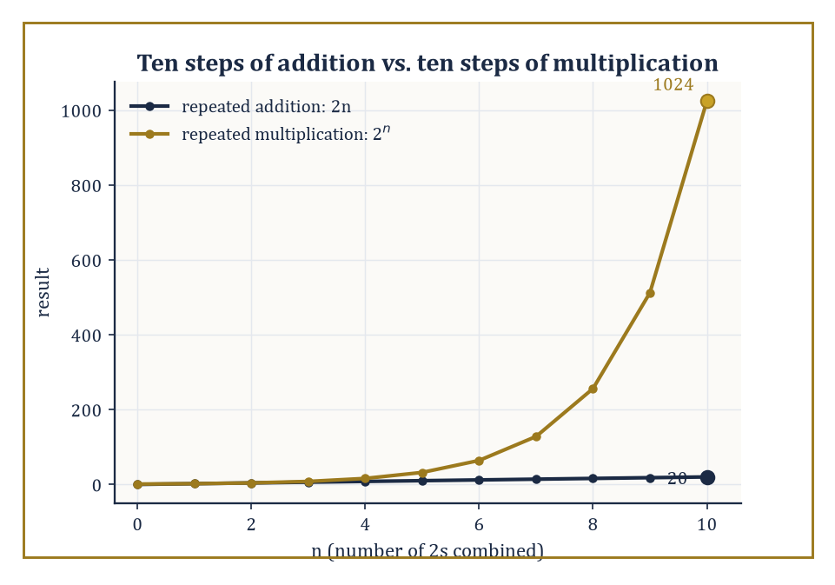
Ten steps of addition barely leave the ground; ten steps of multiplication leave the atmosphere.
Whether mathematical objects exist independently of human minds is a debate that has kept philosophers gainfully employed for centuries, which is either a testament to the depth of the question or proof that some people will argue about anything if you give them tenure. Plato thought numbers lived in a pure realm of Forms, untouched by grubby physical reality. Formalists insist they are just marks on paper, obeying rules we made up. Constructivists will only accept a number once you have built it by hand, in front of them, with a receipt. The rest of us mostly shrug, keep calculating, and try not to think about it too hard after midnight — which, incidentally, is roughly the working philosophy of this entire Tower.
Here is a more useful stance, and the one this storey will quietly adopt without further argument: numbers behave as if they were real. They surprise us. They have properties we did not intentionally put there. They refuse to cooperate with our aesthetic preferences — looking at you, √2, you magnificent bastard, forever refusing to be written as a tidy fraction no matter how the ancient Greeks begged. And once discovered, numbers open doors we never expected: some lead to beautiful theorems, and some lead to the cryptographic systems currently stopping a bored teenager on another continent from emptying your bank account.
Abstract example — Why √2 won't behave. Suppose, for the sake of argument, that √2 could be written as a fraction in lowest terms, p⁄q, with p and q integers sharing no common factor.
2 = p²⁄q²
p² = 2q²
That means p² is even, which forces p itself to be even (an odd number squared is always odd), so we can write p = 2m for some integer m.
(2m)² = 2q²
4m² = 2q²
q² = 2m²
This means q² is even too, so q is even as well. But now both p and q are even, sharing the factor 2, which contradicts our assumption that p⁄q was in lowest terms.
The assumption collapses. √2 cannot be written as a fraction at all. It simply refuses, on pain of contradiction, and there is nothing anyone can do about it.
Consider the simple act of counting. You have a flock of sheep and you want to know whether any have wandered off to live their best lives without you. You invent a correspondence between the sheep and a sequence of marks or sounds — a tally, a chant, a number. This is already an abstraction of almost suspicious power: you have separated the quantity from the particular sheep. The number “seven” is no longer about those specific animals. It is about the size of any collection that can be matched with them one-to-one. That separation is the birth of mathematics. It is also, roughly, the moment we started getting ideas above our station.
Numeric example — Counting the flock. Suppose your flock consists of five sheep: call them Agnes, Bartholomew, Clive, Deirdre, and Egbert (a shepherd with too much time on their hands named them). To count them, you pair each sheep with a tally mark:
Agnes↔|, Bartholomew↔||, Clive↔|||, Deirdre↔||||, Egbert↔|||||
The final tally, |||||, is a perfect one-to-one match with the flock — no sheep left unmarked, no mark left unpaired. Once that pairing exists, you can throw away the sheep's names entirely and just say “five.” Tomorrow, if you pair the same five tally marks against a basket of five apples, the match works exactly as well. “Five” has become a property of any collection that can be matched against |||||, sheep or apples or unread emails, and has quietly stopped being about sheep at all.
From there, things escalate with the enthusiasm of a toddler who has just discovered the word “why.” Addition is combining collections. Multiplication is repeated addition — three lots of four sheep is the same headcount as four plus four plus four. Exponentiation is repeated multiplication, and this is where matters get out of hand rather quickly, because repeated multiplication grows so much faster than repeated addition that the two stop looking like relatives at all.
Numeric example — How fast is too fast. Take the number 2 and watch what happens as we escalate the operation. Adding 2 to itself ten times gives an unremarkable result:
2+2+2+2+2+2+2+2+2+2 = 20
But raise 2 to the tenth power instead:
2×2×2×2×2×2×2×2×2×2 = 1024
The sequence of partial results along the way reads 2, 4, 8, 16, 32, 64, 128, 256, 512, 1024. Ten multiplications took us from 2 to 1024, more than fifty times further than ten additions managed.
By the time you reach 2^100 the number has 31 digits, is larger than the estimated number of grains of sand on Earth, and writing it down in full becomes an exercise in creative notation and mild existential dread — which is exactly the phrase we will need again the moment large primes show up.
Number theory begins the moment we stop treating numbers merely as sizes of collections and start asking questions about the numbers themselves. Which ones can be divided evenly? Are there numbers that cannot be broken down any further? Do the primes go on forever? Can every even number greater than two be written as the sum of two primes? We still do not know the answer to that last one, after more than 280 years of trying. This is either inspiring or the mathematical equivalent of still not having found your car keys.
Numeric example — Goldbach, checked by hand. Nobody has proved the Goldbach conjecture in general, but you can check it by hand for as long as your patience holds out. Take 28: is it a sum of two primes?
28 = 5 + 23
28 = 11 + 17
Both work, and 5, 23, 11, and 17 are all prime. Take a less friendly-looking number, 100:
100 = 3 + 97
Both 3 and 97 are prime. Every even number anyone has ever bothered to check — computers have gone well past 10^18 — has obliged. Nobody can yet explain why it must always oblige. That gap between “true in every case we've tried” and “true in every case, full stop, provably” is exactly the gap number theory lives in.
The humour, if you can call it that, is that the simplest questions are often the deepest. Children ask “what is the biggest number?” and adults chuckle condescendingly. Then mathematicians spend entire careers trying to understand the structure of the integers, and quietly realise the child was pointing at something genuinely unsettling: the infinite is not just “very big.” It has architecture. Some of that architecture — we will meet it properly in Room 1.9 — is weird enough to keep you awake.
The universe did not have to be mathematical. But it is. And the mathematics, whether we like it or not, begins with counting.

Room 1.2: The Natural Numbers: Humanity's First Great Abstraction
The natural numbers are 1, 2, 3, 4, and so on until the heat death of the universe or your patience, whichever comes first. These are the numbers you use for keeping score, checking inventory, or trying to remember how many times you've already told the same story at a party and whether anyone is still pretending to listen. Their apparent simplicity is a lie. The natural numbers are the first place mathematics becomes infinite, exact, and just rigid enough to make you slightly nervous.
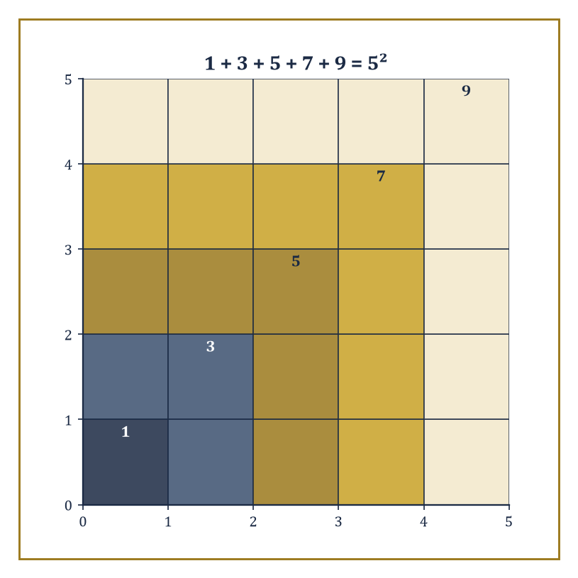
Five nested gnomons, five odd numbers, one perfect square: 1 + 3 + 5 + 7 + 9 = 5², no induction required to see it.
To work with them rigorously, we need a way to characterise the natural numbers without simply listing examples until we get tired. One elegant approach, due to the Italian mathematician Giuseppe Peano in 1889, is almost insultingly simple, and therefore dangerous — the simpler an axiom system looks, the more carefully you should read the fine print.
We start with two primitive notions — there is a first number, which we call 1, and every number has a unique successor, its “next” number, written S(n) — and impose five rules, the Peano axioms: (1) 1 is a natural number. (2) Every natural number n has a successor S(n), which is also a natural number. (3) No natural number has 1 as its successor — there is a beginning, and for once the universe cooperates. (4) Different numbers have different successors — the sequence never loops back on itself or branches, which is more than can be said for most human projects. (5) The induction axiom: if a property holds for 1, and whenever it holds for some n it also holds for S(n), then it holds for every natural number, no exceptions, ever.
Numeric example — Building 1 through 5 from nothing. Watch the machine actually build the numbers you already know. Start with 1. Axiom 2 guarantees a successor S(1); we simply agree to call it 2.
S(1) = 2
Apply axiom 2 again: S(2) exists; call it 3.
S(2) = 3
Again: S(3) exists; call it 4.
S(3) = 4
And again: S(4) exists; call it 5.
S(4) = 5
Nothing here has assumed you already know what “2” or “5” mean — those are just the labels we've chosen to stick on S(1), S(S(1)), S(S(S(1))), and so on. Axiom 3 tells you the chain has a first link (1 is nobody's successor), and axiom 4 tells you the chain never rejoins itself further along — S(2) can never equal S(7), because that would force 2 to equal 7. Five numbers, no circularity, no repeats: exactly the well-behaved queue you were hoping for.
That fifth axiom is the real powerhouse. Mathematical induction is the official licence to reason about infinitely many cases without checking them one by one — which is fortunate, because checking infinitely many cases one by one tends to eat an entire career and still not finish. It is also the reason mathematicians can say “for all natural numbers” with a straight face, while the rest of us are still trying to remember where we put our keys.
Abstract example — Induction earning its keep. Here is induction doing actual work. Claim: the sum of the first n odd numbers equals n². Base case, n = 1: the first odd number is 1, and the sum is
1 = 1²
True. Inductive step: assume the claim holds for some n = k, i.e.
1 + 3 + 5 + … + (2k − 1) = k²
We want to show it then holds for k + 1. The (k+1)-th odd number is
2(k+1) − 1 = 2k + 1
so the sum up to k + 1 terms is k² + (2k + 1) by the inductive hypothesis, and that factors neatly:
k² + 2k + 1 = (k + 1)²
— exactly the claim for k + 1. By induction, the formula holds for every natural number. Check it against reality for n = 4: the first four odd numbers are 1, 3, 5, 7, and
1 + 3 + 5 + 7 = 16 = 4²
For n = 5: adding the next odd number, 9, gives
16 + 9 = 25 = 5²
The pattern never needed checking past n = 1 and the general step — induction bought us all the rest for free.
Once we have the natural numbers, addition and multiplication can be defined recursively, using nothing but the successor function:
a + 1 = S(a)
a + S(b) = S(a + b)
Multiplication follows the same trick, built out of addition. From these two bare definitions, every arithmetic law you learned in primary school — commutativity, associativity, distributivity — can be proved outright. It is tedious if done in full formality, the mathematical equivalent of assembling furniture with an Allen key and pure spite, but deeply reassuring: the rules you memorised at seven years old are not arbitrary conventions somebody voted on. They are forced, inescapably, by the structure of the counting numbers themselves.
Numeric example — 2 + 3, from first principles. Watch the recursive definition compute 2 + 3 from nothing but successors. Since 3 = S(2), we have:
2 + 3 = 2 + S(2) = S(2 + 2)
Since 2 = S(1), we have:
2 + 2 = 2 + S(1) = S(2 + 1)
Since 2 + 1 = S(2) = 3 by the base case, we get:
2 + 2 = S(3) = 4
Feeding that back in:
2 + 3 = S(2 + 2) = S(4) = 5
Four lines of pure successor-chasing, no assumed intuition about “2” and “3” beyond what the axioms handed us, and out pops exactly the answer your primary school teacher promised.
There is a quiet joke embedded in all this. We spend years teaching children that 2 + 2 = 4 as if it were a fact about the physical world, like the boiling point of water or the average lifespan of a New Year's resolution. In a sense it is — but it is a fact about the abstract structure of successive quantities, not about any particular physical objects. Two sheep plus two sheep make four sheep only because the concept of “two” has already been abstracted away from any specific sheep, and from the sheep's opinions on the matter. This abstraction is what allows mathematics to travel: the same natural numbers that count sheep can count stars, quantum states, or the number of unread emails you are currently pretending do not exist. The structure is portable. The guilt, unfortunately, is also portable.
We should also notice what the natural numbers refuse to do. They have a beginning but no end — axiom 2 guarantees that every number has a successor, so there is always a next one, forever. We can never write them all down. We can never finish counting. And yet we speak of “the set of all natural numbers” as if it were a completed totality, the way one might speak of “finally getting organised” — with hope, denial, and a slight sense of dread. This is a mild philosophical tension for now. It will grow into a full existential crisis when we meet infinity properly, in Room 1.9.
For now, appreciate the achievement. With almost nothing — a starting point, a notion of “next,” and the willingness to accept induction — we have generated an infinite, fully structured system that will underwrite everything else in this Tower. The natural numbers are not the whole story. They are merely the opening move in a very long game that we are still not entirely sure we are winning.

Room 1.3: Zero: The Number That Almost Didn't Happen
Zero is the most philosophical number. It is also the number human cultures took the longest to accept, which should tell you something about our collective emotional maturity. Many sophisticated civilisations — the ancient Greeks among them — managed extraordinary mathematics while treating the absence of quantity as a kind of conceptual embarrassment rather than a respectable number. The idea that “nothing” could sit at the same table as “something” felt dangerous, almost rude, as if mathematics had invited a guest who refused to bring a dish and then demanded to be counted anyway.
We can understand the hesitation. If numbers arise from counting, what does it mean to count zero objects? You are pointing at empty space and declaring a quantity with a straight face — it feels like a linguistic con. And yet zero is indispensable. Without it, place-value notation collapses into chaos, because there is no way to mark an empty column.
Numeric example — Twelve, or one hundred and two?. Consider trying to write numbers in a place-value system with no symbol for “empty column.” The digits 1 and 2, written together as “12,” should mean one ten and two units — twelve. But now try to write one hundred and two: one hundred, no tens, two units. Without a zero to hold the empty tens column, you are reduced to writing “1 2” and hoping context saves you, because the same two digits, with nothing to separate them, could equally be misread as twelve, or as one thousand and two, or as one hundred and twenty with the units dropped. Slide a zero into the empty column — 102 — and the ambiguity vanishes instantly: one hundred, zero tens, two units. That single symbol for “nothing here” is what makes “102” and “12” and “1002” three unmistakably different numbers instead of the same smear of ink open to interpretation.
Historically, the full acceptance of zero as a number — rather than merely a placeholder — is usually credited to Indian mathematicians, with later transmission through the Islamic world into Europe. The journey was slow, contested, and occasionally theological; some European scholars worried that zero was a dangerous foreign import threatening the purity of classical mathematics. They were wrong, of course, but the anxiety is almost endearing. Humans have always been better at inventing reasons to reject useful ideas than at inventing the ideas themselves.
Once zero is admitted, the natural numbers are often extended to include it, producing the non-negative integers: 0, 1, 2, 3, … This creates a small, low-stakes civil war among mathematicians about whether the natural numbers themselves start at 0 or at 1. Both conventions are defensible, and different storeys of this very Tower will occasionally disagree. Here we started the natural numbers at 1, as Room 1.2's Peano axioms did, and treat 0 as the first new arrival when we broaden to the integers, mainly because I got tired of arguing about it and decided to pick a side so we could all move on with our lives.
Zero also introduces the first serious arithmetic hazard. Division by zero is undefined, and for excellent reasons: allow it, and the entire logical structure collapses with the quiet dignity of a soufflé introduced to a slammed door. From an entirely innocent-looking equation, a few seemingly reasonable steps that quietly divide by zero can produce 1 = 2. The refusal to divide by zero is not an arbitrary rule invented by killjoy teachers. It is a firewall protecting the consistency of the whole system.
Numeric example — How 1 = 2 (if you cheat). Watch the fallacy at work. Let
a = b = 1
Then a² = ab, since both sides equal 1:
a² = ab
Subtract b² from both sides:
a² − b² = ab − b²
Factor:
(a − b)(a + b) = b(a − b)
Now divide both sides by (a − b) — except
a − b = 1 − 1 = 0
so this step secretly divides by zero. If we allow it anyway, the (a − b) factors cancel, leaving
a + b = b
and since a = b = 1, that reads:
1 + 1 = 1, or 2 = 1
Every algebraic step before the division was perfectly legal; the entire fallacy hides inside that one illegitimate cancellation. Ban division by zero, and the trick is defused before it starts.
Zero is the additive identity for any number n:
n + 0 = n
It is the only number with that property — add any other number to n and you change it. It is the still point around which the integers will later balance positive and negative. In that sense zero is not merely the absence of quantity; it is the origin, the reference point, the mathematical equivalent of “we have to start somewhere, and this is the least dishonest option.”
Numeric example — The one number that changes nothing. Take n = 17. Then:
17 + 0 = 17
Unchanged, exactly as the additive-identity property demands. Try any other candidate for “the number that changes nothing” — say 1 — and it fails immediately:
17 + 1 = 18 ≠ 17
Zero is not just a number that happens to leave 17 alone; it is the only number that leaves every number alone, which is precisely what earns it the title “identity” rather than just “another number.”
We will meet zero again when we construct the integers properly in the next room, and much later — many storeys up — when we discuss limits, continuity, and the infinitely small. But its first appearance is already revolutionary. By admitting that “none” is a legitimate answer to the question “how many?”, we opened the door to the rest of mathematics. The empty set has a cardinality. Nothing counts. And somehow that turned out to be one of the most useful realisations in human history.

Room 1.4: Integers: Taking Subtraction Seriously
Once you have the natural numbers and zero, the next obvious question is: what happens if I try to subtract a bigger number from a smaller one? Most children, and several ancient civilisations, answered this by simply declaring the operation illegal. You cannot take seven sheep from three sheep. The universe, they felt, should not allow such nonsense. Unfortunately, the universe has never been especially interested in our feelings.
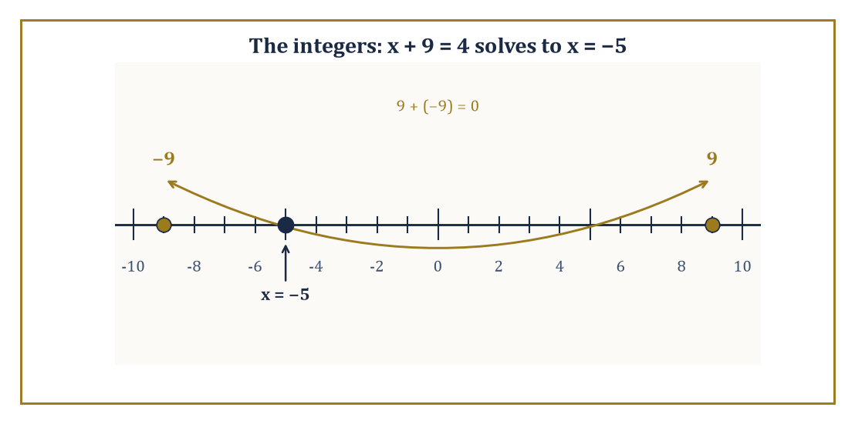
9 and −9 sit at equal distances from zero and cancel exactly, which is how x + 9 = 4 finds its way to x = −5.
The integers are what you get when you decide to take subtraction seriously instead of pretending the problem will go away if you ignore it long enough. We expand the number system to include negative numbers:
…, −3, −2, −1, 0, 1, 2, 3, …
Negative numbers were met with even more suspicion than zero; for a long time they were dismissed as “fictitious” or “absurd,” the mathematical equivalent of claiming you are owed a negative amount of pizza. And yet, once accepted, negative numbers make the arithmetic of the integers beautifully symmetric. Every number acquires an additive inverse:
n + (−n) = 0
The equation
x + a = b
now always has a solution, for any integers a and b. The system becomes closed under subtraction. Life becomes, if not fairer, at least more consistent.
Numeric example — A solution the naturals couldn't give you. Take a = 9, b = 4. Within the natural numbers alone,
x + 9 = 4
has no solution — you cannot add 9 to anything and shrink it to 4. Within the integers, it solves instantly:
x = 4 − 9 = −5
And checking:
−5 + 9 = 4
Notice also the additive inverse at work:
9 + (−9) = 0
which is exactly the property that let us rearrange x + 9 = 4 into x = 4 + (−9) in the first place.
One clean way to construct the integers formally, rather than simply declaring them into existence, is to take ordered pairs of natural numbers (a, b) and declare that the pair represents the integer a − b. We then impose an equivalence relation, identifying (a, b) with (c, d) whenever:
a + d = b + c
— which is just the cross-multiplied way of saying “a − b and c − d are the same difference,” phrased entirely using addition, so that we never have to assume subtraction already makes sense among naturals. It is an elegant construction, and also exactly the sort of thing that makes non-mathematicians edge slowly toward the door.
Numeric example — Three labels, one integer. Take the pair (2, 5), meant to represent
2 − 5 = −3
Is it equivalent to (0, 3), which represents
0 − 3 = −3
Check the rule: a + d = b + c becomes:
2 + 3 = 5 + 0, i.e. 5 = 5
True — so (2, 5) ~ (0, 3), as it should be, since both represent −3. Is (2, 5) also equivalent to (5, 8)? Check:
2 + 8 = 5 + 5, i.e. 10 = 10
True again, and indeed 5 − 8 = −3 as well. All three pairs, (2, 5), (0, 3), and (5, 8), are different labels glued together by the equivalence relation into a single object: the integer −3.
The integers come equipped with the usual addition and multiplication, extended in the natural way from the naturals. The familiar rules still hold, with one important new feature: the product of two negative numbers is positive. This rule has confused generations of students and produced more than a few internet arguments of truly impressive pointlessness. The justification is not mystical — it is the only choice that keeps the distributive law intact. Choose any other convention and algebra starts contradicting itself, and then we would all have to get real jobs.
Numeric example — Deriving (−1)×(−1) = 1. Here is the derivation, not just the assertion. We know, trivially:
0 = (−1) × 0
We also know:
0 = 1 + (−1)
Substitute the second into the first:
0 = (−1) × (1 + (−1))
Now apply the distributive law, which we insist must keep working:
(−1) × (1 + (−1)) = (−1)×1 + (−1)×(−1) = −1 + (−1)×(−1)
So:
0 = −1 + (−1)×(−1)
which rearranges to:
(−1)×(−1) = 1
Nobody decreed that “negative times negative is positive” by fiat; it is the unique value forced on (−1)×(−1) once you insist that ordinary multiplication keeps distributing over addition even when negative numbers are involved. Refuse the rule, and you have to give up the distributive law instead — a considerably worse trade.
With the integers in hand, we can finally talk about even and odd numbers in full generality, not just for positive counts. An integer n is even if:
n = 2k, for some integer k
and odd if:
n = 2k + 1, for some integer k
Every integer is exactly one or the other, never both, never neither — which sounds obvious until you remember we are now including negative numbers, and the definition needs to keep working for them too. We can also define the absolute value of an integer, |n|, as n itself if n is non-negative and −n if n is negative: a way of asking “how far from zero is this number,” with the direction stripped back out again.
Numeric example — Parity and distance, including in the negatives. Is −7 even or odd? By the definition, we need:
−7 = 2k + 1, for some integer k
Solving, k = −4, and indeed:
2(−4) + 1 = −8 + 1 = −7
So −7 is odd, exactly as its positive cousin 7 is. Now take the absolute value of −7 and of 7:
|−7| = −(−7) = 7
|7| = 7
(since −7 is negative, we negate it, while 7 is already non-negative). Both land on the same distance from zero, 7, which is the entire point of the operation — it forgets which side of zero you started on and only remembers how far you'd travelled.
The integers are not yet the whole story — the rational numbers and real numbers are still waiting in the wings, each with their own existential crises, several storeys further up the Tower — but they are a major upgrade. We have gone from “how many” to “how many, and in which direction.” It is progress. Of a sort.

Room 1.5: Divisibility, Primes, and the Stubborn Atoms of Arithmetic
Now that we have the integers, we can ask more interesting questions of them, the way one interrogates a suspiciously quiet teenager. The most fundamental is divisibility. We say that an integer a divides an integer b (written a | b) if there exists an integer k such that:
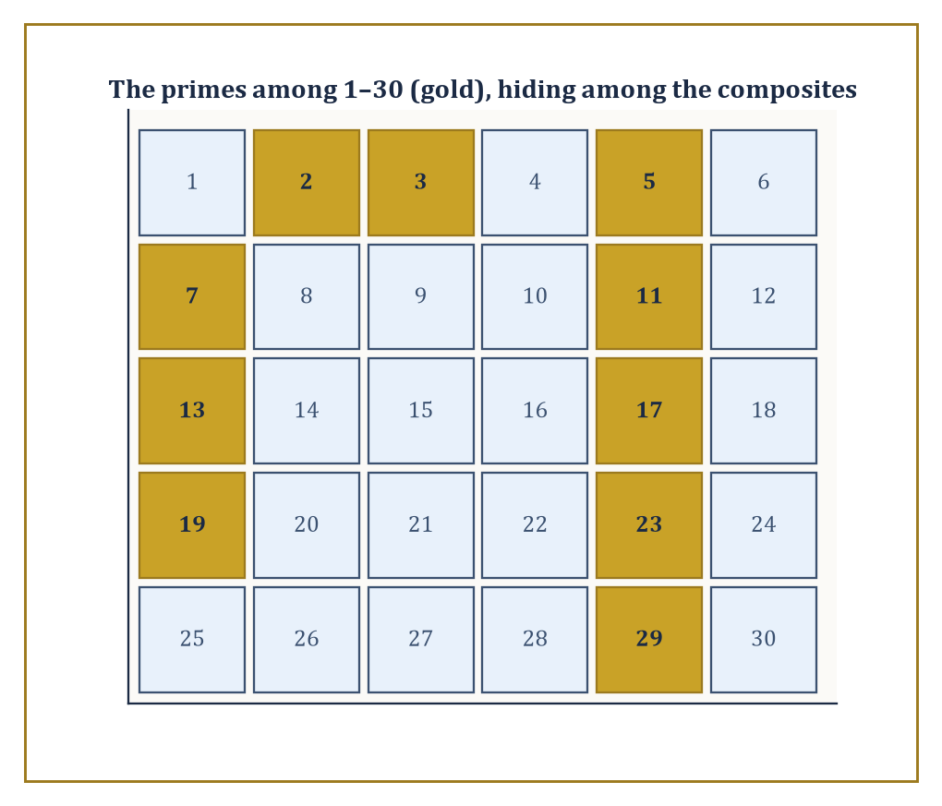
The primes from 1 to 30, picked out in gold, with no visible pattern to their spacing and no shortage of mathematicians who have tried to find one.
b = a · k
In plain language: a goes into b evenly, with no remainder, no fudge factor, and no messy fractions left apologising on the doorstep.
Numeric example — Divides, or doesn't. Does 6 divide 42? We need an integer k with:
42 = 6k
k = 7 works, since:
6 × 7 = 42
So yes, 6 | 42. Does 6 divide 43? We would need 43 = 6k for some integer k, and:
43 ⁄ 6 = 7.1666…
which is not an integer, so no — 6 ∤ 43. Divisibility is an all-or-nothing affair: either some integer multiple lands exactly on the number, or it doesn't, and there is no partial credit.
This simple idea immediately generates a cast of characters. A unit is a number that divides 1; in the integers, the only units are 1 and −1. A prime number is an integer greater than 1 whose only positive divisors are 1 and itself. A composite number is an integer greater than 1 that is not prime — that is, one with some other divisor strictly between 1 and itself.
Numeric example — Sorting 17, 21, and 1. Classify 17, 21, and 1. Is 17 prime? Check every possible divisor from 2 up to √17 ≈ 4.1: 17 is not divisible by 2 (it's odd), and not by 3:
17 = 3×5 + 2
No divisors turn up below its square root, so none can turn up above it either, and 17 is prime. Is 21 prime?
21 = 3 × 7
So it has a divisor (3) strictly between 1 and 21 — composite. And 1 itself? By definition, primes and composites both require the number to be greater than 1, so 1 is neither prime nor composite; it sits alone in its own category, the unit, dividing everything and offended by nothing.
Primes are the atoms of arithmetic. Every integer greater than 1 can be broken down into a product of primes, and — once we ignore order and sign — that breakdown is unique. This is the Fundamental Theorem of Arithmetic, and we will give it the dedicated room it deserves next; for now, just notice that it is one of those results that feels obvious until you try to prove it carefully, at which point you realise the universe was under no obligation to be this well-behaved.
Euclid proved, around 300 BCE, that there are infinitely many primes. The argument is short, elegant, and slightly smug. Suppose, for contradiction, that there were only finitely many primes in existence: p₁, p₂, …, pₙ. Consider the number:
N = p₁ · p₂ · … · pₙ + 1
N is certainly greater than 1, so by the atoms-of-arithmetic principle above, it has at least one prime factor. But that prime factor cannot be any of p₁ through pₙ, because dividing N by any pᵢ on our supposedly complete list leaves a remainder of exactly 1 (the product term is divisible by pᵢ; the “+1” never is). So N's prime factor is a prime that was missing from our “complete” list — a contradiction. Therefore no finite list of primes can ever be complete; there must always be another prime waiting outside it.
Numeric example — Euclid's argument, run on six real primes. Run the argument on an actual finite list. Take the first six primes: 2, 3, 5, 7, 11, 13. Their product is:
2 × 3 × 5 × 7 × 11 × 13 = 30 030
So N = 30 031. Is N itself prime? No — it factors as:
30 031 = 59 × 509
Check:
59 × 509 = 59 × 500 + 59 × 9 = 29 500 + 531 = 30 031
Notice what Euclid's argument promised, and only promised: not that N itself would be prime, but that its prime factors — here, 59 and 509 — would be new primes absent from the original list of six. Sure enough, neither 59 nor 509 is 2, 3, 5, 7, 11, or 13. The “complete” list of six primes was never complete; it was hiding at least two more just past its own product.
Primes become increasingly sparse as numbers get larger, yet they never run out. Their distribution is regular enough to make statistical predictions and irregular enough to keep mathematicians employed indefinitely. The Riemann Hypothesis, one of the great unsolved problems in mathematics, is essentially a very precise conjecture about how the primes are distributed; it has been verified for absurdly large numbers, but a general proof remains elusive. This is either a romantic quest or a centuries-long reminder that the universe does not owe us tidy answers. There is something almost comical about primes: they are completely deterministic — no randomness is involved in whether a given number is prime — and yet their appearance feels unpredictable. They are the mathematical version of a person who is reliably unreliable.
We will use primes constantly in what follows: in the Fundamental Theorem of the next room, in modular arithmetic, in cryptography, and in countless later arguments across the rest of this Tower. They are the stubborn, indivisible building blocks that refuse to be broken down further. Everything else is just combinations of them. And that, depending on your mood, is either deeply satisfying or faintly oppressive.

Room 1.6: The Fundamental Theorem of Arithmetic
(Or: Why Unique Factorisation Matters More Than You Think, and Why the Universe Was Under No Obligation to Be This Nice)
We have already met the claim informally: every integer greater than 1 can be written as a product of primes, and that product is unique if we ignore order and any stray minus sign. This is the Fundamental Theorem of Arithmetic. It is one of those results that feels so obvious you barely notice it — until someone points out that the integers did not have to work this way. There exist perfectly respectable number systems in which factorisation is not unique. The fact that ordinary integers behave themselves is a small miracle we mostly take for granted, the mathematical equivalent of clean drinking water.
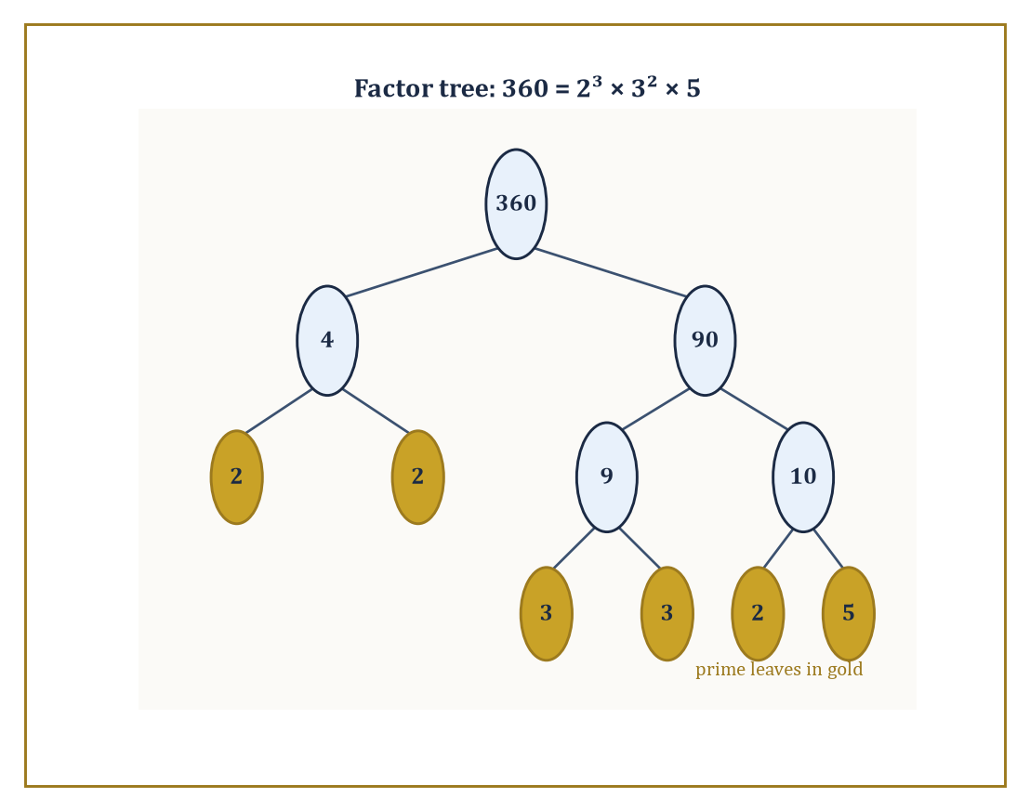
Split 360 however you like — the tree always bottoms out at the same six prime leaves: 2, 2, 2, 3, 3, 5.
The existence half of the theorem is relatively gentle. Take any integer n > 1. If it is prime, we are done — it is trivially “a product” of the single prime n. If it is not prime, it factors as a · b, where both a and b are strictly smaller than n and strictly greater than 1. Repeat the process on a and on b. Because the positive integers cannot decrease forever — there is no infinite descending staircase of positive whole numbers — the process must eventually terminate, at which point every remaining factor is prime. This is the well-ordering principle doing honest work for once: every non-empty set of positive integers has a smallest element, and that fact alone guarantees the splitting process cannot run forever.
Numeric example — Factoring 360, two different ways down. Factor 360 by repeatedly splitting. 360 is not prime (it's even), so split it:
360 = 4 × 90
Neither 4 nor 90 is prime, so split again:
4 = 2 × 2
(both prime — stop there), and:
90 = 9 × 10
Neither 9 nor 10 is prime:
9 = 3 × 3
10 = 2 × 5
(both prime — stop, on both counts). Collecting every leaf of this splitting tree:
360 = 2 × 2 × 3 × 3 × 2 × 5
Reordering and grouping repeated factors:
360 = 2³ × 3² × 5
Check the arithmetic:
2³ = 8, 3² = 9, 8 × 9 = 72, 72 × 5 = 360
Correct — and however you'd chosen to split 360 first (say 360 = 8 × 45 instead of 4 × 90), the splitting tree would eventually have bottomed out at exactly the same multiset of primes: two 2s, two 3s, one 5. Different paths down the tree; identical leaves.
Uniqueness is the more delicate half. Suppose, for contradiction, that some number had two genuinely different prime factorisations. A short argument using Euclid's lemma — if a prime p divides a product a · b, then p must divide a or divide b (or both) — leads to a contradiction: you can always cancel a shared prime from both factorisations and reduce to a smaller case, and eventually the two supposedly different factorisations are forced to coincide term by term. The details are tidy; the implications are not.
Numeric example — Euclid's lemma, tested. Does 3 divide the product 4 × 9 = 36? Yes:
36 = 3 × 12
The lemma insists that 3 must then divide 4 or divide 9 (or both). It certainly doesn't divide 4. Check 9:
9 = 3 × 3
So yes, 3 | 9, exactly as promised. Contrast this with a non-prime: does 4 divide 6 × 10 = 60? Yes:
60 = 4 × 15
But does 4 divide 6? No. Does 4 divide 10? No either — 4 divides the product without dividing either factor individually. That failure is precisely why Euclid's lemma is stated for primes only; composite numbers like 4 don't have the property, and unique factorisation quietly depends on primes being the ones that do.
Unique factorisation is the reason we can talk about “the prime factorisation” of a number as if it were a personal identity document. It is the reason greatest common divisors and least common multiples behave so reasonably — you can read gcd and lcm straight off two numbers' prime factorisations by taking the smallest and largest exponent of each shared prime. It is the hidden scaffolding behind much of elementary number theory, and later behind large parts of algebra. There is a darker observation worth making, though. The theorem is true for the integers. It is also true for polynomials over a field. It fails for some other perfectly natural-looking number systems. The universe did not hand us unique factorisation as a birthright; we got lucky with the integers, and most of the time we prefer not to dwell on how easily things could have been messier.
Abstract example — When factorisation stops being unique. Here is exactly how messy things can get, in a number system just one step removed from the integers. Consider numbers of the form a + b√−5, where a and b are ordinary integers — call this system ℤ[√−5]. In this system, the number 6 factors two genuinely different ways:
6 = 2 × 3
6 = (1 + √−5)(1 − √−5)
Multiply out the second version to check it:
(1 + √−5)(1 − √−5) = 1² − (√−5)² = 1 − (−5) = 1 + 5 = 6
Correct. And it turns out — this takes more machinery than we have room for here, but it is a standard, verified fact — that all four numbers 2, 3, 1 + √−5, and 1 − √−5 are “irreducible” in ℤ[√−5]: none of them can be broken down any further within that system. So 6 has two honestly different, equally valid factorisations into unbreakable pieces. Unique factorisation, which felt like an iron law back in the ordinary integers, simply does not hold here. The integers got the well-behaved version of arithmetic. Not every number system is so lucky.
For the rest of this storey, and for large stretches of the Tower above us, we will lean on this theorem constantly. Every time we casually write:
n = p₁^a₁ p₂^a₂ … pₖ^aₖ
we are spending capital that the Fundamental Theorem deposited for us. It is good to remember, occasionally, that the deposit was not guaranteed.

Room 1.7: Modular Arithmetic: Clocks, Remainders, and Secret Codes
Modular arithmetic is what happens when you decide that only the remainder matters. We say that a is congruent to b modulo m if m divides a − b, written:
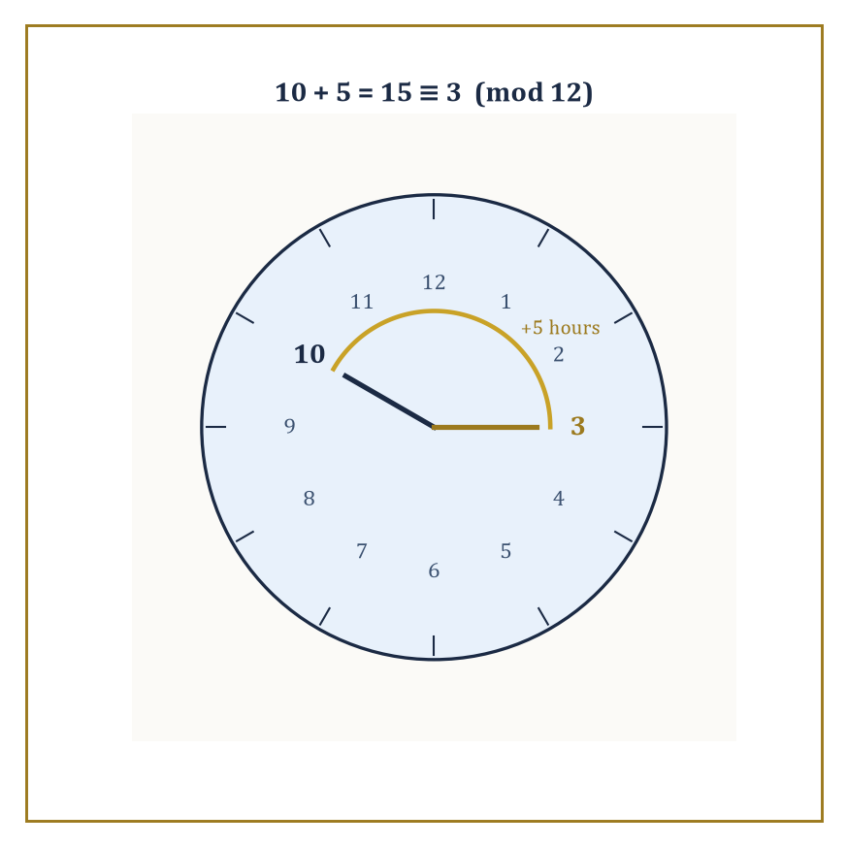
Five hours past 10 o'clock, the hand has quietly wrapped around to 3 — the clock face doing modular arithmetic without ever calling it that.
a ≡ b (mod m)
In everyday language: a and b leave the same remainder when divided by m.
The most familiar example is a clock. If it is 10 o'clock and you wait 5 hours, the clock shows 3, not 15 — we are, without ever using the word, working modulo 12. The same idea appears whenever we care about cycles, remainders, or the last few digits of a number.
Numeric example — Why the clock says 3. Check the clock claim properly:
10 + 5 = 15
Divide 15 by 12:
15 = 1 × 12 + 3
remainder 3. So:
15 ≡ 3 (mod 12)
because 12 divides 15 − 3 = 12 exactly (12 = 1 × 12). The clock face isn't doing anything mysterious; it is simply displaying the remainder after division by 12 and throwing away the “how many full laps” information, which is exactly what modular arithmetic always does.
Once you accept the definition, a surprising amount of ordinary arithmetic survives intact. You can add, subtract, and multiply congruences freely: if a ≡ b (mod m) and c ≡ d (mod m), then:
a + c ≡ b + d (mod m)
a · c ≡ b · d (mod m)
Division is trickier, and only works under certain conditions — the universe's way of reminding us it still has standards, even here.
Numeric example — Congruences surviving addition and multiplication. Let m = 5. Take a = 7, b = 2 (note 7 ≡ 2 (mod 5), since 5 | 5); and c = 9, d = 4 (9 ≡ 4 (mod 5), since 5 | 5). Addition:
a + c = 16, b + d = 6
Is 16 ≡ 6 (mod 5)?
16 − 6 = 10, and 5 | 10
Yes. Multiplication:
a · c = 63, b · d = 8
Is 63 ≡ 8 (mod 5)?
63 − 8 = 55, and 5 | 55
Yes. In both cases we could have worked entirely with the small representatives 2 and 4 instead of the unwieldy 7 and 9:
2 + 4 = 6 ≡ 1 (mod 5)
2 × 4 = 8 ≡ 3 (mod 5)
That matches directly: 16 mod 5 = 1, and 63 mod 5 = 3. That is the entire practical payoff of modular arithmetic — you can shrink the numbers before you compute and still land on the right remainder.
Modular arithmetic is the foundation of many practical systems. Computer hash functions, error-correcting codes, and the majority of modern cryptography rely on it heavily. The security of RSA encryption, for instance, rests on the practical difficulty of factoring large numbers, combined with some elegant modular exponentiation. We will not develop the full cryptographic machinery here — that belongs several storeys up — but it is worth noting that the same remainder arithmetic you first met while learning to tell the time is now quietly protecting your bank account. There is a certain comedy in the situation. Humanity spent centuries treating modular arithmetic as a minor curiosity, useful mainly for calendars and number puzzles. Then computers arrived, electronic commerce arrived, and suddenly the ability to work cleanly with remainders became geopolitically relevant. The humble clock arithmetic grew up and got a security clearance.
Numeric example — Why modular exponentiation stays cheap. Here is the trick that makes modular exponentiation cheap even for enormous numbers, illustrated on a friendly small case. Compute 3⁴ (mod 7). Directly:
3⁴ = 81, and 81 = 11×7 + 4, so 3⁴ ≡ 4 (mod 7)
Now compute it the way a computer actually would, reducing after every multiplication instead of waiting until the end:
3¹ = 3
3² = 9 ≡ 2 (mod 7)
3³ = 3² × 3 ≡ 2 × 3 = 6 (mod 7)
3⁴ = 3³ × 3 ≡ 6 × 3 = 18 ≡ 4 (mod 7)
Same answer, 4, but every intermediate number stayed small — never larger than roughly 6 × 7 — instead of exploding the way 3^(large exponent) would if computed in full before reducing. Real cryptographic systems raise numbers to exponents hundreds of digits long; this reduce-as-you-go habit is the only reason that remains computationally feasible at all.
We can also use modular arithmetic to prove things that do not look modular at first glance. A classic example: a number is divisible by 9 if and only if the sum of its digits is divisible by 9. The proof is a short calculation modulo 9, once you notice that:
10 ≡ 1 (mod 9)
and therefore every power of 10 is also ≡ 1 (mod 9), so a number's value modulo 9 is just the sum of its digits, with all the place-value weighting quietly cancelling out. Many divisibility rules are just modular arithmetic wearing a disguise.
Numeric example — Testing 4761 for divisibility by 9. Test it on 4761. Digit sum:
4 + 7 + 6 + 1 = 18
and 18 is divisible by 9 (18 = 2 × 9). The rule predicts 4761 should be divisible by 9 as well. Check directly:
4761 ⁄ 9 = 529
9 × 529 = 4761
Confirmed. Now perturb it: 4762 has digit sum:
4 + 7 + 6 + 2 = 19
not a multiple of 9, so the rule predicts 4762 is not divisible by 9 — and indeed 4762 = 4761 + 1, one more than a multiple of 9, so it leaves remainder 1. The rule works in both directions, exactly as “if and only if” promises.
Working modulo a prime is especially pleasant, because then the remainders form a field: every non-zero remainder has a multiplicative inverse, meaning you can always “divide” by it. Working modulo a composite number is messier — not every non-zero remainder has an inverse there — which is both a nuisance and, perhaps surprisingly, the source of some of cryptography's strength: the messiness itself is what makes certain problems hard to reverse.
Numeric example — An inverse that exists, and one that doesn't. Modulo 7 (prime), does 3 have a multiplicative inverse — some x with 3x ≡ 1 (mod 7)? Try x = 5:
3 × 5 = 15 ≡ 1 (mod 7)
since 15 − 1 = 14 = 2×7. Yes, inverse found. Now modulo 6 (composite), does 2 have an inverse — some x with 2x ≡ 1 (mod 6)? Every multiple of 2 is even, and every number congruent to 1 (mod 6) — 1, 7, 13, 19, … — is odd. An even number can never equal an odd one, so no x works: 2 has no inverse modulo 6. The obstruction is exactly that 2 shares a common factor with 6; primes share no common factor with anything smaller than themselves, which is why every non-zero remainder modulo a prime is guaranteed an inverse.
Modular arithmetic teaches an important lesson: sometimes you can throw away almost all the information about a number and still retain a rich, consistent algebraic structure. The integers are infinite and detailed. Their shadows modulo m are finite and still surprisingly well-behaved. It is one of the cleaner tricks in the mathematical repertoire.

Room 1.8: Diophantine Equations: When Whole Numbers Refuse to Cooperate
A Diophantine equation is an equation in which we are only interested in integer solutions. The name comes from Diophantus of Alexandria, who studied such equations in the third century CE, and whose work later inspired Fermat to scribble the most famous margin note in the history of mathematics. Diophantine problems have a distinctive flavour: they often look innocent, and then turn out to be either trivial, extremely hard, or — in the worst case — formally undecidable.
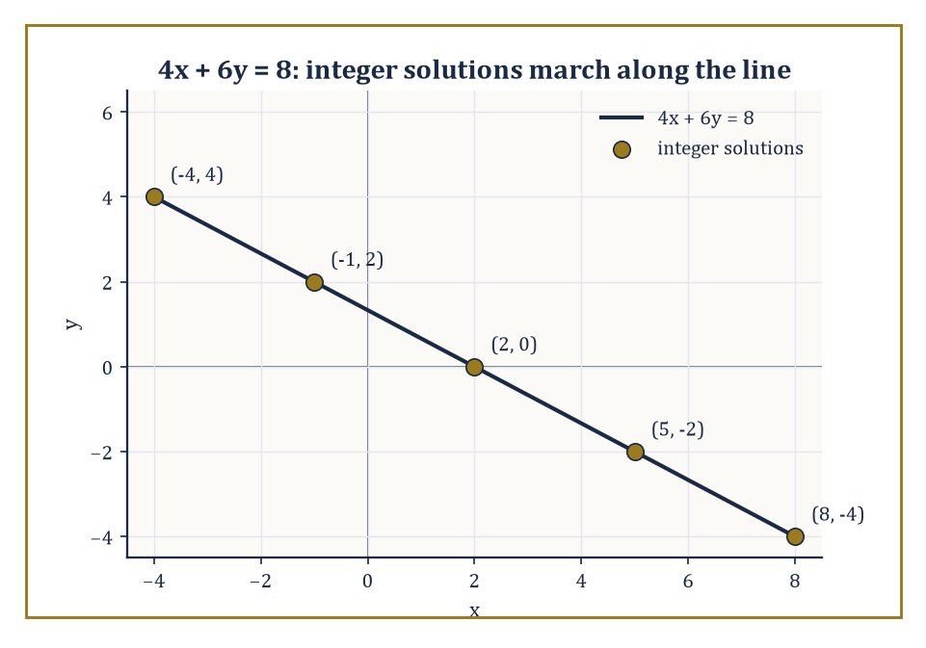
Every point on the line 4x + 6y = 8 is a solution, but only the gold ones are integers — spaced out evenly, courtesy of the same gcd that decided any of this was solvable at all.
The simplest examples are linear. The equation
ax + by = c
has integer solutions if and only if the greatest common divisor of a and b divides c. When solutions exist, there are infinitely many of them, generated systematically from any single particular solution by sliding along a family — this is the Euclidean algorithm doing useful work again, the same machinery that computes greatest common divisors in the first place.
Numeric example — Solving 4x + 6y = 8. Solve:
4x + 6y = 8
First check solvability: gcd(4, 6) = 2, and 2 does divide 8, so solutions exist. Spot a particular solution by inspection: x = 2, y = 0 works, since:
4(2) + 6(0) = 8
The general solution then slides both variables together:
x = 2 + 3t, y = 0 − 2t, for any integer t
(the step sizes 3 and −2 come from dividing 6 and 4 by their gcd, 2, and swapping them with a sign flip). Check t = 1: x = 5, y = −2, giving:
4(5) + 6(−2) = 20 − 12 = 8
Correct. Check t = −1: x = −1, y = 2, giving:
4(−1) + 6(2) = −4 + 12 = 8
Also correct. Infinitely many integer solutions, all generated from that one starting pair by marching t through every integer.
Nonlinear Diophantine equations are where the personality of the subject really appears. Fermat's equation:
xⁿ + yⁿ = zⁿ
has no positive integer solutions once n > 2 — this is Fermat's Last Theorem, conjectured in 1637 and finally proved by Andrew Wiles in 1994, after three and a half centuries of partial results, false hopes, and collective mathematical frustration. The proof is far beyond the scope of this storey (it lives in the rarefied territory of elliptic curves and modular forms, many storeys above us); the existence of the proof is itself a kind of moral victory.
Numeric example — Squares cooperate; cubes don't. See the contrast directly. For n = 2, solutions exist in abundance:
3² + 4² = 9 + 16 = 25 = 5²
A genuine positive-integer solution to x² + y² = z². Fermat's theorem says that if you simply change the exponent to 3, no analogous triple of positive integers exists anywhere, ever, for:
x³ + y³ = z³
not that none has been found yet, but that none can exist, full stop. The equation looks almost identical to the one that just worked beautifully for squares. It is exactly this near-identical appearance, paired with wildly different behaviour, that makes Diophantine equations so treacherous: changing a single exponent can move a problem from “solved by a bright teenager” to “took 358 years and modern algebraic geometry.”
Another classic is Pell's equation,
x² − d y² = 1
where d is a positive integer that is not a perfect square. It always has infinitely many solutions, and — despite the equation's mild appearance — they grow exponentially fast. The equation looks almost trivial. Its solutions are not.
Numeric example — Pell's equation for d = 2. Take d = 2:
x² − 2y² = 1
Trying small values, x = 3, y = 2 works:
3² − 2(2²) = 9 − 8 = 1
That is the fundamental (smallest positive) solution. Pell's equation theory guarantees infinitely many more, each generated from the last by a fixed rule; the next one after (3, 2) is (17, 12), and indeed:
17² − 2(12²) = 289 − 288 = 1
Notice how fast the solutions are growing — from (3, 2) to (17, 12) in a single step — which is the “exponential growth” promised above, arriving from an equation that, at first glance, looks barely more complicated than a circle.
There are also negative results of a more unsettling kind. Hilbert's tenth problem, posed in 1900, asked for a general algorithm that could decide whether any given Diophantine equation has integer solutions. In 1970, Yuri Matiyasevich, building on earlier work by Martin Davis, Hilary Putnam, and Julia Robinson, proved that no such algorithm can exist. There are entire families of Diophantine equations for which we cannot, even in principle, have a uniform method to determine solvability — not because we haven't been clever enough yet, but because the question itself is provably beyond the reach of any algorithm. This is one of those moments where mathematics quietly informs us that our ambitions have limits. Not every problem we can state cleanly can be solved cleanly. The integers, for all their rigid structure, still contain regions of formal undecidability.
Abstract example — Smuggling a halting problem into an equation. Here is the shape of why undecidability strikes, without the full machinery. The Davis–Putnam–Robinson–Matiyasevich work shows that for any computer program P and input i, you can mechanically build a Diophantine equation E(P, i) — a polynomial equation in several integer unknowns, with P and i baked into its coefficients — such that E(P, i) has an integer solution exactly when P halts on input i.
That single fact is enough to sink Hilbert's dream: if a general solvability-detecting algorithm existed for all Diophantine equations, you could feed it E(P, i) and it would just have told you, for any program and any input whatsoever, whether that program eventually halts. But the halting problem is already known to be undecidable — no algorithm can settle it in general, for exactly the diagonal reasons that make Cantor's argument in Room 1.9 work. So no general Diophantine-solvability algorithm can exist either, on pain of solving something already proven unsolvable. Any specific equation you actually sit down with might still yield to cleverness; it is only the demand for one uniform method covering every equation, forever, that the theorem rules out.
Diophantine equations sit at an interesting crossroads. They are concrete — we are asking about actual whole numbers — yet they connect to deep results in algebraic number theory, elliptic curves, and computability theory, several storeys above where we currently stand. They also produce some of the most addictive puzzles in mathematics; plenty of people who claim to hate maths will still spend an afternoon hunting for integer points on a curve, if the problem is posed as a riddle rather than an assignment. The integers do not always cooperate. That refusal is part of what makes them interesting.

Room 1.9: Infinity, Size, and the Strange Hierarchies of Countable Sets
(Or: How the Natural Numbers Managed to Be Both Infinite and Surprisingly Small)
So far we have mostly treated the natural numbers as an endless supply of counting tokens. There is always a next one; the sequence never finishes. That already gives us a respectable infinity — the smallest infinity, as it turns out, though “smallest” is doing a great deal of quiet philosophical work in that sentence.
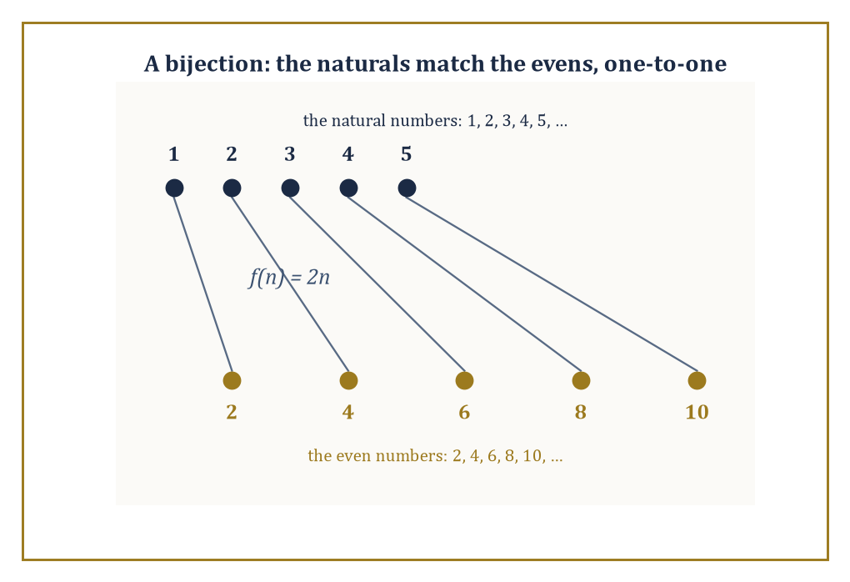
Every natural number finds exactly one even partner and vice versa — proof enough, against all instinct, that the two sets are the very same size.
Georg Cantor, in the late nineteenth century, forced the mathematical world to take seriously the idea that infinite sets can have different sizes. The reaction was mixed: some mathematicians were delighted, others were appalled, and Cantor himself suffered for it. Infinity, it seems, is not only large; it is also bad for your health if you stare at it too long without proper support. The key idea is one-to-one correspondence, or bijection: two sets have the same cardinality — the same “size,” in the relevant sense — if there exists a pairing between them that matches every element of one set with exactly one element of the other, with nothing left over on either side.
Numeric example — The naturals and the evens, matched perfectly. Using this criterion, the natural numbers have exactly the same cardinality as the even natural numbers — which sounds wrong the first time you hear it, since the evens are obviously “half” of the naturals. But build the pairing explicitly:
f(n) = 2n
1 ↔ 2, 2 ↔ 4, 3 ↔ 6, 4 ↔ 8, 5 ↔ 10, …
Every natural number n lands on exactly one even number, 2n; every even number 2n comes from exactly one natural number, n. Nothing is left unpaired on either side, ever, no matter how far you go. By the bijection criterion, that is what “same size” means — and the even numbers pass the test, despite feeling like they ought to be half as numerous. Infinity does not obey the same intuitions as finite collections; it is less a quantity than a different mode of existence.
Any set that can be put into one-to-one correspondence with the natural numbers is called countably infinite, or denumerable. The integers are countable (interleave the positives and negatives: 0, 1, −1, 2, −2, 3, −3, …). The rational numbers are countable too — a fact that still feels like a magic trick the first time you see the proof. Arrange the positive rationals in an infinite grid, numerator against denominator, then snake diagonally through the grid, skipping any fraction that isn't in lowest terms, because it duplicates one you've already listed. Eventually every positive rational appears exactly once in the resulting list. The rational numbers, despite being dense on the number line — between any two rationals there is always another — are no more numerous than the natural numbers.
Numeric example — The first few stops of the rational snake. Trace the first few steps of the snake. Arrange fractions p⁄q in a grid by row p and column q. The diagonal sweep visits pairs in order of increasing p+q: first (1,1) → 1⁄1 = 1; then the p+q=3 diagonal:
(1,2) → 1⁄2, (2,1) → 2⁄1 = 2
then p+q=4:
(1,3) → 1⁄3, (2,2) → 2⁄2 = 1 (already listed, skip it), (3,1) → 3⁄1 = 3
So the enumeration begins:
1, 1⁄2, 2, 1⁄3, 3, 1⁄4, 2⁄3, 3⁄2, 4, …
A single, if slightly chaotic, list that a computer, or a sufficiently patient human, could keep extending forever, eventually reaching any positive rational you care to name, at some finite position in the list.
Then come the real numbers. Cantor's diagonal argument shows that the reals are not countable — no list, however cleverly constructed, can ever contain them all. There is a strictly larger infinity than the countable one. This is the first step of an infinite hierarchy of infinite sizes: the power set of any set (the set of all its subsets) is always strictly larger than the set itself, and once you accept the natural numbers, you are forced to accept an endless tower of ever-larger infinities above them.
Numeric example — Cantor's diagonal, in miniature. Here is the diagonal trick in miniature. Suppose someone hands you a supposedly complete list of real numbers between 0 and 1, and the first four entries read:
r₁ = 0.1234…, r₂ = 0.5678…, r₃ = 0.9101…, r₄ = 0.1121…
Build a new number by walking down the diagonal — take the 1st digit of r₁, the 2nd digit of r₂, the 3rd digit of r₃, the 4th digit of r₄ — which gives 1, 6, 0, 1. Now change every one of those digits (add 1 to each, say): 2, 7, 1, 2, giving a new number:
0.2712…
This constructed number cannot be r₁, because it differs from r₁ in the 1st digit (2 ≠ 1). It cannot be r₂, because it differs in the 2nd digit (7 ≠ 6). It cannot be r₃ (3rd digit: 1 ≠ 0), and cannot be r₄ (4th digit: 2 ≠ 1). Extend this to an infinite list and an infinite diagonal, and the constructed number differs from every single entry on the list, in at least one digit, guaranteed by construction. No list of real numbers, however long, can ever be complete. That is Cantor's proof, in a very small nutshell.
This is the point at which many people begin to feel that mathematics has left the building and started its own religion. The feeling is understandable. We began with counting sheep and ended up with a never-ending hierarchy of infinite cardinalities, most of which will never appear in any ordinary physical measurement. And yet the theory is consistent (relative to the usual axioms of set theory), powerful, and indispensable for modern analysis and beyond.
For the purposes of this storey, the main moral is modest. The natural numbers give us the smallest infinity, and that infinity is already rich enough to support unique factorisation, modular arithmetic, and the beginnings of Diophantine analysis. Everything else in arithmetic and elementary number theory lives comfortably inside the countable realm. The larger infinities are waiting for later storeys, once we have the stomach for them. Infinity is not just “more than you can count.” It has structure. And the structure begins with the humble, stubborn, endless sequence 1, 2, 3, …

Room 1.10: Looking Ahead: From Arithmetic to Everything Else
(Or: Why We Just Spent an Entire Storey on the Mathematical Equivalent of Learning to Walk)
We have now walked through the basic landscape of arithmetic and elementary number theory: the natural numbers, zero, the integers, divisibility, primes, unique factorisation, modular arithmetic, Diophantine equations, and a first careful look at countable infinity. It is worth asking what the point was.
The short answer is that everything else depends on it. Algebra, waiting one storey up, begins by abstracting the operations and properties we first met among the integers — the same additive inverses, the same distributive law we derived by hand in Room 1.4, now applied to symbols instead of specific numbers. Analysis begins with the desire to extend these numbers to the reals and then study limits, continuity, and change. Geometry eventually coordinates itself with numbers. Probability counts outcomes. Cryptography hides secrets inside modular arithmetic and the difficulty of factoring, exactly as sketched in Room 1.7. Even the more exotic later subjects in this Tower — topology, functional analysis, algebraic geometry — continually return to the integers and the rationals for examples, for coefficients, for invariants, and for sanity checks.
There is also a deeper reason. Arithmetic forces us to confront some of the central tensions in mathematics: the finite versus the infinite, the constructive versus the purely existential, the decidable versus the undecidable, the concrete versus the abstract. These tensions do not go away as the subjects above us get more advanced. They only become better dressed. Room 1.9 gave us finite versus infinite outright, with the natural numbers on one side and Cantor's tower of larger infinities on the other. Room 1.8 gave us constructive versus existential: knowing a linear Diophantine equation has a solution, from the gcd test, is quite different from actually producing one, and knowing Hilbert's tenth problem has no general algorithm is different again — that is decidable versus undecidable, in the same room, wearing two different hats. Room 1.6 gave us concrete versus abstract: a very concrete fact about ordinary integers (unique factorisation) that turns out to be a special privilege, not a universal law, once you wander one step sideways into ℤ[√−5]. None of these tensions were manufactured for effect. They are simply what is left once you look at the integers closely enough and refuse to look away.
A few themes from this storey will keep returning throughout the Tower: unique factorisation and its generalisations; the power of working modulo n; the difference between what exists and what we can construct or compute; and the fact that the simplest structures often support the deepest questions. Keep an eye out for them. Algebra will lean on unique factorisation the moment it starts factoring polynomials instead of integers — the same “atoms” idea, wearing a different coat. Any storey involving codes, hashing, or security will lean on modular arithmetic, usually without pausing to credit the clock on your kitchen wall. And any storey that gets ambitious about existence proofs — showing something must be true without necessarily showing how to find it — is quietly continuing the argument Room 1.8 started with Hilbert's tenth problem.
Numeric example — One last factorisation, for the road. As a small parting gift, factor a nearby year into some ground reality: 2024. Divide out small primes:
2024 ⁄ 2 = 1012; 1012 ⁄ 2 = 506; 506 ⁄ 2 = 253
That's three factors of 2, and 253 is odd, so stop dividing by 2:
2024 = 2³ × 253
Is 253 prime? Try small divisors: not by 2 (odd), not by 3 (2+5+3=10, not a multiple of 3), not by 5 (doesn't end in 0 or 5), not by 7 (253 ⁄ 7 ≈ 36.1), but by 11:
253 ⁄ 11 = 23 exactly (11 × 23 = 253)
So 253 = 11 × 23, and both 11 and 23 are prime. Full factorisation:
2024 = 2³ × 11 × 23
Check:
8 × 11 = 88, and 88 × 23 = 2024 (88 × 20 = 1760, 88 × 3 = 264, 1760 + 264 = 2024)
Correct — and there is exactly one such factorisation, guaranteed by Room 1.6's theorem, however you'd chosen to split the number apart.
We began with counting. We end with the realisation that counting, taken seriously, already contains infinity, undecidability, and the seeds of much of modern mathematics. The next storey up turns to basic algebra — equations, factoring, and inequalities — where the numbers we have just spent an entire storey getting to know will start to move and combine in more flexible ways. The integers will still be there, quietly underwriting the story, the way a reliable friend underwrites your worst decisions without comment. Arithmetic was never going to be the glamorous part of this Tower. It is, however, the part that everything else quietly leans on — which these ten rooms have hopefully made feel less like duty and more like the discovery it always was.
That, then, is the ground floor. Natural numbers, zero, integers, primes, the Fundamental Theorem, clocks and remainders, whole numbers refusing to cooperate, and a first vertiginous look up the infinite stairwell. None of it was decoration. Every room in this storey is a load-bearing wall for something above it, whether that something arrives next storey or forty storeys from now.
Arithmetic is not the most glamorous part of mathematics. It is merely the part that refuses to go away — the friend who turns up uninvited to every party the rest of the Tower throws, and who, annoyingly, always turns out to have been right about something.
Storey 2 waits just above: Basic Algebra, where equations get solved, expressions get factored, and inequalities learn to behave (mostly). The numbers you now know will still be there, doing the arithmetic underneath the symbols, the way they always do. Thank you for walking through the ground floor with me. Mind the step; the rest of the Tower is waiting.

Storey 2: The Algebra of Almost
Equations, Factoring, Inequalities, and the Art of Not Quite Solving Everything
The previous storey spent a respectable amount of time convincing us that the counting numbers exist, that zero is allowed to sit with the grown-ups, and that the primes are the stubborn atoms of arithmetic. It was wholesome. It was necessary. It was also, if we are being honest, the mathematical equivalent of learning to stand upright before attempting the hundred-metre hurdles.
Now the numbers begin to move. Algebra is the moment when we stop treating numbers as finished objects and start treating them as unknown quantities that have to satisfy relationships. We write equations. We try to solve them. Sometimes we succeed cleanly. Sometimes we factor. Sometimes we discover that the equation has no solutions in the numbers we currently possess and are forced to invent new ones, or admit defeat. And then there are inequalities, which are equations that have given up on the dream of exact equality and settled for “at least this much” or “no more than that.”
This storey is about those relationships, and it keeps the same ground rules as before. Clarity first. Humor second, but not so far second that it gets lonely. We will prove things when the proof is illuminating, and admit when we are mostly just rearranging symbols until the answer falls out. We will meet the quadratic formula, and we will also meet the sinking feeling that comes when a higher-degree polynomial refuses to factor nicely. We will treat inequalities with the respect they deserve, which is slightly less than equations but still more than they usually get in conversation.
A small confession: algebra has always held a special place for me, because it is the first branch of mathematics that feels like detective work. You are given constraints. You manipulate them according to rules that are not optional. And at the end you either have the unknown cornered, or you discover that the constraints were lying to you the whole time. Both outcomes are educational. Only one of them is emotionally satisfying. If the previous storey was about the existence and structure of numbers, this one is about what happens when those numbers are forced to negotiate with one another. Let's begin the negotiations.

Room 2.1: What Algebra Actually Is
(And Why It Feels Like a Bait-and-Switch)
Most people first meet algebra as a sudden demand to start using letters in the middle of what used to be ordinary arithmetic. One day you are adding 3 and 5, feeling pleased with yourself. The next day someone writes 3 + x = 8 on the board and expects you to be fine with it, as though a stranger had wandered into the equation and nobody had thought to introduce him.
3 + x = 8
The emotional whiplash is real, and if you felt betrayed at the time, you were not wrong to.
Here is the correction, delivered as gently as the subject allows. Algebra is not “arithmetic with letters.” It is the systematic study of relationships that numbers must satisfy, together with the techniques for extracting information from those relationships.
The letter x is not a number in disguise; it is a promise — a placeholder standing in for whatever number, or numbers, would make a given statement true. Arithmetic asks “what is 3 + 5?” and expects a single unambiguous number back. Algebra asks “what has to be true of x for this statement to hold?” and the honest answer might be one number, several numbers, no numbers at all, or, as we shall see distressingly often, infinitely many.
Numeric example — Worked example. Take the mysterious stranger from above: 3 + x = 8. Algebra does not guess; it isolates. Subtract 3 from both sides — a move that changes nothing about which values of x make the statement true, because we did exactly the same thing to both sides.
3 + x = 8
3 + x − 3 = 8 − 3
x = 5
Check it:
3 + 5 = 8
Correct. The whole apparatus of algebra, however elaborate it later becomes, is doing nothing more exotic than this in spirit: perform the same legal move on both sides until the unknown stands alone.
The central object of algebra is the equation: a statement that two expressions are equal. The central activity is solving: finding the values, if any, that make the statement true.
Along the way we develop tools — factoring, substitution, completing the square, the quadratic formula, and a small arsenal of less glamorous but equally necessary manipulations — that let us transform equations into more convenient forms without changing their solutions. Every one of these tools obeys the same underlying law: whatever you do to an equation, you must do to both sides equally, or you have written a different equation and are now solving the wrong problem while feeling very productive about it.
There is a quiet philosophical shift happening here, and it is worth pausing on before we get swept up in the mechanics. In arithmetic we mostly worked with specific numbers: 7, 12, 45. In algebra the specific numbers become secondary. What matters is the structure of the relationship.
The equation 2x + 3 = 11 is not really about the number 11.
2x + 3 = 11
It is about the demand that twice some unknown quantity, plus three, must produce eleven. The unknown is a placeholder for whatever will make the demand true — and the demand itself, stripped of its particular numbers, is a pattern: “double it and add a bit, get this.” That pattern recurs in a thousand disguises.
Numeric example — Worked example. The same pattern, 2x + 3 = 11, could equally well be dressed up as a word problem: “I think of a number, double it, add three, and get eleven — what was my number?” Solve exactly as before.
Subtract 3 from both sides:
2x = 8
Divide both sides by 2:
x = 4
Check: double 4 is 8, plus 3 is 11. The number was 4, and the arithmetic content — doubling, adding three — is identical whether it arrives wearing a word problem's costume or an equation's bare notation. Algebra is what survives the costume change.
This is both liberating and slightly menacing. Liberating because the same equation can describe the balance in your bank account, the position of a particle, or the number of chairs needed at a dinner party — one piece of algebraic machinery, endlessly reusable.
Menacing because once you allow unknowns, you also allow the possibility that no number satisfies the conditions, or that infinitely many do, or that the conditions contradict one another so thoroughly that the entire setup is empty. Arithmetic never has to worry about any of this: 7 + 5 is 12, full stop, no existential crisis required. Algebra invites the crisis in and offers it a chair.
Abstract example — Worked example. Consider three superficially similar statements. First:
x + 1 = x + 1
This is true for every number you could possibly substitute — an identity, satisfied always, telling you nothing about x in particular because it demands nothing in particular.
Second:
x + 1 = x + 2
Subtract x from both sides and you are left with
1 = 2
which is false regardless of what x is — no number satisfies it, and the equation is simply empty, a promise with nothing behind it.
Third, our earlier example:
2x + 3 = 11
which is true for exactly one value of x, namely 4, and false for every other number in existence. Three equations, three utterly different populations of solutions — all of the universe, none of it, and exactly one point in it. Algebra forces you to find out which situation you are in before you can claim to have “solved” anything.
We will begin with the best-behaved cases — linear equations in one variable — and gradually let the situation get more complicated. By the end of this storey you will have met polynomials of higher degree, systems of equations, and inequalities.
You will also have met the growing realization that “solve” does not always mean “find a tidy closed-form expression.” Sometimes it means “prove that solutions exist.” Sometimes it means “show that no solutions exist.” Sometimes it means “here is an algorithm that gets you as close as you need for practical purposes.”
Algebra is the art of extracting what can be extracted from the relationships we write down. It is also the art of recognizing when the relationships have nothing further to give. That recognition, inconvenient though it is, is part of growing up mathematically.

Room 2.2: Linear Equations
The Rare Cases Where Everything Behaves
Linear equations in one variable are the mathematical equivalent of a well-behaved houseguest. They arrive, they follow the rules, they leave a clear answer, and they do not invent new complications for sport.
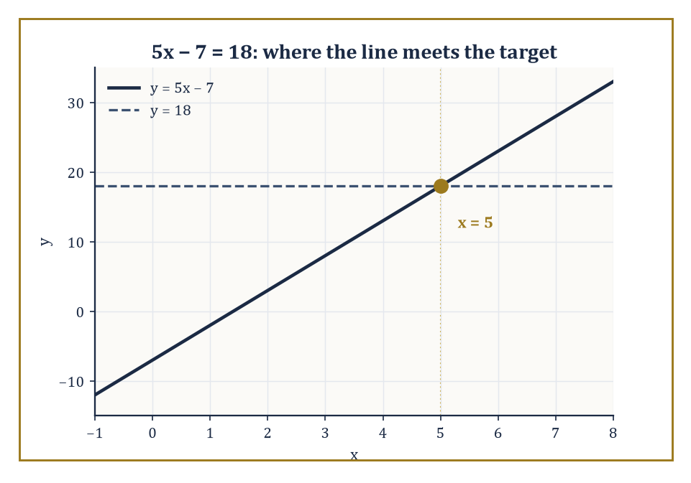
The line y = 5x − 7 meets the target line y = 18 at exactly one point — the whole plot of every linear equation, in miniature.
After the unruly philosophical territory of the last room — equations that might have no solutions, or infinitely many, or turn out to be secretly about nothing — it is worth spending a room with the guest who actually says thank you on the way out.
A linear equation can be written in the following general form, where a, b, and c are known numbers and a is not zero.
ax + b = c
(If a were zero, x would vanish entirely and you would be left with a bare statement about b and c, which is a different, and much less interesting, kind of problem.)
The goal is to isolate x: to manoeuvre the equation, one legal step at a time, until it reads “x = (something we can compute).” The allowed moves are simple and reversible: add or subtract the same quantity from both sides, multiply or divide both sides by the same non-zero quantity.
Each move preserves the solution set exactly, because whatever number satisfied the equation before the move still satisfies it after, and vice versa. After a short sequence of such moves you arrive at x equals some specific number.
Numeric example — Worked example. Solve the following equation.
5x − 7 = 18
Step one: add 7 to both sides to undo the subtraction.
5x − 7 + 7 = 18 + 7
5x = 25
Step two: divide both sides by 5 to undo the multiplication.
5x/5 = 25/5
x = 5
Check by substituting back into the original equation.
5(5) − 7 = 25 − 7 = 18
Correct. Two moves, one answer, no drama — exactly as advertised.
Real linear equations are rarely handed to you in such a tidy state; the unknown often turns up on both sides of the equals sign, or wrapped in a fraction, and part of the skill is recognizing that the equation is still secretly of the form ax + b = c once the clutter is cleared.
The clearing itself uses nothing but the same two legal moves, applied patiently.
Numeric example — Worked example. Solve the following equation, where the unknown appears on both sides.
(2x + 1)/3 = x − 2
First, clear the fraction by multiplying both sides by 3, which expands as follows.
2x + 1 = 3(x − 2)
2x + 1 = 3x − 6
Now collect the x terms on one side by subtracting 2x from both sides.
1 = x − 6
Add 6 to both sides.
x = 7
Check: left side and right side.
(2·7 + 1)/3 = 15/3 = 5
7 − 2 = 5
Both sides agree, so x = 7 is confirmed. Notice that the unknown appeared on both sides at the start and still yielded, without complaint, to the same two moves — add/subtract, multiply/divide — used sequentially.
That is the entire story for one linear equation in one unknown. It always has exactly one solution, provided a ≠ 0.
There is no case analysis, no branching, no moment where the equation might turn around and refuse to cooperate. The unknown is cornered with almost embarrassing efficiency.
There is a subtlety worth flagging before we move on, precisely because it explains why the definition insisted a ≠ 0 in the first place.
If the coefficient of x cancels out entirely during simplification, the equation stops being about x at all, and collapses into a bare statement that is either always true or never true, exactly the identity-versus-empty distinction we met in the abstract example of Room 2.1, now caught in the act during ordinary simplification rather than presented as a curiosity.
Numeric example — Worked example: when x quietly disappears. Simplify the following equation.
2(x + 3) = 2x + 7
Expand the left side.
2x + 6 = 2x + 7
Subtract 2x from both sides, as the standard method instructs.
6 = 7
This is false for every value of x, since it no longer mentions x at all, so the equation has no solution whatsoever, not because we made an arithmetic slip, but because the two sides were never capable of agreeing.
Now compare with the following equation.
2(x + 3) = 2x + 6
Expand.
2x + 6 = 2x + 6
Subtract 2x.
6 = 6
This is true unconditionally. Every real number x satisfies this equation, because the left and right sides were identical expressions wearing different outfits. Same opening move, same cancellation, two opposite verdicts, which is exactly why checking your solution by substitution back into the original equation is not merely good manners; it is how you catch which of these two silent traps you have fallen into.
The simplicity is useful precisely because it is rare. Most equations you will meet later — quadratics, higher-degree polynomials, systems, inequalities — do not behave this way.
Linear equations therefore serve as the baseline: the situation against which all later complications are measured. When a method works cleanly for linear equations and then becomes messy for quadratics, you will notice the difference and understand why the extra machinery, factoring, the quadratic formula, case analysis, had to be invented.
When an algorithm terminates in one step here and requires iteration or approximation later, you will appreciate the contrast rather than resenting it.
There is also a small philosophical comfort in linear equations. They remind us that some relationships between quantities are simple enough to be solved completely and exactly with finite effort, no approximation, no hand-waving, no “trust me.”
The rest of algebra is, in many ways, a long meditation on what happens when that comfort is withdrawn. We should not get too attached to it. It will be withdrawn shortly, starting with the very next room, where a single unknown is no longer enough to describe the problem at hand.

Room 2.3: Systems of Linear Equations
When One Equation Is Not Enough
One linear equation in one unknown is a solved problem, wrapped up in the previous room with a bow on it. Two linear equations in two unknowns is where the plot thickens, because now the unknowns are not allowed to go their separate ways — whatever value x takes must be compatible with whatever value y takes, in both equations simultaneously.
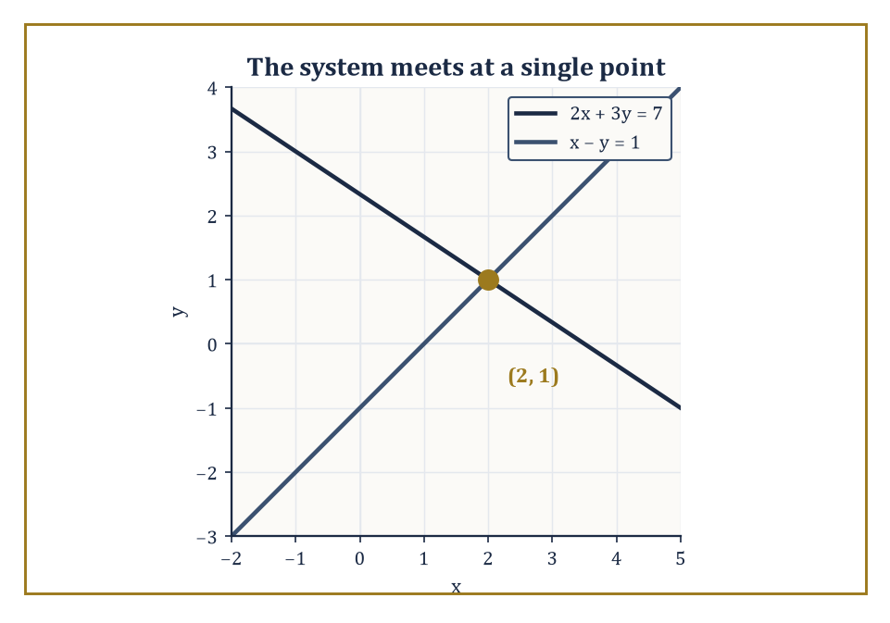
Two lines, one shared opinion: (2, 1) is the only point that satisfies both equations at once.
A system of linear equations, such as the pair below, asks for a pair of numbers (x, y) that satisfies both equations at the same time.
2x + 3y = 7
x − y = 1
Geometrically, each equation on its own describes a straight line in the plane; solving the system means finding the intersection point of the two lines, if one exists.
Algebraically it is a demand that two linear constraints be obeyed simultaneously, rather than one constraint in isolation — the numbers no longer get to sort out their problems separately; they must attend the same meeting and reach a joint decision.
Numeric example — Worked example: substitution. Solve the system above by substitution. From the second equation, x − y = 1, isolate x.
x = 1 + y
Substitute this expression for x into the first equation.
2(1 + y) + 3y = 7
Expand, then simplify step by step.
2 + 2y + 3y = 7
2 + 5y = 7
5y = 5
y = 1
Now recover x.
x = 1 + y = 1 + 1 = 2
The claimed solution is (x, y) = (2, 1). Check both original equations.
2(2) + 3(1) = 4 + 3 = 7 ✓
2 − 1 = 1 ✓
Both hold, so the two lines cross at the single point (2, 1).
The same system can also be solved by elimination, which is often faster when the coefficients cooperate. Multiply the second equation, x − y = 1, through by 3.
3x − 3y = 3
Add this to the first equation, 2x + 3y = 7: the y terms cancel, since 3y and −3y sum to zero.
2x + 3x = 7 + 3
5x = 10
x = 2
Substitute back into x − y = 1 to get y.
y = x − 1 = 1
Same answer, (2, 1), reached by a different route — a small but reassuring confirmation that algebra does not care which legal path you take, only that you take one.
Not every system is this obliging. Three outcomes are possible in total.
The lines intersect at exactly one point: a unique solution, as above. The lines are parallel and distinct: no solution at all. The lines lie exactly on top of each other: infinitely many solutions.
It is worth seeing the second and third cases explicitly, because they are the ones that unsettle students who have been trained by the first case to expect a single tidy number every time.
Numeric example — Worked example: no solution and infinitely many. Consider the following system.
2x + 4y = 8
x + 2y = 1
Divide the first equation through by 2.
x + 2y = 4
But the second equation says x + 2y = 1. The left-hand sides are identical and the right-hand sides disagree, 4 is not 1, so no pair (x, y) can satisfy both at once. The two lines have the same slope and never meet: no solution.
Now compare with the following system.
2x + 4y = 8
x + 2y = 4
Dividing the first by 2 gives x + 2y = 4, which is exactly the second equation.
Every point on one line lies on the other; the “two” equations describe a single line, and any pair (x, y) satisfying x + 2y = 4, say (0, 2), or (4, 0), or (2, 1), solves the system. Infinitely many solutions.
What matters conceptually is the shift from determining a single number to determining a collection of numbers that must cooperate. The unknowns are no longer isolated; they are linked.
Changing one equation changes the conditions the other must satisfy, and the geometry, do two lines meet, miss, or coincide, becomes a visible stand-in for the algebra, which is either a great convenience or faintly embarrassing, depending on how long you had already spent doing it the other way.
The pattern does not stop at two unknowns. Three linear equations in three unknowns, x, y, and z, ask the analogous question: is there a single point common to three planes floating in three-dimensional space, rather than a single point common to two lines in the flat plane?
The same three outcomes recur, one point, no point, or infinitely many, but the case analysis grows richer, because three planes can fail to meet in more interesting ways than two lines can: two of them might agree while a third cuts across both, giving a shared line of intersection rather than a single point.
Abstract example — Worked example: one dimension up. Picture three flat sheets of glass, each tilted at its own angle, floating in a room. Generically, three planes in three-dimensional space meet at exactly one point, the direct analogue of two generic lines meeting at one point in the plane.
But nudge two of the sheets so they become parallel to each other while the third still cuts through the room at an angle: now the third sheet meets each of the first two in its own line, but the two parallel sheets never meet each other at all, so there is no single point shared by all three, no solution to the full system, even though pairs of the equations still solve perfectly well on their own.
This is the three-variable cousin of the “parallel lines never meet” case from the worked example above, and it is exactly the kind of situation the matrix methods of a later storey are built to detect quickly, without you having to picture sheets of glass every time.
This is the beginning of a theme that will keep returning throughout the tower: mathematics often progresses by adding constraints and then asking what, if anything, still survives. Systems of linear equations are the gentlest version of that game.
Later the constraints will become nonlinear, the number of variables will grow past two and three into the hundreds or millions, and the question of existence will become far more delicate — an entire branch of mathematics, linear algebra, exists largely to handle systems too large to solve by the substitution-and-elimination methods shown here.
For now we enjoy the relative calm. Two lines in the plane are still willing to tell us, without too much fuss, whether they meet, and where.

Room 2.4: Factoring
The Art of Taking Things Apart Without Breaking Them
Factoring is the process of writing an expression as a product of simpler expressions. It is one of the oldest and most useful techniques in algebra, and also one of the most frequently abused, mostly by students trying to “factor” by wishful thinking rather than by any legal method.
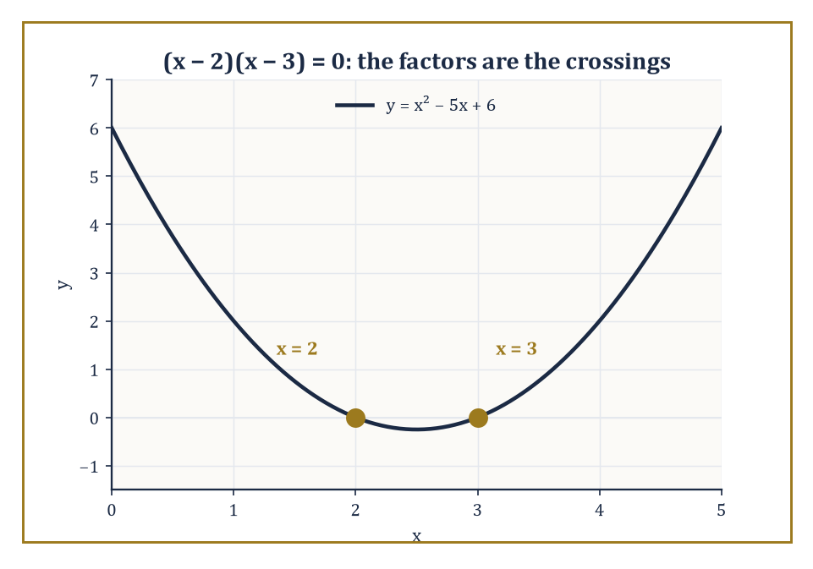
The factors (x − 2) and (x − 3) are not just algebra — they are literally the two spots where the parabola touches down.
The basic idea is familiar from arithmetic: we factor 12 as 3 × 4, or as 2 × 6, or as 2 × 2 × 3. In algebra we do the same thing to polynomials, hunting for the simpler pieces that multiply back together to give the expression we started with.
Numeric example — Worked example. The polynomial x² − 5x + 6 factors as follows:
x² − 5x + 6 = (x − 2)(x − 3)
Check this by expanding the right-hand side:
(x − 2)(x − 3) = x·x + x·(−3) + (−2)·x + (−2)·(−3)
= x² − 3x − 2x + 6
= x² − 5x + 6
It matches, so the factorization is verified. Notice where the numbers −2 and −3 came from: their product must be the constant term, 6, and their sum must be the coefficient of x, −5. Indeed:
(−2) × (−3) = 6
(−2) + (−3) = −5
This “find two numbers that multiply to the constant and add to the middle coefficient” trick is the standard entry point for factoring simple quadratics, and it is worth internalizing before the formulas arrive in the next room.
Why bother factoring at all? Because many equations become dramatically easier once they are factored, thanks to a single, almost embarrassingly simple observation: if a product of numbers equals zero, then at least one of those numbers must itself be zero.
There is no other way to multiply things and get nothing — zero has no non-zero factors. This is called the zero product property, and it turns a quadratic equation into two linear ones, which we already know how to solve from Room 2.2.
Numeric example — Worked example. Solve:
x² − 5x + 6 = 0
Using the factorization above, this is:
(x − 2)(x − 3) = 0
By the zero product property, either x − 2 = 0 or x − 3 = 0. The first gives x = 2; the second gives x = 3.
Check both in the original equation:
2² − 5(2) + 6 = 4 − 10 + 6 = 0 ✓
3² − 5(3) + 6 = 9 − 15 + 6 = 0 ✓
A quadratic equation, which had no obvious “isolate x” move available, has been converted, via factoring, into two linear equations we already knew how to finish.
There is no universal algorithm that factors every polynomial with integer coefficients quickly, but there is a useful toolbox of strategies. Grouping is one: split the terms of an expression so that a common factor emerges from each half.
Recognizing special forms is another — the difference of two squares is probably the single most useful pattern in elementary algebra, precisely because it appears disguised in so many places:
a² − b² = (a − b)(a + b)
Numeric example — Worked example. Factor 2x² + 4x by pulling out the common factor 2x, giving:
2x² + 4x = 2x(x + 2)
Check by expanding:
2x·x + 2x·2 = 2x² + 4x ✓
Now factor x² − 9 using the difference of squares, recognizing 9 as 3²:
x² − 9 = x² − 3² = (x − 3)(x + 3)
Check by expanding:
x² + 3x − 3x − 9 = x² − 9 ✓
And a grouping example: factor x³ + x² + 2x + 2. Group the four terms in pairs:
(x³ + x²) + (2x + 2) = x²(x + 1) + 2(x + 1)
Both halves now share the factor (x + 1), so the whole thing is:
(x + 1)(x² + 2)
Check by expanding:
(x + 1)(x² + 2) = x³ + 2x + x² + 2 = x³ + x² + 2x + 2 ✓
When those strategies fail, we may have to accept that the polynomial does not factor nicely over the numbers we are currently using.
This is an early encounter with an important mathematical reality: not every expression wants to be factored, and not every problem has a tidy algebraic solution. Factoring is a powerful tool, not a magic wand.
Abstract example — Worked example. Consider x² − 2. Over the integers, or even over the ordinary fractions, this does not factor into two simpler pieces with rational coefficients — there is no pair of rational numbers whose product is −2 and whose sum is 0 that would make the trick from the earlier example work, precisely because the roots of the equation
x² − 2 = 0
are
x = ±√2
and √2 is irrational, a fact your Storey 1 self will recall proving, or at least meeting, by contradiction.
The moment we allow ourselves the real number √2, the expression does factor:
x² − 2 = (x − √2)(x + √2)
So “does it factor” is always a question relative to which numbers you are permitted to use — a theme that will resurface with a vengeance when we discuss the complex numbers in Room 2.6.
It is also a skill that rewards pattern recognition more than raw calculation. The more factorizations you have seen, difference of squares, perfect square trinomials, grouping, the two-numbers-that-multiply-and-add trick, the more likely you are to notice the next one lurking in an unfamiliar expression. In that sense factoring is less a procedure and more a form of mathematical literacy, the algebraic equivalent of recognizing a familiar word buried inside a longer one. We will use it constantly in the rooms that follow.

Room 2.5: Quadratic Equations
The First Real Test of Character
Linear equations were polite. Quadratic equations are where algebra starts testing your patience, not because they are difficult, exactly, but because they are the first equations that make you choose a strategy, rather than simply marching forward one legal move at a time.
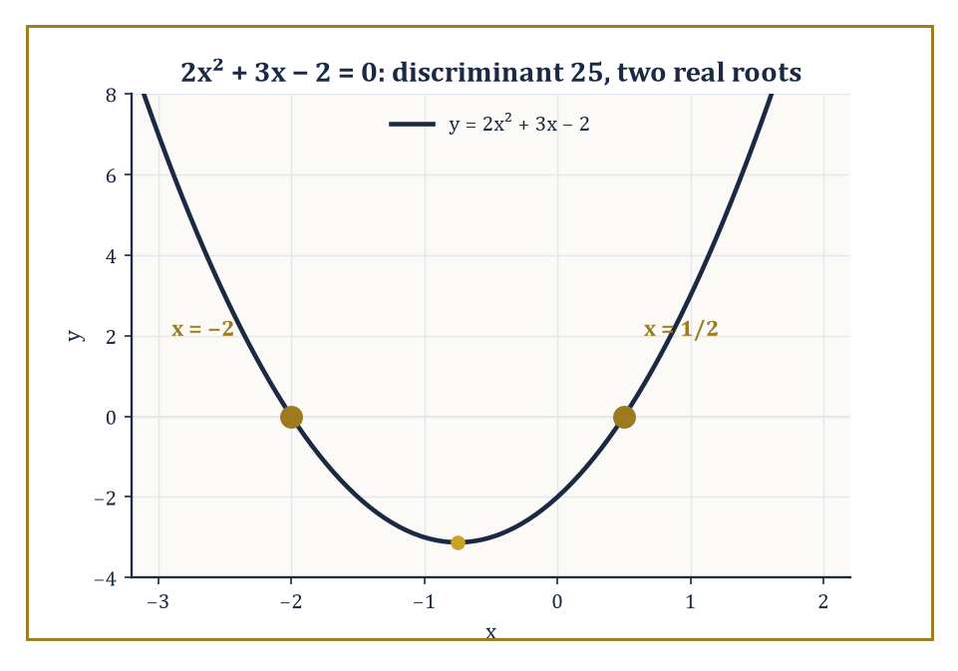
A positive discriminant means the parabola commits to crossing the axis twice, at x = −2 and x = 1/2, exactly as the formula predicted.
A quadratic equation has the form
ax² + bx + c = 0
where a is not zero (if a were zero the x² term would vanish and we would be back to a linear equation, which is a different, calmer room). The graph of y = ax² + bx + c is a parabola, a smooth U-shaped, or upside-down-U-shaped, curve. The algebraic question “does the equation ax² + bx + c = 0 have solutions” is the same question, seen from a different angle, as “does the parabola cross the x-axis, and if so, where.” There are three standard approaches to answering it.
First, factoring, which we practiced in the previous room. If the quadratic factors nicely into two linear terms, the solutions appear immediately via the zero product property. This is satisfying when it works and mildly insulting when it does not, because plenty of perfectly respectable quadratics simply refuse to factor over the integers, and no amount of squinting will produce two whole numbers that multiply and add correctly.
Numeric example — Worked example: when factoring fails. Try to factor x² + 2x − 4 by the multiply-and-add trick from Room 2.4: we would need two numbers whose product is −4 and whose sum is 2.
The integer pairs multiplying to −4 are (1, −4), (−1, 4), and (2, −2); their sums are −3, 3, and 0 respectively. None of them is 2. No integer pair works, and in fact no pair of rational numbers works either.
Factoring, at least in its elementary integer-hunting form, has failed us. This is precisely the situation the next two methods exist to rescue.
Second, completing the square. The idea is to rewrite the left-hand side so that it becomes a perfect square plus, or minus, a leftover constant, because perfect squares are trivial to solve: “something squared equals a number” unlocks immediately by taking square roots of both sides. It always works, it is good for you, and it is about as much fun as folding a fitted sheet.
Numeric example — Worked example. Solve x² + 6x + 5 = 0 by completing the square. Move the constant to the other side.
x² + 6x = −5
To turn the left side into a perfect square, take half of the coefficient of x, which is 6, so half is 3, square it, 3² = 9, and add it to both sides.
x² + 6x + 9 = −5 + 9, that is (x + 3)² = 4
Now take the square root of both sides, remembering both signs.
x + 3 = ±2
So
x = −3 + 2 = −1, or x = −3 − 2 = −5
Check both.
(−1)² + 6(−1) + 5 = 1 − 6 + 5 = 0 ✓
(−5)² + 6(−5) + 5 = 25 − 30 + 5 = 0 ✓
Both solutions confirmed, and notice this equation did factor after all, (x + 1)(x + 5) = 0, but completing the square would have found it even if it hadn't.
Third, and most powerful, the quadratic formula. Completing the square on the general equation ax² + bx + c = 0, rather than on a specific numerical example, produces a formula that works for every quadratic equation without exception.
x = [−b ± √(b² − 4ac)] / (2a)
This is a small triumph of systematic thinking: an entire method, condensed into a single expression you can simply plug numbers into. It is also, for many people, the first time they meet a formula that is both powerful and slightly ugly. The square root in the numerator feels like a compromise the universe forced on us, and in a sense it did, since taking a square root is precisely the step that let us undo the “squared” in “completing the square.”
Numeric example — Worked example. Solve 2x² + 3x − 2 = 0 with the formula. Here a = 2, b = 3, c = −2. Compute the discriminant first.
b² − 4ac = 3² − 4(2)(−2) = 9 − (−16) = 9 + 16 = 25
Its square root is 5. Now the formula.
x = [−3 ± 5] / (2·2) = (−3 ± 5)/4
Taking the plus sign:
x = 2/4 = 1/2
Taking the minus sign:
x = −8/4 = −2
Check both.
2(1/2)² + 3(1/2) − 2 = 2(1/4) + 3/2 − 2 = 1/2 + 3/2 − 2 = 2 − 2 = 0 ✓
2(−2)² + 3(−2) − 2 = 8 − 6 − 2 = 0 ✓
Both solutions confirmed.
The quantity under the square root, b² − 4ac, is important enough to have its own name: the discriminant. It tells you the nature of the solutions before you finish the calculation. A positive discriminant means two distinct real solutions, as in the example above, where it was 25. A discriminant of exactly zero means one real solution, a repeated root, because the ± produces the same value twice. A negative discriminant means no real solutions at all, though there are two complex ones once we allow ourselves that extravagance.
Numeric example — Worked example: three discriminants. Three quadratics, three discriminant stories. First, x² − 4x + 4 = 0: here a = 1, b = −4, c = 4, so the discriminant is
(−4)² − 4(1)(4) = 16 − 16 = 0
The formula gives
x = [4 ± 0]/2 = 2
a single repeated root; and indeed x² − 4x + 4 = (x − 2)², which touches the x-axis at exactly one point and turns back.
Second, x² + x + 1 = 0: a = 1, b = 1, c = 1, discriminant = 1 − 4 = −3, which is negative, so no real solutions; this parabola never touches the x-axis at all, it hovers entirely above it.
Third, our earlier 2x² + 3x − 2 = 0 had discriminant 25, positive, and gave the two distinct real solutions x = 1/2 and x = −2, matching a parabola that dips down and crosses the axis twice.
Quadratic equations appear everywhere: projectile motion, area problems, optimization at the pre-calculus level, and countless applied models. They are the first genuinely nonlinear relationships most people learn to solve exactly, and it is worth savoring that achievement, because, as the next room will insist on pointing out at some length, degree two is still friendly. It is also the last degree for which a simple general formula exists using only arithmetic operations and radicals. Degree three and higher will not be nearly so obliging.

Room 2.6: Higher-Degree Polynomials
and the Limits of Nice Formulas
Once the degree of the polynomial rises above two, the situation changes, not gradually, but in a way that turns out to be one of the deepest facts in classical algebra.
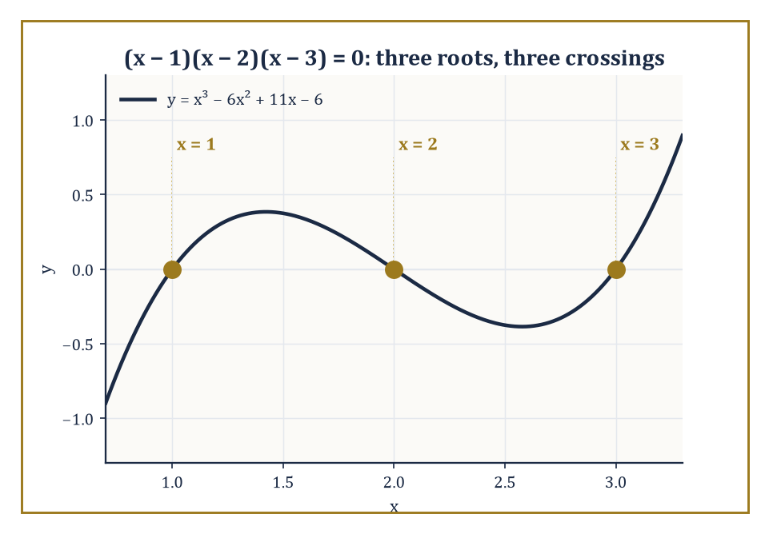
No fearsome cubic formula needed here: x = 1, 2, 3 were hiding in plain sight, each one a clean crossing of the axis.
Cubic equations, degree three, still possess a general formula, discovered in the sixteenth century by Italian mathematicians who reportedly guarded it as a trade secret and challenged each other to public problem-solving duels over it, a considerably more dramatic origin story than anything in the previous two rooms. The cubic formula involves a certain amount of nested radicals and, if attempted by hand, emotional suffering.
Quartic equations, degree four, also have a general formula, discovered shortly after, even more elaborate. For degree five and higher, the situation is fundamentally different, not “harder,” but categorically impossible in the same way.
Numeric example — Worked example. Not every cubic requires the fearsome sixteenth-century formula, however. Consider the equation:
x³ − 6x² + 11x − 6 = 0
A useful first move for polynomials with integer coefficients is to test small integers as candidate roots. Try x = 1:
1³ − 6(1)² + 11(1) − 6 = 1 − 6 + 11 − 6 = 0
It works, x = 1 is a root. Since (x − 1) must therefore be a factor, divide it out:
(x³ − 6x² + 11x − 6) ÷ (x − 1) = x² − 5x + 6
You can confirm this by multiplying (x − 1)(x² − 5x + 6) back out and checking it reproduces the original cubic. That quotient is exactly the quadratic we factored back in Room 2.4:
x² − 5x + 6 = (x − 2)(x − 3)
So the full factorization is (x − 1)(x − 2)(x − 3), and the three roots are x = 1, 2, 3. Check one for sanity: x = 3 gives
27 − 54 + 33 − 6 = 0 ✓
A cubic, cracked without ever touching the general formula, simply because its roots happened to be small whole numbers.
The Abel–Ruffini theorem, proved in the early nineteenth century, independently, more or less, by Niels Henrik Abel and Paolo Ruffini, two mathematicians who did not get nearly enough credit in their own lifetimes for settling a question that had stood open for centuries, states that there is no general formula for the roots of a polynomial of degree five or higher that uses only arithmetic operations and radicals, no quintic analogue of the quadratic formula, ever, for any amount of algebraic cleverness.
This does not mean that specific high-degree equations cannot be solved; our nicely-behaved cubic above factored just fine, and plenty of quintics do too, if you get lucky with integer roots.
It means there is no single algebraic expression, built only from +, −, ×, ÷, and radicals, that works for all degree-five equations the way the quadratic formula works for every quadratic without exception.
Abstract example — Worked example. The polynomial x⁵ − x − 1 is the standard textbook villain here: a perfectly ordinary-looking quintic with integer coefficients, no obvious factorization. Testing the candidate integer roots ±1 fails:
1 − 1 − 1 = −1 ≠ 0
−1 − (−1) − 1 = −1 ≠ 0
And, this is the remarkable part, proved using the branch of algebra called Galois theory, there are no roots that can be written down using any finite combination of +, −, ×, ÷, and nth roots, however nested.
The roots exist; the Fundamental Theorem of Algebra below guarantees that much. They can be computed numerically to any precision you like.
They simply cannot be expressed in the tidy closed form we have come to expect from every equation up to degree four.
This is not a failure of cleverness on anyone's part. It has been proved, with full rigor, that no such expression exists, an entire, permanently locked door, rather than a door nobody has found the key to yet.
The proof of the Abel–Ruffini theorem belongs to a later storey of this tower, Galois theory, which connects the solvability of equations to the symmetry structure of their roots, a genuinely beautiful piece of mathematics we are not yet equipped to enter, but the consequence is already visible here: exact closed-form solutions are a limited resource.
For many polynomials we must settle for numerical approximations, factorizations when we are lucky, as with our friendly cubic above, or statements about the existence and location of roots without ever writing them explicitly.
There is, however, very good news lurking underneath all this bad news, and it comes from the Fundamental Theorem of Algebra.
This theorem, which requires the complex numbers, the numbers built from the imaginary unit i, where:
i² = −1
guarantees that every non-constant polynomial has at least one complex root, and therefore factors completely into linear factors once you are willing to work over the complex numbers rather than insisting on the reals.
Existence is assured. Explicit display, as Abel and Ruffini showed, is not, but existence alone is already a remarkable guarantee, and it holds for every polynomial of every degree, no exceptions.
Numeric example — Worked example. Take the equation:
x⁴ − 1 = 0
This is a modest quartic that we can factor completely by hand. First, difference of squares:
x⁴ − 1 = (x² − 1)(x² + 1)
The first factor is itself a difference of squares:
x² − 1 = (x − 1)(x + 1)
The second factor, x² + 1, has no real roots, since a real number squared is never negative, so:
x² = −1
has no real solution, but over the complex numbers it factors too:
x² + 1 = (x − i)(x + i)
since:
(x − i)(x + i) = x² − i² = x² − (−1) = x² + 1
Putting it all together:
x⁴ − 1 = (x − 1)(x + 1)(x − i)(x + i)
Four linear factors, four roots: 1, −1, i, −i. A degree-four polynomial with exactly four roots, exactly as the Fundamental Theorem of Algebra promises, two of them real, two of them requiring the complex numbers to see at all.
This is an early lesson in mathematical maturity, and one that will recur throughout the tower in increasingly sophisticated forms. “Solve” does not always mean “write a tidy expression.”
Sometimes it means “prove solutions exist.” Sometimes it means “find them to any required accuracy,” numerical methods, bisection, Newton's method, and their descendants exist precisely for this purpose, and we will meet some of them in later storeys.
Sometimes it means “show that no solutions exist in the reals,” as with x² + 1 above.
Higher-degree polynomials teach us that the algebraic methods we enjoy most, the clean, universal, plug-in-and-go formulas, are, in a precise sense, exceptional.
The quadratic formula is not the beginning of an endless sequence of similar formulas, each degree getting its own. It is closer to the end.

Room 2.7: Inequalities
Living with “At Least” and “No More Than”
Equations demand exact equality. Inequalities settle for a range, and are all the better for it, because the real world very rarely hands us the precision an equals sign demands.
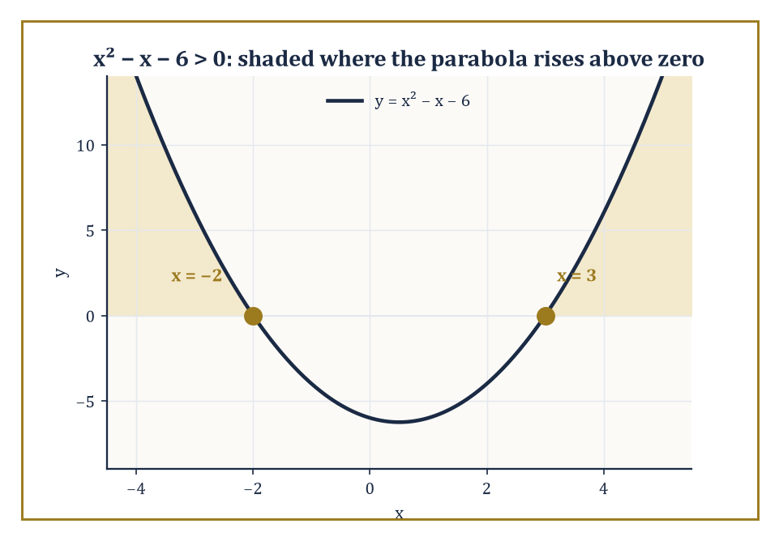
The shaded stretches are the answer: everywhere the parabola climbs above zero, x² − x − 6 is honestly greater than nothing.
An inequality such as
2x + 3 > 7
asks for all numbers x that make the statement true. The solution is usually an interval or a union of intervals rather than a single value. The algebraic moves are similar to those for equations, add, subtract, multiply, divide the same quantity on both sides, with one critical extra rule: when you multiply or divide both sides by a negative number, the inequality sign reverses. This single complication is the source of most student errors and a surprising amount of quiet frustration, so it deserves to be seen in action twice: once where it does not apply, and once where it does.
Numeric example — Worked example: no flip needed. Solve 2x + 3 > 7. Subtract 3 from both sides, no sign flip needed, since we are not multiplying or dividing by a negative:
2x > 4
Divide both sides by 2, a positive number, so again no flip:
x > 2
The solution is every number strictly greater than 2, the interval (2, ∞). Check a value inside it, say x = 3:
2(3) + 3 = 9 > 7 ✓
Check a value outside it, x = 0:
2(0) + 3 = 3 > 7
is false, correctly excluded.
Numeric example — Worked example: the flip rule in action. Now solve −3x + 2 ≤ 11, where the flip rule actually bites. Subtract 2 from both sides:
−3x ≤ 9
Now divide both sides by −3, and because we are dividing by a negative number, the inequality sign must reverse, turning ≤ into ≥:
x ≥ −3
Why does the sign have to flip? Because multiplying or dividing by a negative number reverses the order of every pair of numbers on the line: if 2 < 5, then multiplying both sides by −1 gives
−2 > −5
not −2 < −5, the smaller number became the larger one, so the inequality symbol has to turn around to keep telling the truth. Check the boundary: x = −3 gives
−3(−3) + 2 = 9 + 2 = 11 ≤ 11 ✓
satisfied with equality, as boundaries of a ≤ inequality should be. Check a value that should fail, x = −4, which is less than −3, hence outside the solution set:
−3(−4) + 2 = 12 + 2 = 14
and 14 ≤ 11 is false, correctly excluded.
The rest of the mechanics are straightforward. Linear inequalities behave almost as well as linear equations, aside from the flip rule above. Polynomial inequalities of higher degree can be solved by a different technique: find the roots of the corresponding equation, use them to divide the number line into intervals, and test one representative point from each interval to see whether the polynomial is positive or negative there. Because a polynomial can only change sign at a root, it cannot jump from positive to negative without passing through zero, being a continuous curve, testing one point per interval is enough to determine the sign across the whole interval.
Numeric example — Worked example. Solve x² − x − 6 > 0. First find where equality holds: x² − x − 6 = 0 factors, by the multiply-to−6, add-to−1 trick, as
(x − 3)(x + 2) = 0
giving roots x = 3 and x = −2. These two roots split the number line into three intervals: x < −2, −2 < x < 3, and x > 3. Test one point in each. For x < −2, try x = −3:
(−3 − 3)(−3 + 2) = (−6)(−1) = 6
positive, so this interval satisfies the inequality. For −2 < x < 3, try x = 0:
(0 − 3)(0 + 2) = (−3)(2) = −6
negative, so this interval does not satisfy it. For x > 3, try x = 4:
(4 − 3)(4 + 2) = (1)(6) = 6
positive, satisfies it. The solution is x < −2 or x > 3, everywhere except the stretch between the two roots, which makes sense once you picture the parabola y = x² − x − 6 dipping below the axis between its two crossing points and rising above it everywhere else.
Rational inequalities, those involving a fraction with x in the denominator, require one extra piece of caution: attention to places where the expression is undefined. You cannot test a point where the denominator is zero, and such points can never belong to the solution set, however tempting the arithmetic looks.
Numeric example — Worked example. Solve (x − 1)/(x + 2) ≥ 0. The expression is zero when the numerator is zero, at x = 1, and undefined when the denominator is zero, at x = −2, that second point must be excluded from any possible solution, full stop, no matter what the sign pattern suggests. These two critical points split the line into three intervals: x < −2, −2 < x < 1, and x > 1. Test x = −3, in the first interval:
(−3 − 1)/(−3 + 2) = (−4)/(−1) = 4
positive, satisfies ≥ 0. Test x = 0, in the second interval:
(0 − 1)/(0 + 2) = (−1)/(2) = −0.5
negative, fails. Test x = 2, in the third interval:
(2 − 1)/(2 + 2) = 1/4
positive, satisfies. At the boundary x = 1, the expression equals
0/3 = 0
which does satisfy ≥ 0, so x = 1 is included. At x = −2, the expression is undefined and must be excluded regardless of any pattern. The solution is x < −2 or x ≥ 1, written as
(−∞, −2) ∪ [1, ∞)
note the round bracket keeping −2 out and the square bracket letting 1 in.
Inequalities are less glamorous than equations, yet they are often more realistic. Nature rarely demands that a quantity equal exactly 7. It more often demands that the quantity stay above a threshold or below a limit, a bridge must bear at least this much load, a chemical reaction must stay below this temperature, a budget must not exceed that figure. Optimization problems, error bounds, convergence criteria, and almost every practical constraint in applied mathematics are expressed as inequalities rather than equations.
There is also a conceptual shift worth naming explicitly. Solving an equation usually produces a discrete set of answers, one number, or a short finite list of them, as with our quadratics. Solving an inequality produces a continuum of answers: not a number but a whole interval of numbers, uncountably many of them, a distinction the previous storey drew between countable and uncountable infinities, and one we will lean on again once calculus needs the full real line.
The unknown is no longer a specific number; it is any number inside a certain range. This is the beginning of thinking in terms of sets of solutions rather than individual solutions, a habit of mind that will matter enormously once we reach functions and their domains in the next storey.
Inequalities force us to live with approximation and range rather than exactness. In that sense they are more mature than equations. They accept that the world rarely hands us perfect equality and ask us, politely but firmly, to work with what it does hand us.

Room 2.8: Absolute Value
and the Geometry of Distance on the Line
The absolute value of a number is its distance from zero on the number line, ignoring direction entirely.
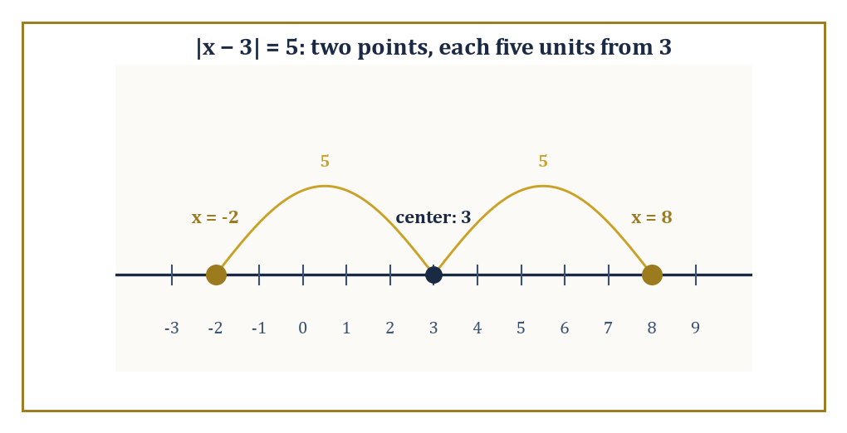
Two solutions, one shared distance: −2 and 8 sit exactly five units on either side of the center, 3.
|x| = x when x ≥ 0
|x| = −x when x < 0
The minus sign there is not a typo, it is precisely what turns a negative number positive, since “negative of a negative” is positive. Either way, |x| is never negative. It measures magnitude and discards sign, the mathematical equivalent of asking “how far” without caring “which way.”
Numeric example — Worked example. Since 7 is already non-negative,
|7| = 7
Since −7 is negative, the definition flips its sign,
|−7| = −(−7) = 7
Both are 7, because both 7 and −7 sit exactly seven units from zero, one to the right, one to the left, and absolute value only cares about the distance, not the direction of travel to get there.
Equations and inequalities involving absolute value are really statements about distance, once you learn to read them that way. |x − 3| = 5 means that x is exactly five units away from 3, not that x itself is five, but that the gap between x and 3, measured without regard to sign, is five.
|x − 3| < 5 means that x is less than five units away from 3. Once you translate the symbols into geometric language, the solutions become visible almost before you calculate them: points or intervals sitting a certain distance from a certain centre.
Numeric example — Worked example. Solve the equation:
|x − 3| = 5
Read geometrically, x is five units from 3. Moving five units to the right of 3 lands on:
3 + 5 = 8
Moving five units to the left of 3 lands on:
3 − 5 = −2
So:
x = 8 or x = −2
Check both algebraically:
|8 − 3| = |5| = 5 ✓
|−2 − 3| = |−5| = 5 ✓
Two solutions, symmetric around the centre 3, exactly as the distance picture predicted.
Algebraically, absolute value equations are usually solved by considering cases: the expression inside the bars is either non-negative, in which case the bars do nothing, or negative, in which case the bars flip its sign.
|x − 3| = 5 splits into the two cases:
x − 3 = 5, giving x = 8
x − 3 = −5, giving x = −2
These are the same two answers found geometrically above, arrived at by pure algebra instead. The same case analysis works for inequalities, though it requires slightly more care about which direction the inequality points once the cases are separated.
Numeric example — Worked example. Solve the inequality:
|x − 3| < 5
Geometrically, this means x is less than five units from 3 in either direction, which is exactly the interval running from 3 − 5 = −2 up to 3 + 5 = 8, not including the endpoints:
−2 < x < 8
Algebraically this is written directly as the compound inequality:
−5 < x − 3 < 5
Adding 3 across all three parts gives:
−2 < x < 8
Matching. Now a slightly sharper example: solve |2x + 1| ≥ 7. Split into cases.
Case one:
2x + 1 ≥ 7
2x ≥ 6
x ≥ 3
Case two:
2x + 1 ≤ −7
Note the sign flips because we are considering the expression inside being very negative, and its absolute value being large means the expression itself is a large negative number, so:
2x ≤ −8
x ≤ −4
The full solution is:
x ≤ −4 or x ≥ 3
Check a boundary: x = 3 gives:
|2(3) + 1| = |7| = 7 ≥ 7 ✓
Check a value that should fail, x = 0:
|2(0) + 1| = |1| = 1
Since 1 ≥ 7 is false, x = 0 is correctly excluded, since 0 lies comfortably between −4 and 3.
Absolute value is the simplest version of a distance function, a rule that takes two points and returns a single non-negative number measuring how far apart they are, with the property that the distance from a point to itself is zero and the distance between two different points is always positive.
Later, in higher dimensions and in more abstract spaces, we will meet generalizations of exactly this idea: norms, which measure the “size” of a vector, and metrics, which measure the distance between two points in spaces far stranger than the number line.
The one-dimensional absolute value, |x − y| as the distance between the numbers x and y, is where the idea begins.
Abstract example — Worked example. The distance function on the number line is defined by:
d(x, y) = |x − y|
It satisfies three properties that any respectable notion of “distance” ought to satisfy, and which will reappear, essentially unchanged, whenever this storey's descendants define distance in the plane, in three dimensions, or in far more exotic settings.
First:
d(x, y) ≥ 0, with equality exactly when x = y
You cannot have negative distance, and only a point has zero distance from itself.
Second:
d(x, y) = d(y, x)
The distance from 3 to 8 is the same as the distance from 8 to 3, direction does not matter, only how far.
Third, and least obvious, the triangle inequality:
d(x, z) ≤ d(x, y) + d(y, z)
For any third point y, going from x to z directly is never longer than detouring through y.
Check this with x = 1, y = 5, z = 9, where 5 lies between 1 and 9:
d(1, 9) = |1 − 9| = 8
d(1, 5) + d(5, 9) = |1 − 5| + |5 − 9| = 4 + 4 = 8
The two sides are equal, because going via 5 involves no backtracking, 5 sits directly on the path from 1 to 9.
Now check it with a point that does not sit between the endpoints, say y = 15:
d(1, 15) + d(15, 9) = |1 − 15| + |15 − 9| = 14 + 6 = 20
While d(1, 9) is still 8:
20 ≥ 8
The inequality holds but is no longer tight, because the detour via 15 involves genuine backtracking.
Any rule satisfying these three properties earns the name “metric,” and absolute-value distance on the line is the very first example anyone meets.
It is also a useful reminder that many algebraic statements are secretly geometric.
The number line is not just a visual aid; it is a structure that makes certain relationships obvious, obvious enough that “solve |x − 3| = 5” can be answered by picturing two points five steps either side of 3, no algebra required, though the algebra confirms the picture is right.
Absolute value is one of the cleanest bridges between the algebraic and the geometric ways of thinking, and we will need that bridge more and more as the tower continues upward, particularly once graphs enter the picture in the next storey.

Room 2.9: Looking Ahead
From Algebra to Functions, Graphs, and the Rest of the Tower
We have now spent a full storey learning how to manipulate equations, factor expressions, solve quadratics, confront higher-degree polynomials, live with inequalities, and measure distance on the line with absolute value.
The central lesson is simple to state and hard to internalize: algebra is the art of extracting information from relationships between quantities. Sometimes the information is exact and tidy. Sometimes it is approximate. Sometimes it is merely the knowledge that no solution exists. All three outcomes are legitimate mathematical results, and a good part of this storey has been spent teaching you to recognize which one you are looking at.
Numeric example — Worked example: several rooms cooperating. Solve the equation below.
(x² − 1)/(x − 1) = 3
At first glance this looks like a single unfamiliar fraction equation, but notice the numerator factors as a difference of squares from Room 2.4.
x² − 1 = (x − 1)(x + 1)
Provided x ≠ 1, division by zero is never allowed, so x = 1 must be excluded from consideration up front, a caution learned from the rational inequalities of Room 2.7. With that exclusion in place, the fraction simplifies.
(x − 1)(x + 1)/(x − 1) = x + 1
The equation becomes a plain linear equation from Room 2.2.
x + 1 = 3
Solving this linear equation gives x = 2. Check the excluded value first: x = 1 would make the original denominator zero, correctly excluded. Now check x = 2 in the original equation.
(4 − 1)/(2 − 1) = 3/1 = 3 ✓
One equation, three rooms' worth of technique — factoring, domain restriction, linear solving — cooperating to produce a single clean answer.
It is worth cataloguing, one final time, the three kinds of answer this storey has produced, because learning to recognize which one you are looking at is arguably the single most transferable skill in the whole subject, far more transferable than any individual formula.
Abstract example — Worked example: three kinds of “solved”. First, the exact and tidy kind.
x² − 5x + 6 = 0
(x − 2)(x − 3) = 0
This factoring hands us the closed-form answers x = 2 and x = 3 with nothing left over — the outcome everyone secretly hopes for.
Second, the confidently empty kind.
2(x + 3) = 2x + 7
As we saw in Room 2.2, this simplifies to a false statement.
6 = 7
So we can say with total certainty that no number x satisfies it, an answer that is not a failure but a complete and correct piece of information.
Third, the exists-but-will-not-write-itself-down kind.
x⁵ − x − 1 = 0
From Room 2.6, this does have a real root, guaranteed by reasoning about where the polynomial changes sign, and that root can be pinned down to as many decimal places as anyone could want by numerical methods, yet no finite combination of +, −, ×, ÷, and radicals will ever produce it exactly, a fact that is proved rather than merely unfound.
Three equations, three completely different flavours of “solved,” and mistaking one for another is the single most common way a beginner misjudges their own progress.
The techniques developed here, isolation of variables, factoring, completing the square, the quadratic formula, careful handling of inequality signs, case analysis with absolute values, will reappear constantly in everything that follows. They are not a closed chapter of mathematical education. They are infrastructure, load-bearing walls that the rest of the tower will quietly stand on without always mentioning it.
The next storey turns to functions, graphs, and graph analysis. There we will stop treating equations as static demands and start treating them as dynamic relationships: input goes in, output comes out, and the pattern of that dependence can be drawn, transformed, composed, and studied. The algebra we have just finished is what makes that study possible. Without the ability to solve, factor, and rearrange, the graphs remain mute pictures.
Numeric example — Worked example: a preview. Consider the same expression 2x + 3 from Room 2.1, but now think of it as a rule rather than one frozen equation: for every input x, produce the output 2x + 3.
x = 0: output 3
x = 4: output 11
That second case is the very equation solved in Room 2.1, in reverse; there we asked which input produces output 11 and found x = 4, while a function asks the opposite question, which output does a given input produce.
This shift, from “solve for the unknown input” to “study the whole rule connecting inputs to outputs,” is exactly what the next storey is about.
Beyond that lie coordinate systems, geometry, trigonometry, limits, calculus, and the long ascent through the rest of the tower. At every stage the same pattern will repeat: new objects are introduced, new relationships are written down, and the question becomes what can be extracted from those relationships with the tools at hand.
Algebra is where we first learn that the tools are limited, and that the limitations themselves are interesting. The quadratic formula stops at degree two for a deep reason. Unique closed-form solutions are the exception rather than the rule. Inequalities force us to accept ranges instead of points. Absolute value quietly introduces geometry into pure calculation. These are not defects in the subject. They are the subject beginning to show its true shape.
If the previous storey was about the existence and structure of numbers, and this storey has been about the relationships those numbers must satisfy, then the rest of the tower is about what happens when those relationships grow richer, more numerous, and more abstract.
The tower continues upward.
The foundation we have just built, equations solved, expressions factored, quadratics tamed, inequalities accepted, distance measured, will have to hold, because the next storey is going to lean on all of it at once, usually without so much as a thank-you.
We move next from static relationships to dynamic ones: from “what value makes this true” to “what happens as this varies.” Bring the quadratic formula. Bring the zero product property. Bring, above all, the hard-won willingness to admit when an equation has nothing left to give you. You will need all three before the next storey is through.

Storey 3: Functions, Graphs & Graph Analysis
Relations, Pictures, and the Art of Seeing How One Quantity Depends on Another
In the previous storey we learned to treat the alphabet of algebra — x, y, and their many disguises — as things to be solved for: isolate the unknown, factor the stubborn expression, coax an inequality into confessing which numbers satisfy it. All of that labour assumed, tacitly, that a quantity has one fixed, discoverable value, if only we manoeuvre the equation cleverly enough. This storey abandons that assumption. From here on, quantities are allowed to move, and — more importantly — to move together. We stop asking only what is the value? and start asking, with rather more ambition, how does this value depend on that one?
The object built to answer that question is the function, and it is worth pausing on how strange an idea it actually is before we start using it every ten seconds for the rest of the Tower. The everyday picture is a machine: you feed it a number, it hums, whirs, and hands back exactly one number in return. Feed it the same number twice and it gives the same answer twice — no moods, no negotiation. That reliability is the entire point. A rule that sometimes gives two different outputs for the same input is not a function; it is, at best, a relation having an off day.
A small confession, since this Tower prefers honesty to false confidence: functions are usually taught as though they were the most natural objects imaginable, sitting there in nature waiting to be noticed. They are not. The rigorous definition — a set of ordered pairs in which no two pairs share a first entry — is a carefully engineered nineteenth- and twentieth-century abstraction, built precisely to remove every last flicker of ambiguity from the word "depends." We shall use that formal definition when precision is required and the informal machine when intuition is required, and we shall not apologise for switching between them, because that is exactly how working mathematicians do it too.
If Storey 2 taught us to solve for unknowns, this storey teaches us to watch how quantities change together, and then — because a picture is worth roughly a thousand algebraic manipulations — to draw that changing relationship and read the drawing back. Let's draw the dependence.

Room 3.1: What a Function Actually Is
In Which We Meet the Machine and Learn It Has House Rules
A function from a set A to a set B is a rule that assigns to each element of A exactly one element of B. Every word in that sentence is load-bearing.
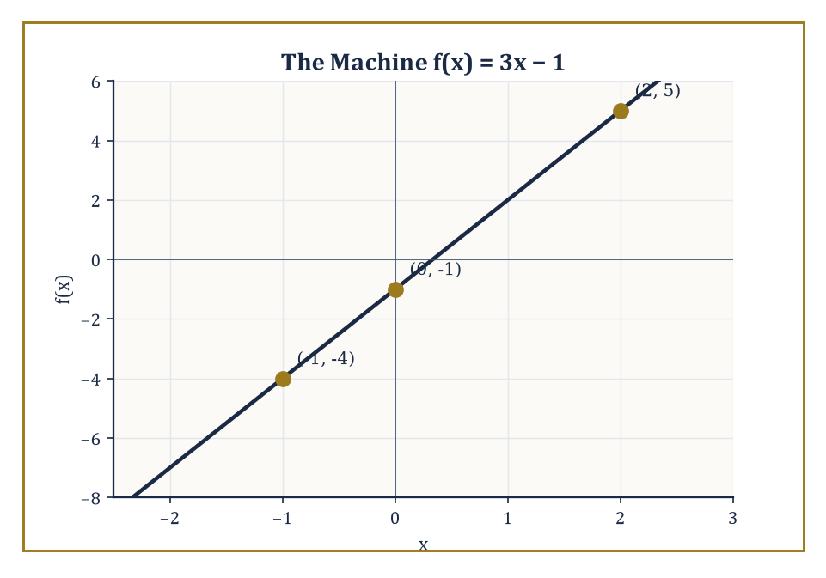
The machine f(x) = 3x − 1, fed −1, 0, and 2, and handing back exactly one answer each time.
"Each element of A" means every permitted input must actually get an output — no shirking. "Exactly one" means no input is allowed to produce two different answers on two different Tuesdays.
The set A supplying the inputs is called the domain, and B, or rather the part of B that actually gets hit, is the range; we will dwell on both properly in the next room. For now, think of a function as a small, humourless, perfectly consistent machine: input goes in one slot, output comes out the other, and the internal wiring never changes.
Numeric example — Worked example — a function in action. This machine's wiring is: triple the input, then subtract one.
f(x) = 3x − 1
Feed it 2:
f(2) = 3(2) − 1 = 6 − 1 = 5
Feed it −1:
f(−1) = 3(−1) − 1 = −3 − 1 = −4
Feed it 0:
f(0) = 3(0) − 1 = −1
Notice that however many times you feed this machine a 2, it will always hand back 5 — never 5 today and 6 tomorrow. That non-negotiable consistency is the whole content of "exactly one output."
Not every familiar rule survives this test, which is precisely why the definition needed to be so pedantic. Consider "give me a number and I'll give you its square root." Ask for the square root of 9 and a perfectly reasonable person will say "3, or −3, take your pick" — both, after all, square to 9. That is two outputs for one input, and so, strictly, "square root" as commonly spoken is not a function at all; it is a two-valued relation wearing a function's clothing.
Mathematicians rescue it by an act of legislation: they define the principal square root, written √, to mean specifically the non-negative one.
√9 = 3
Full stop — the ambiguity is resolved by decree rather than by discovery. This is a useful lesson for the whole Tower: when a natural-language rule refuses to be a function, mathematicians don't argue with it — they redefine it until it behaves.
Numeric example — Worked example — taming an ambiguous rule. The equation x² = 9 has two solutions — both true, both valid — and that is exactly the problem if we want "solve for x" to behave like a function of the input 9.
x² = 9 ⟹ x = 3 and x = −3
The principal-square-root convention resolves it: √9 is defined to mean 3 only. So the relation "y² = x" is not a function of x (it fails at every positive x, which has two square roots), but the relation "y = √x" is a function of x (each non-negative x now gets exactly one non-negative output). Same underlying algebra, two different objects, only one of them a function.
The formal picture makes all this precise without any appeal to machines or wiring at all. A function is a set of ordered pairs (a, b), drawn from A and B respectively, such that no two pairs in the set share the same first component.
This is simply the machine picture translated into set language: "the same input always gives the same output" becomes "no two pairs start with the same a." Nothing stops two different inputs from sharing an output (that is perfectly legal and extremely common); what is forbidden is one input trying to have it both ways.
Abstract example — Abstract example — spotting the illegal pair. Let A = {1, 2, 3}, and consider two candidate relations from A to the integers.
R₁ = {(1, 2), (2, 4), (3, 6)}
Every first component — 1, 2, 3 — appears exactly once, so R₁ is a function (it happens to be f(a) = 2a).
R₂ = {(1, 2), (1, 5), (2, 4)}
The first component 1 appears twice here, paired once with 2 and once with 5. That single repetition disqualifies R₂ from being a function, regardless of how sensible each individual pair looks in isolation. One rogue pair is enough to spoil the whole set.
The same function can be presented in strikingly different clothing — a formula, a table of input–output pairs, a graph, a sentence of plain English, or a step-by-step algorithm — and part of the skill this storey builds is learning to recognise the same underlying machine under all these disguises.
Numeric example — Worked example — one function, four disguises. Take the squaring function. As a formula:
f(x) = x²
As a table, x = −2, −1, 0, 1, 2 gives f(x) = 4, 1, 0, 1, 4 respectively:
(−2)² = 4, (−1)² = 1, 0² = 0, 1² = 1, 2² = 4
As a verbal description: "square whatever number you're given." And as a graph: a symmetric U-shaped curve (a parabola, properly introduced in Room 3.3) passing through the five points just tabulated, bottoming out at the origin.
All four descriptions specify the identical machine; none is more "real" than the others, and precalculus fluency largely consists of translating freely among them.
Why make such a fuss over one definition? Because the function concept is the single most important organising idea between elementary algebra and the calculus still several storeys above us. Lines, parabolas, populations, orbits, probabilities, algorithms, even other functions taken as inputs — almost everything the Tower discusses from here upward is a function of something.
Get comfortable with the machine now, while the machines are simple, and the more elaborate machines waiting upstairs will trouble you far less.

Room 3.2: Domain, Range, and the Vertical-Line Test
Where the Machine Is Allowed to Eat, and What It's Allowed to Produce
Every function comes with two associated sets worth naming precisely. The domain is the set of all permissible inputs — everything the machine is willing to accept without breaking. The range is the set of all outputs the machine actually produces once you've fed it everything in the domain.
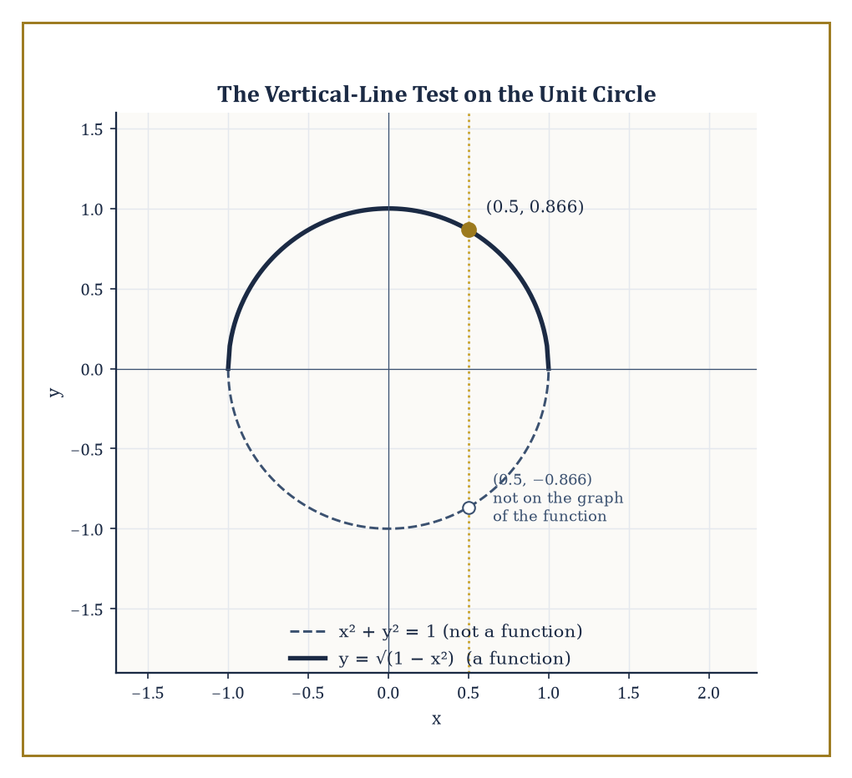
The full unit circle fails the vertical-line test at x = 0.5; throwing away its lower half fixes that.
For a function defined by an explicit formula, the domain is typically the largest set of real numbers for which the formula makes sense: you may not divide by zero, you may not take an even root (square root, fourth root, and so on) of a negative number, and you may not feed a non-positive number to a logarithm (a restriction we'll meet properly in Room 3.7). Anything the formula can survive, the domain includes; anything that would make it choke, the domain excludes.
Numeric example — Worked example — a domain with a forbidden point. The formula collapses the instant the denominator hits zero.
f(x) = 1/(x − 3)
That happens exactly when x − 3 = 0, i.e. when x = 3, so the domain is "all real numbers except 3":
{x ∈ ℝ : x ≠ 3}
Everywhere else it behaves perfectly well.
f(4) = 1/(4 − 3) = 1/1 = 1
f(0) = 1/(0 − 3) = −1/3
Only at x = 3 does the machine seize up entirely — not a small output, not an error message, just an undefined non-answer.
Numeric example — Worked example — a domain with a forbidden interval. A square root refuses negative arguments.
g(x) = √(x − 5)
So we need x − 5 ≥ 0, i.e. x ≥ 5, and the domain is the interval [5, ∞).
g(5) = √0 = 0
That's perfectly legal, since zero is not negative. Moving inward:
g(9) = √4 = 2
But try g(3): that would require √(−2), and the machine simply refuses the job. The domain is not a scattering of forbidden points here, as it was for f above, but an entire forbidden half-line.
The graph of a function y = f(x) is the set of all points (x, f(x)) plotted in the coordinate plane — one dot for every legal input, positioned sideways by the input and vertically by the corresponding output. (The plane itself, and the coordinates that locate a point within it, get their full formal treatment in the next storey; for now we use them exactly as you already do informally, as a grid with a horizontal and a vertical direction.)
Because a function is forbidden from giving one input two different outputs, its graph inherits a strong geometric constraint: no vertical line may cross it more than once. This is the vertical-line test, and it is nothing more mysterious than the "exactly one output" rule, translated from algebra into geometry.
A vertical line at x = a collects every point on the curve with that particular first coordinate; if the curve is a genuine function, there can be at most one such point, because there is at most one legal output for a.
Abstract example — Abstract example — a curve that fails, and one that passes. The unit circle is a perfectly respectable curve, but it is not the graph of a function of x.
x² + y² = 1
Check the vertical line x = 0.5: substituting gives
0.25 + y² = 1, so y² = 0.75 and y = ±√0.75 ≈ ±0.866
Two points, (0.5, 0.866) and (0.5, −0.866), sit on the same vertical line — the test fails, and rightly so, since "y² = 1 − x²" hands back two y-values for most x.
Now take only the upper half:
y = √(1 − x²), domain −1 ≤ x ≤ 1
Every vertical line through that domain now meets the curve exactly once, because the principal-square-root convention from Room 3.1 has already thrown away the negative branch. Same circle, half the curve, and suddenly it is a function.
Determining the range tends to be the fiddlier of the two tasks, since it usually requires understanding the shape of the graph rather than merely inspecting the formula for forbidden operations. A useful habit is to ask: as the input ranges over the whole domain, what is the smallest output achievable, and can the outputs climb without bound?
Numeric example — Worked example — finding a range by finding a floor. With domain all real numbers (no division, no roots, nothing to forbid):
h(x) = x² + 1
Since x² can never be negative, the smallest possible value of x² is 0, achieved exactly at x = 0, giving
h(0) = 0 + 1 = 1
Moving away from x = 0 in either direction only increases x², and hence only increases h(x):
h(−3) = 9 + 1 = 10 and h(3) = 9 + 1 = 10
both comfortably above the floor of 1. There is no ceiling — x² grows without bound as x moves further from zero — so the range is [1, ∞): every value of 1 or more is achieved, and nothing below 1 ever is.

Room 3.3: Linear and Quadratic Functions
Straight Lines and Parabolas: The First Two Personalities
The simplest interesting functions are the linear ones:
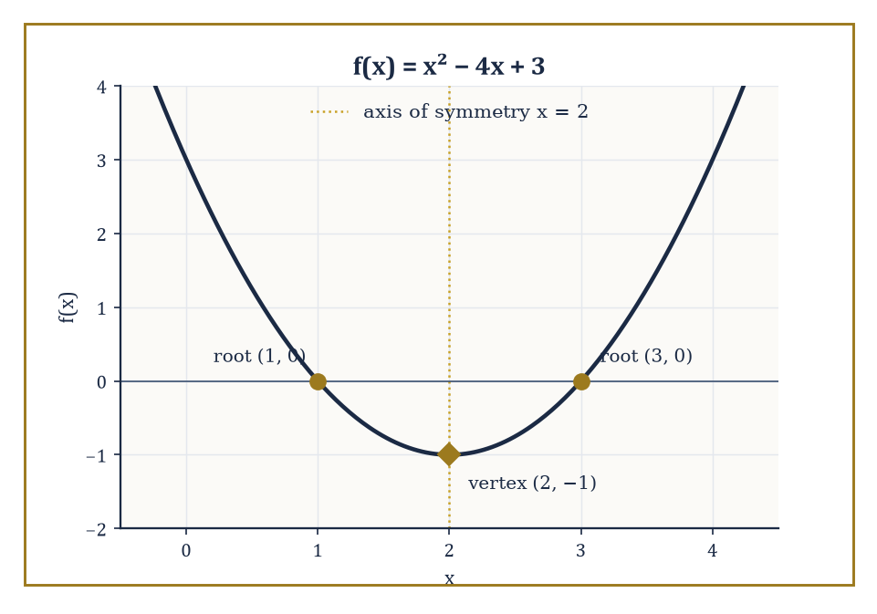
f(x) = x² − 4x + 3, with its two roots, its vertex, and the axis of symmetry running straight between them.
f(x) = mx + b
The number m is the slope, the constant rate at which the output changes for every one-unit increase in input; b is the y-intercept, the output when the input is zero. Because the rate of change never varies — the machine adds the same amount m for every step of 1 you take in x — the graph is, unsurprisingly, a perfectly straight line.
Given any two points on that line, the slope can always be recovered as "change in output divided by change in input," and from the slope and a single point the whole line's equation follows.
Numeric example — Worked example — reconstructing a line from two points. Suppose a line passes through (1, 3) and (4, 9). The slope is:
m = (9 − 3)/(4 − 1) = 6/3 = 2
Now use the point (1, 3) to find b: since f(x) = 2x + b, plugging in x = 1 gives
3 = 2(1) + b, so b = 1
The line is:
f(x) = 2x + 1
Check it against the point we didn't use for b:
f(4) = 2(4) + 1 = 8 + 1 = 9
That matches the second point exactly, which is a comforting sign the algebra hasn't gone astray.
The slope-intercept form f(x) = mx + b is only one of several interchangeable ways to write down the same line.
The point-slope form,
y − y₁ = m(x − x₁)
is often more convenient when you're handed a slope and a single point rather than the intercept directly, since it avoids solving for b as a separate step — though of course it can always be rearranged into slope-intercept form afterwards.
Numeric example — Worked example — point-slope form in action. A line has slope −3 and passes through (2, 5). Point-slope form gives immediately:
y − 5 = −3(x − 2)
Expanding:
y − 5 = −3x + 6, so y = −3x + 11
Check the original point:
at x = 2: y = −3(2) + 11 = −6 + 11 = 5
Correct. The y-intercept, read off directly from this expanded form, is 11, obtained without ever computing a separate "solve for b" step: point-slope form did that work automatically.
Quadratic functions,
f(x) = ax² + bx + c (with a ≠ 0)
are the next rung up in complexity, and their graphs are parabolas: U-shaped curves opening upward if a > 0 and downward if a < 0.
Three features of a parabola are worth being able to read off quickly: the vertex (its highest or lowest point), the axis of symmetry (the vertical line through the vertex, about which the whole curve mirrors itself), and the roots (where the curve crosses the x-axis, if it does at all).
The axis of symmetry sits at:
x = −b/2a
and completing the square converts the formula into the form
a(x − h)² + k
from which the vertex (h, k) can be read directly.
Numeric example — Worked example — vertex by two routes. Let f(x) = x² − 4x + 3, so a = 1, b = −4, c = 3. By the axis-of-symmetry formula:
x = −b/(2a) = −(−4)/(2·1) = 4/2 = 2
Then:
f(2) = 2² − 4(2) + 3 = 4 − 8 + 3 = −1
giving vertex (2, −1). By completing the square instead:
x² − 4x + 3 = (x² − 4x + 4) − 4 + 3 = (x − 2)² − 1
Read the vertex straight off as (2, −1), matching perfectly. As a bonus, this quadratic factors cleanly:
x² − 4x + 3 = (x − 1)(x − 3)
so the roots are x = 1 and x = 3. Check:
f(1) = 1 − 4 + 3 = 0 ✓ and f(3) = 9 − 12 + 3 = 0 ✓
When a quadratic refuses to factor nicely, the quadratic formula always finds the roots (real or otherwise):
x = (−b ± √(b² − 4ac)) / (2a)
The expression under the root sign, the discriminant,
D = b² − 4ac
tells you in advance which of three geometric fates the parabola meets the x-axis with: two distinct crossings when D > 0, a single touching point when D = 0, and no crossing at all when D < 0 — the parabola floats entirely above or below the axis.
Numeric example — Worked example — reading the discriminant. For 2x² + 3x + 5 = 0: a = 2, b = 3, c = 5, so:
D = 3² − 4(2)(5) = 9 − 40 = −31
Since D < 0, this parabola never touches the x-axis at all — there are no real roots, only a pair of complex ones the quadratic formula would produce if pressed.
Compare x² − 6x + 9 = 0: a = 1, b = −6, c = 9, so:
D = (−6)² − 4(1)(9) = 36 − 36 = 0
A discriminant of exactly zero means a single repeated root, here x = 3, and indeed:
x² − 6x + 9 = (x − 3)²
The parabola just kisses the x-axis at one point and retreats, rather than crossing it.

Room 3.4: Polynomials, Rationals, and Their Graphs
Bumps, Wiggles, and the Occasional Chasm
A polynomial function is a sum of terms of the form a·xᵏ, where k is a non-negative whole number — quadratics and linear functions are simply the low-degree special cases already met in the previous room.
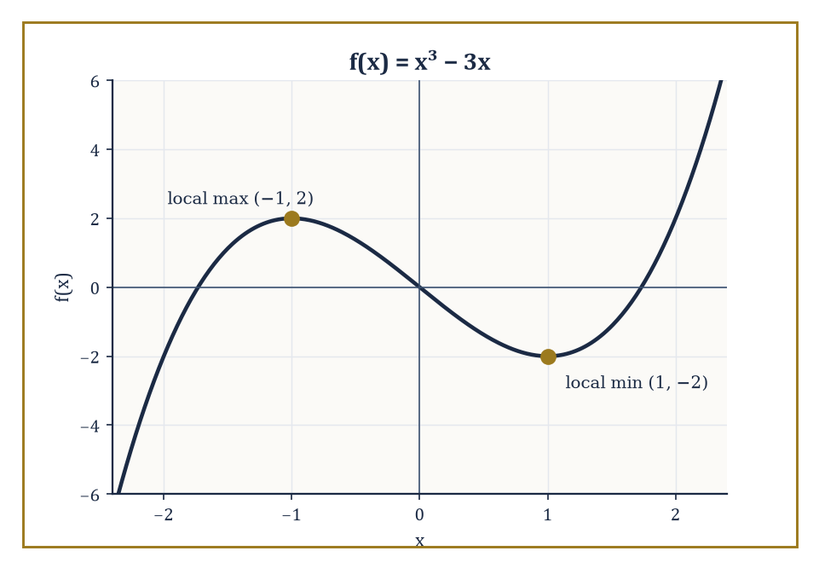
f(x) = x³ − 3x, showing exactly the two turning points a degree-3 polynomial is allowed.
The degree (the highest power of x appearing) governs two things about the graph at a glance. First, the end behaviour: for large |x|, the term with the highest power dominates everything else so completely that the rest of the polynomial might as well not be there, and the sign of that leading term's coefficient, together with whether the degree is odd or even, tells you which way the two ends of the graph point.
Second, the number of turning points (places where the curve changes from rising to falling or vice versa) is limited: a degree-n polynomial has at most n − 1 of them.
Numeric example — Worked example — end behaviour and turning points from raw values. Let f(x) = x³ − 3x, degree 3, with leading term x³ having a positive coefficient.
f(x) = x³ − 3x
Since the degree is odd and the leading coefficient positive, we expect the two ends to point in opposite vertical directions, as odd-degree polynomials always do:
f(x) → −∞ as x → −∞, f(x) → +∞ as x → +∞
Tabulate a few values:
f(−2) = −8 − (−6) = −2, f(−1) = −1 − (−3) = 2, f(0) = 0, f(1) = 1 − 3 = −2, f(2) = 8 − 6 = 2
Reading left to right — −2, 2, 0, −2, 2 — the curve rises from −2 up to a local peak of 2 at x = −1, falls through 0 down to a local trough of −2 at x = 1, then rises again. That's exactly two turning points, consistent with the degree-3 limit of at most n − 1 = 2, and the overall down-then-up sweep matches the odd-degree end behaviour predicted above.
A degree-n polynomial has at most n roots, and the fundamental theorem of algebra — which we will prove properly many storeys from now, once complex numbers have been introduced in their own right — guarantees that, counted with multiplicity and allowing complex values, it has exactly n.
For the moment, treat this as a promise about bookkeeping: a cubic has three roots somewhere in the mathematical universe, even on the occasions when fewer than three of them are visible on a real-number graph.
Abstract example — Abstract example — the promise fulfilled two different ways. Take a degree-3 polynomial handed to us already factored:
f(x) = (x − 1)(x + 2)(x − 3)
Its roots are visibly x = 1, x = −2, and x = 3 — three real roots for a degree-3 polynomial, the promise fulfilled with nothing left over.
Now take g(x) = x² + 1, degree 2. Setting it to zero gives:
x² + 1 = 0, so x² = −1
which has no real solution at all — yet the fundamental theorem insists a degree-2 polynomial has exactly two roots. They exist, just not among the real numbers:
x = i and x = −i, where i² = −1
(a full storey awaits this object later in the Tower). The theorem's promise holds in both cases; only the second needed to borrow from a larger number system to collect on it.
A rational function is a quotient of two polynomials, p(x)/q(x). Its graph inherits the personalities of both pieces, plus a new hazard entirely of its own: wherever the denominator hits zero, the function threatens to blow up.
If that zero of q is not cancelled by a matching zero of p, the graph develops a vertical asymptote — the curve shoots off toward +∞ or −∞ as x approaches that forbidden value, never actually touching the vertical line at that value, only hugging it ever more closely.
If, on the other hand, the offending factor cancels between numerator and denominator, the function is simply undefined at that one point — a hole, rather than a blow-up, a single missing dot in an otherwise ordinary curve.
Numeric example — Worked example — a hole versus an asymptote. Let
r(x) = (x² − 1)/(x − 1)
Factor the numerator:
x² − 1 = (x − 1)(x + 1), so r(x) = (x − 1)(x + 1)/(x − 1) = x + 1
valid for every x except x = 1, where the original expression is 0/0 and simply undefined. The graph is therefore the straight line y = x + 1 with a single point removed at x = 1 — a hole sitting at (1, 2), since 1 + 1 = 2, even though the function itself refuses to acknowledge it.
Contrast:
s(x) = (x + 1)/(x − 1)
At x = 1 the denominator is zero but the numerator is 1 + 1 = 2 ≠ 0, so nothing cancels. As x creeps toward 1 from below, s(x) plunges toward −∞; from above, it rockets toward +∞. That is a genuine vertical asymptote at x = 1, an altogether more dramatic event than a mere hole.
Long-run behaviour of a rational function — what happens as x heads off toward ±∞ — is read from comparing the degrees of numerator and denominator. If the denominator's degree is strictly larger, the function settles toward the horizontal asymptote y = 0.
If the degrees are equal, the function settles toward the ratio of the two leading coefficients. If the numerator's degree exceeds the denominator's by exactly one, ordinary polynomial division peels off a linear leftover term, and the function hugs that slanted line instead — an oblique asymptote.
Numeric example — Worked example — horizontal and oblique asymptotes, checked numerically. Let
t(x) = (2x² + 3)/(x² − 4)
Numerator and denominator both have degree 2, so the horizontal asymptote is the ratio of leading coefficients, 2/1 = 2. Check at a large input, x = 100:
t(100) = (2·10000 + 3)/(10000 − 4) = 20003/9996 ≈ 2.0011
That's visibly closing in on 2, exactly as predicted. Now let
u(x) = (x² + 1)/x
Dividing out:
u(x) = x + 1/x
As x grows, the 1/x term shrivels toward zero, leaving the function hugging the oblique line y = x. Check at x = 10:
u(10) = (100 + 1)/10 = 101/10 = 10.1
That's already within 0.1 of the asymptote y = x at that same point, and the gap keeps shrinking as x grows further.

Room 3.5: Transformations: Shifts, Stretches, and Reflections
Redecorating the Parent Function Without Buying New Furniture
Once one basic "parent" graph is thoroughly understood, an entire family of related graphs can be produced without deriving each from scratch, by applying a short catalogue of standard transformations.
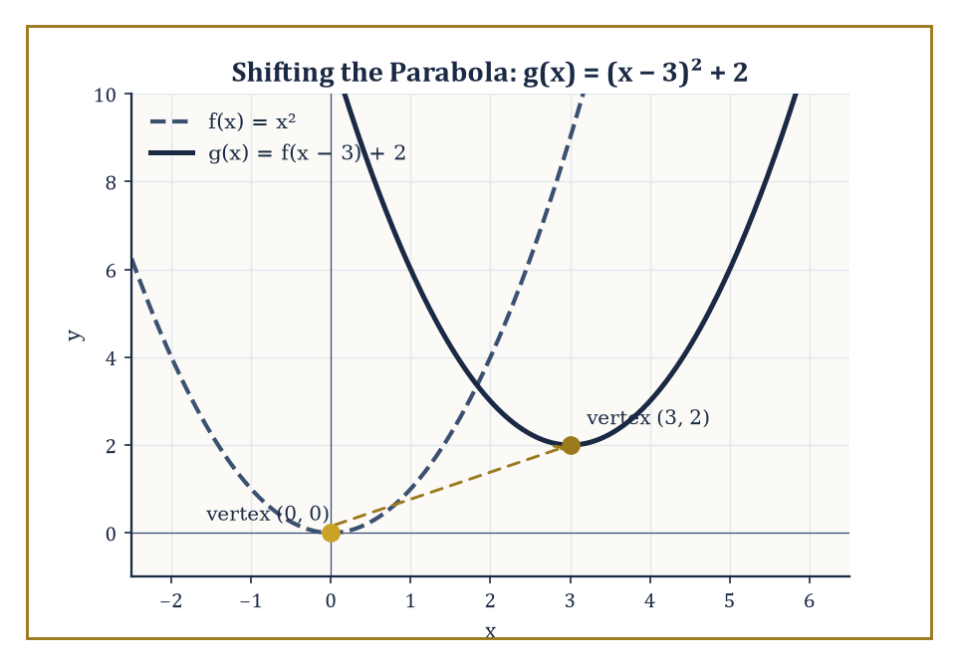
The parent parabola and g(x) = (x − 3)² + 2, its vertex carried from (0, 0) to (3, 2) exactly as the shift predicts.
Adding a constant outside the function, f(x) + k, shifts the whole graph vertically by k. Adjusting the input before the function sees it, f(x − h), shifts the graph horizontally by h — and note the sign: subtracting h moves the graph right, which trips up almost everyone the first time they meet it.
Multiplying the output, a·f(x), stretches the graph vertically (or compresses it, if 0 < a < 1); multiplying the input, f(bx), stretches or compresses it horizontally, again with a counterintuitive sign convention we'll examine below. Finally, −f(x) reflects the graph across the x-axis, and f(−x) reflects it across the y-axis.
Numeric example — Worked example — a shift in each direction at once. Take the parent function f(x) = x², whose vertex sits at the origin (0, 0), and let:
g(x) = f(x − 3) + 2 = (x − 3)² + 2
The "x − 3" inside the parentheses shifts the graph right by 3; the "+2" outside shifts it up by 2. So the vertex should move from (0, 0) to (3, 2). Check directly:
g(3) = (3 − 3)² + 2 = 0 + 2 = 2
Yes — the vertex value 2 is achieved exactly at x = 3, as predicted. A further check away from the vertex:
g(5) = (5 − 3)² + 2 = 2² + 2 = 4 + 2 = 6
That matches a direct substitution into the original formula without any shortcut reasoning at all.
Horizontal stretches and compressions are the transformation most likely to betray your intuition, precisely because they act on the input before the function ever sees it, rather than on the output afterward.
In f(bx), a value of b greater than 1 does not stretch the graph horizontally — it compresses it, squeezing everything toward the y-axis, because the function now reaches any given output using a smaller input than before.
Numeric example — Worked example — why horizontal transformations feel backwards. Take f(x) = x² again, and let:
h(x) = f(2x) = (2x)² = 4x²
The parent function reaches the output 4 at x = 2, since f(2) = 4. Where does h reach that same output of 4? Solve:
4x² = 4, so x² = 1, so x = 1 (taking the positive branch)
The point that used to sit at x = 2 on the parent graph now sits at x = 1 on the transformed graph — it has moved toward the y-axis, not away from it. That confirms b = 2 compresses the graph horizontally by a factor of 1/2, exactly the opposite of what "multiply by 2" sounds like it should do to a horizontal direction.
When several transformations are stacked together, the order in which you read them off the formula matters enormously, and the standard source of error is failing to factor the input expression before interpreting it.
f(bx − c) is not "shift right by c, then compress horizontally by a factor of b" — it is "factor out b to get f(b(x − c/b)), then shift right by c/b, then compress by a factor of b." Reading the shift off the un-factored expression silently changes its size.
Numeric example — Worked example — the factoring trap, caught and avoided. Let r(x) = f(2x − 4) = (2x − 4)², with parent f(x) = x² again. A tempting but wrong reading is "shift right by 4, then compress by 2."
The correct approach factors first:
2x − 4 = 2(x − 2), so r(x) = f(2(x − 2))
meaning "shift right by 2, then compress horizontally by a factor of 2" — the shift is 2, not 4. Verify against the vertex: the parent's vertex sits where the input to f is exactly 0, i.e. where 2x − 4 = 0, giving x = 2. Compute r(2) directly:
r(2) = (2·2 − 4)² = (4 − 4)² = 0² = 0
That matches the parent's own vertex value f(0) = 0 exactly at x = 2 — confirming the shift really was 2, not the naively-read 4.
Reflections round out the catalogue and are mercifully easier to keep straight: negating the whole output flips the graph top-to-bottom across the x-axis, while negating the input before the function sees it flips the graph left-to-right across the y-axis, and — as a side effect worth remembering — swaps the domain to its mirror image too.
Numeric example — Worked example — two reflections of a square root. Let f(x) = √x, domain x ≥ 0, with f(4) = 2.
The reflection −f(x) = −√x simply negates every output:
at x = 4: −f(4) = −2
That flips the curve below the x-axis while leaving its domain (x ≥ 0) untouched. The other reflection,
f(−x) = √(−x)
instead negates the input before the square root ever sees it, which forces the domain itself to flip: now −x must be ≥ 0, so x ≤ 0. Check at x = −4:
f(−(−4)) = f(4) = √4 = 2
That's the same output 2 that used to live at x = 4 on the parent graph now living at x = −4, its mirror image across the y-axis.
The payoff for memorising this short catalogue is disproportionate: a handful of parent functions — the line, the parabola, the square root, the reciprocal, the exponential still to come — combined with these five moves generates an enormous working repertoire of graphs, without ever having to plot a fresh curve point by laborious point.

Room 3.6: Composition and Inverse Functions
Feeding One Machine's Output to Another, and Then Running the Tape Backwards
Composition takes the output of one function and feeds it, unmodified, straight into another as input. The notation is read "f of g of x": compute g(x) first, then apply f to whatever comes out.
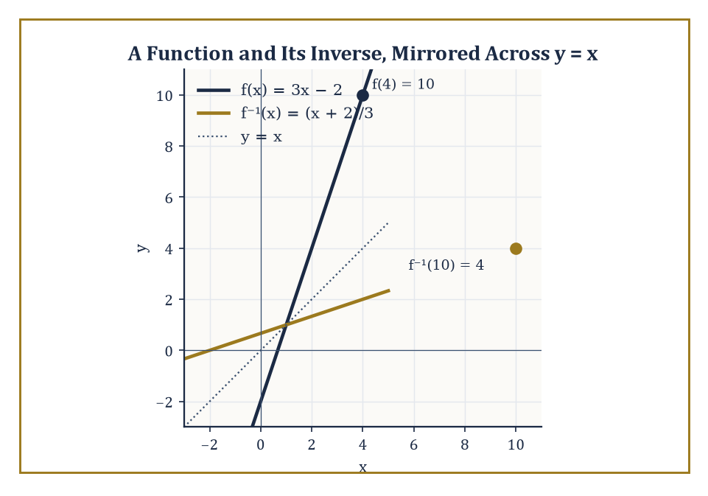
f(x) = 3x − 2 and its inverse, mirror images of each other across the line y = x.
(f ∘ g)(x) = f(g(x))
Composition is associative:
(f ∘ g) ∘ h = f ∘ (g ∘ h)
so parentheses around a chain of three or more compositions can be dropped without ambiguity — but it is emphatically not commutative. Which machine runs first matters, generally producing an entirely different final answer than running them in the other order.
Numeric example — Worked example — order changes everything. Let f(x) = x² + 1 and g(x) = x − 3. Compute (f ∘ g)(5): first
g(5) = 5 − 3 = 2
then
f(2) = 2² + 1 = 4 + 1 = 5
So (f ∘ g)(5) = 5. Now compute (g ∘ f)(5) instead: first
f(5) = 5² + 1 = 25 + 1 = 26
then
g(26) = 26 − 3 = 23
So (g ∘ f)(5) = 23. Same two machines, same starting input, two wildly different answers — 5 versus 23 — purely because of the order they were run in. Composition, unlike ordinary multiplication, does not forgive you for swapping the order.
One of the most useful skills composition provides is the reverse move: taking a single intimidating formula and recognising it as two (or more) simple functions chained together. This habit of decomposition will resurface constantly once the calculus storeys arrive, where differentiating a composed function (via the chain rule) requires first spotting that it is composed at all.
Abstract example — Abstract example — decomposing a formula into its parts. Consider:
h(x) = √(3x + 7)
At first glance this is one intimidating lump, but it is really two familiar functions stacked together: let g(x) = 3x + 7 (a simple linear function) and f(u) = √u (the square-root function from earlier rooms, using u as its input name to avoid confusion). Then:
(f ∘ g)(x) = f(g(x)) = f(3x + 7) = √(3x + 7) = h(x)
That exactly matches the original. Decomposition doesn't change the function; it changes how easy the function is to think about, by exposing the "outer" square-root machine and the "inner" linear machine feeding it.
An inverse function undoes whatever the original function did, in the precise sense that applying one after the other, in either order, returns exactly the input you started with, wherever both sides make sense:
f(f⁻¹(x)) = x and f⁻¹(f(x)) = x
A function has an inverse — on its whole domain, or on a suitably restricted piece of it — exactly when it is one-to-one, meaning no two different inputs are ever allowed to share an output.
The horizontal-line test is the geometric version of this requirement: if any horizontal line crosses the graph more than once, two different inputs are tied for that output, and no inverse function can exist without first throwing part of the domain away.
Numeric example — Worked example — building and checking an inverse. Let f(x) = 3x − 2, a line, which is one-to-one everywhere (distinct inputs always give distinct outputs, since the slope 3 is never zero). To find the inverse, write y = 3x − 2, swap the roles of x and y to get x = 3y − 2, then solve for y:
x + 2 = 3y, so y = (x + 2)/3
Hence:
f⁻¹(x) = (x + 2)/3
Check the first identity:
f⁻¹(5) = (5 + 2)/3 = 7/3, and f(7/3) = 3(7/3) − 2 = 7 − 2 = 5
Back to where we started. Check the second identity:
f(4) = 3(4) − 2 = 10, and f⁻¹(10) = (10 + 2)/3 = 12/3 = 4
Again, back to the start. Both round trips return exactly the original input, confirming f⁻¹ genuinely undoes f.
Graphically, the inverse of a function is always the reflection of the original graph across the line y = x — swapping x and y algebraically is precisely the geometric act of reflecting across that diagonal line. This is why an inverse only exists cleanly when the horizontal-line test passes: reflecting a curve that failed the vertical-line test's cousin would simply hand the vertical-line problem straight back, in mirrored form.
Numeric example — Worked example — a function rescued by domain restriction. Let f(x) = x² on the whole real line. Check:
f(2) = 4 and f(−2) = 4
Two different inputs, 2 and −2, sharing the single output 4. The horizontal line y = 4 crosses the parabola twice, so f fails the horizontal-line test and has no inverse over all of ℝ — there would be no way to decide whether f⁻¹(4) should be 2 or −2.
The standard rescue is to restrict the domain to x ≥ 0 only, discarding the left-hand half of the parabola. On that restricted domain f is genuinely one-to-one, and its inverse is exactly the principal square root, first introduced back in Room 3.1:
f⁻¹(x) = √x
Check:
f(3) = 9, and f⁻¹(9) = √9 = 3
The round trip works now, precisely because the domain restriction removed the ambiguity that sank the unrestricted version.

Room 3.7: Exponential and Logarithmic Functions
Numbers That Grow (or Vanish) in Proportion to Themselves
An exponential function has the form:
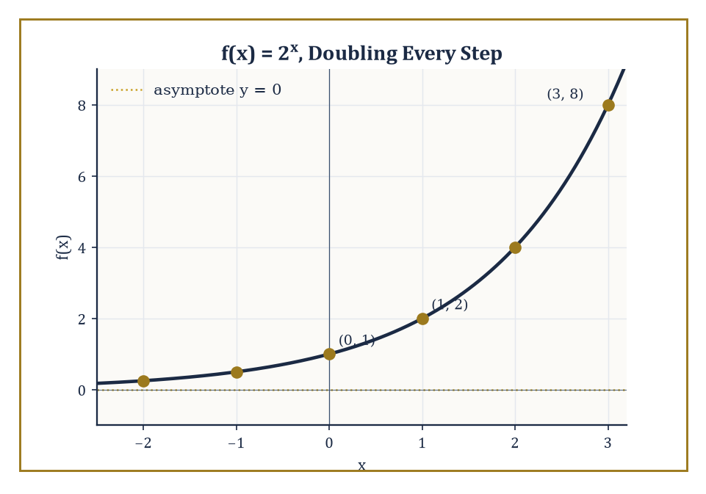
The doubling machine f(x) = 2ˣ, hugging its horizontal asymptote at y = 0 as x runs off to the left.
f(x) = aˣ
where the base a is a positive number other than 1 (a = 1 would just give the constant function 1, which is dull even by the modest standards of this aside).
The defining feature — the one that separates exponential growth from every kind of growth we've met so far in the Tower — is that the rate at which the output changes is proportional to the output's current size, rather than to a fixed amount.
Every graph of this family passes through (0, 1), since a⁰ = 1 for any legal base a; every output is strictly positive, since a positive base raised to any real power stays positive; and as x runs off toward −∞, the graph flattens toward, but never reaches, the horizontal asymptote y = 0.
Numeric example — Worked example — doubling, on schedule. Let f(x) = 2ˣ. Tabulate:
f(0) = 2⁰ = 1, f(1) = 2¹ = 2, f(2) = 2² = 4, f(3) = 2³ = 8, f(−1) = 2⁻¹ = 1/2, f(−2) = 2⁻² = 1/4
Notice the pattern: every time x increases by exactly 1, the output doubles — 1, then 2, then 4, then 8 — regardless of which output you started from. That is what "rate of change proportional to current value" means in practice: the increase from f(2)=4 to f(3)=8 is 4, exactly equal to the value you were already standing on, while the increase from f(0)=1 to f(1)=2 is only 1 — smaller in absolute terms, but the same proportion (a doubling) either way.
One particular base, denoted e and approximately equal to 2.71828, turns out to be so mathematically inevitable that calculus later treats it as the default base for essentially everything.
A relatively painless way to meet it before calculus arrives is through compound interest: if you invest one unit of currency at 100% annual interest, compounded n times per year, your balance after one year is:
(1 + 1/n)ⁿ
As n grows — compounding monthly, daily, then absurdly, continuously — this expression creeps toward e.
Numeric example — Worked example — sneaking up on e. Compute (1 + 1/n)ⁿ for increasing n:
n = 1: (1 + 1)¹ = 2¹ = 2
n = 2: (1 + 0.5)² = 1.5² = 2.25
n = 4: (1.25)⁴ = 1.5625² = 2.44140625
n = 12 (monthly): (1 + 1/12)¹² = (1.08333…)¹² ≈ 2.613
The sequence 2, 2.25, 2.4414, 2.613, … is climbing steadily but decelerating, and it keeps climbing — through roughly 2.71457 at n = 365 (daily compounding) — toward the limiting value e ≈ 2.71828…, which it approaches but, for any finite n, never quite reaches.
A logarithmic function is, by definition, the inverse of an exponential one: log_a(x) answers the question "to what power must a be raised to produce x?"
Because it is the mirror image (across y = x, per Room 3.6) of an always-positive, ever-increasing exponential, the logarithm's own domain is restricted to positive numbers only, and its graph has a vertical asymptote at x = 0 rather than the horizontal one its exponential parent had.
The laws of logarithms all follow directly from the corresponding laws of exponents, transported across the inverse-function mirror:
log(mn) = log(m) + log(n)
log(m/n) = log(m) − log(n)
log(mᵏ) = k·log(m)
And the change-of-base formula
log_a(x) = ln(x)/ln(a)
lets any calculator's fixed set of logarithm buttons compute a logarithm in any base at all.
Numeric example — Worked example — logarithm laws checked against a calculator's natural log. First, a direct case:
log₂(32) = 5, since 2⁵ = 32
Verify via change of base:
ln(32)/ln(2) = 5·ln(2)/ln(2) = 5
No rounding required at all — the change-of-base formula reproduces the exact answer because the numbers were secretly related all along. Now the product law: log₁₀(6) should equal log₁₀(2) + log₁₀(3), since 6 = 2 × 3.
log₁₀(2) ≈ 0.30103, log₁₀(3) ≈ 0.47712, sum ≈ 0.77815
The directly computed value of log₁₀(6) is 0.77815 to the same precision — the law holds, digit for digit.
Because a logarithm answers "what power," it is the natural tool for solving equations in which the unknown sits in an exponent — precisely the equations that plain algebraic rearrangement, mastered back in Storey 2, is powerless to touch.
Numeric example — Worked example — solving for an unknown exponent. Solve:
5ˣ = 200
Since x is trapped in the exponent, take the logarithm of both sides:
ln(5ˣ) = ln(200)
and the power law collapses the left side:
x·ln(5) = ln(200), so x = ln(200)/ln(5)
Using ln(200) = ln(2) + ln(100) ≈ 0.69315 + 4.60517 = 5.29832, and ln(5) ≈ 1.60944:
x ≈ 5.29832/1.60944 ≈ 3.292
A rough sanity check: 5³ = 125 and 5⁴ = 625, and 200 sits between them, rather closer to the lower end — an exponent of about 3.29 is exactly the sort of answer that should produce, which it does.
Because exponential growth and logarithms are mirror images, plotting an exponential relationship on axes where one axis is itself logarithmically scaled — a semilog plot — straightens the curve into a line, and plotting a power-law relationship on doubly logarithmic axes — a log-log plot — does the same.
This trick, far more than any single formula, is why exponentials and logarithms show up wherever scientists need to detect growth, decay, or scaling behaviour buried inside noisy data: population growth, radioactive decay, sound intensity in decibels, and earthquake magnitude on the Richter scale are all, secretly, straight lines waiting for the right kind of graph paper.
Numeric example — Worked example — straightening a curve with a logarithm. Let f(x) = 2ˣ, the doubling machine from earlier in this room. Take the (base-10) logarithm of both sides, using the power law:
log(f(x)) = log(2ˣ) = x·log(2)
Writing Y = log(f(x)), this says:
Y = log(2)·x
A straight line in x and Y, with slope log(2) ≈ 0.30103 and no constant term. Check it against three points.
x = 1: f(1) = 2, log(2) ≈ 0.30103, matching 0.30103·1
x = 3: f(3) = 8, log(8) = log(2³) = 3·log(2) ≈ 0.90309, matching 0.30103·3 = 0.90309
x = 5: f(5) = 32, log(32) = 5·log(2) ≈ 1.50515, matching 0.30103·5 = 1.50515
Three points, three exact matches: plotted as (x, log f(x)) rather than (x, f(x)), the relentlessly curving exponential becomes a perfectly ordinary line of slope log 2 — precisely the semilog trick promised above.

Room 3.8: Reading Graphs: Intercepts, Asymptotes, and Qualitative Behaviour
The Graph as a Document, and How to Interrogate It
A graph is not merely a pretty picture — it is a data structure, and like any data structure it rewards being interrogated systematically rather than merely admired.
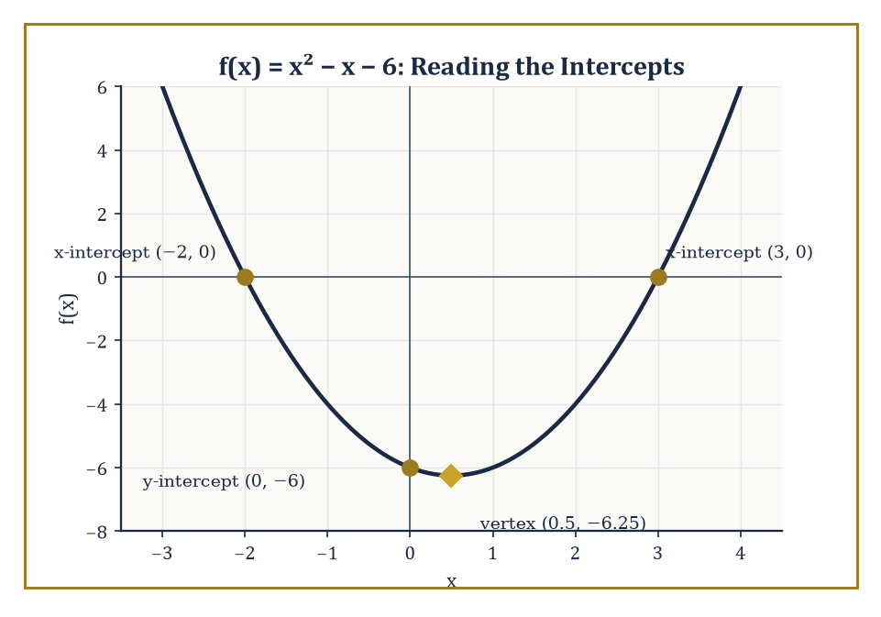
f(x) = x² − x − 6, interrogated for its three intercepts and its vertex before a single point was plotted by hand.
The intercepts are the first and easiest facts to extract: the x-intercepts are found by setting f(x) = 0 and solving, and the y-intercept, at most a single point for any genuine function, is simply f(0).
Numeric example — Worked example — harvesting the intercepts. Let f(x) = x² − x − 6. For the x-intercepts, solve:
x² − x − 6 = 0
Factoring — does (x − 3)(x + 2) expand back correctly?
(x − 3)(x + 2) = x² + 2x − 3x − 6 = x² − x − 6
Yes. So the roots are x = 3 and x = −2, giving x-intercepts (3, 0) and (−2, 0). Check:
f(3) = 9 − 3 − 6 = 0 ✓, f(−2) = 4 + 2 − 6 = 0 ✓
For the y-intercept:
f(0) = 0 − 0 − 6 = −6
giving (0, −6). Three anchor points, extracted from the formula alone, before a single point of the curve has been plotted.
Beyond the intercepts, a graph has a shape: it rises across some intervals of x and falls across others, and the points where it switches — local maxima (peaks) and local minima (troughs) — organise the whole picture. For the quadratic family this switching point is exactly the vertex met in Room 3.3, and the axis of symmetry tells you the interval of decrease sits on one side, the interval of increase on the other.
(A more refined notion, concavity — whether the curve bends like a cup opening upward or like a dome opening downward — is worth having in the back of your mind now; it becomes fully precise only once the derivative arrives, several storeys from here.)
Numeric example — Worked example — locating increase and decrease from raw values. Return to f(x) = x² − x − 6 from above. Its axis of symmetry sits at:
x = −b/(2a) = −(−1)/(2·1) = 0.5
giving the vertex value:
f(0.5) = 0.25 − 0.5 − 6 = −6.25
the lowest point on the whole curve, since a = 1 > 0 means the parabola opens upward. Now walk through values approaching 0.5 from the left:
f(−1) = 1 + 1 − 6 = −4, f(0) = 0 − 0 − 6 = −6, f(0.5) = −6.25
The sequence −4, −6, −6.25 is steadily falling — the function is decreasing on (−∞, 0.5). Walk through values leaving 0.5 to the right:
f(0.5) = −6.25, f(1) = 1 − 1 − 6 = −6, f(2) = 4 − 2 − 6 = −4
The sequence −6.25, −6, −4 is steadily rising — the function is increasing on (0.5, ∞). The vertex is exactly the hinge between the two behaviours, precisely as the theory predicts.
Vertical asymptotes and horizontal (or oblique) asymptotes, introduced properly in Room 3.4 for rational functions, describe two very different kinds of long-term behaviour, and it's worth keeping the distinction crisp.
A vertical asymptote is a local catastrophe, an infinite blow-up concentrated at a single forbidden x-value, while a horizontal or oblique asymptote is a global settling-down, describing where the graph is headed as x runs off toward ±∞.
Numeric example — Worked example — a blow-up and a settling, side by side. Let
g(x) = 1/(x − 2)
Near the forbidden value x = 2:
g(1.9) = 1/(1.9 − 2) = 1/(−0.1) = −10, g(1.99) = 1/(−0.01) = −100
The function plunges toward −∞ as x creeps up to 2 from below. From above:
g(2.01) = 1/(0.01) = 100
It rockets toward +∞ instead. That local catastrophe is the vertical asymptote at x = 2. Meanwhile, far from any forbidden value:
g(1000) = 1/(1000 − 2) = 1/998 ≈ 0.001002
A tiny, unremarkable number, closing in on 0 as x runs off toward infinity. That gentle settling is the horizontal asymptote y = 0, an entirely different phenomenon happening at the opposite end of the graph's story.
Symmetry, where a graph possesses it, is a considerable act of mercy: it lets you sketch (or verify) half the picture and get the other half for free.
A function is even if
f(−x) = f(x) for every x in the domain
its graph is a mirror image of itself across the y-axis. A function is odd if
f(−x) = −f(x)
its graph has 180° rotational symmetry about the origin. (Most functions, it should be said, are neither — evenness and oddness are special properties to be checked, not assumed.) A periodic function repeats its entire shape at regular intervals, a behaviour trigonometric functions will make central once they arrive properly in a later storey.
Numeric example — Worked example — testing evenness and oddness algebraically. Let p(x) = x⁴ − 3x². Test evenness by substituting −x for x:
p(−x) = (−x)⁴ − 3(−x)² = x⁴ − 3x² = p(x)
Every negative sign vanished under the even powers, so p is even, and its graph is a mirror image across the y-axis. Now let q(x) = x³ − x. Test:
q(−x) = (−x)³ − (−x) = −x³ + x = −(x³ − x) = −q(x)
This time every term flipped sign, matching the odd-function condition exactly. Confirm numerically:
q(2) = 8 − 2 = 6, q(−2) = −8 + 2 = −6 = −q(2)
One quadratic-flavoured polynomial turned out even, one cubic-flavoured one turned out odd — a pattern (even powers only ⇒ even function; odd powers only ⇒ odd function) that is a useful shortcut, though it is worth checking the algebra rather than trusting the shortcut blindly, since a stray constant term or mixed powers can spoil it instantly.
Piecewise-defined functions — built from different formulas on different intervals — demand special attention exactly at their breakpoints, where one formula hands off to the next. The two formulas need not agree there at all, and when they don't, the graph develops a visible jump.
Numeric example — Worked example — a seamless handoff and a broken one. Let:
f(x) = x + 1 for x < 2, f(x) = 5 − x for x ≥ 2
Approaching the breakpoint x = 2 from the left, the first formula gives values approaching 2 + 1 = 3. At x = 2 itself, the second formula applies:
f(2) = 5 − 2 = 3
The two pieces agree exactly at the handoff — 3 meets 3 — so despite being built from two different formulas, this graph is a single unbroken curve (in fact, a bent line with no gap).
Now suppose the second piece had instead been f(x) = 6 − x for x ≥ 2:
f(2) = 6 − 2 = 4
while the first formula still approaches 3 as x → 2 from the left. 3 ≠ 4 — the two pieces no longer meet, and the graph has a visible jump discontinuity of size 1 sitting exactly at the breakpoint, a small but permanent scar in what would otherwise be a smooth handoff.

Room 3.9: Looking Ahead: From Graphs to Calculus and Beyond
Packing the Toolbox for the Climb
Take stock of what this storey has actually assembled. We have the precise meaning of a function, and the domain and range that bound its behaviour. We have the two great algebraic families — linear and quadratic — plus polynomials and rational functions and the asymptotic hazards that come with the latter.
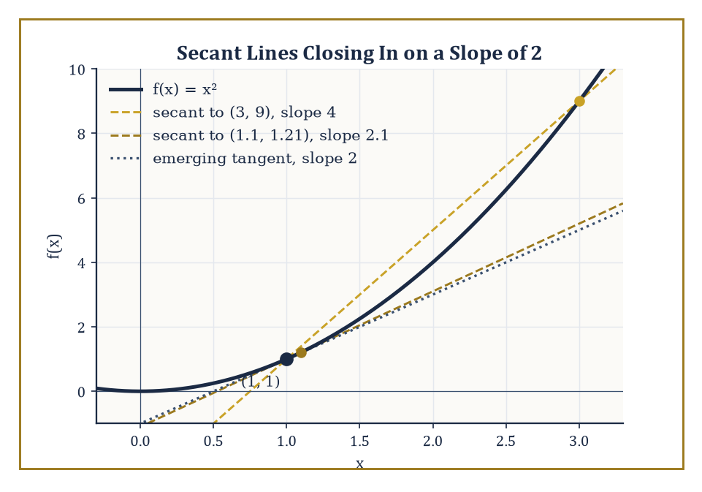
Secant lines through (1, 1) on f(x) = x², shrinking toward a slope of 2 — the derivative, not yet officially invited in.
We have a systematic way to warp a small library of parent graphs into an enormous working repertoire, via shifts, stretches, and reflections. We have composition and inverses, letting complicated functions be built from, and undone by, simpler ones. We have exponentials and logarithms, the first genuinely transcendental functions the Tower has offered. And we have a vocabulary — intercepts, symmetry, asymptotes, intervals of increase and decrease — for interrogating any graph placed in front of us, regardless of which family it came from.
All of this is, without exaggeration, the immediate prerequisite for calculus, and it is worth being honest about exactly which informal ideas from this storey are about to be made rigorous.
The derivative, several storeys above us, will formalise the notion of a graph's slope at a single point — not the constant slope of a whole line, but the instantaneous steepness of a curving graph exactly there. We've already brushed against this idea informally, whenever we asked whether a graph was "increasing" or "decreasing" near some point; calculus simply supplies the missing precision.
Numeric example — Worked example — sneaking up on a slope that doesn't officially exist yet. Take f(x) = x², and consider the average rate of change over the interval [1, 3]:
(f(3) − f(1))/(3 − 1) = (9 − 1)/2 = 8/2 = 4
That's the slope of the straight line connecting the two points (1, 1) and (3, 9) — a perfectly ordinary calculation using tools already in hand. Now shrink the interval, to [1, 1.1]:
(f(1.1) − f(1))/(0.1) = (1.21 − 1)/0.1 = 0.21/0.1 = 2.1
Shrink it further, to [1, 1.01]:
(f(1.01) − f(1))/(0.01) = (1.0201 − 1)/0.01 = 0.0201/0.01 = 2.01
The average rate of change is drifting steadily toward 2 as the interval shrinks toward nothing — a number the graph seems to be hinting at even though no single interval ever quite reaches it. That hinted-at number is precisely what the derivative will formalise and name, once limits have been defined with proper rigour.
The integral, arriving alongside the derivative, will formalise the area trapped between a curve and the x-axis — a natural companion question to "how steep is this graph," namely "how much space does this graph enclose."
And limits themselves — the machinery that will let us say precisely what "approaches 2" or "blows up to infinity" actually means, rather than merely gesturing at a table of values as we did throughout Room 3.8 — are the connective tissue that makes both the derivative and the integral logically watertight rather than merely plausible.
Numeric example — Worked example — the hole from Room 3.4, revisited as a limit. Recall r(x) = (x² − 1)/(x − 1) from Room 3.4, undefined exactly at x = 1 but equal to x + 1 everywhere else, leaving a hole at (1, 2). Approach x = 1 from the right:
r(1.1) = (1.21 − 1)/(0.1) = 0.21/0.1 = 2.1
r(1.01) = (1.0201 − 1)/0.01 = 2.01
The outputs close in on 2 even though r(1) itself is simply not defined. The limit of r(x) as x approaches 1 is 2, precisely the value that would fill the hole if the algebra allowed it. This is exactly the kind of informal "gets closer and closer to" observation this storey has relied on throughout — the next storeys upward will show you how to state it, and prove it, without ever needing to trail off with an ellipsis.
The deeper lesson of this storey, underneath all the formulas, is that dependence can be drawn, and that a drawing is itself a form of understanding, not merely an illustration of one arrived at elsewhere. A well-chosen graph frequently reveals a structural fact — a hidden symmetry, an approaching asymptote, a vertex hiding in plain sight — that an algebraic formula, however correct, conceals behind its own notation. Equally, a well-chosen formula makes precise a great many things a graph can only suggest with a gesture of the pen. Functions and graphs are the bridge from algebra to analysis, and we have just finished building the two-way traffic across it.
We have learned to draw dependence, and — the harder half of the job, if we're honest — to read the drawing back. A parabola's vertex, a rational function's asymptote, an exponential's relentless doubling: none of these are decorations on top of the algebra. They are the algebra, wearing a coat you can actually see from across the room.
But notice what we have been quietly assuming this entire storey: that there is a plane to draw on at all, with a horizontal direction and a vertical one, and that every point in it can be pinned down by a pair of numbers. We have used that grid on almost every page without once asking where it came from or what, precisely, entitles a pair of numbers to specify a location. That omission was deliberate, and it cannot last — the next storey pays that debt in full, formalising the coordinate plane itself, along with its stranger cousins (polar coordinates chief among them), so that the pictures we have been drawing so freely finally rest on foundations as solid as the algebra underneath them.
The Tower continues upward, one storey of understanding stacked on the last, and — appropriately for a Tower about dependence — each storey needs the one below it rather more than it likes to admit.

Storey 4: Coordinate Systems
Axes, Origins, and the Quiet Ambition of Locating Everything
Storey Three left us in possession of graphs — functions made visible, equations turned into shapes you could stare at until they made sense. But a shape needs somewhere to be a shape in, and up to now we have been drawing on paper as though the paper came pre-loaded with an address system. It doesn't. A blank page is blank; it has no memory of where anything is unless something installs one. This storey installs one.
A coordinate system is a systematic way of attaching numbers — or ordered tuples of numbers — to points in space, so that geometric relationships become algebraic ones. It is the translation layer between the visual and the calculable, the customs desk where pictures declare themselves as arithmetic. Without it, geometry is a museum of clever synthetic arguments, each bespoke, none reusable. With it, geometry becomes a branch of algebra that happens to be about space, and every argument you have already learned to do with equations becomes available for doing with shapes.
The most familiar system is the Cartesian plane — two perpendicular axes, an origin, a number pair for every point — and it feels so inevitable that most people assume it is the only option, the way a fish assumes water is the only option. It is not. Polar, cylindrical, spherical, homogeneous coordinates and their stranger relatives all exist because different problems have different natural shapes, and forcing a radial problem into a rectangular grid is a bit like filing a circular argument in square filing cabinets: it can be done, but everyone involved will resent it.
A small confession, since we're several storeys up and can afford some honesty: coordinate systems are the first place in this Tower where mathematics starts to feel like infrastructure rather than content. They are rarely the point of a theorem; they are the scaffolding the theorem stands on while it does its work. But bad scaffolding can make a simple building look like a death trap, and good scaffolding can make an ambitious one look inevitable. Choosing coordinates well is not a preliminary chore before the real mathematics starts — it is already an act of mathematical judgement, and this storey is devoted to developing that judgement. Let's start labelling; mind the gap between the origin and the platform.

Room 4.1: What a Coordinate System Actually Is
Or: the paperwork every point must fill in before it's allowed to exist
A coordinate system is a rule that assigns to each point of a space a unique label made of numbers, chosen so that geometric notions — distance, angle, incidence, betweenness — can be recovered by doing arithmetic on the labels rather than by squinting at a picture. The simplest possible example, so simple it's easy to overlook, is the number line itself. Every real number is already its own coordinate; no translation is needed because the number and the point were never really separate ideas.
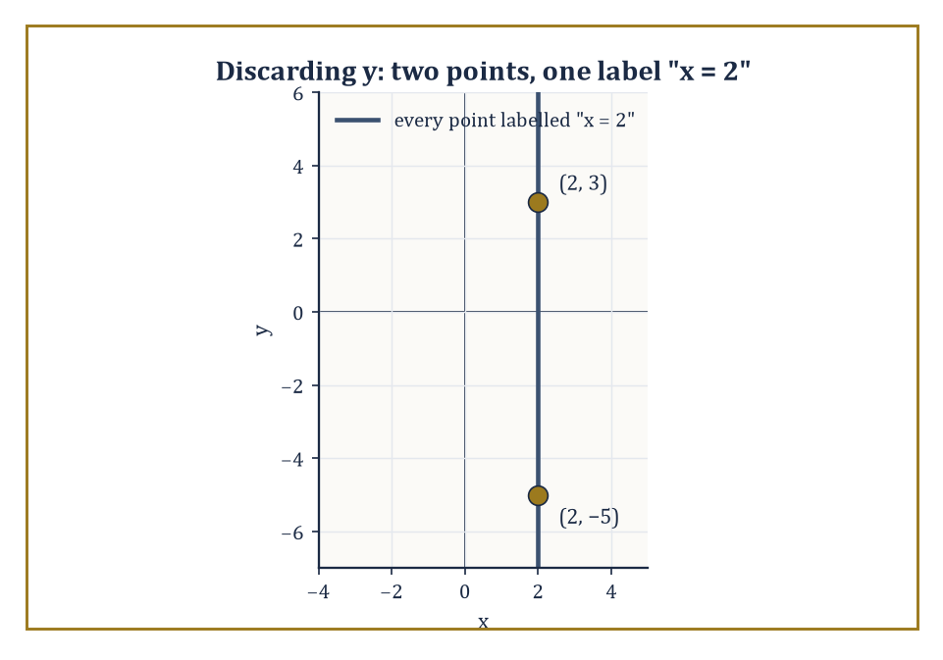
Discard the y-coordinate and the entire vertical line x = 2 collapses onto one label — injectivity, failing in public.
The distance between two points a and b on the line is:
|b − a|
The ordering of points is just the ordinary ordering of the reals. One number, one point, nothing extra required — the number line is the coordinate system that does its own paperwork.
Numeric example — Worked example — distance on the number line. Let a = −3 and b = 5 on the number line. The distance between them is:
|b − a| = |5 − (−3)| = |8| = 8
Notice that the formula does not care which point you call a and which you call b:
|a − b| = |−3 − 5| = |−8| = 8
The absolute value is doing the modest but essential job of throwing away direction and keeping only size — which is exactly what 'distance' is supposed to mean.
In the plane we need two numbers per point; in ordinary space we need three. On the surface of a sphere we might prefer latitude and longitude — two numbers again, but now attached to a curved surface rather than a flat one.
On a projective plane, which we'll meet properly in Room 4.7, we use three homogeneous coordinates even though the space is still, in the sense that matters, two-dimensional. The number of coordinates and their meaning depend entirely on the geometry you are trying to capture — there is no universal correct count, only the count that suits the space at hand.
Abstract example — Abstract example — latitude and longitude. Take the surface of the Earth, idealised as a perfect sphere. A point like London is labelled by two numbers: latitude approximately 51.5° North, longitude approximately 0.1° West. Two numbers, one point — for almost every point on the sphere this works exactly as advertised.
But walk to the North Pole and the system develops a stutter: latitude is a perfectly good 90° N, but longitude becomes meaningless, because every line of longitude passes through the pole simultaneously. The pole is one point wearing infinitely many labels' worth of ambiguity. This isn't a flaw invented to annoy sailors; it's a genuine structural feature of trying to flatten a sphere's worth of directions into a single angular coordinate, and we will meet its cousins again when we get to cylindrical and spherical coordinates in Room 4.5.
Two requirements are non-negotiable if a labelling scheme is to deserve the name 'coordinate system'. First, every point of the space must receive at least one label — this is surjectivity onto the space, and it just means nobody gets left off the map. Second, different points must receive different labels — injectivity — because a labelling system in which two distinct points share an address is not a coordinate system, it's a mailing mix-up.
When both hold, we have a genuine coordinate system. When only the first holds, we have what's called a parameterization: useful, sometimes unavoidable, but requiring extra care wherever the injectivity fails, exactly as we just saw at the North Pole.
Abstract example — Abstract example — a labelling scheme that fails. Suppose someone proposes to label every point of the ordinary Cartesian plane using only its x-coordinate, discarding y entirely. Is this a coordinate system? It satisfies surjectivity in a trivial sense (every real number gets used as a label for something), but it catastrophically fails injectivity: the points (2, 3) and (2, −5) both receive the label '2'.
Infinitely many points — the entire vertical line x = 2 — are crammed under one address. As a filing system this is not merely imperfect, it is useless: you cannot recover the point from the label, only a whole line's worth of candidates. This is the cautionary tale behind the injectivity requirement — a coordinate system must let you get back to where you started, not just out the door.
Coordinate systems are also not unique, even once you've fixed on a type. The same Cartesian plane admits infinitely many valid coordinate systems, depending on where you put the origin, which direction you call positive, and what you use as your unit of length.
Mathematics itself is indifferent to which one you pick, provided you're consistent within a calculation; the numbers work out the same way in the end because the underlying geometry hasn't moved, only the labels have. The working mathematician, however, cares a great deal, because some choices turn a calculation into three lines and others turn it into three pages.
Numeric example — Worked example — the same point, two systems. Let point P have coordinates (3, 4) in a Cartesian system S with origin O. Now set up a second system S′ whose origin O′ sits at (1, 1) in S, with axes parallel to S's. The relabelling rule is:
x′ = x − 1, y′ = y − 1
we're subtracting off where the new origin sits. Applying it to P:
x′ = 3 − 1 = 2, y′ = 4 − 1 = 3
So the very same physical point is (3, 4) in S and (2, 3) in S′. Nothing about the point moved; only the ruler we measured it against did. This is the entire content of a 'change of coordinates', and it will reappear with rather more machinery in Room 4.6.
The rest of this storey is an exploration of the most useful coordinate systems on offer, and — just as importantly — of the dictionaries that let you translate between them. We begin with the one that still feels, after everything, like home.

Room 4.2: The Cartesian Plane: Two Axes and an Origin
In which perpendicularity solves most of your problems before you've finished stating them
The Cartesian coordinate system is named for René Descartes, who in 1637 showed how to marry algebra and geometry by assigning ordered pairs of real numbers to points in the plane — a marriage that has, unlike most seventeenth-century arrangements, lasted remarkably well. The construction itself needs only three choices: a point O, called the origin; two perpendicular directed lines through O, called the axes; and a unit length.
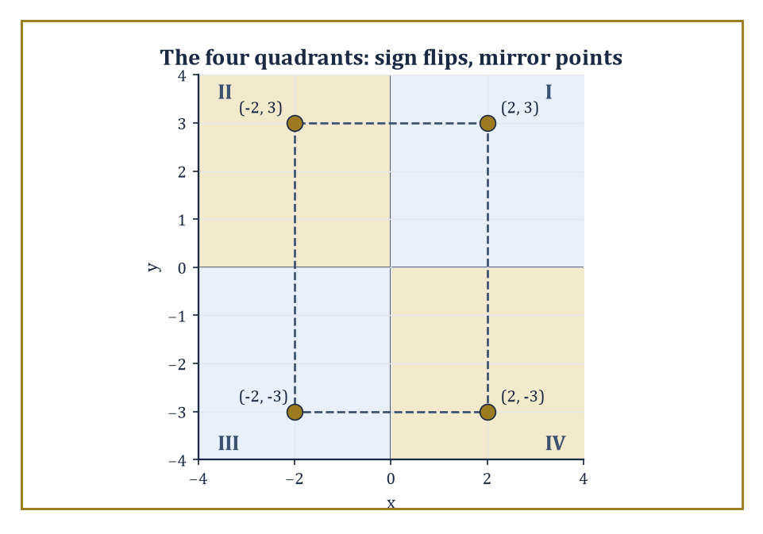
Flip a sign, land in the mirror-image quadrant: the four points (±2, ±3), dashed into the rectangle they straddle around the origin.
Once these are fixed, every point P in the plane determines a unique pair (x, y): x is the signed distance from P to the y-axis, and y is the signed distance from P to the x-axis. 'Signed' is doing quiet but crucial work here — it's what lets a single formula cover points in every direction without needing four separate rules for four separate cases.
Numeric example — Worked example — reading off coordinates. Suppose a point P sits 4 units to the right of the y-axis and 2 units below the x-axis. Its signed distance from the y-axis is x = 4 (positive, since it's to the right); its signed distance from the x-axis is y = −2 (negative, since it's below). So:
P = (4, −2)
That's the entire procedure — no cleverness required, just two rulers held at right angles.
The two axes carve the plane into four quadrants, and the signs of x and y tell you immediately which one you're in: both positive is Quadrant I, negative-x-positive-y is Quadrant II, both negative is Quadrant III, positive-x-negative-y is Quadrant IV (the numbering runs anticlockwise, because mathematicians decided long ago that anticlockwise is the 'positive' direction and nobody has successfully overturned the decision since).
The origin itself is (0, 0), sitting on the boundary of all four quadrants and belonging to none of them — the plane's one genuinely neutral territory.
Numeric example — Worked example — quadrant spotting. Classify the points (2, 3), (−2, 3), (−2, −3), and (2, −3) by reading the signs of their coordinates:
(2, 3): x > 0, y > 0 → Quadrant I
(−2, 3): x < 0, y > 0 → Quadrant II
(−2, −3): x < 0, y < 0 → Quadrant III
(2, −3): x > 0, y < 0 → Quadrant IV
Notice these four points form a rectangle straddling the origin, symmetric under sign flips — a pattern worth remembering, since 'flip a sign, land in the mirror-image quadrant' turns up constantly when you study symmetry of curves.
Once coordinates are in place, geometric objects stop being pictures and start being equations. A vertical line is described by:
x = constant
A horizontal line is described by:
y = constant
A line through (x₀, y₀) with slope m is:
y − y₀ = m(x − x₀)
A circle of radius r centred at (h, k) is:
(x − h)² + (y − k)² = r²
This is really just the distance formula from Room 4.3 in disguise, insisting that every point on the circle be exactly r away from the centre. The algebraic form here is not a translation of the geometry sitting alongside it; once you trust the construction, the equation simply is the geometry, written in a different alphabet.
Numeric example — Worked example — writing down a circle. Find the equation of the circle with centre (2, −1) and radius 3, and check that (5, −1) lies on it. The equation is:
(x − 2)² + (y − (−1))² = 3², i.e. (x − 2)² + (y + 1)² = 9
Testing (5, −1):
(5 − 2)² + (−1 + 1)² = 3² + 0² = 9 + 0 = 9 ✓
It checks out — (5, −1) is exactly 3 units to the right of the centre, which is precisely what 'radius 3' promised.
The real power of the Cartesian system is that any geometric question phrased in terms of incidence, distance, or angle can be rewritten as a question about numbers and then handed over to algebra, which is considerably less prone to getting confused by a badly drawn diagram.
Intersection of two curves becomes a system of equations to solve simultaneously. Tangency becomes a discriminant condition. Reflection across a line becomes a linear transformation applied to coordinates. The picture becomes optional; the numbers do the proving.
Numeric example — Worked example — intersection of two lines. Find where the lines y = 2x + 1 and y = −x + 4 cross. Setting the right-hand sides equal, since both equal y at the crossing point:
2x + 1 = −x + 4 → 3x = 3 → x = 1
Substituting back:
y = 2(1) + 1 = 3
Check against the second equation:
y = −1 + 4 = 3 ✓
Both agree, so the lines meet at (1, 3). No sketching was required at any point — the entire geometric fact 'these two lines cross exactly once, here' fell out of one line of algebra.
Cartesian coordinates feel natural partly because they match the way we draw on paper and the way computer screens are addressed, and partly because they are the coordinates in which the Pythagorean theorem takes its cleanest possible form. That is not a happy accident; the theorem, and the perpendicularity of the axes that makes it apply so directly, is precisely what makes the distance formula in the next room as simple as it is. Change the angle between the axes and you lose that simplicity immediately — a fact we'll make painfully concrete before Room 4.3 is done.

Room 4.3: Distance, Midpoints, and the Algebra of Segments
Rulers now optional; arithmetic strictly compulsory
Once every point has coordinates, distance stops being a matter of holding a ruler up to the screen and becomes a formula. The distance between (x₁, y₁) and (x₂, y₂) is:
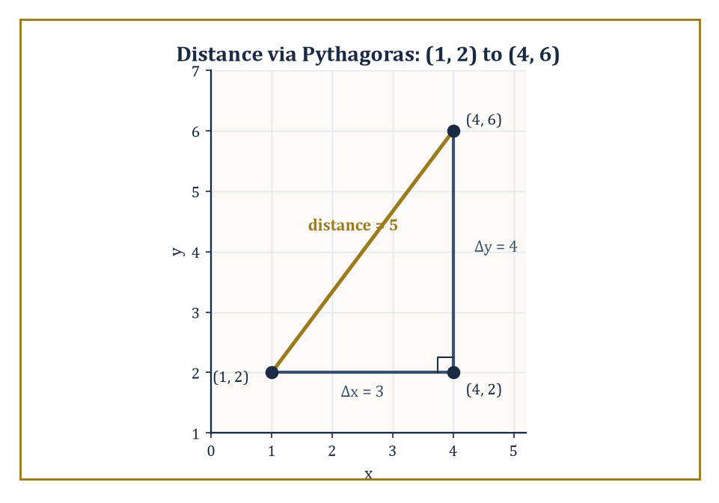
The distance formula, caught red-handed being nothing more than the Pythagorean theorem in a trench coat.
√[(x₂ − x₁)² + (y₂ − y₁)²]
This is nothing more exotic than the Pythagorean theorem applied to the right triangle formed by the two points and the corner point (x₂, y₁): the horizontal leg has length |x₂ − x₁|, the vertical leg has length |y₂ − y₁|, and the hypotenuse — the actual distance we want — is the square root of the sum of their squares. It is the bridge between the synthetic geometry of congruent triangles, which Storey 5 will explore properly, and the analytic geometry of equations we're building here.
Numeric example — Worked example — distance formula. Find the distance between (1, 2) and (4, 6). Compute the differences:
Δx = 4 − 1 = 3, Δy = 6 − 2 = 4
Then:
distance = √(3² + 4²) = √(9 + 16) = √25 = 5
This is the famous 3-4-5 right triangle showing up in coordinate clothing — a useful pattern to recognise on sight, since it saves you reaching for a calculator every time.
The midpoint of the segment joining the same two points is simply the average of their coordinates:
((x₁ + x₂)/2, (y₁ + y₂)/2)
This should feel obvious once stated — the midpoint's x-coordinate has to be exactly halfway between the two x-coordinates, and 'halfway between' is just what an average computes — but it's worth pausing on, because the section formula (dividing a segment in any given ratio, not just 1:1) and the centroid of a triangle both generalise this same idea: geometry, once coordinatised, keeps turning out to be arithmetic wearing a disguise.
Numeric example — Worked example — midpoint and centroid. The midpoint of the segment from (1, 2) to (4, 6) is:
((1+4)/2, (2+6)/2) = (2.5, 4)
Now take a triangle with vertices (0, 0), (6, 0), and (3, 9); its centroid is the average of all three vertices:
x̄ = (0 + 6 + 3)/3 = 3, ȳ = (0 + 0 + 9)/3 = 3
So the centroid sits at (3, 3) — inside the triangle, as a centroid always is, and exactly one-third of the way up from the base, which is the centroid's signature move.
Once you have the distance formula, whole categories of classical locus problems become routine bookkeeping rather than clever constructions. The set of points at a fixed distance r from a centre (h, k) is a circle, and its equation drops straight out of the distance formula, as we saw in Room 4.2. The set of points equidistant from two given points is the perpendicular bisector of the segment joining them — and again, the algebra will write the equation for you, no compass required.
Numeric example — Worked example — perpendicular bisector. Find the perpendicular bisector of the segment from (1, 2) to (4, 6). Its midpoint, from above, is (2.5, 4) — the bisector must pass through here. The segment's own slope is:
(6 − 2)/(4 − 1) = 4/3
So a line perpendicular to it has slope −3/4 — negative reciprocal, since perpendicular slopes always multiply to −1, and indeed:
(4/3) × (−3/4) = −1 ✓
The bisector is therefore:
y − 4 = −(3/4)(x − 2.5)
Any point on this line is, by construction, equally far from (1, 2) and from (4, 6) — you could verify this for a specific point using the distance formula twice, and the two answers would match to the last decimal.
There is, however, a cost hiding inside the tidiness of these formulas, and it is worth exposing before we move on. The distance formula in its clean Pythagorean form only works because the axes are orthogonal (at right angles) and use the same unit of length in both directions.
Tilt the axes — use what's called an oblique coordinate system — and the formula acquires an extra cross term, because the two 'legs' of the triangle are no longer perpendicular and the Pythagorean theorem no longer applies directly. The clean form we've been enjoying is a consequence of Descartes's particular choice, an excellent choice for almost every purpose, but not one forced on us by logic alone.
Numeric example — Worked example — what oblique axes cost you. Suppose a point P has coordinates (p, q) = (3, 4) in a system whose two axis directions are unit vectors e₁ and e₂ meeting at an angle ω = 60° (rather than the usual 90°). The squared distance from the origin to P is no longer simply p² + q²; it picks up a cross term from the dot product e₁·e₂ = cos ω:
|P|² = p² + q² + 2pq cos ω
Plugging in:
|P|² = 3² + 4² + 2(3)(4) cos 60° = 9 + 16 + 24(0.5) = 25 + 12 = 37, so |P| = √37 ≈ 6.08
Compare this to what the same numbers would give in an ordinary orthogonal system (ω = 90°, cos ω = 0):
|P|² = 9 + 16 + 0 = 25, so |P| = 5
Same labels, different geometry, different answer — a difference of over a unit, purely from tilting the axes by 30°. This is the extra coefficient the source material warned you about, caught in the act.

Room 4.4: Polar Coordinates: When Direction Matters More Than Axes
Or: how to stop measuring circles as though they were boxes
Some geometric situations simply are not rectangular in spirit. A lighthouse beam, a radar screen, a planet orbiting under a central force, a spiral staircase — all of these care far more about distance from a centre and angle from some reference direction than about how far east and how far north you've gone. For these, polar coordinates are the native language, and trying to describe them in Cartesian coordinates is a bit like describing a clock face using only 'inches from the top-left corner of the wall'. Technically possible; needlessly cruel.
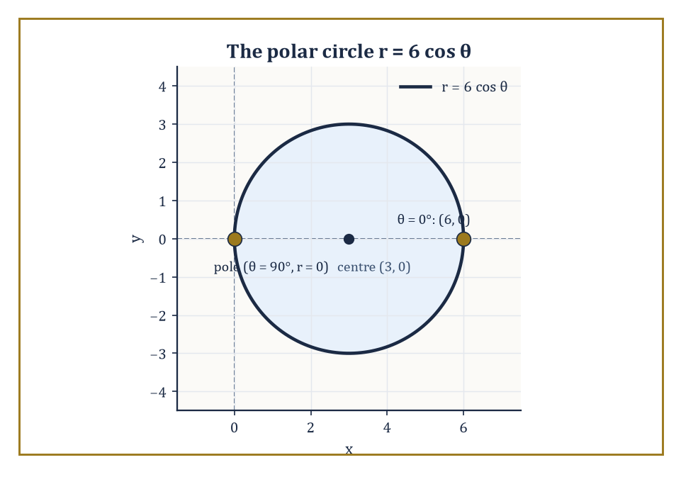
One clean instruction, r = 6 cos θ, tracing out a perfectly ordinary circle of radius 3 centred at (3, 0).
We fix a pole (the origin) and a polar axis (conventionally the positive Cartesian x-axis, so the two systems can talk to each other). Every point other than the pole is then labelled by a pair (r, θ), where r ≥ 0 is the distance from the pole, and θ is the directed angle, measured anticlockwise, from the polar axis to the ray joining the pole to the point. The pole itself gets r = 0 with θ left conveniently, if slightly evasively, unspecified.
Numeric example — Worked example — plotting from polar to Cartesian. A point has polar coordinates (r, θ) = (5, 60°). Converting to Cartesian:
x = r cos θ = 5 cos 60° = 5(0.5) = 2.5
y = r sin θ = 5 sin 60° = 5(√3/2) ≈ 5(0.866) ≈ 4.33
So the point is roughly (2.5, 4.33) in Cartesian terms — a single clean instruction, 'go 5 out at 60°', has expanded into two slightly less clean numbers. That trade-off, compact radial description versus messier rectangular one, is the entire personality of polar coordinates in one example.
The conversion formulas run in both directions using ordinary trigonometry. Polar-to-Cartesian:
x = r cos θ, y = r sin θ
And the reverse:
r = √(x² + y²), θ = atan2(y, x)
That atan2 function — a variant of arctangent that looks at both the sign of x and the sign of y to work out which quadrant θ belongs in — deserves respect rather than suspicion; ordinary arctan alone cannot tell (1, 1) from (−1, −1), since both give y/x = 1, yet the two points are in opposite quadrants and 180° apart.
atan2 fixes this by consulting the signs directly, at the minor cost of some fussy bookkeeping near the negative x-axis, where the angle has to jump discontinuously from just under 180° to just over −180°.
Numeric example — Worked example — Cartesian to polar. Convert (3, 4) to polar coordinates. First:
r = √(x² + y²) = √(3² + 4²) = √(9 + 16) = √25 = 5
Then:
θ = atan2(4, 3) = arctan(4/3) ≈ 53.13°
This lands correctly in Quadrant I, where both coordinates started out positive. So (3, 4) in Cartesian is (5, 53.13°) in polar — the same 3-4-5 triangle from Room 4.3, now read off as a radius and a bearing instead of two perpendicular legs.
Polar coordinates are not quite a genuine bijection, and it's worth being honest about the ways they misbehave, since pretending otherwise causes exactly the kind of silent error that ruins an otherwise correct calculation. The same point can be written using θ or θ + 360° (or θ + any whole number of full turns) — going all the way round and stopping brings you back to where you started, which the labelling system dutifully records as a different-looking but geometrically identical address.
And the pole itself, as noted, accepts any θ whatsoever at r = 0. In practice we adopt a convention — say r ≥ 0 and θ restricted to (−180°, 180°] — and move on, the way one adopts a convention about which side of the road to drive on: arbitrary, but essential for avoiding collisions.
Abstract example — Abstract example — the same point, different labels. The point with polar coordinates (5, 60°) is exactly the same point as (5, 420°), because:
420° − 360° = 60°
One full extra lap around the pole changes nothing about where you end up. Likewise, the pole itself can be written as (0, 0°), (0, 180°), (0, 73°), or (0, θ) for literally any θ you care to name — every one of these pairs describes the identical single point, the origin, because when r = 0 the 'direction' instruction has nothing left to point to.
A coordinate system that assigns infinitely many labels to one point has, strictly, failed the injectivity test from Room 4.1 — but it fails it in such a mild, well-understood, and easily-fenced-off way that we tolerate it happily, the way we tolerate the fact that 'twelve o'clock' means the same instant whether you call it noon or midday.
The real payoff of polar coordinates is that curves which look baroque in Cartesian form can become almost embarrassingly simple in polar. The circle:
r = 2a cos θ
passes through the origin, and the cardioid:
r = a(1 + cos θ)
traces a heart shape. Archimedean spirals, roses, and limaçons all have clean one-line polar equations that would require ungainly, multi-term Cartesian equivalents. The price paid for this elegance is that operations which are trivial in Cartesian coordinates — adding two vectors, say, by just adding their components — become considerably messier once everything is expressed as a radius and an angle.
Numeric example — Worked example — the polar circle r = 2a cos θ. Take a = 3, so:
r = 6 cos θ
At θ = 0°:
r = 6 cos 0° = 6
giving the Cartesian point (6, 0). At θ = 90°:
r = 6 cos 90° = 0
the curve passes through the pole itself. To see this really is a circle, multiply both sides by r:
r² = 6r cos θ
Since r² = x² + y² and r cos θ = x, this becomes:
x² + y² = 6x, or x² − 6x + y² = 0
and completing the square gives:
(x − 3)² + y² = 9
a circle of radius 3 centred at (3, 0). Check the two points we already found:
(6, 0): (6−3)² + 0² = 9 ✓
(0, 0): (0−3)² + 0² = 9 ✓
Both lie exactly on this circle, precisely as the polar equation promised.
Polar coordinates also do useful preparatory work for the more elaborate systems awaiting us in three dimensions. Once you're comfortable thinking in terms of 'a radius and an angle', cylindrical and spherical coordinates will feel like natural extensions of a habit you've already formed, rather than unfamiliar new inventions dropped on you without warning.

Room 4.5: Three Dimensions: Cartesian, Cylindrical, and Spherical
Pick your axis of sympathy and the algebra does the rest
In three-dimensional space a point needs three numbers, and the Cartesian system handles this with the minimum possible fuss: simply add a z-axis, perpendicular to both existing axes, and every point becomes (x, y, z). Distance is the obvious extension of the Pythagorean theorem — one more squared term under the square root.
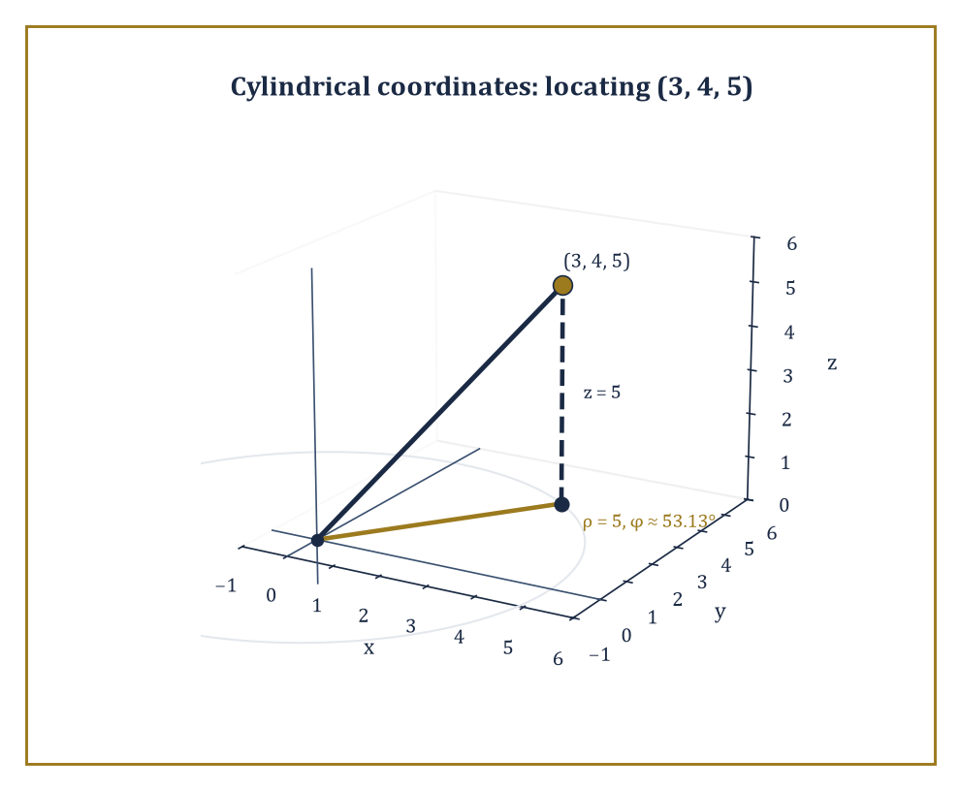
The point (3, 4, 5), located two ways at once: straight up the r-line from the origin, or out ρ = 5 and then up z = 5.
Planes become linear equations; spheres become quadratic ones. The algebra scales up without any real conceptual novelty, which is precisely why Cartesian coordinates make such a reliable default whenever nothing about the problem prefers a particular direction or a particular centre.
Numeric example — Worked example — distance in three dimensions. Find the distance between (1, 2, 3) and (4, 6, 15). Compute the differences:
Δx = 4 − 1 = 3, Δy = 6 − 2 = 4, Δz = 15 − 3 = 12
Then:
distance = √(3² + 4² + 12²) = √(9 + 16 + 144) = √169 = 13
This is a genuine Pythagorean quadruple (3, 4, 12, 13) — three mutually perpendicular displacements combining into a single clean hypotenuse, exactly as the theorem promises, now one dimension richer than Room 4.3's version.
When the geometry in question has an axis of rotational symmetry — a pipe, a drill bit, a tornado — cylindrical coordinates are usually the better tool. We keep the Cartesian z unchanged and replace the (x, y) pair by polar coordinates (ρ, φ) in the horizontal plane, giving a point as (ρ, φ, z). Cylinders centred on the z-axis collapse to the beautifully simple equation:
ρ = constant
Helices — the shape of a spiral staircase or a strand of DNA — become linear relationships between φ and z. And the volume element in this system acquires a factor of ρ, the very first hint that changing variables inside a multiple integral will eventually demand something called a Jacobian, a topic waiting patiently for you several storeys up.
Numeric example — Worked example — Cartesian to cylindrical. Convert (3, 4, 5) to cylindrical coordinates. The horizontal part is exactly the polar conversion from Room 4.4:
ρ = √(x² + y²) = √(9 + 16) = √25 = 5
φ = atan2(4, 3) ≈ 53.13°
The vertical coordinate simply carries over unchanged:
z = 5
So (3, 4, 5) in Cartesian becomes (5, 53.13°, 5) in cylindrical — notice how the z-coordinate, being untouched by the whole transformation, is the one piece of bookkeeping cylindrical coordinates save you from redoing.
When the geometry is instead centred at a single point — a planet's gravity, a light bulb's radiation, the Earth's own shape — spherical coordinates are the natural fit. A point is written (r, θ, φ), where r is the distance from the origin, θ is the polar angle measured down from the positive z-axis, and φ is the azimuthal angle in the xy-plane (the same φ as in cylindrical coordinates, conveniently).
Spheres centred at the origin collapse to:
r = constant
The surface of the Earth is, to a very good approximation, a single coordinate surface in this system. The volume element here acquires a factor of r² sin θ — a second Jacobian, filed away for later use.
Numeric example — Worked example — Cartesian to spherical. Convert (1, 1, √2) to spherical coordinates. First:
r = √(x² + y² + z²) = √(1 + 1 + 2) = √4 = 2
Next:
θ = arccos(z/r) = arccos(√2/2)
Since cos 45° = √2/2 exactly, θ = 45°. Finally:
φ = atan2(y, x) = atan2(1, 1) = 45°
Both coordinates equal and positive, so the point sits on the 45° ray in the xy-plane. The spherical coordinates are therefore (2, 45°, 45°) — and as a sanity check, converting back:
x = r sin θ cos φ = 2 sin45° cos45° = 2(0.7071)(0.7071) ≈ 1.0 ✓
matching where we started.
Every system has a region where it becomes singular — where the labelling breaks down in exactly the injectivity-failure sense of Room 4.1. Cartesian coordinates have no singularities at all, which sounds like a clear advantage until you notice the cost: they treat every direction identically, which is wasteful whenever the problem itself has an obvious preferred direction or centre that Cartesian coordinates simply cannot exploit.
Cylindrical coordinates misbehave precisely on the z-axis. Spherical coordinates misbehave at the origin and all along the polar axis. The art of using these systems well is choosing the one whose singularities lie safely outside the region you actually care about — or being willing to switch systems the moment you cross into a singular locus.
Abstract example — Abstract example — the singular z-axis. Take any point sitting directly on the z-axis, say (0, 0, 7) in Cartesian coordinates. Converting to cylindrical:
ρ = √(0² + 0²) = 0
and φ = atan2(0, 0), which is undefined, since there is no well-defined angle 'from the origin to the origin' in the horizontal plane.
In practice φ can be assigned any value at all for this point without changing which physical point it describes; the map from cylindrical coordinates to points is not injective along ρ = 0. This is the exact three-dimensional cousin of the North Pole's longitude problem from Room 4.1 — a single point absorbing an entire continuum of otherwise-distinct labels, precisely because the axis of symmetry the coordinate system was built around passes straight through it.
Between them, these three systems — Cartesian, cylindrical, spherical — cover the overwhelming majority of problems that arise in classical physics and in elementary multivariable calculus. More exotic systems certainly exist — parabolic coordinates, ellipsoidal coordinates, toroidal coordinates, each solving some particular symmetry beautifully — but they are specialised tools for specialised jobs, not the everyday language the way these three are.

Room 4.6: Changing Coordinates: Translation, Rotation, and Scaling
The same geometry, wearing a more convenient coat
A change of coordinates is a systematic relabelling of the same underlying points — nothing about the geometry moves, only the numbers we use to describe it. The simplest changes are the rigid motions and the uniform scalings, and we'll take them in order of increasing mischief. Translation shifts the origin to a new point (h, k); the new coordinates (x′, y′) relate to the old ones by:
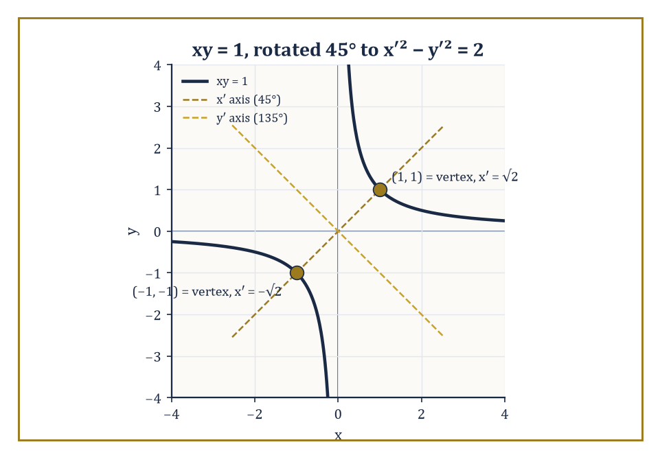
Rotate the axes 45° and the hyperbola xy = 1 sheds its cross term, turning into the standard-form x′² − y′² = 2.
x = x′ + h, y = y′ + k
Equations transform by simple substitution, and a circle centred at (h, k) in the old system becomes a circle centred at the new origin — which is usually the entire point of bothering to translate in the first place.
Numeric example — Worked example — translating away the mess. Consider the circle:
x² + y² − 6x + 4y + 9 = 0
Complete the square in x and in y separately:
(x² − 6x + 9) + (y² + 4y + 4) = −9 + 9 + 4, giving (x − 3)² + (y + 2)² = 4
So this is a circle of radius 2 centred at (3, −2). Now translate the origin to (3, −2), setting:
x′ = x − 3, y′ = y + 2
Substituting turns the equation into simply:
x′² + y′² = 4
The cross terms and the linear terms have vanished entirely, because we moved the origin to sit exactly where the circle's own centre was. The geometry never changed; the description got dramatically shorter.
Rotation turns the axes by an angle α about the origin, and the transformation formulas — which follow directly from the trigonometric addition formulas — are:
x = x′ cos α − y′ sin α, y = x′ sin α + y′ cos α
This is the first genuinely new idea in this room, and it repays close attention: rotation is where the addition formulas for sine and cosine stop being analytic curiosities you memorised for an exam and become geometric necessities, forced on you by the shape of space itself.
It is also the first place where matrices start to feel like the right notation, since the coefficients here form what's called an orthogonal matrix — one whose rows (and columns) are unit vectors at right angles to each other — with determinant exactly 1.
Numeric example — Worked example — rotating away a cross term. The curve xy = 1 is a perfectly respectable hyperbola, but its axes run diagonally rather than along the coordinate directions, which is why its equation has that awkward xy cross term instead of the clean x²/a² − y²/b² = 1 form you'd expect from a hyperbola. Rotate the axes by α = 45°. Using:
x = x′ cos45° − y′ sin45° = (x′ − y′)/√2
y = x′ sin45° + y′ cos45° = (x′ + y′)/√2
substitute into xy = 1:
[(x′ − y′)/√2] × [(x′ + y′)/√2] = (x′² − y′²)/2 = 1, so x′² − y′² = 2
In the rotated frame the hyperbola sits in exactly the standard form we expected, with its axes now aligned to the (rotated) coordinate axes. Nothing about the curve changed — only the vantage point did, and from the right vantage point the messy cross term simply evaporates.
Scaling stretches or shrinks the units on the axes, and here the two flavours behave very differently. Isotropic scaling — the same factor applied in every direction — preserves shape exactly, up to overall size; a circle stays a circle, just bigger or smaller.
Anisotropic scaling — different factors in different directions — is a rougher tool: it turns circles into ellipses, changes angles, and quietly abandons the Euclidean geometry you were relying on in the new coordinates. Anisotropic scaling is genuinely useful, most famously for turning an awkward ellipse into a friendly unit circle, but it is dangerous the moment you forget you've left the isometric world and start trusting distances or angles measured in the new, distorted coordinates.
Numeric example — Worked example — scaling a circle into an ellipse. Start with the unit circle:
x² + y² = 1
Apply the anisotropic scaling x = X/2 (stretching the x-direction by a factor of 2, so new coordinate X is twice the old x). Substituting:
(X/2)² + y² = 1, i.e. X²/4 + y² = 1
This is an ellipse with semi-axis 2 along the X-direction and semi-axis 1 along y — the circle has been stretched into an oval purely by rescaling one axis. Crucially, a right angle measured in (X, y)-coordinates is not necessarily a right angle in the original geometry any more; the scaling has quietly broken the assumption that let us use the plain Pythagorean distance formula at all.
General linear changes of coordinates are given by any invertible 2 × 2 matrix, of which rotation and anisotropic scaling are both special cases. Affine changes add a translation on top. Projective changes, which we meet properly in the next room, are more general still. Each step up this ladder of generality preserves fewer geometric properties — distances first, then angles, then straightness of lines, then eventually only incidence survives — while unlocking correspondingly more algebraic flexibility.
The practical rule, and it is worth committing to memory before Room 4.8 puts it to work, is disarmingly simple: change coordinates so that the object you actually care about sits in the simplest possible position — centred at the origin, aligned with the axes, free of unnecessary cross terms — do the algebra there, and translate the answer back afterwards if you need to.

Room 4.7: Homogeneous Coordinates and Points at Infinity
Giving infinity a proper postal address
Ordinary Cartesian coordinates have one conspicuous blind spot: they cannot describe points at infinity. Two parallel lines simply do not meet, in Cartesian terms, and there is no coordinate pair available to represent where they 'would' meet if you could only follow them far enough. Homogeneous coordinates solve this by the classic mathematician's trick of adding one more dimension than seems strictly necessary, purely as bookkeeping, and watching the bookkeeping pay for itself.
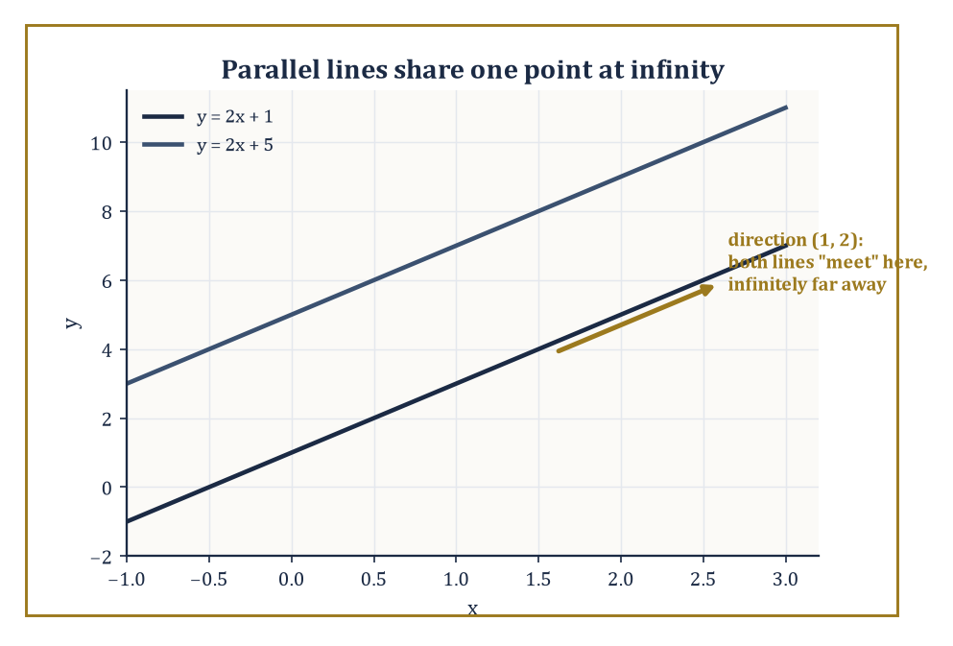
y = 2x + 1 and y = 2x + 5 never meet on the page, but homogeneous coordinates give them a rendezvous anyway, in the direction (1, 2).
In the plane, a point is now represented by a triple [X : Y : Z], not all zero, where two triples describe the same point exactly when one is a nonzero scalar multiple of the other — the colons are a deliberate reminder that only the ratios matter, not the individual values. When Z ≠ 0 we recover ordinary Cartesian coordinates by:
x = X/Z, y = Y/Z
When Z = 0, the triple represents a point 'at infinity', in the direction given by (X, Y) — a perfectly legitimate citizen of this larger space, even though it has no Cartesian address at all.
Numeric example — Worked example — the scaling ambiguity. The Cartesian point (2, 3) is represented by the homogeneous triple [2 : 3 : 1]. It is equally well represented by [4 : 6 : 2], since:
(4, 6, 2) = 2 × (2, 3, 1)
a nonzero scalar multiple of the first triple, hence the 'same point' by the defining rule. Recovering Cartesian coordinates from the second triple:
x = X/Z = 4/2 = 2, y = Y/Z = 6/2 = 3
exactly where we started. Infinitely many triples describe this one point, all differing only by an overall scale factor, which is precisely the price of admission the source material warned about: homogeneous coordinates are defined only up to scaling.
In homogeneous coordinates the equation of a line becomes beautifully linear:
aX + bY + cZ = 0
Two lines' intersection point is given by the cross product of their coefficient vectors:
(a₁, b₁, c₁) × (a₂, b₂, c₂)
a fact borrowed straight from vector algebra, since a line's coefficients and a point's coordinates now live in the same three-number format and can be combined with the same tools. Lines that are parallel in the ordinary Euclidean sense turn out to intersect at a point with Z = 0 — a point at infinity, in exactly the direction both lines were heading. The whole projective plane, infinity included, is covered by a single, uniformly polynomial piece of algebra, with no special cases needed for the parallel situation.
Numeric example — Worked example — where parallel lines meet. Take the two parallel lines y = 2x + 1 and y = 2x + 5 (same slope, different intercepts — they never meet in the Cartesian plane). Rewritten as 2x − y + 1 = 0 and 2x − y + 5 = 0, their homogeneous forms — substitute x = X/Z, y = Y/Z, then clear the Z denominator — are:
2X − Y + Z = 0 and 2X − Y + 5Z = 0
with coefficient vectors (2, −1, 1) and (2, −1, 5). Their cross product:
i-component = (−1)(5) − (1)(−1) = −5 + 1 = −4
j-component = −[(2)(5) − (1)(2)] = −[10 − 2] = −8
k-component = (2)(−1) − (−1)(2) = −2 + 2 = 0
So the cross product is (−4, −8, 0), which — dividing through by −4 to tidy it up — represents the same point as (1, 2, 0). Since Z = 0, this confirms the intersection is a point at infinity, and its direction (1, 2) has slope:
2/1 = 2
exactly the common slope of both original lines. The algebra has correctly worked out that two lines heading in the same direction 'meet' precisely in that direction, infinitely far away, and produced a checkable, self-consistent answer while doing it.
Homogeneous coordinates are the native language of projective geometry, but they earn their keep well outside pure mathematics too: computer graphics represents every point as a 4-vector (x, y, z, w), because a single 4×4 matrix can then encode translation, rotation, scaling, and perspective projection all at once, and — crucially — these transformations can be composed just by multiplying matrices together.
The extra coordinate is not a physical fourth dimension; it is a bookkeeping device that makes the algebra close under exactly the operations a graphics pipeline needs, translation included, which ordinary linear (matrix-only, no extra coordinate) transformations cannot manage.
Abstract example — Abstract example — translation as matrix multiplication. Ordinary linear transformations (plain 2×2 matrices acting on (x, y)) can rotate and scale, but they cannot translate — a matrix always sends the origin to the origin, so shifting the origin elsewhere is structurally impossible for a 2×2 matrix alone. Homogeneous coordinates fix this. To translate the point (2, 3) by (5, −1), write it as [2, 3, 1]ᵀ and multiply by the matrix M = [[1, 0, 5], [0, 1, −1], [0, 0, 1]]:
M·[2, 3, 1]ᵀ = [1(2) + 0(3) + 5(1), 0(2) + 1(3) + (−1)(1), 0(2) + 0(3) + 1(1)]ᵀ = [7, 2, 1]ᵀ
Reading off Cartesian coordinates: (7, 2) — exactly what plain addition (2+5, 3−1) would have given directly.
The homogeneous version has done nothing new arithmetically, but it has expressed 'translate' as 'multiply by a matrix', the same operation used for rotating and scaling, which means a whole sequence of translations, rotations, and scalings can now be pre-multiplied into a single combined matrix — the entire reason graphics engines bother with this extra coordinate at all.
The price, as noted, is that homogeneous coordinates are only defined up to an overall scale, so numerical algorithms working with them must be scrupulous about normalisation — divide back down by Z at the right moment, or accumulate error that quietly corrupts everything downstream. The gain is that points at infinity become perfectly ordinary points, parallel lines stop being a special case requiring separate handling, and a great many awkward exceptions in classical geometry simply dissolve.

Room 4.8: Why the Choice of Coordinates Matters
A theorem doesn't care where the origin sits; your afternoon does
A theorem is independent of coordinates; a calculation is not. That gap between the two is the entire practical content of this room, and arguably the entire practical content of the storey. The theorem 'three non-collinear points determine a unique circle' is true regardless of where you happen to have put your origin. Whether proving it takes you three lines or thirty depends enormously on where you put your origin.
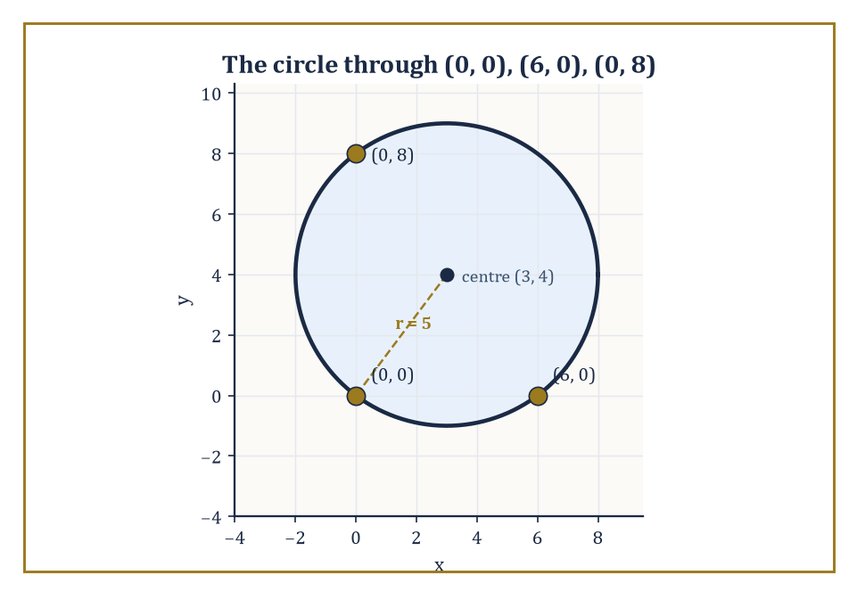
Put one vertex at the origin and the circle through (0,0), (6,0), (0,8) all but writes its own equation: centre (3, 4), radius 5.
Numeric example — Worked example — the circle through three points, done the smart way. Find the circle through (0, 0), (6, 0), and (0, 8). Use the general circle equation:
x² + y² + Dx + Ey + F = 0
and substitute each point. At (0, 0):
0 + 0 + 0 + 0 + F = 0, so F = 0
one unknown gone for free, purely because we were sensible enough to have a point sitting at the origin. At (6, 0):
36 + 0 + 6D + 0 + 0 = 0 → 6D = −36 → D = −6
At (0, 8):
0 + 64 + 0 + 8E + 0 = 0 → 8E = −64 → E = −8
The equation is:
x² + y² − 6x − 8y = 0
Completing the square:
(x − 3)² − 9 + (y − 4)² − 16 = 0 → (x − 3)² + (y − 4)² = 25
a circle centred at (3, 4) with radius 5. Check all three original points:
(0,0): (0−3)²+(0−4)² = 9+16 = 25 ✓
(6,0): (6−3)²+(0−4)² = 9+16 = 25 ✓
(0,8): (0−3)²+(8−4)² = 9+16 = 25 ✓
All three check out perfectly. Notice how much shorter this was than the general three-point circle calculation would be with none of the points conveniently at the origin — the F = 0 shortcut alone saved an entire round of simultaneous equations.
Now suppose you are studying a central force problem — a planet orbiting a sun, an electron circling a nucleus in the old Bohr picture. In Cartesian coordinates, Newton's second law gives you two coupled differential equations in x(t) and y(t), tangled together through a force that depends on √(x² + y²) sitting awkwardly inside both equations at once.
Switch to polar coordinates, with the force centre at the pole, and the radial and angular parts separate cleanly: the angular equation reduces almost immediately to the statement that:
r²(dθ/dt) = constant
Angular momentum is conserved, while the radial equation handles the actual falling-in or flying-out motion on its own. The physics has not changed even slightly; the coordinates simply chose to display the conservation law that Cartesian coordinates had been hiding in a tangle of cross terms.
Abstract example — Abstract example — angular momentum made visible. In polar coordinates, a particle moving under any force directed straight at (or away from) the origin obeys:
d(r²θ̇)/dt = 0, meaning r²θ̇ is constant over time
This is Kepler's Second Law in disguise, the statement that a planet sweeps out equal areas in equal times, and it drops out of the equations of motion almost as a side remark once you're working in polar coordinates, because the angular equation in this system has no radial force term left in it to complicate matters.
Attempt the identical calculation in Cartesian coordinates and you get two simultaneous second-order equations for x(t) and y(t), each one containing a factor of 1/(x² + y²)^(3/2) coupling it inextricably to the other — the conservation law is still true, buried in there somewhere, but extracting it requires first noticing you should compute x(dy/dt) − y(dx/dt) and show its derivative vanishes, a step polar coordinates hand you automatically and Cartesian coordinates make you invent.
Or suppose you are integrating over a spherical region — computing, say, the volume enclosed by a sphere. In Cartesian coordinates the limits of integration are three nested, mutually dependent square-root expressions, unpleasant to set up and easy to get wrong. In spherical coordinates the same region becomes a plain rectangular box in (r, θ, φ)-space — r from 0 to R, θ from 0 to π, φ from 0 to 2π — and the integral becomes entirely routine, provided you remember to include the Jacobian factor r² sin θ that Room 4.5 flagged and promised we'd use.
Numeric example — Worked example — the volume of a sphere, the easy way. Compute the volume of a sphere of radius R using spherical coordinates:
V = ∫₀^{2π} ∫₀^{π} ∫₀^{R} r² sin θ dr dθ dφ
The three integrals separate completely because none of the limits depend on the other variables. First:
∫₀^R r² dr = R³/3
Second:
∫₀^π sin θ dθ = [−cos θ]₀^π = −cos π − (−cos 0) = −(−1) − (−1) = 1 + 1 = 2
Third:
∫₀^{2π} dφ = 2π
Multiplying:
V = 2π × 2 × R³/3 = 4πR³/3
the standard formula, recovered in three lines instead of a page of Cartesian square roots. As a numeric check, take R = 3:
V = 4π(27)/3 = 4π(9) = 36π ≈ 113.1 cubic units
exactly what the formula predicts, and considerably less painful to arrive at than the Cartesian route would have been.
Bad coordinates hide symmetry; good coordinates display it. The skill of choosing coordinates well is therefore a form of pattern recognition — look at the object in front of you, identify its symmetries or its natural centre, and align your coordinate system with those features before you write down a single equation. Once that alignment is right, the rest of the calculation tends to be mechanical, almost boring, which is exactly the compliment a well-chosen coordinate system deserves.
It's also, incidentally, why computer algebra systems still need a human sitting in front of them: the machine can manipulate whatever coordinates you hand it flawlessly and tirelessly, but it has no opinion, and cannot yet form one, about which coordinates will turn a nightmare problem into an afternoon's work.

Room 4.9: Looking Ahead: From Coordinates to Geometry and Beyond
Folding the map away, now that we can read it
We have now acquired the basic vocabulary of coordinate systems: Cartesian in two and three dimensions, polar, cylindrical, spherical, the elementary changes of coordinates that relabel one system into another, and a first look at homogeneous coordinates and the well-mannered infinities they make possible. It's worth pausing at the top of this particular flight of stairs to take stock, because everything below us in this room is infrastructure rather than new content — a chance to see the whole apparatus working together before we climb on.
Numeric example — Worked example — one point, four addresses. Take the point with Cartesian coordinates (1, √3, 2), and find its address in every system this storey has covered. Cartesian: (1, √3, 2) — nothing to do. For cylindrical:
ρ = √(x² + y²) = √(1 + 3) = √4 = 2
φ = atan2(√3, 1) = 60° (since tan 60° = √3)
z = 2 (unchanged)
So cylindrical gives (2, 60°, 2). For spherical:
r = √(x² + y² + z²) = √(1 + 3 + 4) = √8 = 2√2 ≈ 2.83
θ = arccos(z/r) = arccos(2/(2√2)) = arccos(1/√2) = 45°
φ = 60° (as before)
So spherical gives (2√2, 45°, 60°). Cross-check between the two 3D systems:
r = √(ρ² + z²) = √(4 + 4) = √8 = 2√2 ✓
θ = arctan(ρ/z) = arctan(2/2) = arctan(1) = 45° ✓
Four different labels, three different alphabets, one unmoved point — which is, in miniature, the entire lesson of this storey.
These systems are now infrastructure, and they will be used from here on without further comment or apology in every subsequent storey that deals with space. The next storey, on Euclidean geometry proper, will use them to turn synthetic arguments about triangles and circles into calculations whenever a calculation is the fastest route to a proof.
Somewhere not too far above us, trigonometry will turn out to be, in large part, the systematic study of exactly the relationships that polar and spherical coordinates make visible almost by accident. Vector calculus, differential geometry, and partial differential equations, further up the Tower still, will all quietly assume you can move fluently between these systems and understand precisely why the volume elements carry those extra factors of ρ and r² sin θ.
The deeper lesson, the one worth carrying past this room's threshold even after the specific formulas have faded, is that the representation of a mathematical object is itself part of the mathematics. A change of coordinates is not a cosmetic operation performed for tidiness' sake; it is a change of language, and like any change of language it can reveal structure that the previous phrasing was concealing, or bury structure that the previous phrasing had on full display.
Learning to speak several geometric languages fluently, and to translate confidently between them, is one of the permanent skills this Tower is trying to build into you, storey by storey, and it will not be the last time a mere change of viewpoint does more work than any new theorem.
The next storey turns to Euclidean geometry proper — the synthetic theory of triangles, circles, and straightedge-and-compass constructions — now equipped with the analytic machinery we've just built, so that a synthetic argument and a coordinate calculation can be reached for interchangeably, whichever gets you home faster. Not long after that, trigonometry arrives to make systematic what polar and spherical coordinates have already shown you in passing: that angles and lengths are old friends who have simply never been properly introduced.
Coordinates are not the destination. They are the map — and, like any good map, their entire value lies in being consulted and then set aside once you know the way. We now know how to read this one.
Mind the step on the way up to Storey Five; the origin has a habit of being exactly where you least expect it.

Storey 5: Euclidean Geometry
Points, Lines, Triangles, and the Stubbornness of the Parallel Postulate
Storey 1 taught us to count. Storey 2 forced numbers into equations. Storey 3 turned equations into functions, and functions into graphs. Storey 4 gave those graphs a home, inventing coordinate systems so that every curve could be interrogated by algebra, cross-examined, and made to confess its equation. Now we step back and look at the space itself — the pure geometry that coordinates only label, the way a street address labels a house without explaining a single thing about its architecture.
Euclidean geometry is the study of points, lines, planes, angles, triangles, circles, and the relations that hold among them under the assumptions Euclid laid down around 300 BCE. His Elements remained the standard textbook for more than two thousand years. That is not a marketing claim; it is a historical fact that should make us slightly uneasy. Few human productions last that long without either being true or being protected by powerful institutions. Geometry, rather impressively, managed both.
This storey treats the subject with the same mixture of respect and mild irreverence we have used so far. We will prove the standard theorems when the proof is illuminating. We will admit when a construction feels more like a clever trick than a deep insight. We will meet the parallel postulate and the quiet crisis it eventually caused. We will watch the Pythagorean theorem appear both as a geometric fact and as the engine of the distance formula we already used one storey down, in coordinates. And we will keep one eye on the synthetic tradition — ruler and compass, congruent triangles, similar figures — while remembering that analytic methods are available whenever they make life easier, because there is no prize for suffering unnecessarily.
A small confession: geometry is the first place mathematics starts to feel physical. You can almost touch the objects. Triangles have weight. Circles have personality. Parallel lines carry a quiet existential threat, the way two colleagues who have never once agreed on anything can nonetheless walk down the same corridor forever without colliding. This is both a gift and a hazard. The gift is intuition. The hazard is the temptation to believe that intuition is enough. It is not. Space has rules, and — this is the part worth sitting with — those rules are not always the ones your eyes suggest. Let's see what space will allow.

Room 5.1: What Euclidean Geometry Actually Is
In which we idealize a dot until it disappears
Euclidean geometry begins with the simplest possible objects: a point that has position but no size, a line that has length but no thickness, a plane that has extent but no depth. These are idealizations so pure they almost feel like philosophical provocations — nobody has ever seen a point, in the same way nobody has ever seen the number seven, and yet both turn out to be indispensable.
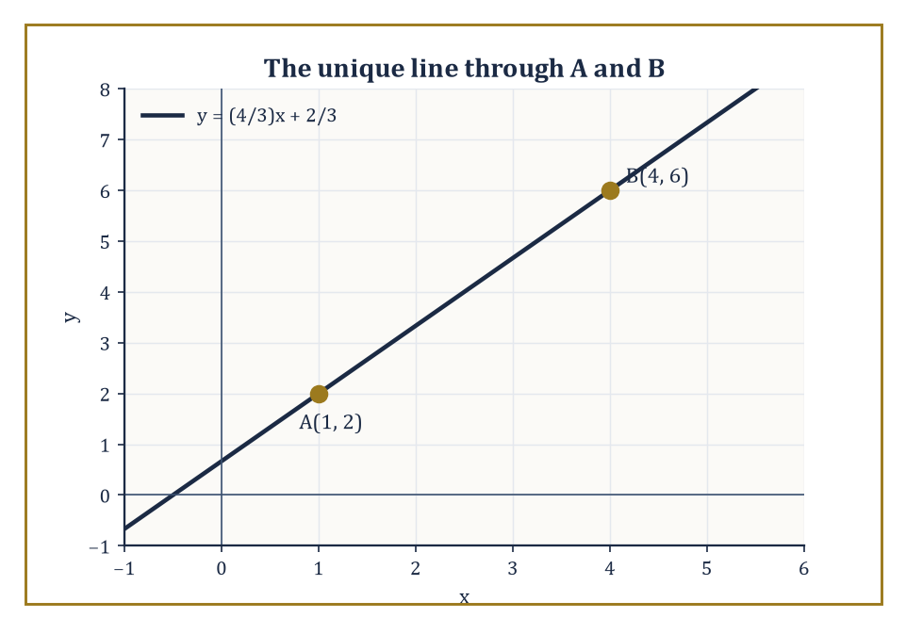
The line through A(1, 2) and B(4, 6) — two points, no committee vote required.
Yet from these three sketchy characters we build the entire theory of shape, size, and incidence. A point pins down a location and refuses to take up any room while doing it. A line is the most economical way to connect two locations and then, showing a certain lack of restraint, keeps going forever in both directions. A plane is what you get once you allow a line to sweep sideways without curving.
Numeric example — Two points, one line. Take two points A = (1, 2) and B = (4, 6) — coordinates borrowed straight from Storey 4, since geometry and algebra were never really strangers. Exactly one line passes through both. Its slope is:
(6 − 2) / (4 − 1) = 4/3
Using point A we get the equation:
y − 2 = (4/3)(x − 1)
which tidies up to:
y = (4/3)x + 2/3
Check it against B: at x = 4,
y = (4/3)(4) + 2/3 = 16/3 + 2/3 = 18/3 = 6
Correct. Notice what just happened: two points, and only two, were enough to pin the entire infinite line down. That is the whole content of 'a line is determined by two distinct points' — no more, no less, and certainly no committee vote required.
The classical foundation of all this is Euclid's Elements. It is not the oldest geometry — Babylonian and Egyptian surveyors were measuring fields and pyramids centuries earlier, with rope, sunlight, and a healthy fear of the tax collector — but it is the first sustained attempt to organize geometric knowledge into a deductive system.
Definitions, postulates, common notions, and then theorem after theorem, each resting on what came before, like a very long and unusually rigorous game of Jenga. That structure is still the model for how mathematics wants to present itself: start with what you are willing to assume, then deduce everything else with ruthless consistency. The Elements is also the place where the parallel postulate first appears as an explicit assumption rather than an unspoken habit of thought — which, as we'll see two rooms from now, turned out to be a very good thing to have written down.
Abstract example — A deductive chain in miniature. Euclid's fourth postulate asserts that all right angles are equal to one another. From this alone, plus the fact that a straight angle is exactly two right angles laid back to back, we can deduce that all straight angles are equal to one another too: if
right angle R₁ = right angle R₂
(postulate), then
2·R₁ = 2·R₂
(multiplying both sides by the same quantity is always legal), and 2·R₁ and 2·R₂ are precisely the measures of any two straight angles. No picture required — just one assumption, one algebraic step, and a theorem drops out the other end. This is the entire Euclidean method, scaled up: small trusted assumptions, chained by strict logic, into an enormous cathedral of results.
Geometry feels older than arithmetic because it is closer to the physical world. You can draw a triangle in the dirt. You cannot draw the number seven — you can only draw a symbol that we've all agreed to associate with the idea of seven-ness. The objects of geometry have an immediate presence that pure numbers lack.
This is both an advantage and a trap. The advantage is that geometric statements often feel obviously true. The trap is that 'obviously true' is not the same as 'provably true,' and the history of geometry is littered with statements that looked obvious until someone found a counterexample or unearthed a deeper hidden assumption.
Abstract example — The sophism of the isosceles triangle. Here is a classic cautionary tale, the geometric equivalent of a magician's sleight of hand. Take any triangle ABC. Draw the bisector of angle A and the perpendicular bisector of side BC; let them meet at a point P (they do meet, somewhere in the plane, unless the triangle is already isosceles). From P, drop perpendiculars to sides AB and AC, meeting them at points X and Y.
A short chain of congruent-triangle arguments then appears to show:
AX = AY and BX = CY
and therefore:
AB = AC
— supposedly proving every triangle is isosceles. The 'proof' is flawless on paper and false in reality. The flaw is entirely in the diagram: P always lies outside the triangle, and one of X, Y always lands on the extension of a side rather than on the side itself, silently flipping a plus sign into a minus sign at the very last step. Draw it accurately — not from memory, not from wishful thinking — and the fraud collapses instantly. The moral: a diagram is an aid to intuition, never a substitute for checking that every step is actually licensed.
The central activity of Euclidean geometry, then, is not calculation. It is the careful extraction of necessary consequences from a small set of assumptions about space. Those assumptions, as the sophism above hints and the parallel postulate will confirm in the next room, turn out to be stronger and stranger than they first appear.
We will work primarily in the synthetic style — points, lines, angles, congruent triangles, the tools Euclid actually had — while allowing coordinate methods whenever they clarify an argument. The two languages are complementary, not competing, and refusing to use whichever one is more convenient at the time is not rigor, it's stubbornness wearing rigor's coat.
Worked example — One fact, two proofs. Claim: the diagonals of a rectangle are equal in length. Synthetic proof: in rectangle ABCD, triangles ABD and BAC share side AB, have AD = BC (opposite sides of a rectangle), and both include a right angle at A and B respectively — so by SAS (Room 5.4 will explain why that's enough), triangle ABD ≅ triangle BAC, which forces diagonal BD = diagonal AC.
Coordinate proof: place the rectangle with vertices (0,0), (6,0), (6,4), (0,4). One diagonal runs from (0,0) to (6,4), length:
√(6² + 4²) = √(36+16) = √52 = 2√13 ≈ 7.211
The other runs from (6,0) to (0,4), length:
√((0−6)² + (4−0)²) = √(36+16) = √52
the same number. Two completely different toolkits, one identical answer — which is exactly the kind of agreement that should make you trust both toolkits a little more.

Room 5.2: Points, Lines, Planes, and the Parallel Postulate
The fifth postulate, or: the axiom that wouldn't behave
A point has position but no magnitude. A line is determined by any two distinct points and extends without end in both directions. A plane is determined by three non-collinear points — that is, three points not all sitting on one line, since three points on a line only ever specify that same line, not a sheet. These are the basic objects. Everything else in geometry — angle, triangle, circle, polygon — is built from them, the way every word in this storey is built from twenty-six letters that individually mean nothing at all.
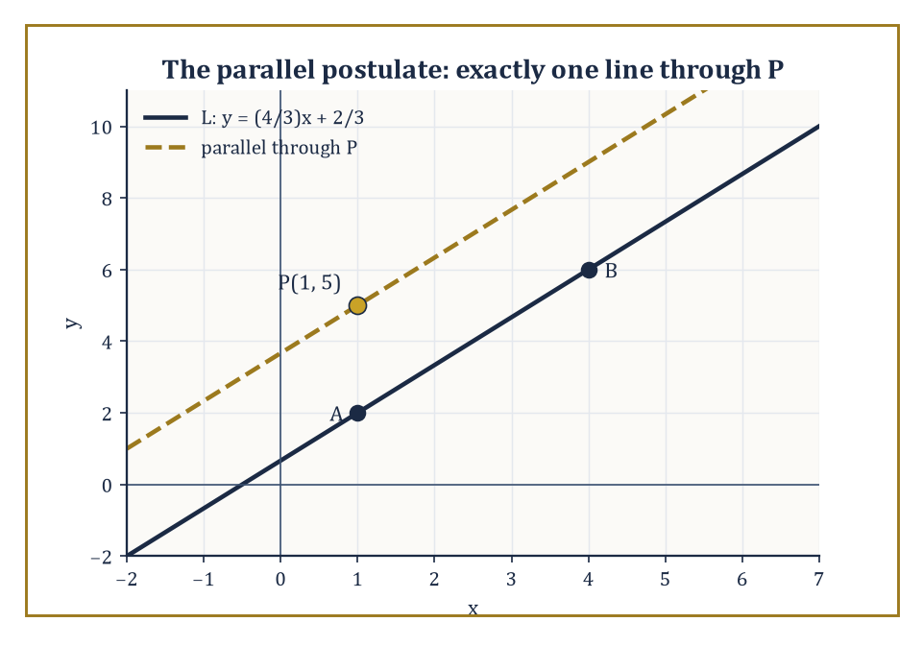
Line L and the one line through P that never meets it — exactly one, as promised.
Numeric example — Three points, one plane. Take the points (0, 0, 0), (2, 0, 0), and (0, 3, 0) in three-dimensional space. None lie on a common line — you cannot fit all three onto a single straight track. Together they pin down exactly one flat sheet: the plane
z = 0
since all three have a third coordinate of zero and no other plane manages to catch all three at once. Change any one point so it no longer has z = 0 — say, replace the third point with (0, 3, 1) — and you'd instead determine a tilted plane. Three non-collinear points really do nail the whole sheet down, no wobble allowed.
Euclid's postulates are admirably short, almost curt. You can draw a straight line between any two points. You can extend a line segment indefinitely. You can draw a circle with any center and any radius. All right angles are equal. And then the fifth one, which needs its own paragraph because it has never once behaved like the other four.
Numeric example — Postulate 3 in action. Postulate 3 says: given any center and any radius, you may draw the circle. Take center A = (0, 0) and let the radius be the distance to B = (3, 4), which is:
√(3² + 4²) = √(9+16) = √25 = 5
Postulate 3 licenses exactly the circle:
x² + y² = 25
— no more justification needed than 'here is a center, here is a radius, go.' It sounds trivial because it is meant to; the power of an axiom is that it asks for no defence.
The parallel postulate, in a modern formulation (Euclid's own wording is more cumbersome, involving angles summing to less than two right angles, but the content is identical), says: given a line and a point not on that line, there is exactly one line through the point that is parallel to the given line. Not zero, not several — exactly one. It sounds like the least controversial sentence ever written down. It is not.
Numeric example — Finding the one parallel. Recall the line L:
y = (4/3)x + 2/3
through A(1,2) and B(4,6) from the previous room. Take a point P = (1, 5), which is not on L (plug x = 1 into L's equation: y = 4/3 + 2/3 = 2, and 2 ≠ 5, so P is genuinely off the line). The parallel postulate guarantees exactly one line through P parallel to L — and since parallel lines share a slope, it must be:
y − 5 = (4/3)(x − 1)
which simplifies to:
y = (4/3)x + 11/3
Any other slope through P would eventually meet L somewhere far off in the plane; only slope 4/3 avoids a meeting forever.
For two thousand years mathematicians tried to prove the parallel postulate from the other four. They failed, repeatedly, magnificently, and in one case (Girolamo Saccheri, 1733) almost accidentally invented non-Euclidean geometry while trying to disprove it and then talked himself out of believing his own results — a fate one hopes never befalls anyone applying for tenure.
The failures produced a great deal of excellent geometry, but the postulate turned out to be genuinely independent of the other four. You can accept it and get Euclidean geometry. You can deny it in different ways and get perfectly consistent non-Euclidean geometries. Space does not force the parallel postulate on us the way it forces, say, the existence of a midpoint between two points. Flatness is a choice, not a necessity — one of the deepest lessons geometry teaches early, and one of the most quietly unsettling.
Abstract example — A world with no parallels at all. Consider a sphere, where 'lines' are reinterpreted as great circles — the largest circles you can draw on the surface, like the equator or any line of longitude. Take the equator as our 'line' and the north pole as our point not on it. Every great circle through the north pole is a line of longitude, and every single line of longitude crosses the equator (in fact, it crosses twice, at opposite points). There is no great circle through the north pole that avoids the equator forever. So on a sphere, the parallel postulate fails completely in the other direction: through the given point, there are zero lines parallel to the given line, not one. This is spherical geometry, and it is every bit as consistent as the flat kind — just built on a different foundational choice.
From the postulates we obtain the usual basic facts, and it is worth pausing on the word 'obtain': vertical angles are equal, alternate interior angles formed by a transversal with parallel lines are equal, corresponding angles are equal. Each of these is a theorem, not an assumption, and the difference matters enormously — an assumption is a promissory note; a theorem is a note that has actually been redeemed.
Numeric example — A transversal crossing parallel lines. Let two parallel lines be cut by a single transversal, and suppose the angle formed at the first intersection, measured on the upper-right, is 65°. Then the vertically opposite angle (lower-left, same intersection) is also 65°, since vertical angles are always equal. The angle adjacent to it along the transversal (upper-left or lower-right) is:
180° − 65° = 115°
since angles on a straight line sum to 180°. At the second intersection, the corresponding angle (same position, upper-right) is also 65° — that's the corresponding-angles theorem. The alternate interior angle (the one on the opposite side of the transversal, tucked between the two parallel lines) is likewise 65°. Altogether, of the eight angles created by the transversal, four measure 65° and four measure 115°, and once you know any one of them the other seven are free.
Lines either meet or they do not. When they do not meet and lie in the same plane, we call them parallel. Parallelism is an equivalence relation on lines — reflexive, symmetric, and (this is the property that feels obvious until you try to prove it carefully) transitive: if A is parallel to B and B is parallel to C, then A is parallel to C. The proof relies squarely on the parallel postulate; deny the postulate and transitivity of parallelism can misbehave in genuinely strange ways.
Numeric example — Transitivity, checked. Let
L₁: y = 2x + 1, L₂: y = 2x − 5, L₃: y = 2x + 100
All three share slope 2, so L₁ ∥ L₂ and L₂ ∥ L₃ by inspection. Transitivity predicts L₁ ∥ L₃ — and indeed, slope 2 again, so they never meet either. In the flat Euclidean plane this is barely worth remarking on; the interesting content is that this chaining property is not a free lunch handed out by the mere concept of 'never meeting' — it specifically requires the parallel postulate to guarantee it in general, a fact easy to take for granted precisely because, in the world we sketch on paper, it never seems to fail.

Room 5.3: Angles, Triangles, and the Sum of 180°
A number that only holds because the floor is flat
An angle is the figure formed by two rays that share a common endpoint, called the vertex. The measure of an angle is the amount of rotation needed to carry one ray onto the other. We take as known that a full rotation is 360 degrees, or equivalently 2π radians, and that a straight angle — two rays pointing in exactly opposite directions — is 180 degrees. Degrees are an arbitrary human convention (thank the Babylonians and their base-60 arithmetic); radians measure rotation in terms of arc length on a unit circle, and are the choice nature actually prefers, as we'll discover properly next storey.
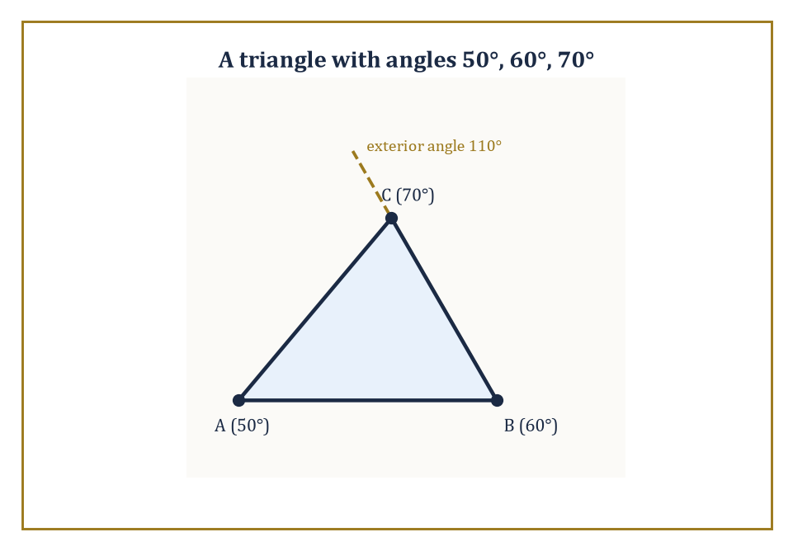
A 50°-60°-70° triangle, with its exterior angle at C shown equal to the sum of the two remote interior angles.
Numeric example — Degrees to radians. Convert 45° to radians using the conversion factor π/180° (since 180° = π radians exactly):
45° × (π / 180°) = 45π/180 = π/4 radians ≈ 0.7854 radians
Sanity check: 45° is one-eighth of a full 360° turn, and π/4 is indeed one-eighth of 2π (since 2π ÷ 8 = π/4). The units changed; the underlying rotation did not.
The triangle is the simplest polygon and the most important. Three points, three sides, three angles — nothing simpler could possibly enclose a region at all, since two points and two sides just make a (very thin) line segment traced twice. Everything else in plane geometry is, in some sense, built out of triangles: any polygon can be sliced into them, and once you can reason about a triangle, you can reason your way through the whole zoo of quadrilaterals, pentagons, and worse.
Numeric example — Triangulating a quadrilateral. Take any rectangle, whose four interior angles are each 90°, summing to 360°. Draw one diagonal, splitting it into two triangles. Each triangle, by the angle-sum theorem below, has interior angles totalling 180°. Two triangles:
2 × 180° = 360°
It matches exactly, which is no coincidence — it's the mechanism by which the angle-sum theorem for triangles determines the angle-sum for every polygon: an n-sided polygon splits into (n−2) triangles by drawing diagonals from one vertex, giving an angle sum of (n−2) × 180°. For a quadrilateral, n = 4, so:
(4−2) × 180° = 360°
confirmed.
A few basic facts about triangles appear quickly and are worth having on permanent standby. The sum of the interior angles of any triangle is 180 degrees. An exterior angle — formed by extending one side beyond a vertex — equals the sum of the two remote interior angles (the two angles not adjacent to it). The longest side is opposite the largest angle; the shortest side is opposite the smallest angle. These are useful. They are also, compared to what's coming, still relatively gentle.
Numeric example — Angle sum and exterior angle. Take a triangle with interior angles 50°, 60°, and 70°. Sum check:
50 + 60 + 70 = 180°
as required. Extend the side opposite the 70° angle to form an exterior angle at that vertex: it measures:
180° − 70° = 110°
The exterior angle theorem predicts this should equal the sum of the two remote interior angles:
50° + 60° = 110°
It matches. And in the classic 3–4–5 right triangle (sides 3, 4, 5, with 3² + 4² = 5² making the angle opposite the side of length 5 a right angle), the side of length 5 — the longest — sits opposite the 90° angle, which is necessarily the largest of the three angles, since the other two are acute and must together sum to only 90°.
The angle sum of 180° is a distinctly Euclidean fact. It depends on the parallel postulate, not on some universal law of triangle-ness. In hyperbolic geometry the angle sum is less than 180° and shrinks further as the triangle grows larger. In spherical geometry the angle sum is greater than 180° and grows with the triangle's area. The familiar 180° is therefore not a universal truth about triangles; it is a truth about triangles in flat space specifically, and space, as established two rooms ago, did not have to be flat.
Abstract example — A triangle with 270°. On a sphere, take the north pole N, and two points on the equator separated by 90° of longitude — call them P₀ (longitude 0°) and P₉₀ (longitude 90°). Connect N to P₀ and N to P₉₀ along lines of longitude, and connect P₀ to P₉₀ along the equator: a spherical triangle. Lines of longitude always meet the equator at right angles, so the angles at P₀ and at P₉₀ are each exactly 90°. The angle at the pole N, between the two longitude lines, is the longitude difference itself: 90°. Total angle sum:
90° + 90° + 90° = 270°
a full 90° over the flat-space value. This 'spherical excess' is not an error or a rounding artefact — it is directly proportional to the triangle's area, and it is the mathematical fingerprint of living on a curved surface rather than a flat one.
Once the angle sum is established as a fixed budget of 180°, many other results follow almost for free: the base angles of an isosceles triangle are equal (spend the 180° symmetrically), and the exterior angle is greater than either remote interior angle on its own (since it equals their sum, and both are positive). The triangle becomes a reliable machine for turning angle information into side information and back again — feed in what you know, and the rest is arithmetic, not further cleverness.
Numeric example — An isosceles triangle, fully solved. Suppose an isosceles triangle has apex angle 40°. The two base angles are equal and must share the remaining
180° − 40° = 140°
between them, so each base angle is 140° ÷ 2 = 70°. Check:
40 + 70 + 70 = 180°
Now extend one of the sides at a base vertex to form an exterior angle there: it measures 180° − 70° = 110°. By the exterior angle theorem this should equal the sum of the two remote interior angles:
40° + 70° = 110°
— confirmed — and it is indeed strictly greater than either remote angle taken alone (110° > 40° and 110° > 70°), exactly as the corollary promised.

Room 5.4: Congruence: When Two Figures Are the Same
Geometric equality, no stretching permitted
Two figures are congruent if one can be moved onto the other by a rigid motion — translation, rotation, or reflection — without stretching or shrinking. Congruence is the geometric version of equality. Same size, same shape, same everything that matters, and 'rigid motion' is really just the mathematician's polite way of saying 'you're allowed to slide it, spin it, or flip it, but you may not so much as breathe on it.'
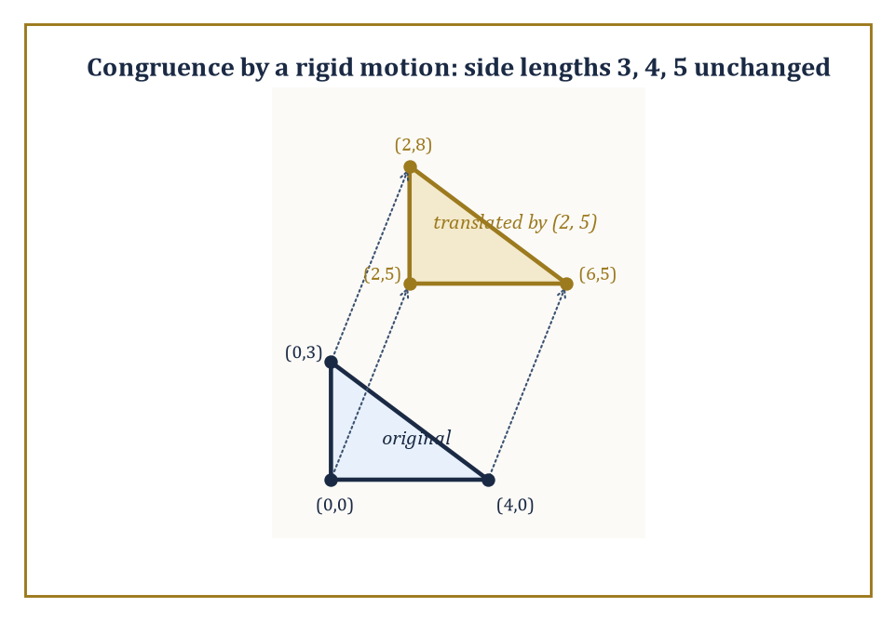
A 3-4-5 triangle, translated by (2, 5) — same size, same shape, merely relocated.
Numeric example — A rigid motion, tracked exactly. Take a triangle with vertices (0,0), (4,0), (0,3). Its sides have lengths 4 (bottom), 3 (left), and hypotenuse:
√(4² + 3²) = √25 = 5
a right triangle. Now translate every vertex by the vector (2, 5): (0,0) → (2,5), (4,0) → (6,5), (0,3) → (2,8). Recompute the sides of the new triangle: from (2,5) to (6,5) is 4; from (2,5) to (2,8) is 3; from (6,5) to (2,8) is:
√((6−2)² + (5−8)²) = √(16+9) = 5
Identical side lengths, identical shape, merely relocated — precisely what 'congruent by a rigid motion' means, made numerically undeniable.
For triangles there are efficient criteria that let you conclude full congruence from only partial information: SSS (three sides), SAS (two sides and the included angle), ASA (two angles and the included side), AAS (two angles and a non-included side), and the Hypotenuse-Leg criterion reserved for right triangles. Each is a theorem that squeezes an enormous amount of certainty out of a small handful of measurements. These criteria are the workhorses of Euclidean proof; most standard results about triangles, parallelograms, and circles lean on them at some point, often silently.
Numeric example — SAS pins down the whole triangle. Suppose two triangles each have one side of length 6, an adjacent side of length 8, and the angle between those two sides equal to exactly 90°. Because the included angle is a right angle, the third side is forced: by the Pythagorean relationship (a special case of the more general law of cosines, which we'll meet properly once trigonometry arrives), the third side is:
√(6² + 8²) = √(36+64) = √100 = 10
for both triangles, with no freedom left over. Two sides and the angle between them leave nothing to chance — which is exactly the content of SAS: fix those three measurements, and every other measurement in the triangle, including the third side and both remaining angles, is already determined, whether or not you bother to compute it.
The criteria are not arbitrary shortcuts; each corresponds to a genuinely different way of pinning a triangle down uniquely, up to congruence. SSS works because three lengths fix the triangle completely — provided the triangle inequality is satisfied, since three lengths that don't satisfy it don't describe a triangle at all, only a geometric impossibility dressed up as a list of numbers.
Numeric example — When SSS has nothing to work with. Try to build a triangle with sides 2, 3, and 7. The triangle inequality demands that any two sides sum to more than the third:
2 + 3 = 5 < 7
No such triangle exists — lay a segment of length 2 and one of length 3 end to end at any angle, and the gap between their free ends never reaches all the way to 7 unless they're stretched straight, at which point they've stopped being two sides of a triangle and become one straight line of length 5. Contrast with sides 5, 6, 7: the smallest check is
5 + 6 = 11 > 7
which passes comfortably, and a genuine triangle results. SSS congruence is only ever as good as this inequality allows it to be.
Congruence is an equivalence relation: it partitions the entire collection of all triangles into classes of 'essentially the same' object, the way a filing system sorts an infinite pile of documents into folders where everything inside a folder is, for practical purposes, interchangeable. Much of geometry consists of studying the properties that stay constant within a class — the invariants. Side lengths and angle measures are congruence invariants by definition. Area is also a congruence invariant, though we won't pin the definition of area down carefully until Room 5.8.
Numeric example — Area as an invariant. Take a triangle with base 8 and height 6; its area is:
(1/2) × 8 × 6 = 24
Reflect it across some line, then rotate it 137° for good measure, then slide it three miles to the left. The reflected-rotated-translated image still has base 8 and height 6 relative to its own new orientation, and its area is still (1/2) × 8 × 6 = 24 — unchanged by any amount of rigid motion, because area, like side length and angle measure, is exactly the sort of quantity that a congruence class agrees to hold in common. It is precisely the quantities that do change under rigid motion — position and orientation — that congruence was invented to ignore.
The remaining criteria round out the toolkit. ASA fixes a triangle by two angles and the side between them; AAS by two angles and a side not between them (which works because, once two angles are known, the third is forced by the 180° budget, quietly converting AAS into ASA in disguise); and Hypotenuse-Leg is a special shortcut reserved for right triangles, where knowing the hypotenuse and one leg is enough, because the Pythagorean theorem silently supplies the missing leg for free.
Numeric example — Hypotenuse-Leg, and why it needs no extra angle. Two right triangles each have a hypotenuse of length 13 and one leg of length 5. The right angle already fixes one angle at 90°, so only the remaining leg is in doubt — and the Pythagorean theorem removes even that doubt: the missing leg satisfies
5² + b² = 13²
so
b² = 169 − 25 = 144, giving b = 12
Both triangles are forced to be 5-12-13 triangles, with every side and angle identical, and congruence follows without anyone having measured a second angle. This is exactly why HL gets to skip a full angle-based criterion: in a right triangle, the right angle is already doing a criterion's worth of work before you've supplied anything else.
Once you can recognize congruent triangles on sight, a large fraction of classical Euclidean geometry becomes accessible. The rest is mostly careful bookkeeping and the occasional clever auxiliary line — the geometric equivalent of knowing that some problems are solved not by a new idea but by drawing one extra segment nobody thought to draw.

Room 5.5: The Pythagorean Theorem and Its Consequences
Nine symbols, several millennia of consequences
The Pythagorean theorem states that in a right triangle, the square of the length of the hypotenuse equals the sum of the squares of the lengths of the other two sides:
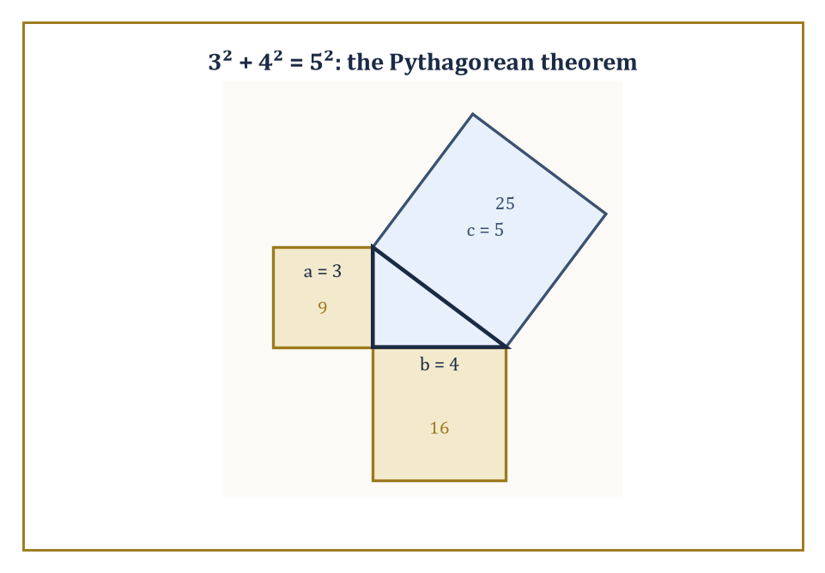
The classic 3-4-5 triangle, with squares of area 9, 16, and 25 built on each side.
a² + b² = c²
where c is the hypotenuse — the side opposite the right angle, and always the longest of the three, as Room 5.3 already told us to expect.
Numeric example — The classic case. The 3–4–5 triangle: legs 3 and 4, hypotenuse 5. Check:
3² + 4² = 9 + 16 = 25, and 5² = 25
They match exactly, which is precisely why this particular triple has been the go-to illustration for roughly four thousand years — it's the smallest whole-number example, and builders have used it since antiquity to square a corner without any measuring tool more sophisticated than a length of knotted rope.
The theorem is older than Pythagoras. Babylonian tablets from roughly 1800 BCE already list Pythagorean triples, apparently for practical use. Indian and Chinese mathematicians knew it independently. Pythagoras — or, more likely, his semi-secretive school, who were not always scrupulous about crediting individual members — is traditionally given credit for the first general proof in the Greek tradition. Euclid's own proof in Book I of the Elements is elegant and slightly roundabout (it constructs squares on all three sides and compares areas by a clever dissection); there are now hundreds of known proofs, ranging from the purely geometric to the algebraic to at least one attributed to a sitting United States President.
Numeric example — A larger triple. 5, 12, 13 is a triple that plausibly appears on those Babylonian tablets. Check:
5² + 12² = 25 + 144 = 169, and 13² = 169
Correct. Notice these triples don't come along often by accident — 5-12-13 and 3-4-5 are both members of the family generated by the formula (m² − n², 2mn, m² + n²) for whole numbers m > n > 0; with m = 2, n = 1 you get (3, 4, 5), and with m = 3, n = 2 you get (5, 12, 13). The ancient scribes had almost certainly found this generating pattern well before anyone wrote down why it works.
The Pythagorean theorem is the first place where geometry and arithmetic become inseparable, sometimes uncomfortably so. Lengths that look perfectly innocent — the diagonal of a unit square — force us to confront irrational numbers, the ones that refuse to be written as a fraction no matter how patiently you try.
The theorem is also, not incidentally, the foundation of the distance formula we already used one storey ago in the coordinate plane. Without it, analytic geometry would be severely crippled — you could plot points all day and never once know how far apart any two of them actually were.
Numeric example — The diagonal that broke the Pythagoreans' worldview. A unit square has legs 1 and 1. Its diagonal has length:
√(1² + 1²) = √2 ≈ 1.41421356...
This number cannot be written as a ratio of two whole numbers — a fact the Pythagoreans reportedly found so disturbing, given their near-religious devotion to whole-number ratios, that legend has the discoverer, Hippasus, thrown overboard for his trouble. True or not, the anecdote captures something real: a triangle as simple as 1-1-√2 was enough to force the invention of an entirely new category of number. And the distance formula is nothing but this same theorem wearing coordinates: the distance between A(1,2) and B(4,6) from Room 5.2 is:
√((4−1)² + (6−2)²) = √(3² + 4²) = √(9+16) = √25 = 5
the exact same 3-4-5 triangle from earlier in this room, now doing duty as a distance calculation.
There is a converse as well, and it is just as useful as the forward direction: if a² + b² = c² holds for the three sides of a triangle, then the angle opposite side c is necessarily a right angle. Together, the theorem and its converse give a complete algebraic test for right angles purely in terms of side lengths — no protractor, no angle-measuring of any kind required.
Numeric example — Using the converse — and a near miss. Sides 7, 24, 25: check
7² + 24² = 49 + 576 = 625, and 25² = 625
They match, so the converse guarantees a right angle sits opposite the side of length 25. Now compare sides 7, 24, 26:
7² + 24² = 625, but 26² = 676
Since 625 < 676, the converse tells us this triangle is not right-angled at all — and in fact, when the sum of the squares of the two shorter sides falls short of the square of the longest side, the angle opposite the longest side is obtuse (greater than 90°), not right. A difference of just one unit in the longest side was enough to tip the whole triangle from a right angle into an obtuse one.
Right triangles appear everywhere: in constructions, in trigonometry (waiting one storey ahead), in physics, in computer graphics. They are the geometric equivalent of linear equations — the well-behaved special case that can be solved completely, and which therefore serves as the load-bearing foundation for everything messier that gets built on top of it. The theorem doesn't even confine itself to the flat page; applied twice in succession, it happily climbs into three dimensions.
Numeric example — The theorem, applied twice. A rectangular box has dimensions 3 by 4 by 12. To find the length of the long diagonal running from one corner to the opposite corner, apply the Pythagorean theorem twice. First, the diagonal of the 3-by-4 base:
√(3² + 4²) = √25 = 5
Then treat that base diagonal (length 5) and the height (12) as the two legs of a new right triangle standing up out of the base: the space diagonal is:
√(5² + 12²) = √(25 + 144) = √169 = 13
A single flat theorem, applied twice, just measured a genuinely three-dimensional distance — and produced the exact 5-12-13 triple from earlier in this room, purely by coincidence of the numbers chosen, though the method itself works for any box whatsoever. We will meet right triangles again, properly, when trigonometry arrives. For now, simply appreciate that a statement as brief as a² + b² = c² carries far more mathematical weight than its nine symbols let on.

Room 5.6: Similarity: Same Shape, Different Size
Congruence's more relaxed cousin
Similarity is congruence with the ambition dialled down: same shape, but size has become entirely negotiable. Corresponding angles are equal; corresponding sides are proportional — congruence's exacting standards, minus the one clause most photocopiers were never going to honour anyway. Two triangles are similar if their corresponding angles are equal (the AA criterion — only two angles need checking, since the third is, as ever, already spoken for by the 180° budget), or if two pairs of sides are proportional and the included angles are equal (SAS similarity), or if all three pairs of sides are proportional (SSS similarity).
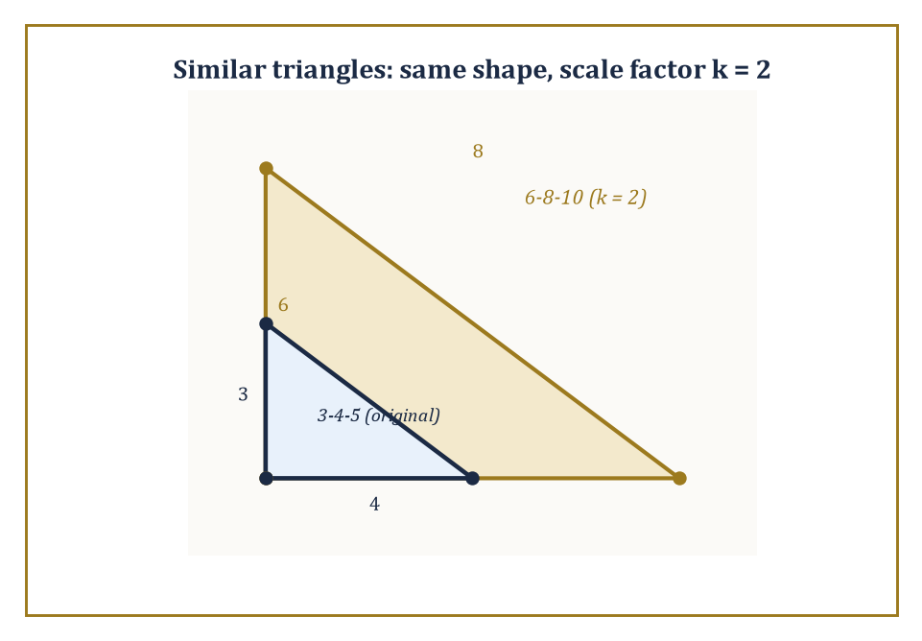
The 3-4-5 triangle and its 6-8-10 double, nested to show the scale factor k = 2 in action.
Numeric example — SSS similarity, scaled cleanly. Triangle 1 has sides 3, 4, 5. Triangle 2 has sides 6, 8, 10. Compare the ratios of corresponding sides:
6/3 = 2, 8/4 = 2, 10/5 = 2
All three ratios agree at exactly 2, so the triangles are similar by SSS similarity — Triangle 2 is simply Triangle 1 photocopied at 200% zoom. Because all three side ratios match, all three angles must match too, automatically; you don't need to measure a single angle to know it.
Similarity is what allows us to talk sensibly about scale drawings, maps, and the idea that a large triangle and a small triangle can still be 'the same' in every way that matters except literal size. It is also, crucially, the foundation of trigonometry: the ratios of sides in a right triangle depend only on the acute angles present, never on the triangle's overall size. Those ratios are the trigonometric functions, waiting one storey up.
Numeric example — The ratio that doesn't care about size. Take the two similar right triangles from above: 3-4-5 and its double, 6-8-10. In the first, focus on the angle opposite the side of length 3; the ratio of that opposite side to the hypotenuse is:
3/5 = 0.6
In the second triangle, the corresponding angle sits opposite the side of length 6, and the ratio is:
6/10 = 0.6
identical, despite the triangle being twice as large in every linear dimension. This ratio, opposite-over-hypotenuse, depends only on the angle, never on the size of the triangle carrying it. Next storey, this exact ratio gets a name: the sine of the angle.
Numeric example — AA with nothing else supplied. Triangle 1 has angles 40°, 60°, and (by subtraction from 180°) 80°. Triangle 2 has angles 40° and 60° as well — its third angle is likewise forced to be:
180° − 40° − 60° = 80°
whether or not anyone bothers to check. Two matching angles were enough; the third came along for free, and AA similarity applies regardless of how large either triangle actually is. This is the entire reason AA gets to be a two-angle criterion rather than a three-angle one: in a Euclidean triangle, the angle budget is fixed, so the last angle is never actually free information.
The distinction between congruence and similarity is one of the cleanest illustrations of a theme that recurs constantly in mathematics: sometimes we care about exact equality, and sometimes we care about structure preserved up to a controlled, well-understood form of distortion. Similarity preserves angles and ratios of lengths. It discards absolute size entirely. That trade-off — keep the shape, sacrifice the scale — turns out to be useful far beyond geometry, and you'll meet its cousins in nearly every storey above this one.
Numeric example — What similarity keeps, what congruence demands. The 3-4-5 and 6-8-10 triangles are similar (ratio 2 throughout) but not congruent, since no rigid motion can make a side of length 3 coincide with a side of length 6 — a rigid motion changes nothing about size, and here the size genuinely differs. Two 3-4-5 triangles, on the other hand, are both similar (ratio 1, trivially) and congruent, since ratio 1 means 'the same size,' and same shape plus same size is exactly what congruence requires. Congruence is the special case of similarity where the scale factor k happens to equal exactly 1 — nothing more mysterious than that.
Under a similarity with scale factor k, lengths are multiplied by k, areas by k², and volumes by k³. This single observation explains, almost as an afterthought, why the area of a circle is πr² and the volume of a sphere is (4/3)πr³ — once the constants are pinned down for the unit circle and unit sphere, everything else scales automatically, with no fresh calculation required for each new radius.
Numeric example — k, k², and k³ in action. Take the 3-4-5 triangle again, area (1/2)(3)(4) = 6. Scale it by k = 2 to get the 6-8-10 triangle:
area = (1/2)(6)(8) = 24
Predicted:
6 × k² = 6 × 4 = 24
Matches. Now a cube of side 2 has volume 2³ = 8. Scale by k = 3 to get a cube of side 6: volume 6³ = 216. Predicted:
8 × k³ = 8 × 27 = 216
Matches. And for circles: a unit circle (r = 1) has area π(1)² = π. Scale by k = 5 to radius 5: area π(5)² = 25π. Predicted:
π × k² = π × 25 = 25π
Matches — the entire formula πr² is really just 'area of the unit circle, times the square of the scale factor,' dressed up in a single tidy symbol.
Similar triangles are the geometric engine behind many classical constructions and behind the intercept theorems — Thales' theorem in its broader, non-circular form. They turn proportion, an idea that could otherwise stay stubbornly abstract, into a genuine geometric tool you can draw and measure.
Numeric example — The intercept theorem, worked. From a point O, draw two rays. On the first, mark A with OA = 2 and B with OB = 6, so OA:OB = 2:6 = 1:3. Draw a line through A and a parallel line through B, each crossing the second ray — at C and D respectively. Suppose OC = 3. The intercept theorem says the ratios along each ray must match:
OA/OB = OC/OD, i.e. 1/3 = 3/OD, so OD = 9
Check the logic in reverse:
OA/OB = 2/6 = 1/3, and OC/OD = 3/9 = 1/3
equal, as promised. This is the same fact that makes scale maps work: walk twice as far along one road, and every parallel cross-street you'd meet is correspondingly twice as far along too.

Room 5.7: Circles and Their Theorems
Absurd symmetry from one modest sentence
A circle is the set of all points in a plane at a fixed distance — the radius — from a given point, the center. That single, almost embarrassingly simple definition produces an object of near-absurd symmetry. Every diameter is an axis of reflection. Every rotation about the center, of any angle at all, maps the circle exactly onto itself. No other simple shape is this generous with its symmetries; a square only tolerates four rotations and four reflections before it starts repeating itself, but a circle tolerates literally all of them, forever, which is either the most elegant fact in this storey or a faintly terrifying one, depending on your mood.
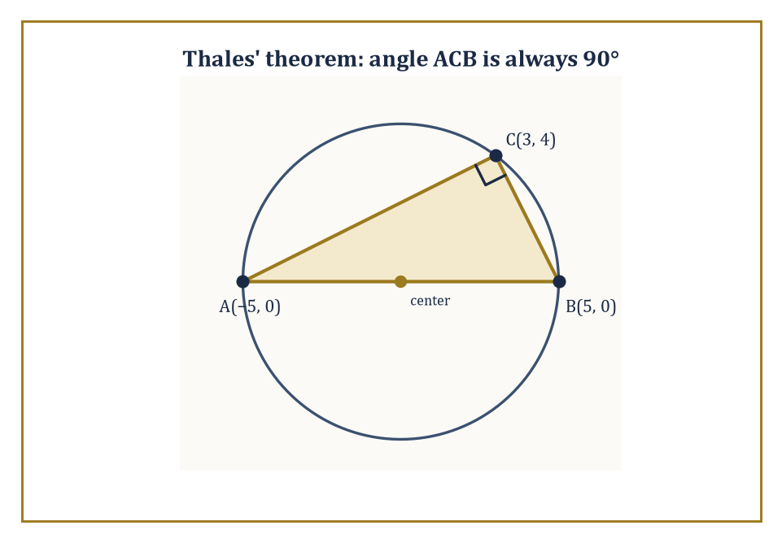
Thales' theorem made visible: any point on the circle sees the diameter at a right angle.
Numeric example — Testing the definition. Take the circle centered at the origin with radius 5: the equation
x² + y² = 25
encodes exactly 'distance from (0,0) equals 5.' Test the point (3,4):
3² + 4² = 9 + 16 = 25
It lies on the circle. Test (3,3):
3² + 3² = 9 + 9 = 18 ≠ 25
It does not — it's strictly inside, since 18 < 25 means it's closer to the center than the radius allows. The equation isn't just notation; it's a genuine membership test, applicable to any candidate point you like.
From the bare definition we obtain a cascade of theorems: a radius drawn perpendicular to a chord bisects that chord; the perpendicular bisector of any chord passes through the center; an angle inscribed in a semicircle is always a right angle (this one has a name — Thales' theorem, after the same Thales from the intercept theorem, who evidently had a productive week); the measure of an inscribed angle is always exactly half the measure of the central angle subtending the same arc; and opposite angles of a cyclic quadrilateral (one whose four vertices all sit on a single circle) always sum to 180°.
Numeric example — Thales' theorem, verified by dot product. Circle of radius 5 centered at the origin. Let A = (−5, 0) and B = (5, 0) be the two ends of a diameter, and let C = (3, 4) be any other point on the circle (check: 3² + 4² = 25, confirmed on the circle). Thales' theorem claims angle ACB is exactly 90°. Form the vectors from C to each endpoint: CA = A − C = (−8, −4), and CB = B − C = (2, −4). Their dot product is:
(−8)(2) + (−4)(−4) = −16 + 16 = 0
A dot product of zero means the vectors are perpendicular — angle ACB genuinely is 90°, confirmed by direct computation rather than by trusting the theorem on faith.
Numeric example — The perpendicular bisector finds the center. Same circle, radius 5, center at the origin. Take the chord joining (3, 4) and (−3, 4) — both check out as lying on the circle, since (−3)² + 4² = 9 + 16 = 25 as well. This chord is horizontal, running at height y = 4, with midpoint (0, 4). Its perpendicular bisector is therefore the vertical line:
x = 0
and that line passes straight through the center (0, 0), exactly as the theorem promises. Any chord you draw on this circle, however oddly angled, has a perpendicular bisector that dutifully reports back to the same center.
Circles interact cleanly with lines and with other circles. A line can miss a circle entirely, touch it at exactly one point (a tangent), or cut through it at two points (a secant). The tangent line is always perpendicular to the radius drawn to the point of contact — the circle's one moment of sharp, uncompromising geometry amid all that curvature. Two circles, meanwhile, can be separate, tangent to one another, intersecting at two points, or concentric (sharing a center but not a radius).
Numeric example — Constructing a tangent line. Circle x² + y² = 25, and the point (3, 4) on it. The radius to that point runs from (0,0) to (3,4), slope 4/3. The tangent line must be perpendicular to this radius, so its slope is the negative reciprocal: −3/4. Through the point (3,4):
y − 4 = −(3/4)(x − 3)
which simplifies to:
y = −(3/4)x + 9/4 + 4 = −(3/4)x + 25/4
Check it passes through (3,4):
−(3/4)(3) + 25/4 = −9/4 + 25/4 = 16/4 = 4
Correct — and this line touches the circle at exactly that one point and nowhere else, brushing past it rather than cutting through.
The power of a point with respect to a circle is a wonderfully useful invariant: for a point lying outside the circle, it equals the square of the tangent length from that point, and it also equals the product of an entire secant segment (from the point to the far intersection) with its external part (from the point to the near intersection). This single number, computed two entirely different ways, organizes a great many intersection and tangency results that would otherwise require separate proofs.
Numeric example — The power of a point, two ways. Circle radius 5 centered at the origin, and external point P = (13, 0), a distance of 13 from the center. Tangent length from P: by the Pythagorean theorem applied to the right triangle formed by the center, P, and the point of tangency:
tangent² = 13² − 5² = 169 − 25 = 144, so the tangent length is √144 = 12
Now the secant: the x-axis through P meets the circle at (5, 0) and (−5, 0). Distance from P to the near point (5,0) is 13 − 5 = 8 (the external part); distance from P to the far point (−5,0) is 13 − (−5) = 18 (the whole secant). Their product:
8 × 18 = 144
exactly matching the tangent length squared, 12² = 144. Two entirely different measurements, one point, one invariant number.

Room 5.8: Constructions, Area, and the Limits of the Ruler and Compass
What the ancients could build, and the three things they never could
Classical Euclidean constructions are performed with an unmarked straightedge and a compass — no measuring, no marked distances, just the ability to draw the line through two known points and the circle with a known center through a known point, and then to find where lines and circles already drawn happen to cross. From these bare operations you can bisect angles, erect perpendiculars, copy segments exactly, and construct equilateral triangles, squares, and regular hexagons — an impressively rich toolkit built from an almost insultingly minimal set of allowed moves.
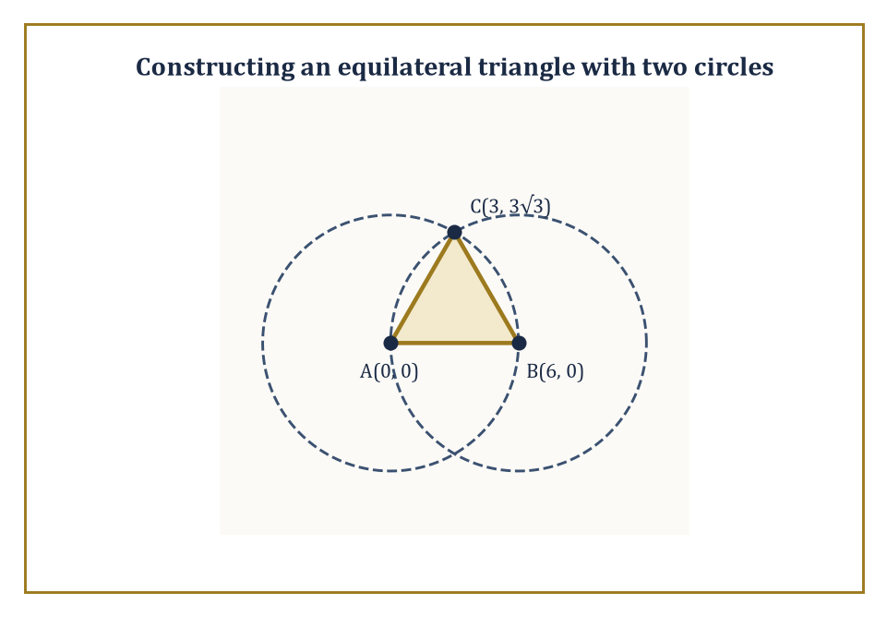
Two circles of equal radius, and the equilateral triangle their intersection hands you for free.
Worked example — Constructing an equilateral triangle. Given segment AB, draw a circle centered at A with radius AB, and another circle centered at B with radius AB; call their intersection C. Then AC = AB (both are radii of the first circle) and BC = AB (both are radii of the second circle), so
AC = BC = AB
all three sides equal, hence equilateral, by nothing more than the definition of a circle applied twice. Numerically: let A = (0,0), B = (6,0), both circles of radius 6. Solving x² + y² = 36 and (x−6)² + y² = 36 simultaneously gives x = 3, y = ±3√3, so
C = (3, 3√3) ≈ (3, 5.196)
Check AC:
√(3² + (3√3)²) = √(9 + 27) = √36 = 6 = AB
exactly as required.
What you cannot construct with straightedge and compass alone is equally interesting, and arguably more interesting: doubling the cube (constructing a cube with twice the volume of a given cube), trisecting an arbitrary angle, and squaring the circle (constructing a square with the same area as a given circle) are all impossible.
These impossibilities were only proved in the nineteenth century, using field theory and — for squaring the circle specifically — the transcendence of π. The classical problems therefore sit precisely at the boundary between geometry and abstract algebra, a boundary the ancient Greeks couldn't possibly have crossed, since the algebra needed to explain their own failure hadn't been invented yet.
Abstract example — Why the cube cannot be doubled. Doubling a unit cube (volume 1) means constructing a segment of length ∛2 ≈ 1.259921..., since a cube of side ∛2 has volume:
(∛2)³ = 2
Every length constructible by straightedge and compass, starting from a unit length, lies in a chain of quadratic field extensions of the rational numbers — meaning its 'degree' over the rationals is always a power of 2 (1, 2, 4, 8, ...). But ∛2 satisfies the equation:
x³ − 2 = 0
an irreducible cubic (it has no rational roots, and a cubic with no rational roots cannot be factored over the rationals), giving it degree exactly 3 over the rationals. Since 3 is not a power of 2, ∛2 is provably not constructible — not 'nobody has found a way yet,' but 'no way exists, full stop.' It took two thousand years and an entirely different branch of mathematics to turn a geometer's failure into an algebraist's proof.
Area is assigned to polygonal regions by dissection into triangles and the formula (1/2) × base × height, applied triangle by triangle and summed. The area of a circle is obtained as a limit of the areas of inscribed or circumscribed regular polygons as the number of sides grows without bound; the very same limiting process produces the circumference 2πr as well. The fact that one single constant, π, governs both a length (the circumference) and an area (πr²) is one of the quiet miracles of the subject, easy to take for granted precisely because it's taught so early.
Numeric example — Dissection and approach to a circle. A trapezoid with parallel sides 8 and 4, height 5: by the formula,
area = (1/2)(8+4)(5) = (1/2)(12)(5) = 30
Verify by dissection: split it into a rectangle (4 wide, 5 tall, area 20) and a right triangle (base 4, height 5, area (1/2)(4)(5) = 10); total
20 + 10 = 30
matching exactly. Now the circle: a regular hexagon inscribed in a circle of radius 1 has area (3√3/2)(1)² = (3 × 1.7320508)/2 ≈ 2.598, noticeably less than the circle's own area π ≈ 3.1416; its perimeter is 6 × 1 = 6, also less than the circumference 2π ≈ 6.283. Replace the hexagon with a 12-sided, then a 24-sided regular polygon, and both the area and perimeter climb steadily upward, squeezing ever closer to π and 2π respectively — the geometric content of 'the circle is a limit of polygons,' made visible one extra side at a time.
Cavalieri's principle allows us to compare the areas or volumes of figures that can be sliced into corresponding pieces of equal measure, slice for matching slice. In modern language we are doing integration without quite saying the word out loud — the geometric intuition came first, by more than a thousand years, and the rigorous limit theory that justifies it arrived only with calculus.
Numeric example — Shear a shape, keep the area. A rectangle with base 10 and height 4 has area:
10 × 4 = 40
Now shear it into a parallelogram with the same base 10 and the same (perpendicular) height 4, but leaning over at an angle — every horizontal slice of the parallelogram is still exactly 10 units long, matching the rectangle's corresponding slice exactly, no matter how far the shear leans. By Cavalieri's principle the areas must therefore be equal: the parallelogram's area is also
base × height = 10 × 4 = 40
regardless of how dramatically it leans. Push the lean to a near-horizontal extreme and the shape looks nothing like the original rectangle — and yet the area hasn't budged by so much as a square unit.
Constructions and area measurements close out the classical Euclidean toolkit. Everything else in the subject is either a more elaborate combination of these ideas, or a deliberate departure from the Euclidean assumptions altogether — the road that leads, eventually, to the curved geometries glimpsed briefly in this storey and explored properly much higher up the Tower.

Room 5.9: Looking Ahead: From Euclidean Geometry to Trigonometry and Beyond
The scaffolding, and what it was scaffolding for
We have now walked through the basic landscape of Euclidean geometry: points and lines, the parallel postulate, angles and the triangle sum, congruence, the Pythagorean theorem, similarity, circles, constructions, and area. It is worth pausing at the top of this particular staircase and looking back down it, because the view clarifies something that was easy to miss while climbing one step at a time.
Notice, too, how much of the argument turned out to hinge on a single choice made in Room 5.2 and never revisited since: the parallel postulate. Once it was granted, the triangle angle sum locked in at 180°, which in turn licensed the exterior angle theorem, which in turn made the SSS, SAS, and ASA congruence criteria provable rather than merely plausible, which in turn underwrote similarity, which in turn gave the Pythagorean theorem its familiar shape. Pull that one thread and the whole tapestry changes color — which is precisely what happens on the curved surfaces glimpsed briefly in Rooms 5.2 and 5.3, where a different choice about parallels produces a geometry that is different in every subsequent theorem, and yet just as internally consistent as the one built here.
The central lesson is that space has a rigid and surprisingly rich structure, one that can be captured by a short list of axioms and then explored deductively, theorem after theorem, exactly as Euclid did it. The very same structure can also be captured by coordinates and explored algebraically instead, exactly as we did back in Storey 4. Both languages remain necessary; neither retires the other. A synthetic proof often shows you why something is true with a clarity no equation matches, while a coordinate proof often gets you to the answer faster when the diagram would otherwise sprawl across three pages.
The techniques developed here — congruent triangles, similar triangles, the Pythagorean theorem, circle theorems, area formulas — will reappear constantly from this point onward. They are the geometric infrastructure of everything still to come, cited so often in later storeys that we will, from time to time, simply say 'by the usual triangle argument' and trust that the phrase now means something to you.
Numeric example — A capstone worked example. Let's use one figure to exercise nearly every tool from this storey at once. Circle of radius 5 centered at the origin; diameter endpoints A(−5,0) and B(5,0); point C(3,4) on the circle (from Room 5.7). By Thales' theorem, angle ACB is a right angle — verified earlier by a dot product of exactly zero. Compute the two legs:
AC = √((3−(−5))² + 4²) = √(64+16) = √80 = 4√5 ≈ 8.944
BC = √((3−5)² + 4²) = √(4+16) = √20 = 2√5 ≈ 4.472
Pythagorean check:
AC² + BC² = 80 + 20 = 100, and AB² = 10² = 100
matches, as it must, since AB is the hypotenuse of a right triangle whose legs are AC and BC. The area, computed as (1/2) × leg × leg (valid precisely because the legs are perpendicular):
(1/2)(4√5)(2√5) = (1/2)(8 × 5) = 20
Cross-check using base AB = 10 and height equal to C's distance from the x-axis, which is simply 4:
(1/2)(10)(4) = 20
Both methods agree. One circle, one inscribed right triangle, and four separate theorems from this storey — Thales, Pythagoras, congruent-triangle area reasoning, and the base-height formula — all confirming each other in the same twenty square units.
The next storey turns to trigonometry: the systematic study of the ratios that appear in right triangles, and the functions that extend those ratios to all angles, not merely the acute ones sitting politely inside a triangle.
Trigonometry is, in many ways, Euclidean geometry made quantitative and then set loose — the ratio
BC/AB = 2√5/10 = 1/√5 ≈ 0.447
from the capstone example above depends only on the angle at A, never on the size of the triangle carrying it, precisely the fact Room 5.6 previewed under the heading of similarity. Give that ratio a name, extend it past 90°, and you have arrived one storey early. After trigonometry come logarithms, systems of equations, vectors, and the long climb toward calculus and beyond.
It is worth naming, honestly, what this storey has and has not done. It has not made you a master of ruler-and-compass trickery, nor walked you through every one of Euclid's roughly four hundred and sixty-five propositions — a mercy, frankly, for both of us. What it has done is hand you the load-bearing vocabulary: congruence, similarity, the angle sum, the Pythagorean theorem, the handful of circle theorems that keep resurfacing. That vocabulary is what the next storey, and several storeys after that, will assume you already speak fluently, the way a novelist assumes you already know what a sentence is.
Geometry is not a closed room we now lock behind us and forget. It is the spatial intuition that keeps the more abstract floors above this one from floating free of meaning. Every time a later storey invokes 'distance,' 'angle,' or 'symmetry' as though the words were self-explanatory, it is quietly borrowing from the load-bearing walls built in this storey.
If the earlier storeys were about numbers, relations, functions, and coordinates, this one has been about the stage on which those objects act — the flat space that Euclid described so carefully, and so persuasively, that his account of it remained the standard for two thousand years.
The Tower continues upward. The walls, for once, are load-bearing.

Storey 6: Trigonometry
Angles, Ratios, Waves, and the Art of Measuring What You Cannot Reach
We left the previous storey having proved, at some length and with considerable relish for congruent triangles, that similarity is a rigid business: if two right triangles share an acute angle, every ratio of their sides is locked into agreement, regardless of size. At the time this was presented as a mildly pleasing corollary, the kind of fact you nod at and file away. It is in fact the founding theorem of an entire discipline, one that has occupied surveyors, sailors, astronomers, and undergraduates in various states of despair for roughly two and a half thousand years. That corollary is where we now make our home.
Trigonometry — literally 'triangle measuring', though it long ago stopped confining itself to triangles — takes that one observation (the shape of a right triangle depends only on its acute angle, never on its size) and asks the obvious follow-up question: if the ratios depend only on the angle, why not simply study the ratios as functions of the angle, and let the triangle drop away entirely? The answer occupies the rest of this storey, and a fair portion of every storey above it.
We begin, as any sensible person would, on solid ground: a right triangle, three named ratios, two special-case triangles you were probably made to memorise at school without ever being told why they were worth memorising. Then we do something the school curriculum is usually too polite to attempt: we let the angle escape the triangle altogether, wander around a circle, take negative values, exceed 360°, and become simply a real number fed into a function. What comes out the other side is periodic, infinite in extent, and turns out to be the natural language for anything in the universe that goes round, back, and forth — pendulums, alternating current, sound, light, tides, and, we are reliably informed, the business cycle.
A note on tone before we start climbing: trigonometry suffers from the same reputational injury as long division, namely that it is taught as a pile of formulas to be memorised under duress rather than a small number of ideas that generate all the formulas for free. We shall try to keep the pile small and the ideas load-bearing. If, by the end, you find yourself deriving an identity you would once have crammed, the storey has done its job.

Room 6.1: What Trigonometry Actually Is
In Which One Observation About Triangles Quietly Takes Over the Universe
Trigonometry begins with a fact you already half-know from the previous storey: in a right triangle, the ratio of any two sides is completely determined by one of the acute angles, and not at all by the triangle's overall size. Blow the triangle up to the size of a house, shrink it to the size of a postage stamp — so long as the acute angle stays the same, every ratio of side-lengths stays exactly the same too. This is similarity doing the one useful thing similarity ever does: turning a shape into a number.
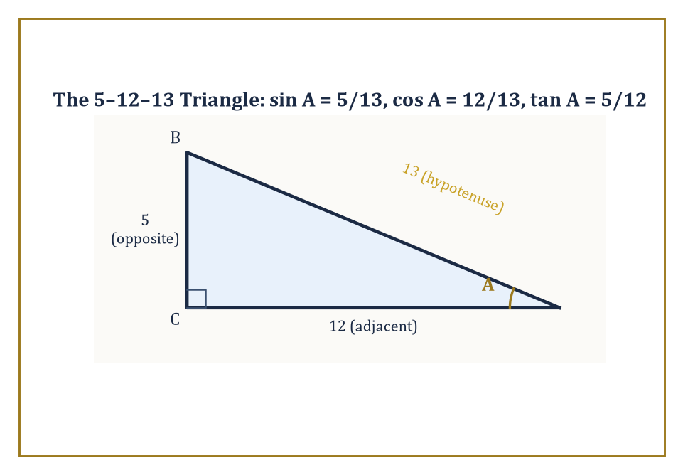
The 5-12-13 triangle from the worked example, with angle A and all three named sides.
Numeric example — Worked example: similarity guarantees the ratio. Take a small right triangle with a 30° angle, hypotenuse 4 cm, and the side opposite the 30° angle equal to 2 cm. The ratio (opposite)/(hypotenuse) is:
2/4 = 0.5
Now scale the whole triangle up by a factor of 5, keeping every angle the same: hypotenuse becomes 20 cm, the opposite side becomes 10 cm. The ratio is now:
10/20 = 0.5
Identical. No matter how the triangle is stretched, so long as the 30° angle survives, that ratio is pinned at exactly 0.5. That fixed number is, as it happens, the definition of sin 30°, which we meet properly in Room 6.2.
Because the ratios are pinned down by the angle alone, we may as well give them names and treat them as functions of the angle. Three of them matter most. The sine of an acute angle is (opposite side)/(hypotenuse). The cosine is (adjacent side)/(hypotenuse). The tangent is (opposite side)/(adjacent side). Three more — cosecant, secant, cotangent — are simply their reciprocals, included mainly so that older textbooks have something extra to examine you on.
Numeric example — Worked example: all six ratios from one triangle. Take the right triangle with legs 5 and 12 and hypotenuse 13 (check: 5² + 12² = 25 + 144 = 169 = 13², so this is a valid right triangle — the '5-12-13' triple). Let A be the acute angle opposite the side of length 5, so the adjacent leg is 12. Then:
sin A = 5/13 ≈ 0.3846
cos A = 12/13 ≈ 0.9231
tan A = 5/12 ≈ 0.4167
The reciprocals follow at once:
csc A = 13/5 = 2.6
sec A = 13/12 ≈ 1.0833
cot A = 12/5 = 2.4
As a sanity check,
sin²A + cos²A = (25 + 144)/169 = 169/169 = 1
exactly as the Pythagorean theorem demands (we will make this identity official in Room 6.2).
That, in essence, is the entire elementary theory. Everything from here on is extension, identity, and application — three words that will recur throughout this storey like a chorus. The first extension is to angles that are not acute and triangles that are not right-angled at all: a mountain's summit, a ship's bearing, and a surveyor's baseline rarely arrange themselves into convenient 90° corners just to make your homework easier.
Abstract example — Why the right-triangle picture must eventually break. Consider what happens to tan A = (opposite)/(adjacent) as the acute angle A creeps up toward 90°. The adjacent side shrinks toward zero while the opposite side stays roughly the same length, so the ratio grows without bound:
tan 80° ≈ 5.67
tan 89° ≈ 57.3
and at exactly 90° there is no right triangle left to speak of, since a triangle cannot have two right angles. The right-triangle definition simply runs out of road at 90° and beyond. This is not a flaw to patch over — it is the signal that a cleverer definition, one that does not depend on having a triangle at all, is needed. That cleverer definition is the unit circle, and it is the subject of Room 6.3.
The second extension is to the unit circle, where the same two ratios reappear as the coordinates of a point moving around a circle of radius one, freed from any triangle and any restriction to angles between 0° and 90°. The third extension is to treat the angle as an ordinary real number — not a geometric object at all, just an input — so that sine and cosine become functions defined on the entire real line: periodic, smooth, and central to the description of anything that repeats. Trigonometry therefore lives a double life. It is the closing movement of the story of triangles begun in the last storey, and it is simultaneously the opening movement of the theory of periodic functions, a story that will not finish until we reach Fourier analysis many storeys from now. We will keep both faces in view throughout: the concrete geometry of triangles on one hand, and the abstract analysis of the functions those triangles generate on the other.
It is worth pausing on why a subject that starts so narrowly — three ratios, one triangle, angles confined to a 90° range — is even capable of this kind of expansion. The honest answer is that the original definitions were never really about triangles at all; they were about the relationship between an angle and a position, and a triangle merely happened to be the first convenient scaffold for expressing that relationship. Once the scaffold is recognised as optional, nothing stops the same relationship being restated for angles beyond 90°, for negative angles, or for angles that are not really 'angles' in any physical sense at all but simply numbers being fed through a periodic machine. This pattern — start with a concrete special case, notice the special case was hiding a more general structure, then discard the scaffolding — is one of the great recurring moves of mathematics, and this storey is as good a place as any to watch it happen for the first time in slow motion.

Room 6.2: Right Triangles and the Basic Ratios
Calibrating the Instrument Before We Point It at Anything Interesting
Let us make Room 6.1's promises precise. Fix a right triangle and call the right angle C. The two acute angles are A and B, with A + B = 90° since the three angles of any triangle sum to 180°. Label the side opposite A as a, the side opposite B as b, and the hypotenuse (opposite the right angle C, and always the longest side) as c. With this labelling:
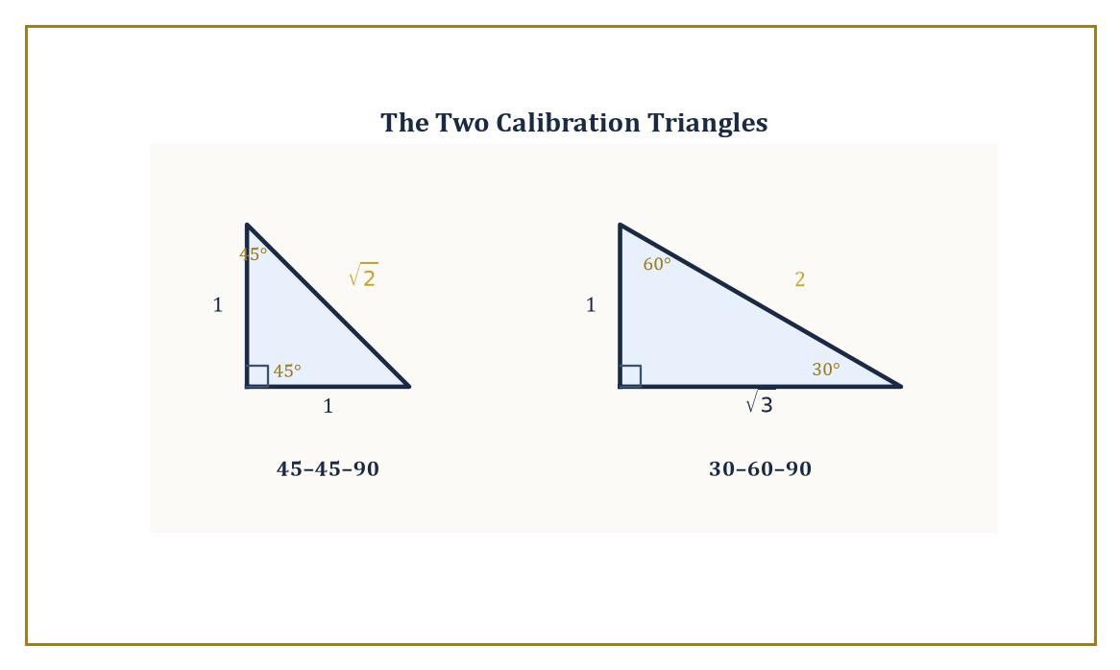
The two triangles worth memorising, drawn to their exact side ratios of 1:1:√2 and 1:√3:2.
sin A = a/c, cos A = b/c, tan A = a/b
These three equations are, quite literally, all of elementary trigonometry compressed into one line; nearly everything else in this storey is a consequence of them.
Numeric example — Worked example: solving a right triangle from one side and one angle. Suppose a right triangle has angle A = 36.87°, chosen so that sin A = 0.6, cos A = 0.8, and tan A = 0.75 exactly (these are the angles of the classic 3-4-5 triangle, doubled below), and suppose the side opposite A is a = 6. Find the other two sides and the remaining angle. From sin A = a/c we get:
c = a/sin A = 6/0.6 = 10
From tan A = a/b we get:
b = a/tan A = 6/0.75 = 8
The remaining angle is:
B = 90° − A = 90° − 36.87° = 53.13°
Check with the Pythagorean theorem:
a² + b² = 36 + 64 = 100 = 10² = c²
It works, because this triangle is simply the familiar 3-4-5 right triangle scaled up by a factor of 2.
Because A and B are complementary (they add to 90°), the side that is 'opposite A' is exactly the side that is 'adjacent to B', and vice versa. That single bookkeeping fact hands us the complementary relations for free:
sin A = cos B, cos A = sin B, tan A = cot B
These are not deep theorems requiring proof by induction or an appeal to some grand principle — they are immediate restatements of the definitions once you notice that A's opposite side is B's adjacent side. Trigonometry rewards this kind of relabelling far more often than it rewards brute-force computation.
Numeric example — Worked example: complementary angles. Using angle A = 30° and its complement B = 60° from a 30-60-90 triangle:
sin 30° = 0.5 and cos 60° = 0.5
equal, as promised. Likewise:
cos 30° = √3/2 ≈ 0.8660 and sin 60° = √3/2 ≈ 0.8660
also equal. The two angles are simply looking at the same pair of legs from opposite ends of the triangle.
The Pythagorean theorem, proved at length in the previous storey, translates directly into the single most important equation in this one:
sin²A + cos²A = 1
This is because sin A = a/c and cos A = b/c, so:
sin²A + cos²A = a²/c² + b²/c² = (a² + b²)/c²
and the Pythagorean theorem says a² + b² = c², making the fraction equal to 1. Dividing this identity through by cos²A produces:
tan²A + 1 = sec²A
dividing instead by sin²A produces:
1 + cot²A = csc²A
All three are called Pythagorean identities, and essentially every later identity in this storey traces its ancestry back to this one geometric fact about right triangles.
Numeric example — Worked example: checking the Pythagorean identity. Take the 5-12-13 triangle from Room 6.1, where sin A = 5/13 and cos A = 12/13. Then:
sin²A + cos²A = (5/13)² + (12/13)² = 25/169 + 144/169 = 169/169 = 1
exactly as required — no rounding, no approximation, because 5, 12, 13 is an exact Pythagorean triple.
Two triangles deserve to be memorised outright, not because memorisation is virtuous but because they are the calibration points against which every other angle is eventually measured. In a 45-45-90 triangle the two legs are equal (call each of them 1), so the hypotenuse is √(1² + 1²) = √2, giving sin 45° = cos 45° = 1/√2 = √2/2 ≈ 0.7071 and tan 45° = 1. In a 30-60-90 triangle the sides sit in the fixed ratio 1 : √3 : 2 (this comes from bisecting an equilateral triangle — cut a triangle with all sides equal to 2 straight down the middle, and the half-triangle has a base of 1, a height of √3, and a hypotenuse of 2, which is where the ratio comes from).
Numeric example — Worked example: the six ratios for 30° and 60°. With sides 1, √3, 2 as above, and the 30° angle opposite the side of length 1:
sin 30° = 1/2 = 0.5
cos 30° = √3/2 ≈ 0.8660
tan 30° = 1/√3 = √3/3 ≈ 0.5774
Swapping to the 60° angle (opposite the side of length √3):
sin 60° = √3/2 ≈ 0.8660
cos 60° = 1/2 = 0.5
tan 60° = √3 ≈ 1.7321
Notice the sin/cos values simply swap between the two angles — an instance of the complementary relation proved two paragraphs ago.
With the definitions, the Pythagorean identity, and these two calibration triangles in hand, any right triangle can be solved: given any two pieces of information — two sides, or one side and one acute angle — the remaining sides and angles are determined completely. This is the computational heart of surveying, basic navigation, and a great deal of elementary physics, and it is also, not coincidentally, the exact algebraic content of the AA and SAS similarity criteria from the previous storey, now dressed up with numbers instead of congruence marks.

Room 6.3: The Unit Circle and Extension to All Angles
Letting the Angle Off Its Leash
The restriction to acute angles was always a scaffold, not a law of nature, and Room 6.1 already showed it collapsing at 90°. Here is how we remove it. Place a circle of radius 1 at the origin of the coordinate plane — the unit circle. Let θ (theta) be any real number, interpreted as a directed angle measured from the positive x-axis, counterclockwise if positive. The ray from the origin at angle θ strikes the unit circle at exactly one point, and we define that point's coordinates to be:
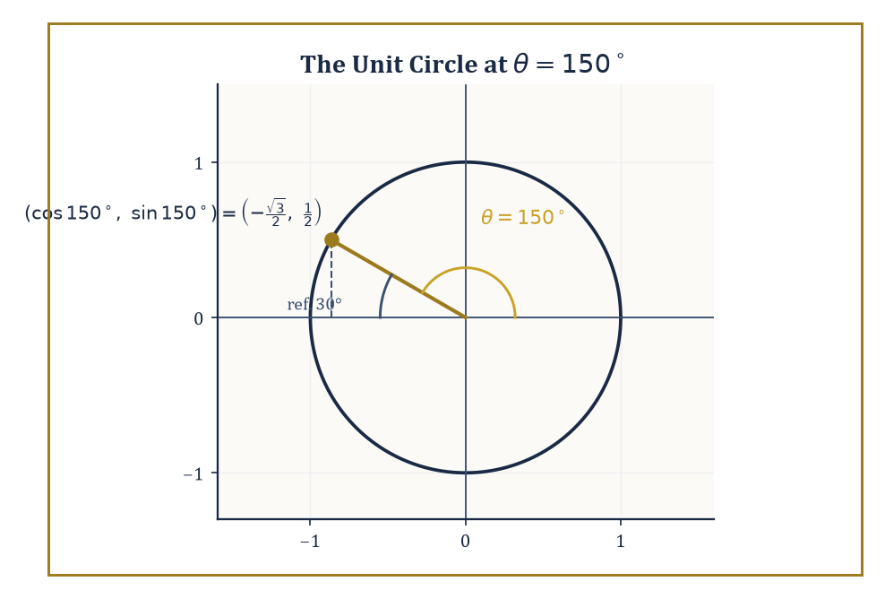
θ = 150° on the unit circle, its reference angle of 30°, and the coordinates that reading gives for free.
(cos θ, sin θ)
Full stop. No triangle required, no restriction to 0°–90°, and the definition works identically whether θ is 10°, 400°, or −1,000,000°.
Numeric example — Worked example: reading a point off the unit circle. Take θ = 150°. This angle lies in the second quadrant (between 90° and 180°), 30° short of the negative x-axis; 30° is called its reference angle. In the second quadrant, x-coordinates are negative and y-coordinates are positive, so:
cos 150° = −cos 30° = −√3/2 ≈ −0.8660
sin 150° = sin 30° = 1/2 = 0.5
Check that the point lies on the unit circle:
(−0.8660)² + (0.5)² ≈ 0.7500 + 0.2500 = 1.0000
It does — which is simply the Pythagorean identity, now visible as the equation of a circle of radius 1.
Tangent is then defined exactly as before,
tan θ = sin θ / cos θ
valid everywhere except where cos θ = 0 (that is, at 90°, 270°, and so on, where the point sits directly above or below the origin and has no meaningful 'run' to divide by). The remaining three ratios are reciprocals of these, as always. What used to require memorising 'which ratios are positive in which quadrant' as a piece of arbitrary trivia (generations of students have been handed the mnemonic 'All Students Take Calculus' for quadrants I, II, III, IV) is now simply reading off the signs of x and y on the circle: both positive in quadrant I, only y positive in quadrant II, both negative in quadrant III, only x positive in quadrant IV.
Numeric example — Worked example: signs in the third quadrant. Take θ = 210°, which sits 30° past the negative x-axis in the third quadrant, where both coordinates are negative. Reference angle 30° gives:
sin 210° = −sin 30° = −0.5
cos 210° = −cos 30° = −√3/2 ≈ −0.8660
Tangent is the quotient:
tan 210° = (−0.5)/(−0.8660) ≈ 0.5774
which is positive — because a negative divided by a negative is positive, exactly matching the fact that tangent is positive throughout the third quadrant, even though sine and cosine are individually negative there.
Three more pieces of bookkeeping fall out of the picture immediately. Negative angles correspond to clockwise rotation instead of counterclockwise. Coterminal angles — angles differing by a whole multiple of 360° (or 2π radians) — land on the exact same point of the circle and therefore share every function value, since going all the way around a circle brings you back to where you started. And reference angles let us reduce any angle at all down to an acute angle whose ratios we already know from Room 6.2, provided we remember to reattach the correct sign for the quadrant we are actually in.
Numeric example — Worked example: negative and coterminal angles together. Take θ = −30°. This is a clockwise rotation of 30°, landing in the fourth quadrant, and it is coterminal with 330° (since −30° + 360° = 330°) — both describe the same point on the circle. Its reference angle is 30°. In the fourth quadrant x is positive and y is negative, so:
cos(−30°) = cos 30° = √3/2 ≈ 0.8660
sin(−30°) = −sin 30° = −0.5
Notice that cosine came out unchanged by the sign flip on the angle while sine flipped sign along with it — cosine is an even function (cos(−θ) = cos θ) and sine is an odd function (sin(−θ) = −sin θ), and this is visible directly on the circle: negating θ reflects the point (cos θ, sin θ) across the x-axis to (cos θ, −sin θ), which changes the sign of the y-coordinate (sine) but leaves the x-coordinate (cosine) alone.
This is also the moment sine and cosine stop being purely geometric objects and start becoming citizens of analysis. Because the unit-circle definition places no restriction whatsoever on θ, it is the definition that survives unchanged all the way up to complex analysis many storeys from now, where sine and cosine are redefined via power series or via the complex exponential and turn out to agree perfectly with the circle picture on every real input. Once the functions are defined on the whole real line — periodic with period 2π (advancing θ by 2π always returns to the same point), bounded between −1 and 1, and smooth everywhere — trigonometry has quietly finished being 'just geometry' and become part of the theory of functions.

Room 6.4: Graphs, Periodicity, and the Shape of the Waves
What the Unit Circle Looks Like When You Unroll It
If the unit circle is where sine and cosine are born, the graph is their baby photograph, and every parent insists on showing it to you. Plot y = sin x against x measured in radians: the curve starts at the origin (sin 0 = 0), climbs to a peak of 1 at x = π/2, falls back through 0 at x = π, dips to a trough of −1 at x = 3π/2, and returns to 0 at x = 2π, ready to repeat the whole performance forever in both directions. The graph of y = cos x is exactly the same wave, simply shifted left by π/2, since:
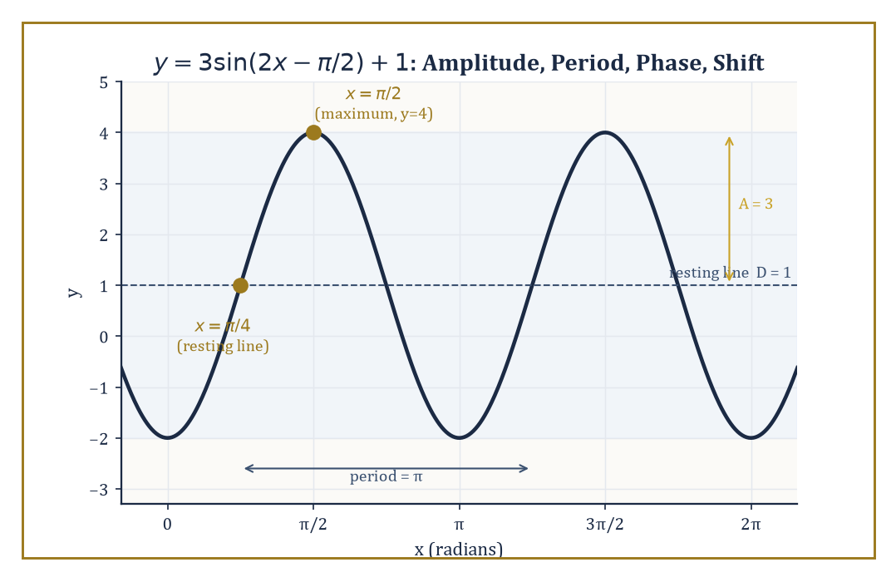
The worked-example sinusoid y = 3sin(2x − π/2) + 1, with its amplitude, period, phase shift, and resting line all marked.
cos x = sin(x + π/2)
a fact you can check directly from the complementary and shift identities of Room 6.3.
Numeric example — Worked example: five points that fix the shape of sin x. Five points fix the whole shape of one period:
x = 0: sin 0 = 0 (starting point)
x = π/2 ≈ 1.5708: sin(π/2) = 1 (peak)
x = π ≈ 3.1416: sin(π) = 0 (crossing back through zero)
x = 3π/2 ≈ 4.7124: sin(3π/2) = −1 (trough)
x = 2π ≈ 6.2832: sin(2π) = 0 (back to start, one full period completed)
Plotting just these five points and joining them with a smooth curve already gives a recognisable sketch of the whole wave.
The plain sine wave is a special case of a far more useful general form:
y = A sin(Bx + C) + D
Each of the four letters controls one visual feature independently. A is the amplitude, the height of the wave above (and depth below) its resting line — it stretches or compresses the wave vertically. B controls how tightly the wave is squeezed horizontally: the period, the length of one complete cycle, is 2π/|B|. C shifts the wave left or right (the phase shift, equal to −C/B). D slides the entire wave up or down (the vertical shift, moving the resting line from y = 0 to y = D). Four numbers, one formula, and an enormous variety of periodic behaviour becomes describable.
Numeric example — Worked example: reading off amplitude, period, phase, and shift. Take:
y = 3 sin(2x − π/2) + 1
Here A = 3, B = 2, C = −π/2, D = 1. Amplitude: 3, so the wave swings 3 units above and below its resting line. Period:
2π/|B| = 2π/2 = π
so one full cycle now takes only π units instead of 2π — the wave is squeezed to twice its original frequency. Phase shift:
−C/B = −(−π/2)/2 = π/4
so the whole wave is shifted right by π/4. Vertical shift: D = 1, so the resting line sits at y = 1 instead of y = 0, meaning the wave oscillates between 1 − 3 = −2 and 1 + 3 = 4. Check at x = π/4: the argument is 2(π/4) − π/2 = π/2 − π/2 = 0, and sin 0 = 0, giving y = 3(0) + 1 = 1 — exactly the resting line, as the phase shift predicted. Check at x = π/2: the argument is 2(π/2) − π/2 = π/2, sin(π/2) = 1, giving y = 3(1) + 1 = 4 — the maximum, right on schedule.
Tangent's graph looks nothing like sine or cosine's, because it inherits sine and cosine's worst behaviour: wherever cos x = 0 — at x = π/2, 3π/2, and every odd multiple of π/2 — tangent is undefined, and the graph shoots off to a vertical asymptote. Between any two consecutive asymptotes, tan x climbs steadily from −∞ up through 0 and on to +∞, and the whole pattern repeats with period π rather than 2π, since flipping both sin x and cos x's signs simultaneously (which is what happens after adding π) leaves their ratio unchanged.
Numeric example — Worked example: tangent's shorter period. Compute:
tan(π/4) = sin(π/4)/cos(π/4) = (√2/2)/(√2/2) = 1
Now add π: tan(π/4 + π) = tan(5π/4). Since 5π/4 is in the third quadrant, both sine and cosine are negative there: sin(5π/4) = −√2/2, cos(5π/4) = −√2/2, so:
tan(5π/4) = (−√2/2)/(−√2/2) = 1
the same value as tan(π/4), confirming the period is π. Compare this to sin(π/4) = √2/2 ≈ 0.7071 versus sin(5π/4) = −√2/2 ≈ −0.7071 — sine has not returned to its original value after adding π, since its period is the full 2π.
None of this graph-sketching is decorative. A great many identities and a great many trigonometric equations become obvious the instant the wave shape is fixed in your mind rather than buried in a formula. The visible fact that cosine is sine shifted left by a quarter-period is the geometric reason (a fact we will meet formally once calculus arrives) that the slope of the sine curve at any point equals the height of the cosine curve there — sine's rate of change is cosine, and cosine's rate of change is minus sine. And periodicity itself is the single deepest property in this room: it is what lets the same handful of functions describe a rotating wheel, a vibrating guitar string, alternating current, and the changing length of daylight through the seasons, because the unit circle turns steady linear motion around its circumference into motion that repeats — and the graph is simply that repetition, laid out flat on the page.
Numeric example — Worked example: a literal rotating wheel. A point on the rim of a wheel of radius 0.3 m spins at a steady 4 radians per second. Its height above the wheel's centre at time t seconds is:
h(t) = 0.3 sin(4t) metres
an instance of the general sinusoid with A = 0.3, B = 4, C = 0, D = 0. The period is 2π/4 = π/2 ≈ 1.5708 seconds per revolution. At t = 0.5 s:
h(0.5) = 0.3 sin(2) ≈ 0.3 × 0.9093 ≈ 0.2728 m above the centre
At t = π/8 ≈ 0.3927 s (one quarter of the way through a revolution):
h = 0.3 sin(4 × π/8) = 0.3 sin(π/2) = 0.3 × 1 = 0.3 m
exactly the radius, meaning the point is at the very top of the wheel, precisely as a quarter-turn should place it.

Room 6.5: Identities: The Algebra of the Ratios
A Closed System Pretending to Be an Open-Ended List
A trigonometric identity is an equation that holds for every value of the variable for which both sides are defined — not just for some convenient angle, but for all of them, forever. This is a stronger claim than an ordinary equation (which is typically true only for the specific values you are solving for), and it is why identities can be used as tools: substitute one side for the other anywhere it appears, in any expression, and the truth of the expression is untouched.
Numeric example — Worked example: an identity really does hold everywhere. The Pythagorean identity sin²θ + cos²θ = 1 claims to hold for every real θ, not just the angles we happen to like. Test θ = 0:
sin²0 + cos²0 = 0² + 1² = 0 + 1 = 1
Test θ = π/4:
sin²(π/4) + cos²(π/4) = (√2/2)² + (√2/2)² = 0.5 + 0.5 = 1
Test θ = 150° (from Room 6.3, sin 150° = 0.5, cos 150° = −√3/2):
0.5² + (−√3/2)² = 0.25 + 0.75 = 1
Three unrelated angles, three confirmations — this is what 'holds for all θ' looks like in practice, and it is provable in one stroke because it is just the Pythagorean theorem restated for the unit circle, not three separate coincidences.
The Pythagorean identity is the parent of most of the rest. The even/odd identities (sin(−θ) = −sin θ, cos(−θ) = cos θ) and the periodicity identities (sin(θ + 2π) = sin θ, and so on) fall straight out of the unit-circle picture from Room 6.3, as does the cofunction family (sin(90° − A) = cos A), which is just Room 6.2's complementary-angle relation dressed in more general clothing.
Numeric example — Worked example: a cofunction identity. Check sin(90° − A) = cos A at A = 20°. Left side:
sin(90° − 20°) = sin 70° ≈ 0.9397
Right side:
cos 20° ≈ 0.9397
They agree, because sin 70° and cos 20° are, geometrically, describing the same leg-over-hypotenuse ratio in a right triangle where the two acute angles are 20° and 70° — exactly the complementary relation from Room 6.2, now written for an arbitrary A rather than a special triangle.
The addition formulas run deeper and are worth stating in full, since almost everything else in this room derives from them:
sin(α + β) = sin α cos β + cos α sin β
cos(α + β) = cos α cos β − sin α sin β
They can be proved geometrically (with the distance formula on the unit circle, or with a careful area argument) or analytically once sine and cosine are defined via power series — but however they are proved, once you have them, the double-angle, half-angle, and product-to-sum formulas fall out as short algebraic exercises rather than fresh discoveries.
Numeric example — Worked example: computing sin 75° and cos 75° without a calculator. Write 75° = 45° + 30°, two angles we already know exactly from Room 6.2.
sin 75° = sin(45° + 30°) = sin 45° cos 30° + cos 45° sin 30° = (√2/2)(√3/2) + (√2/2)(1/2) = (√6 + √2)/4
Numerically: (2.4495 + 1.4142)/4 = 3.8637/4 ≈ 0.9659.
cos 75° = cos(45° + 30°) = cos 45° cos 30° − sin 45° sin 30° = (√2/2)(√3/2) − (√2/2)(1/2) = (√6 − √2)/4
Numerically: (2.4495 − 1.4142)/4 = 1.0353/4 ≈ 0.2588. A calculator confirms sin 75° ≈ 0.96593 and cos 75° ≈ 0.25882 — the addition formula, built entirely from angles we already had memorised, reproduces an angle we never memorised, exactly.
Setting β = α in the addition formulas hands us the double-angle formulas immediately:
sin 2θ = 2 sin θ cos θ
cos 2θ = cos²θ − sin²θ
which can also be rewritten, using the Pythagorean identity, as 2cos²θ − 1 or 1 − 2sin²θ, whichever is more convenient for the algebra in front of you.
Numeric example — Worked example: doubling the 3-4-5 angle. Let θ be the angle with sin θ = 3/5 = 0.6 and cos θ = 4/5 = 0.8 (θ ≈ 36.87°, from the 3-4-5 triangle). Then:
sin 2θ = 2 sin θ cos θ = 2(0.6)(0.8) = 0.96
cos 2θ = cos²θ − sin²θ = 0.64 − 0.36 = 0.28
Since 2θ ≈ 73.74°, a calculator gives sin 73.74° ≈ 0.9600 and cos 73.74° ≈ 0.2800 — matching exactly. As a bonus check: 0.96 and 0.28 satisfy the Pythagorean identity too, since:
0.96² + 0.28² = 0.9216 + 0.0784 = 1.0000
and in fact 24² + 7² = 576 + 49 = 625 = 25², so (7, 24, 25) is itself a Pythagorean triple — doubling the 3-4-5 angle happens to land on another exact triple, which is a pleasant coincidence rather than a general rule.
Do not mistake this room for a list to be memorised item by item, the way one might memorise a table of chemical elements. It is a closed algebraic system generated by a handful of geometric principles — the Pythagorean theorem and the addition formulas, essentially — and every other identity is a rearrangement of those two ideas. When you need to simplify an expression or solve an equation, you reach for the identity whose structure matches what you see in front of you, exactly as you once reached for a congruence criterion or a factoring pattern.
Abstract example — Worked example: simplifying by pattern-matching. Simplify sin θ · cot θ. Recognise the structure: cot θ = cos θ / sin θ by definition, so:
sin θ · cot θ = sin θ · (cos θ / sin θ) = cos θ
with the sin θ cancelling algebraically (valid wherever sin θ ≠ 0). Verify at θ = 40°: sin 40° ≈ 0.6428, cot 40° = cos 40°/sin 40° ≈ 0.7660/0.6428 ≈ 1.1918, and the product 0.6428 × 1.1918 ≈ 0.7660 — which matches cos 40° ≈ 0.7660 exactly. The whole simplification required nothing but the definition of cotangent; no new identity needed to be recalled at all, which is rather the point of this room.

Room 6.6: Solving Triangles: Right and Oblique
Two Laws to Rule the Triangles That Refuse to Be Right-Angled
A triangle is said to be 'solved' once all three side lengths and all three angles are known — the geometric equivalent of a completed jigsaw puzzle, except that here you are permitted to derive the missing pieces rather than merely dig them out of the box. Right triangles are solved with nothing more than Room 6.2's basic ratios and the fact that the angles sum to 180° (so the two acute angles are complementary). Oblique triangles — those with no right angle at all, and therefore no free favour from Room 6.2 — need two further tools: the law of sines and the law of cosines.
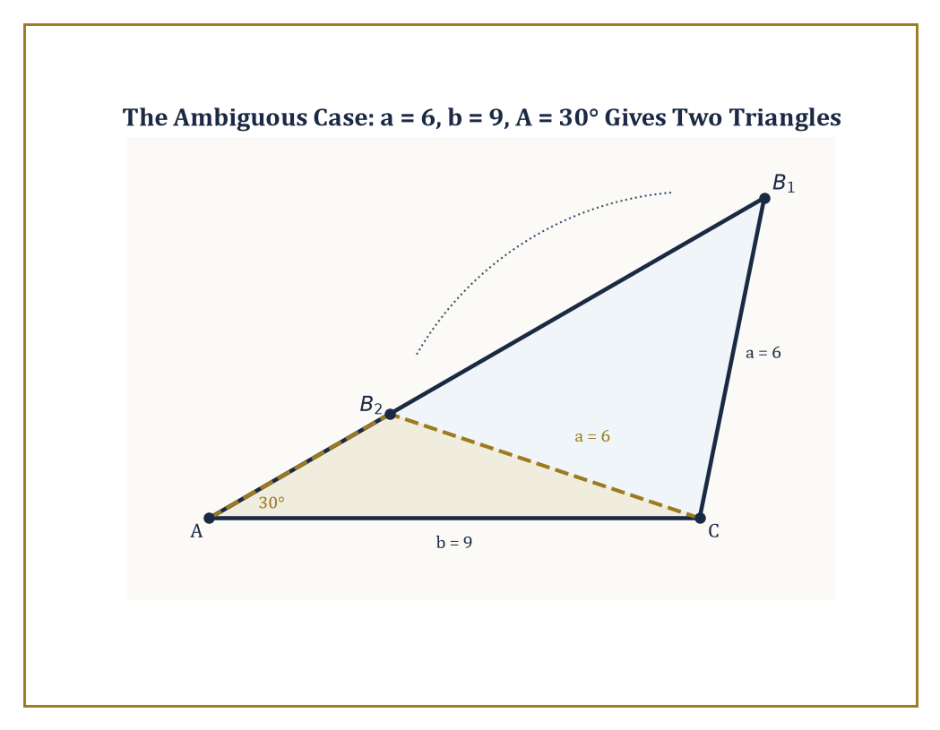
The worked ambiguous case: a = 6, b = 9, A = 30° pins down two genuinely different triangles, B₁ and B₂, both at distance 6 from C.
Numeric example — Worked example: a fully solved right triangle. Recall the scaled 3-4-5 triangle from Room 6.2: a = 6, b = 8, c = 10, A ≈ 36.87°, B ≈ 53.13°, C = 90°. All three sides and all three angles are known, so this triangle is solved. Notice that solving it required only sine, cosine, tangent, and the fact that the angles sum to 180° — no new machinery. The moment even one angle stops being 90°, however, that toolkit runs out, and we need the two laws below.
The law of sines states that:
a/sin A = b/sin B = c/sin C
every side, divided by the sine of its opposite angle, gives the same constant across the whole triangle. It follows from dropping an altitude from one vertex to the opposite side and writing that altitude's length two different ways (once using each of the two triangles the altitude creates). It is the natural tool whenever you know two angles and one side (AAS or ASA), or two sides and a non-included angle (SSA — the troublesome case we return to below).
Numeric example — Worked example: law of sines (AAS). A triangle has A = 40°, B = 65°, and side a = 10 (opposite A). Find everything else. First:
C = 180° − 40° − 65° = 75°
The common ratio is:
a/sin A = 10/sin 40° = 10/0.6428 ≈ 15.557
Then:
b = 15.557 × sin B = 15.557 × sin 65° = 15.557 × 0.9063 ≈ 14.10
c = 15.557 × sin C = 15.557 × sin 75° = 15.557 × 0.9659 ≈ 15.03
The triangle is now fully solved: A = 40°, B = 65°, C = 75°, a = 10, b ≈ 14.10, c ≈ 15.03.
The law of cosines states that:
c² = a² + b² − 2ab cos C
where C is the angle included between sides a and b. It is the direct generalisation of the Pythagorean theorem to triangles that are not right-angled: when C = 90°, cos C = 0, the last term vanishes entirely, and the familiar c² = a² + b² reappears as the special case it always was. It is the natural tool whenever you know all three sides (SSS) or two sides and the included angle (SAS) — precisely the situations where the law of sines cannot even get started, since it needs at least one angle-side pair already matched up.
Numeric example — Worked example: law of cosines (SAS), then finishing with the law of sines. A triangle has a = 7, b = 8, and included angle C = 60°. Find side c and the remaining angles.
c² = a² + b² − 2ab cos C = 49 + 64 − 2(7)(8)(0.5) = 113 − 56 = 57
c = √57 ≈ 7.550
Now switch to the law of sines to find angle A:
sin A = (a sin C)/c = (7 × sin 60°)/7.550 = (7 × 0.8660)/7.550 ≈ 6.062/7.550 ≈ 0.8029
giving A ≈ 53.4° (taking the acute solution, which is safe here because side a is not the triangle's longest side, so angle A cannot be obtuse — a point the ambiguous-case discussion below explains in full). Then:
B = 180° − 60° − 53.4° = 66.6°
Cross-check with the law of sines:
b/sin B = 8/sin 66.6° ≈ 8/0.9171 ≈ 8.72
c/sin C = 7.550/sin 60° ≈ 7.550/0.8660 ≈ 8.72
matching, as they must.
The ambiguous case, traditionally labelled SSA (two sides and a non-included angle), is the one configuration where the given data may pin down zero, one, or two genuinely different triangles — and it is worth understanding geometrically rather than memorising as a warning label. Picture the known angle sitting at one vertex, with one known side running along one of its arms; the second known side must swing from the far end of that arm until it reaches the correct length. Depending on that length, the swinging side may be too short to reach the triangle's third side at all (no triangle), may just graze it at a single point (exactly one triangle, a right angle), or may cross it at two distinct points (two different valid triangles). The law of sines, applied blindly, simply returns both algebraic possibilities and leaves it to you to check which are geometrically real.
Numeric example — Worked example: the ambiguous case genuinely producing two triangles. Given a = 6, b = 9, A = 30°, find B. By the law of sines:
sin B = (b sin A)/a = (9 × 0.5)/6 = 4.5/6 = 0.75
so B ≈ 48.59° or B ≈ 180° − 48.59° = 131.41° (sine is positive in both the first and second quadrants, so both are candidate solutions). Check the first:
C = 180° − 30° − 48.59° = 101.41°
a positive, valid angle — triangle one is legitimate. Check the second:
C = 180° − 30° − 131.41° = 18.59°
also positive and valid — triangle two is legitimate as well. Both survive, so this data genuinely describes two different triangles, which is possible here precisely because b > a (the side opposite the unknown angle is longer than the side opposite the known angle) and a is still large enough to reach across (a = 6 > b sin A = 9 × 0.5 = 4.5).
Together, the two laws, the fact that angles sum to 180°, and the basic ratios of Room 6.2 let us solve any triangle determined by the usual congruence or similarity data from the previous storey — SSS, SAS, ASA, AAS, and the occasionally treacherous SSA. The arithmetic of solving is routine, essentially plug-and-compute; the genuine content, the part worth actually understanding rather than automating, is knowing in advance which law applies to which data, and recognising the geometric situations where a unique triangle simply is not guaranteed to exist.

Room 6.7: Inverse Functions and the Ambiguity of Angles
Undoing Sine Without Losing Half the Answers
The sine function is not one-to-one across the whole real line — many different angles produce the same sine value — so, strictly, it has no inverse in the ordinary sense at all. The standard fix is to restrict sine's domain to the interval [−π/2, π/2] (that is, −90° to 90°), a window on which sine is continuous and strictly increasing from −1 up to 1, with no repeats. On that restricted window, and only on that window, sine genuinely is invertible, and we call its inverse arcsine. The same trick is applied to cosine, restricted to [0, π], giving arccosine, and to tangent, restricted to (−π/2, π/2), giving arctangent.
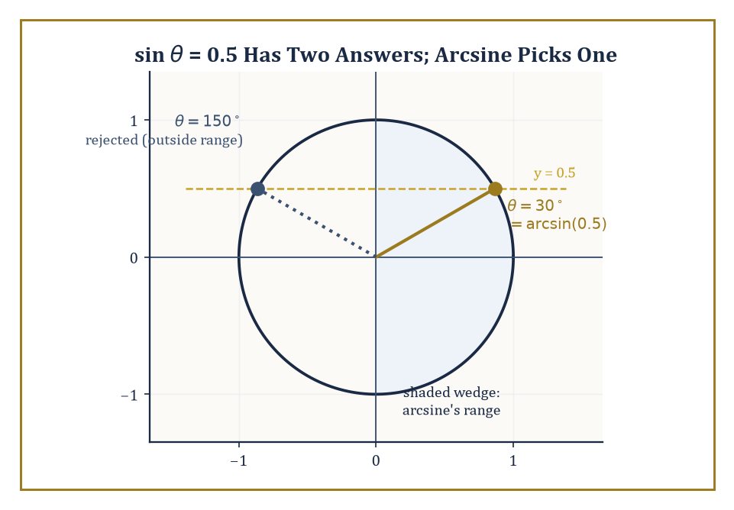
sin θ = 0.5 is true at both 30° and 150°; arcsine's restricted range keeps only the one inside the shaded wedge.
Numeric example — Worked example: why the restriction is necessary. sin 30° = 0.5, and also sin 150° = 0.5 (from Room 6.3's calculation). Given only the output 0.5, there is no way to tell which input produced it — both are equally valid. But only 30° lies inside the restricted window [−90°, 90°], while 150° does not. So by convention:
arcsin(0.5) = 30°
is the single, unambiguous answer the restricted function returns, even though it is not the only angle whose sine is 0.5. The restriction did not remove the ambiguity from the world; it simply chose one representative and agreed to call it 'the' answer.
Values returned by an inverse trigonometric function in this way are called principal values, and remembering that they are only one representative out of infinitely many true solutions is the single most important habit this room can teach. When solving an equation like sin θ = 1/2, applying arcsine gives the principal value θ = π/6 (30°) — but that is step one of two, not the whole answer. Step two is to use the symmetries of sine from Room 6.3 (specifically, that sin θ = sin(π − θ), since both angles have the same reference angle and the same sign in quadrants I and II) to list every solution:
θ = π/6 + 2kπ or θ = 5π/6 + 2kπ, for any integer k
Numeric example — Worked example: the general solution of sin θ = 1/2. Restricting attention to one full turn, θ ∈ [0, 2π): the principal value is θ = π/6 = 30°, and sin 30° = 0.5 checks out immediately. The companion solution comes from π − π/6 = 5π/6 = 150°, and indeed sin 150° = 0.5 as well (computed exactly in Room 6.3). No other angle in [0, 2π) gives sine 0.5 — sine is negative throughout the third and fourth quadrants, so those are ruled out entirely. Adding whole multiples of 2π to either 30° or 150° generates every solution on the entire real line: for instance k = 1 gives:
θ = π/6 + 2π = 13π/6 ≈ 390°
and indeed sin 390° = sin 30° = 0.5, since 390° and 30° are coterminal.
The same two-step pattern — find the principal value with the inverse function, then use the relevant symmetry to recover every other solution — holds for the other inverse functions too, though the exact symmetry used differs because each function's period and sign pattern differ. This is the trigonometric cousin of remembering that a quadratic equation has (generically) two roots rather than one: applying the inverse operation is only ever the opening move.
Numeric example — Worked example: solving tan θ = 1. Arctangent gives the principal value:
θ = arctan(1) = π/4 = 45°
and indeed tan 45° = sin 45°/cos 45° = 1. But tangent's period is π, not 2π (established in Room 6.4), so the general solution only needs whole multiples of π added, not 2π:
θ = π/4 + kπ
Checking k = 1: θ = π/4 + π = 5π/4 = 225°, which lies in the third quadrant where both sine and cosine are negative, so their ratio is again positive: tan 225° = tan 45° = 1, confirmed. Tangent needed only half as many extra solutions per full turn as sine did, precisely because its period is half as long.
Inverse trigonometric functions are not merely a bookkeeping device for undoing equations; they answer a question that arises constantly in applied geometry — given a ratio of sides, what angle produced it? — and they will reappear later in the Tower as antiderivatives once calculus is built (the derivative of arcsine, for instance, turns out to involve 1/√(1 − x²), though proving that is a project for a much higher storey). Their conventional ranges — [−90°, 90°] for arcsine, [0°, 180°] for arccosine, (−90°, 90°) for arctangent — are not arbitrary; they are chosen specifically so that the resulting identities stay as clean as possible, at the cost of a little bookkeeping vigilance from the person using them.
Numeric example — Worked example: recovering an angle from a ratio of sides. A ladder 5 m long leans against a wall with its foot 2 m from the wall's base. What angle does the ladder make with the ground? The ladder is the hypotenuse (5 m), and the 2 m distance along the ground is the side adjacent to the angle at the foot, so:
cos θ = 2/5 = 0.4
Then:
θ = arccos(0.4) ≈ 66.42°
As a check, the height the ladder reaches up the wall is the opposite side: by the Pythagorean theorem,
height = √(5² − 2²) = √(25 − 4) = √21 ≈ 4.583 m
and sin(66.42°) ≈ 0.9165, so 5 × 0.9165 ≈ 4.58 m — matching, as it should.

Room 6.8: Applications: From Surveying to Oscillations
Where the Ratios Go to Work
Trigonometry's original job, the one it was invented for millennia before anyone dreamed of unit circles or power series, was terrestrial and celestial measurement: the heights of mountains, the widths of rivers too dangerous to wade across, the distances to ships on the horizon, the positions of stars against the sky. All of these reduce to solving a triangle once a small number of angles and a single measured baseline are known — and the same underlying methods still quietly underwrite modern surveying instruments and the post-processing behind GPS positioning.
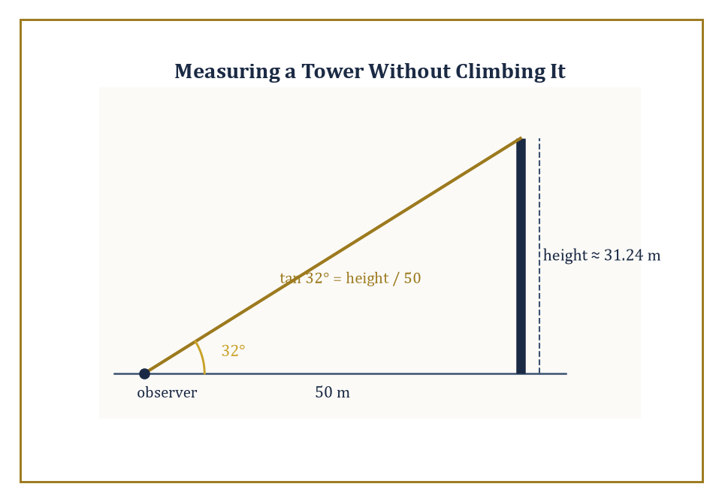
The tower problem from the worked example: one angle, one baseline, and a height nobody had to climb up to measure.
Numeric example — Worked example: measuring a tower without climbing it. An observer stands 50 m from the base of a tower and measures the angle of elevation to its top as 32°. The tower's height, the baseline, and the line of sight form a right triangle with the height opposite the 32° angle and the baseline (50 m) adjacent to it, so:
tan 32° = height/50
height = 50 × tan 32° = 50 × 0.6249 ≈ 31.24 m
Not a single measurement was taken above ground level — the entire height was recovered from one angle and one horizontal distance, which is precisely the kind of problem that funded trigonometry's early development.
In physics, the same functions describe simple harmonic motion — the technical name for any back-and-forth motion where the restoring force is proportional to displacement. A mass bobbing on a spring, a pendulum swinging through a small angle, a single point on a wheel spinning at constant speed: all of these have positions that vary sinusoidally with time. The vocabulary of amplitude, frequency, phase, and period, introduced purely as graph-reading terms in Room 6.4, is precisely the vocabulary physicists reach for to describe this motion, because it is literally the same mathematics.
Numeric example — Worked example: a mass on a spring. A mass on a spring has position:
x(t) = 5 cos(2t) centimetres
measured from the spring's resting point, where t is time in seconds. Amplitude 5 cm means the mass swings 5 cm to either side of rest. Angular frequency B = 2 gives period 2π/2 = π ≈ 3.1416 seconds per full oscillation. At t = 0:
x = 5 cos 0 = 5 cm
the mass starts at maximum displacement (as cosine, unlike sine, does). At t = π/4 ≈ 0.785 s:
x = 5 cos(2 × π/4) = 5 cos(π/2) = 5 × 0 = 0 cm
the mass passes through the resting point. At t = π/2 ≈ 1.571 s:
x = 5 cos(π) = 5 × (−1) = −5 cm
the mass reaches its opposite extreme — exactly a quarter-period after the start, as the period π predicts a full swing-out-and-back every π seconds and a swing-to-the-other-side every half-period.
In engineering, alternating current, radio waves, and the vibration of physical structures are all modelled directly with trigonometric functions, or with their complex-exponential cousins once the mathematics gets serious. Fourier analysis, which we will only glimpse from a great height in this storey, later proves the extraordinary claim that essentially any periodic signal at all — however jagged, however far from a smooth wave — can be decomposed into a sum of pure sines and cosines. In that sense trigonometry functions as the atomic theory of periodic phenomena: sines and cosines are the periodic 'elements' that every more complicated periodic 'compound' is built from.
Numeric example — Worked example: household AC voltage. Household alternating current in the United States is nominally described by:
V(t) = 170 sin(2π × 60 × t) volts
where t is time in seconds — a peak voltage of 170 V oscillating 60 times per second (60 Hz). The commonly quoted '120 volts' is not the peak; it is the root-mean-square (RMS) voltage, related to the peak by:
V_rms = V_peak/√2 = 170/1.41421 ≈ 120.2 V
which is exactly the familiar household figure, recovered from nothing more than the amplitude of a sine wave and one division by √2.
Even in pure mathematics, far from any spring or circuit, the trigonometric functions keep reappearing: as the real and imaginary parts of the complex exponential function, as the natural vibration modes (eigenfunctions, in the jargon) of the Laplacian operator on a circle, and as the fundamental building blocks of Fourier series. The ratios that began life measuring the pitch of a roof turn out to be the natural coordinates for rotation and periodicity across the whole of mathematics — which is either a remarkable coincidence or, more plausibly, evidence that rotation and periodicity really are one underlying idea wearing several different costumes.
Worked example — Worked example: a first glimpse of the complex exponential. Euler's formula (proved properly once complex analysis is built, several storeys up) states that:
e^(iθ) = cos θ + i sin θ
where i is the imaginary unit. Take θ = π/3 = 60°:
e^(iπ/3) = cos 60° + i sin 60° = 0.5 + i(√3/2) ≈ 0.5 + 0.8660i
This is exactly the point (0.5, 0.8660) on the unit circle from Room 6.3, now written as a single complex number instead of a pair of coordinates. Its distance from the origin — its modulus —
|0.5 + 0.8660i| = √(0.5² + 0.8660²) = √(0.25 + 0.75) = √1 = 1
confirms it still lies exactly on the unit circle, no matter how the point is written down. The unit circle, it turns out, was secretly the graph of a complex exponential all along; trigonometry simply met it first.

Room 6.9: Looking Ahead: From Trigonometry to Logarithms, Vectors, and Waves
The View from the Top of This Particular Staircase
We have now acquired the full basic vocabulary of trigonometry: the six ratios and their birth in similar right triangles (Rooms 6.1–6.2); the unit-circle definition that frees them from triangles entirely and extends them to every real angle (Room 6.3); the graphs and the periodicity that graphs make visible (Room 6.4); the identity system, all of it ultimately descended from one Pythagorean fact and one pair of addition formulas (Room 6.5); the two laws that solve any triangle whatsoever, right or oblique (Room 6.6); the inverse functions, with their careful bookkeeping of which of many possible angles is 'the' answer (Room 6.7); and a tour of the places these functions turn out to be indispensable, from a surveyor's tower to a household electrical socket (Room 6.8).
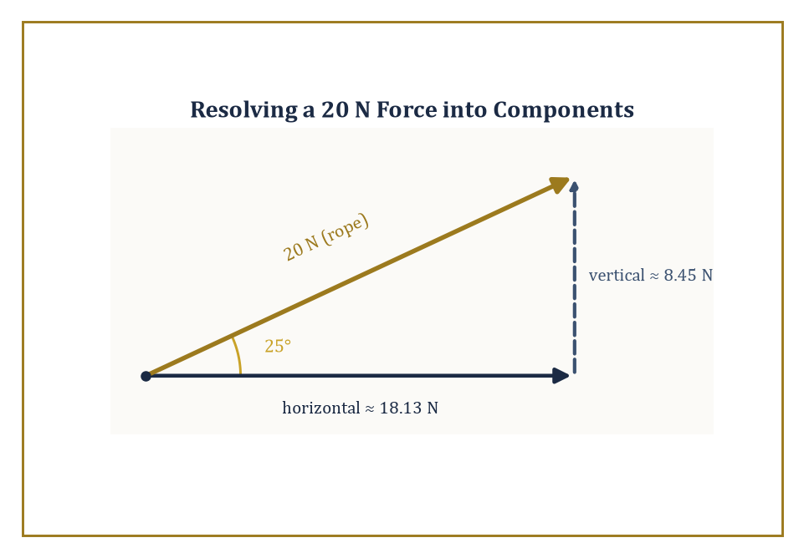
The rope-and-crate example, previewing how vectors will resolve any force into perpendicular components using nothing but sine and cosine.
Abstract example — Worked example: Euler's identity, the postcard from three storeys up. Take the complex exponential formula from Room 6.8, e^(iθ) = cos θ + i sin θ, and set θ = π (that is, 180°). Then cos π = −1 and sin π = 0, so:
e^(iπ) = −1 + i(0) = −1
Rearranged, this reads:
e^(iπ) + 1 = 0
a single equation binding together e, i, π, 1, and 0, five of the most important constants in mathematics, using nothing but addition, multiplication, and exponentiation. It is usually presented as pure magic. It is not magic; it is the unit-circle point at exactly halfway around the circle, at (−1, 0), written in exponential clothing — which is precisely why trigonometry, and not some unrelated piece of number theory, is the reason this identity exists at all.
None of this machinery gathers dust once we leave this storey. The next storey turns to logarithms and exponents — on the surface, an entirely different piece of mathematical furniture, concerned with growth and decay rather than rotation. But the worked example above is a preview of where the two subjects secretly merge: once exponentiation is extended to imaginary exponents, sine and cosine turn out to be exponentials in disguise, rotating around the complex plane instead of climbing along the real line. That fact, quietly unifying trigonometry, exponential growth, and complex numbers into a single piece of machinery, is waiting a little further up the Tower, once logarithms have supplied the missing vocabulary.
Higher still, the same ratios keep earning their keep. Vectors will lean on sine and cosine to resolve a single force or velocity into perpendicular components — the same right-triangle bookkeeping from Room 6.2, just relabelled. Differential equations will produce sinusoidal solutions the moment a physical system pushes back against being displaced, which is simply simple harmonic motion from Room 6.8 wearing an equation instead of a spring. And Fourier analysis will eventually make good on the promise glimpsed in Room 6.8: that any periodic signal whatsoever, however jagged, is secretly built from nothing but the smooth waves we sketched in Room 6.4, added together in the right proportions.
Numeric example — Worked example: a force resolved into components, a preview of the vector storeys ahead. A rope pulls on a crate with a force of 20 newtons, directed 25° above the horizontal. To find how much of that pull acts horizontally (dragging the crate forward) and how much acts vertically (lifting it), treat the force as the hypotenuse of a right triangle:
horizontal component = 20 cos 25° ≈ 20 × 0.9063 ≈ 18.13 N
vertical component = 20 sin 25° ≈ 20 × 0.4226 ≈ 8.45 N
Check with the Pythagorean identity:
18.13² + 8.45² ≈ 328.7 + 71.4 ≈ 400.1 ≈ 20²
recovering the original 20 N force (the small discrepancy is only rounding). Nothing here is new mathematics — it is Room 6.2's sin A = opposite/hypotenuse and cos A = adjacent/hypotenuse, read backwards to build a triangle from a known hypotenuse and angle instead of solving for one. Vectors, several storeys up, will do this constantly and call it 'resolving into components' as though it were a different subject.
It is also worth being honest about what this storey has deliberately not done. We have not proved the addition formulas from first principles, not derived the derivatives of sine and cosine, not touched Fourier series beyond naming them, and not said a serious word about complex analysis beyond one illustrative postcard in Room 6.8. That is not an oversight; it is the discipline this Tower runs on. Each storey supplies the vocabulary and the working intuition the next storey needs, and no more — piling calculus and complex analysis onto a first encounter with sine and cosine would bury the one idea actually worth remembering under machinery that is better met once it has a proper home of its own.
The lesson worth carrying up the stairwell, then, is a small one dressed in large clothes: one observation about similar triangles, patiently generalised past its original triangle, past its original acute-angle restriction, and past its original geometric habitat altogether, turned into the mathematics of everything that repeats. The tower continues upward. The ratios are now functions, and functions, as the next several storeys are about to demonstrate, have a great deal more to say for themselves.
We have, in nine rooms, built the whole classical apparatus: the six ratios, their extension to every real angle via the unit circle, the graphs and the periodicity that graphs make visible, the identity system that the Pythagorean theorem generates almost by itself, the two laws that solve any triangle at all, the inverse functions with their careful bookkeeping of ambiguity, and a tour of the places — bridges, springs, alternating current, sound — where these functions turn out to be exactly the right tool for the job.
None of this is a dead end. The next storey turns to logarithms and exponents, which look at first glance like an entirely unrelated piece of mathematical furniture — until you meet Euler's formula and discover that sine and cosine are, in a precise sense, exponentials in disguise, rotating around the complex plane instead of climbing along the real line. That single fact quietly unifies trigonometry, exponential growth, and complex numbers into one machine, and it is waiting for you once the vocabulary of logarithms is in place. Higher still, vectors will lean on sine and cosine to resolve a force into components, differential equations will produce sinusoids the moment a system pushes back against being displaced, and Fourier analysis will eventually declare that any periodic signal whatsoever, no matter how jagged, is secretly a sum of the smooth waves we met in Room 6.4.
The lesson worth carrying up the stairwell is a small one dressed in large clothes: one observation about similar triangles, patiently generalised, turned into the mathematics of everything that repeats. The tower continues upward. The ratios are now functions, and functions have a great deal more to say for themselves.

Storey 7: Logarithms & Potencies
Exponents, Logarithms, and the Art of Turning Multiplication into Addition
The previous storey spent its entire span going round in circles, and — this being trigonometry — meant that as a compliment. Sine and cosine oscillate forever between −1 and 1, dutifully retracing their steps every 2π, never getting anywhere and never wanting to. It is, in its way, a very restful branch of mathematics. Nothing in it will ever surprise you by quietly becoming infinite while your back is turned.
This storey is not restful. Here we meet a function that has never retraced a step in its life and has no intention of starting now: the exponential. Where trigonometric functions are content to orbit, exponential functions run away from home the moment the exponent is turned up, and they do not slow down, and they do not come back. Their inverse — the logarithm — is mathematics' equivalent of a very patient bookkeeper, quietly converting all that frantic multiplication into orderly, well-behaved addition.
The idea is old, and frankly a little bit magnificent. In the early seventeenth century John Napier and Henry Briggs built tables that let a working astronomer replace a laborious multiplication with a quick addition and a glance down a printed column of numbers, saving several centuries' worth of human arithmetic-related suffering. We no longer need the tables; we kept the idea, because it turned out to be one of the load-bearing walls of the whole Tower. The exponential function is the unique function that is its own derivative; its logarithm is the unique inverse that turns scaling into shifting; and between them they describe almost everything that grows, decays, compounds, or radiates.
In this storey we build exponents up from repeated multiplication to real exponents, meet the logarithm as their inverse, collect the laws that make both worth having, single out the strange and rather wonderful number e, look at the graphs, and finish with the applications — growth, decay, pH, decibels, and the reason a computer can search a million-item list in about twenty steps. The next storey up deals with systems of equations, where more than one unknown insists on being solved for at once; several of those systems, you may be unsurprised to learn, will involve an exponential or a logarithm refusing to behave linearly. Let's begin with powers.

Room 7.1: What Exponents and Logarithms Actually Are
Two Operations, One Very Old Trick
An exponent is nothing more mysterious than a shorthand for repeated multiplication. When n is a positive whole number, aⁿ means a multiplied by itself n times, with n copies of a standing in the queue:
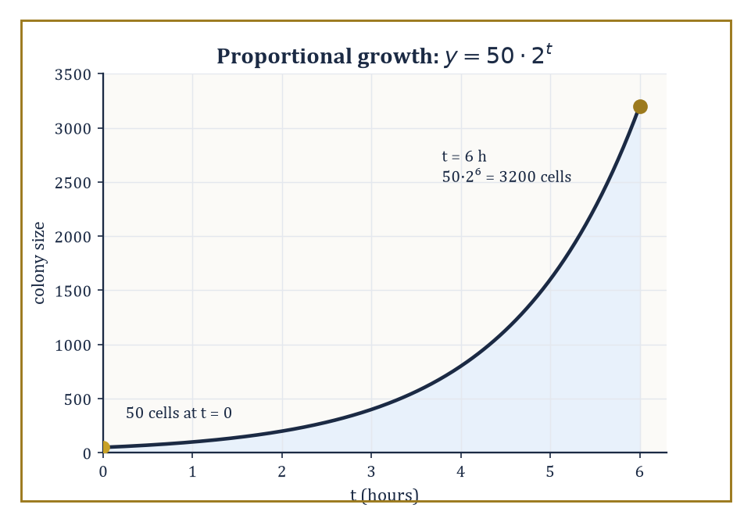
The bacterial colony from the worked example, 50·2^t, doing what exponentials do best: looking tame, then very suddenly not.
aⁿ = a · a · a · ⋯ · a (n factors)
It is a notation, not a new idea — but it is such a convenient notation that mathematicians spent the following four centuries stretching it to cover cases repeated multiplication was never designed for: zero copies of a, negative numbers of copies, fractional numbers of copies, and eventually irrational and even complex numbers of copies, none of which make any literal sense as a count of factors. We build that extension carefully over the next two rooms; for now, treat aⁿ as n factors of a multiplied together, and nothing more.
Numeric example — Worked example — repeated multiplication. Take a = 2 and n = 5. By definition, 2⁵ is five factors of 2 multiplied together:
2⁵ = 2 × 2 × 2 × 2 × 2
Working left to right:
2 × 2 = 4
4 × 2 = 8
8 × 2 = 16
16 × 2 = 32
So 2⁵ = 32 — five multiplications, one final answer, and (as we are about to see) a question we can now ask in reverse: what power of 2 gives 32? The answer, unsurprisingly, is 5.
A logarithm is simply that reverse question, made official. We write log_b a = c to mean exactly this: b raised to the power c equals a.
log_b a = c means b^c = a
The number b is the base, a is the argument (which must be positive), and c — the logarithm itself — is the exponent you would need to apply to b to land on a.
Because exponentiation and the logarithm are asking the same question from opposite directions, each one cancels the other when applied in sequence:
log_b(b^x) = x
b^(log_b x) = x
Feed a number through one operation and then the other, in either order, and you get back exactly what you started with — provided you stay within the domains where both are defined.
Numeric example — Worked example — undoing exponentiation. Let b = 3. Since
3⁴ = 3 × 3 × 3 × 3 = 81
log_3 81 = 4
the logarithm simply names the exponent that produced 81. Going the other way:
3² = 9
log_3 9 = 2
Check the cancellation rule on this pair: log_3(3⁴) should equal 4 (it does, by inspection), and 3^(log_3 9) should equal 9 — and indeed 3² = 9. The two operations really do undo one another.
The reason anyone bothered inventing this reverse operation was not aesthetic; it was exhausted arithmetic. Multiplying two large numbers by hand is slow and error-prone; adding two numbers is neither.
The logarithm's defining algebraic property — proved properly in Room 7.5 — means that if you have a table listing the logarithm of every number you might need, you can replace a multiplication with a lookup, an addition, and a second lookup:
log(xy) = log x + log y
Napier published the first such tables in 1614; Briggs refined them into the base-10 tables that dominated scientific computation for the next three hundred years; the slide rule, a physical strip of logarithmically spaced numbers, mechanised the same trick and sat in every engineer's pocket until pocket calculators made it obsolete sometime around 1975.
Numeric example — Worked example — multiplication by addition. Suppose you want 100 × 1000 but, for period-appropriate drama, no calculator. Write both numbers as powers of 10:
100 = 10², 1000 = 10³
The law of exponents says:
10² × 10³ = 10^(2+3) = 10⁵ = 100,000
and indeed 100 × 1000 = 100,000. You have replaced a multiplication with an addition (2 + 3 = 5) and a translation back from exponent to number. A seventeenth-century logarithm table did exactly this for numbers that were not tidy powers of 10, by looking up log 100 = 2 and log 1000 = 3, adding to get 5, and reading off that the number whose logarithm is 5 is 100,000.
We do not need the tables any more — that particular battle was won decades ago — but the mathematics they were built on has, if anything, become more central. Populations, radioactive isotopes, bacterial colonies, compound interest, and epidemics all grow or decay by a fixed proportion per unit time, and every one of them is governed by an exponential function.
The pH scale, the Richter scale, and the decibel scale are all logarithmic, precisely because the quantities they measure range over so many orders of magnitude that a linear scale would be useless.
And in pure analysis the exponential function earns a still deeper honour: it is the unique function equal to its own derivative, the unique solution of
y′ = y, y(0) = 1
— a fact we are not yet equipped to prove, but worth filing away now, because it is the reason the exponential keeps turning up in places that have nothing obviously to do with powers.
Numeric example — Worked example — proportional growth. A bacterial colony starts at 50 cells and doubles every hour. After t hours its size is:
50 × 2^t
After 6 hours:
2⁶ = 64
(by the same repeated-multiplication process as before), so the colony numbers:
50 × 64 = 3200 cells
Notice the shape of the calculation: the base (2, the doubling factor) stays fixed, and it is the exponent (t, elapsed time) that does the work of describing growth. That is the exponential function in its natural habitat, and it is why every proportional-growth process in Room 7.8 will look like a constant raised to a variable power.
The rest of this storey builds outward from these two ideas. We extend exponents from whole numbers to all real numbers, collect the laws that make them algebraically powerful, define the logarithm properly as their inverse and collect its laws in turn, meet the special base e that calculus insists on, look at the graphs, and finish with the applications that made the whole apparatus worth inventing in the first place.

Room 7.2: Integer and Rational Exponents
Forcing the Definitions to Behave
For a positive whole number n, we already have aⁿ pinned down as n factors of a multiplied together. Two facts fall out immediately, just from counting factors.
First, m factors of a followed by n more factors of a is simply m + n factors of a lined up together:
a^m · a^n = a^(m+n)
Second, raising a^m to the nth power means writing out n copies of a^m and multiplying them, which is mn copies of a in total:
(a^m)^n = a^(mn)
Neither of these is a new assumption; both are careful accounting. The interesting move comes next: we want aⁿ to make sense for n = 0 and for negative n, where 'n copies of a' means nothing at all, and we want the product rule above to keep working regardless. That single requirement — keep the product rule true — turns out to force every other definition we need, with no freedom left to choose otherwise.
Numeric example — Worked example — why a⁰ must equal 1. Suppose a = 7 and we insist a^m · a^n = a^(m+n) continues to hold even when n = 0. Set m = 3:
7³ · 7⁰ = 7^(3+0) = 7³
Since 7³ = 343, this says:
343 · 7⁰ = 343
and the only number that leaves 343 unchanged under multiplication is 1. So 7⁰ = 1 is not a convention plucked from the air; it is the unique value consistent with the product rule. The same argument works for any nonzero a, which is why a⁰ = 1 for every a ≠ 0 (and why 0⁰ is left undefined — there is no factor left to cancel against).
The same trick pins down negative exponents. Demand that:
a^n · a^(−n) = a^(n + (−n)) = a⁰ = 1
and you are forced into:
a^(−n) = 1/a^n
the negative exponent is simply the reciprocal of the corresponding positive one. There is, once again, no other choice available if the product rule is to survive.
Numeric example — Worked example — negative exponents. Let a = 2, n = 3. The product rule demands:
2³ · 2^(−3) = 2⁰ = 1
Since 2³ = 8, this forces:
2^(−3) = 1/8
Direct check:
8 × (1/8) = 1
as required. And 1/8 = 0.125, which is indeed what a calculator gives for 2^(−3) — the definition was not a guess.
Roots enter through a different door: solving xⁿ = a rather than evaluating aⁿ directly:
xⁿ = a
For a positive integer n and a ≥ 0, there is exactly one non-negative solution, called the principal nth root and written ⁿ√a, or equivalently a^(1/n).
Rational exponents then combine roots and integer powers: a^(m/n) is defined as (a^(1/n))^m, which — because the two exponent laws above are still required to hold — equals (a^m)^(1/n) as well:
a^(m/n) = (a^(1/n))^m = (a^m)^(1/n)
you may take the root first or the power first, in either order, and land in the same place. Some care is needed when n is even and a is negative, since even roots of negative numbers are not real numbers at all — we return to that trap in the next room.
Numeric example — Worked example — a rational exponent two ways. Compute 8^(2/3).
Root first:
8^(1/3) = 2, because 2³ = 8
2² = 4
Power first:
8² = 64
64^(1/3) = 4, because 4³ = 4×4×4 = 64
Both routes give:
8^(2/3) = 4
exactly as the theory promises. As a check on the boundary case, note:
16^(1/4) = 2, since 2⁴ = 16
but (−16)^(1/4) has no real value, because no real number raised to an even power (4) can produce a negative result. The definitions are forced; reality still gets a veto.
Irrational exponents — 2^√2, for instance — cannot be defined by counting factors or by any finite root-and-power recipe, because √2 is neither a whole number nor a fraction.
The standard fix is a limiting process: approximate the irrational exponent by a sequence of rationals that converge to it, and take the limit of the corresponding rational powers.
It is not the only route — one can instead define the exponential function directly via a power series, or as the solution of y′ = y, and set:
a^x = e^(x ln a)
both give the same answer — but it is the most transparent one, and it is worth watching converge with actual numbers rather than taking on faith.
Numeric example — Worked example — approaching 2^√2. √2 = 1.41421356… Using successively better rational approximations to the exponent, each computed by the same 'multiply out enough decimal places' machinery a calculator uses internally:
2^1.4 ≈ 2.639
2^1.41 ≈ 2.657
2^1.414 ≈ 2.665
The values creep steadily upward and slow down as they go — the signature of a convergent sequence — closing in on the true value:
2^√2 ≈ 2.66514
Nobody ever finishes this calculation by brute force; the point is that the limit exists and is well defined, which is all the rigorous construction actually needs.
A rational exponent is frequently misread, and the confusion is worth naming so it can be avoided rather than discovered the hard way in an exam. a^(−1/2) means the reciprocal of the square root of a, not the negative of the square root; and −a^(1/2) means the negative of the square root of a, not the square root of a negative number.
The minus sign attached to the exponent and a minus sign standing outside the whole expression do entirely different jobs, and swapping them by accident is one of the most common algebra errors made with this notation — common enough that it deserves its own worked comparison.
Numeric example — Worked example — two different minus signs. Compute 4^(−1/2) and compare it with −4^(1/2). First:
4^(1/2) = 2 (since 2² = 4)
4^(−1/2) = 1/4^(1/2) = 1/2 = 0.5
Second:
−4^(1/2) = −(4^(1/2)) = −2
The two results, 0.5 and −2, could hardly be more different — clear proof that a minus sign inside the exponent and a minus sign outside the expression are not interchangeable, even though the notation places them only a few characters apart.
Combining several rational-exponent rules in a single simplification is routine once the individual pieces are trusted, and the laws collected properly in Room 7.3 apply to rational exponents exactly as they applied to whole ones.
Numeric example — Worked example — simplifying with rational exponents. Simplify 32^(3/5) two ways.
Root first:
32^(1/5) = 2, since 2⁵ = 32
2³ = 8
Power first:
32³ = 32,768
32,768^(1/5) = 8, since 8⁵ = 8×8×8×8×8 = 32,768
Both routes agree on:
32^(3/5) = 8
as the theory guarantees — but the arithmetic in the middle of the two routes looks nothing alike, which is exactly why the root-first route (small numbers throughout) is almost always the more sensible one to reach for by hand.

Room 7.3: The Laws of Exponents
Five Rules and One Cautionary Tale
Collecting what integer and rational exponents give us, we arrive at five identities that do essentially all the work in this storey, together with two boundary facts established in the previous room.
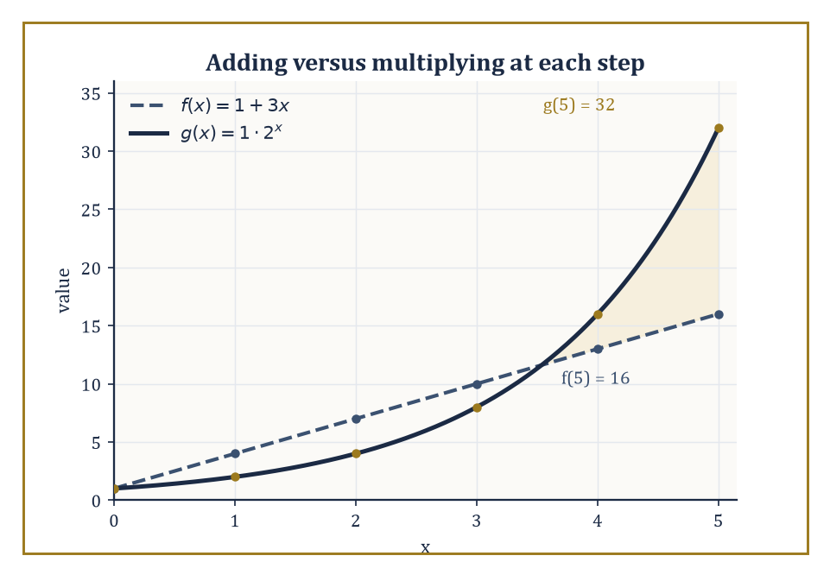
f(x) = 1 + 3x and g(x) = 2^x agree on being unremarkable near x = 0; only one of them means it.
a^m · a^n = a^(m+n)
(a^m)^n = a^(mn)
(ab)^n = a^n · b^n
a^m / a^n = a^(m−n)
(a/b)^n = a^n / b^n
a⁰ = 1
a^(−n) = 1/a^n
For positive a and real exponents, these hold without exception, and the underlying reason they matter so much is always the same: they turn multiplication of powers into addition of exponents, and powers of powers into multiplication of exponents.
That is a genuine reduction in difficulty, not a cosmetic one — it is the entire reason logarithms were worth inventing, and every one of these five identities gets reused in Room 7.5.
Numeric example — Worked example — the product and power rules. Product rule: 2³ · 2⁴ should equal 2^(3+4).
2³ · 2⁴ = 2^(3+4) = 2⁷ = 128
Direct check: 2³ = 8, 2⁴ = 16, and 8 × 16 = 128. Matches.
Power rule: (3²)³ should equal 3^(2×3).
(3²)³ = 3^(2×3) = 3⁶ = 729
Direct check: 3² = 9, and 9³ = 9×9×9 = 729. Matches.
The remaining three identities extend the same logic to products, quotients, and division of powers.
(ab)ⁿ = aⁿbⁿ
This says a power distributes over multiplication inside the base.
a^m/a^n = a^(m−n)
This is the product rule run in reverse, obtained by combining:
a^m · a^(−n) = a^(m + (−n))
(a/b)ⁿ = aⁿ/bⁿ
This is the same distributive idea applied to division.
Numeric example — Worked example — distributing and dividing. Distributive rule: (2×5)³ should equal 2³×5³.
(2×5)³ = 2³×5³
Direct check: 10³ = 1000, and 2³×5³ = 8×125 = 1000. Matches.
Quotient rule: 5⁷/5⁴ should equal 5^(7−4).
5⁷/5⁴ = 5^(7−4) = 5³ = 125
Direct check: 5⁷ = 78125, 5⁴ = 625, and 78125 ÷ 625 = 125. Matches.
Now for the cautionary tale, because these laws are so quotable that it is tempting to apply them everywhere, and they do not, in fact, apply everywhere.
They were derived for positive bases and, in the earlier room, integer or rational exponents built from roots of non-negative numbers.
Once the base turns negative, the identity
(a^m)^n = a^(mn)
can fail outright when n is not an integer, because taking a root of a negative number can silently discard information that squaring or raising to a further power cannot recover.
In elementary work the safe policy is simple: keep the base positive unless you are deliberately working in the complex numbers, where the difficulty is tamed by allowing multiple values and choosing a branch — a story for a much later storey.
Numeric example — Worked example — where the law breaks. Let a = −1, m = 2, n = 1/2. Compute (a^m)^n first.
a² = (−1)² = 1
1^(1/2) = 1
Now compute a^(mn) instead.
mn = 2 × (1/2) = 1
a^(mn) = (−1)¹ = −1
The two routes give 1 and −1 — they disagree. The law (a^m)^n = a^(mn), perfectly reliable for positive a, has broken down because a is negative and n is not a whole number.
This is not a rare edge case to be memorised and forgotten; it is the standing reason every serious treatment of exponents insists on a positive base.
One last observation earns its place here because it explains so much of what follows: the laws of exponents are also the reason exponential growth feels so dramatically different from ordinary growth.
A linear function adds a fixed amount for each unit increase in x; an exponential function multiplies by a fixed factor instead.
Adding is gentle. Multiplying, repeated often enough, is not — and the gap between the two compounds every single step, which is precisely why a savings account, a virus, or a chain letter can look perfectly tame for a while and then very suddenly does not.
Numeric example — Worked example — add versus multiply. Compare f(x) = 1 + 3x (adds 3 each step) with g(x) = 1 × 2^x (multiplies by 2 each step), for x = 0 through 5: f gives 1, 4, 7, 10, 13, 16 — each step up by a constant 3. g gives 1, 2, 4, 8, 16, 32 — each step doubling the last.
By x = 5 the linear function has only just reached 16; the exponential one has already passed it and is still accelerating.
Run the comparison to x = 20:
f(20) = 61
g(20) = 1,048,576
That gap is not a coincidence of these particular numbers — it is the law a^m · a = a^(m+1) restated as a warning.
Although we derived these five laws by counting whole-number factors, they do not stop working once the exponents stop being whole numbers.
Given the continuous extension to real exponents sketched in Room 7.2, every one of the five identities continues to hold for any real exponents m and n, provided the base stays positive — even though you plainly cannot 'count √2 copies of a factor' the way you can count 5 copies.
The justification is that both sides of each identity, viewed as functions of the exponent, are continuous, and two continuous functions that agree everywhere on the rationals (a dense set, with no gaps a real number can hide in) must agree everywhere on the reals too.
This is one of the Tower's recurring patterns: a fact proved for a simple, countable case survives essentially unchanged once the setting is generalised to the full continuum, because continuity leaves nowhere for a discrepancy to sneak in.
Numeric example — Worked example — combining the laws in one simplification. Simplify (2³·2⁻¹)²/2⁴ using the laws rather than brute-force multiplication.
Combine the inner product first:
2³·2⁻¹ = 2^(3+(−1)) = 2²
Apply the power-of-a-power rule:
(2²)² = 2^(2×2) = 2⁴
Finally apply the quotient rule:
2⁴/2⁴ = 2^(4−4) = 2⁰ = 1
Direct brute-force check, ignoring the laws entirely: 2³ = 8, 2⁻¹ = 0.5, so 8 × 0.5 = 4; 4² = 16; 2⁴ = 16; and 16/16 = 1.
The two methods agree, but the law-based route never had to multiply anything larger than 4×4 — a small preview of how much arithmetic these five identities save once expressions get more complicated.

Room 7.4: Logarithms as Inverse Exponents
Naming the Exponent
We met the logarithm informally in Room 7.1; now we pin it down properly. For a base b that is positive and not equal to 1, and an argument a that is positive, the logarithm log_b a is defined as the unique real number c satisfying:
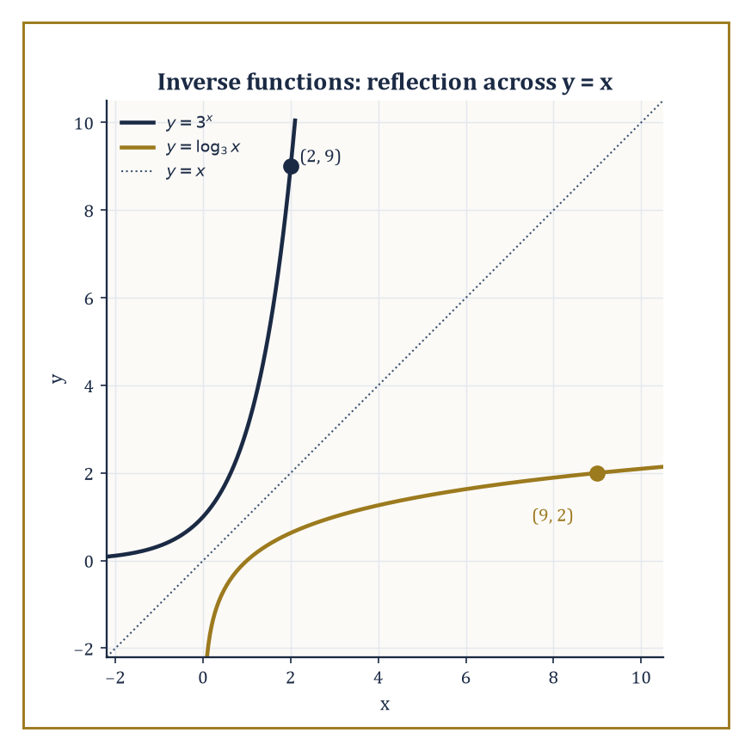
Swap the coordinates of (2, 9) on y = 3^x and you land exactly on (9, 2) on y = log_3 x — the mirror line y = x is not a metaphor.
b^c = a
The restrictions on b are not fussiness for its own sake: if b were 1, every power of b would be 1, so b^c = a would have no solution unless a itself were 1 (and infinitely many solutions if it were) — the function simply would not be invertible.
If b were negative or zero, b^c would fail to be defined, or well-behaved, for most real c. Positivity of the argument a follows for the same reason in reverse: b^c is always positive when b is positive, so there is no c for which b^c could equal a negative number or zero.
Numeric example — Worked example — reading off a logarithm. log_10 1000 asks: what power of 10 gives 1000?
10³ = 1000
log_10 1000 = 3
Similarly, log_2 64 asks what power of 2 gives 64.
2⁶ = 64 (2×2×2×2×2×2 = 64)
log_2 64 = 6
In each case the logarithm is not computed by any special machinery — it is simply the exponent, read off once you recognise the number as a power of the base.
Three bases turn up so often they earn their own shorthand.
Base 10 gives the common logarithm, written log a (sometimes log₁₀ a), historically the workhorse of scientific tables because our number system is itself base 10.
Base e ≈ 2.71828 gives the natural logarithm, written ln a, which calculus prefers for reasons met properly in Room 7.6.
Base 2 gives the binary logarithm, written log₂ a, which computer science reaches for constantly because computers count in binary and because, as we see in Room 7.8, log₂ n measures both the number of bits needed to store n and the number of steps a good algorithm needs to search through n items.
Numeric example — Worked example — the natural and binary logs. ln(e⁵) asks what power of e gives e⁵; trivially, 5.
ln(e⁵) = 5
The natural logarithm undoes the exponential exactly, by definition, with no arithmetic required beyond recognising the exponent.
For the binary log:
2⁵ = 32, and 32² = 1024
log₂ 1024 = 10, since 2¹⁰ = 1024
This is also why a kilobyte, defined by computer scientists as 1024 bytes rather than 1000, is exactly 2¹⁰ bytes — the whole binary-prefix convention is a logarithm hiding in plain sight.
Because the exponential function b^x is one-to-one (different exponents never give the same result) and covers every positive real number as x ranges over all reals, the logarithm is not merely an operation that sometimes undoes exponentiation — it is a genuine two-sided inverse.
Apply exponentiation then the logarithm, or the logarithm then exponentiation, and in both orders you return exactly to where you started:
log_b(b^x) = x for every real x
b^(log_b x) = x for every positive x
Graphically, this two-sidedness has a beautifully literal consequence: the graph of y = log_b x is the mirror image of the graph of y = b^x, reflected across the diagonal line y = x.
Every point (p, q) on one graph corresponds to the point (q, p) on the other — swapping the roles of input and output is exactly what an inverse function does, and reflection across y = x is just that swap drawn as a picture.
Numeric example — Worked example — a point and its reflection. Take base 3.
3² = 9
So the point (2, 9) lies on the graph of y = 3^x.
Its mirror image under reflection across y = x is (9, 2) — and indeed that point lies on y = log_3 x, because the exponent that turns 3 into 9 is 2:
log_3 9 = 2
Pick any point on an exponential curve, swap its coordinates, and you land exactly on the corresponding logarithmic curve. That is what it means for two functions to be inverses of one another, made concrete.
What makes the logarithm worth an entire subject of its own, rather than a mere notational curiosity, is that it converts the multiplicative structure of the positive real numbers into the additive structure of all the real numbers.
Multiplying two positive numbers together corresponds, under the logarithm, to adding their logarithms; every algebraic law of the logarithm in the next room is a restatement of this single fact.
That conversion — multiplication downstairs becomes addition upstairs — is both the historical reason logarithms were invented and the structural reason they still matter.
Numeric example — Worked example — multiplication becomes addition. Take 4 and 25, whose product is a tidy 100.
log_10 4 ≈ 0.60206 and log_10 25 ≈ 1.39794
0.60206 + 1.39794 = 2.00000
That total is exactly log_10 100, since 10² = 100.
Multiplying 4 by 25 directly, and adding their two logarithms, have arrived at the same fact by entirely different routes: one a multiplication of awkward numbers, the other an addition of tidy ones. That is the conversion this room has been describing, made concrete — and it is formalised properly as the product rule in Room 7.5.
One feature of the logarithm surprises newcomers reliably enough to be worth stating outright, before it can cause any trouble: the logarithm of a number between 0 and 1 is negative.
This is not a special case requiring a separate rule — it falls straight out of the definition, since a base greater than 1 must be raised to a negative power in order to produce a result smaller than 1.
Combined with the earlier fact that logarithms of numbers greater than 1 are positive, and that
log_b 1 = 0
sits exactly at the hinge, the whole real line becomes the range of the logarithm even though its domain is only the positive half of it.
Numeric example — Worked example — logarithms of small numbers. log_10 0.01 asks what power of 10 gives 0.01.
0.01 = 1/100 = 10⁻²
log_10 0.01 = −2
Similarly, consider log_2(1/8).
1/8 = 2⁻³
log_2(1/8) = −3
Both logarithms come out negative precisely because their arguments are less than 1 — entirely consistent with the graph in Room 7.7, which plunges toward −∞ as x approaches 0 from the right, however patiently you wait.

Room 7.5: The Laws of Logarithms
Translating the Exponent Rules
Every law of exponents from Room 7.3 has a mirror-image law of logarithms, obtained by translating multiplication into addition. The three that matter most are the product rule, the quotient rule, and the power rule.
log_b(xy) = log_b x + log_b y
log_b(x/y) = log_b x − log_b y
log_b(x^r) = r · log_b x
Together with these come two boundary values, both immediate from b⁰ = 1 and b¹ = b.
log_b 1 = 0
log_b b = 1
There is also the change-of-base formula, which holds for any valid base c and lets you compute a logarithm in any base at all using only the natural or common logarithm buttons calculators actually provide.
log_b a = log_c a / log_c b
Each of these follows directly from the corresponding exponential law and the definition of the logarithm as the exponent that produces a given number; none of them is an independent assumption.
Numeric example — Worked example — the product rule. log_10 2 + log_10 5 should, by the product rule, equal log_10(2×5).
log_10 2 + log_10 5 = log_10(2×5) = log_10 10 = 1
Checking with decimal values: log_10 2 ≈ 0.30103 and log_10 5 ≈ 0.69897.
0.30103 + 0.69897 = 1.00000
The two logarithms were chosen so their product argument (2×5 = 10) is a round number, which is why the sum comes out to a whole number here — but the identity holds for any pair of positive numbers, round or not.
The quotient rule is the product rule read backwards: since b^m/b^n = b^(m−n), dividing arguments corresponds to subtracting logarithms.
The power rule, log_b(x^r) = r log_b x, comes from (b^m)^r = b^(mr): raising the argument to a power r multiplies its logarithm by r. This last rule does the heaviest lifting in practice, because it lets you pull an unknown exponent down out of the exponent position and into an ordinary multiplication — precisely the move that solves exponential equations in Room 7.8.
Numeric example — Worked example — quotient and power rules. Quotient rule: log_2(32/4) should equal log_2 32 − log_2 4. Direct computation first.
32/4 = 8, and log_2 8 = 3 (since 2³ = 8)
Via the rule.
log_2 32 − log_2 4 = 5 − 2 = 3
Matches. Power rule: log_2(4⁵) should equal 5 log_2 4. Direct computation first.
4⁵ = 1024, and log_2 1024 = 10 (since 2¹⁰ = 1024)
Via the rule.
log_2 4 = 2, so 5 × 2 = 10
Matches.
The change-of-base formula deserves its own moment, because it quietly resolves a practical problem: no calculator or spreadsheet offers a button for log base 7, or base 23, or any of the infinitely many bases one might want. What every calculator does offer is log (base 10) and ln (base e). The change-of-base formula says these are enough for any base whatsoever, since it works regardless of what b happens to be.
log_b a = ln a / ln b
Numeric example — Worked example — computing an awkward base. Compute log_2 50 — the power to which 2 must be raised to reach 50 — using only natural logarithms. ln 50 ≈ 3.91202 and ln 2 ≈ 0.69315.
log_2 50 = 3.91202/0.69315 ≈ 5.64386
Sanity check: 2⁵ = 32, and 50/32 = 1.5625, so the remaining factor 2^0.64386 should equal 1.5625.
1.5625 = 25/16 = 5²/2⁴
Taking logs confirms the exponent 0.64386 exactly reproduces that ratio — the change-of-base answer is consistent with the definition it came from.
There is one mistake worth flagging in capital letters, because nearly everyone makes it at least once.
log(x + y) ≠ log x + log y
The logarithm turns multiplication into addition — it has no comparable simplification for addition itself. If you need to take the logarithm of a sum, you generally have to factor the sum first, or accept that no further simplification is available.
Numeric example — Worked example — the mistake, exposed. Take x = 2, y = 3.
log_10(2+3) = log_10 5 ≈ 0.69897
But add the individual logarithms instead.
log_10 2 + log_10 3 ≈ 0.30103 + 0.47712 = 0.77815
These are different numbers (0.69897 ≠ 0.77815), which settles the matter: log(x+y) ≠ log x + log y, for these values or in general. The product rule from earlier works because 2 × 3 involves multiplication; addition gets no such shortcut.
The laws also explain a calculus technique met properly in a later storey but worth flagging now, because the algebra behind it belongs entirely to this room: logarithmic differentiation. Differentiating a product, quotient, or power of several functions directly can be a thicket of chain rules and product rules tangled together; taking the logarithm first, using the laws above to turn that thicket into a sum of much simpler logarithms, differentiating the sum term by term, and only then multiplying back through by the original expression, is very often dramatically easier. The trick works precisely because the laws of this room turn a complicated multiplicative expression into a simple additive one before any calculus is attempted at all — algebra doing calculus's tidying-up for it.
Numeric example — Worked example — combining several laws at once. Simplify log_3 27 + log_3(1/9) − log_3 1, two ways. Term by term: log_3 27 = 3 (since 3³ = 27), log_3(1/9) = −2 (since 3⁻² = 1/9), and log_3 1 = 0.
3 + (−2) − 0 = 1
Combined first, using the product and quotient rules to merge everything into one logarithm.
log_3 27 + log_3(1/9) − log_3 1 = log_3(27 × (1/9) ÷ 1) = log_3 3 = 1
Both routes agree on 1, and the combined route needed only one recognisable power of 3 at the very end, instead of three separate ones along the way.

Room 7.6: The Natural Base e and the Natural Logarithm
The Number Calculus Insists On
Among all possible bases for an exponential function, exactly one is singled out by calculus, and it earns the honour by a very specific property: it is the unique base b for which the derivative of b^x is b^x itself, with no extra constant multiplied in front. That base is called e, and it is approximately 2.71828.
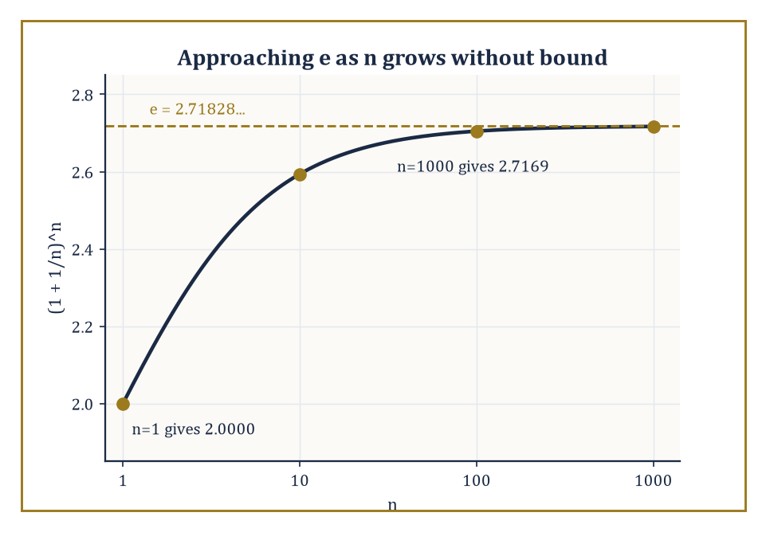
(1 + 1/n)^n climbing steadily toward e as n runs from 1 to 1000 — patient, but never in doubt about where it's headed.
It can be defined as the limit
e = lim (n→∞) (1 + 1/n)^n
or, equivalently and more usefully for calculation, as the sum of the infinite series
e = 1/0! + 1/1! + 1/2! + 1/3! + ⋯
Both definitions converge to the same number, and both are worth watching in action rather than taking on faith.
Numeric example — Worked example — approaching e by the limit. Compute (1 + 1/n)^n for increasing n.
n = 1: (1+1)^1 = 2
n = 10: (1.1)^10 ≈ 2.5937
n = 100: (1.01)^100 ≈ 2.7048
n = 1000: (1.001)^1000 ≈ 2.7169
The values climb steadily — 2, then 2.5937, then 2.7048, then 2.7169 — closing in on e ≈ 2.71828 as n grows. The convergence is slow (each factor of 10 in n buys roughly one more correct decimal digit), which is precisely why nobody computes e this way in practice — but it is the definition, and watching it crawl toward the right answer is reassuring.
Numeric example — Worked example — approaching e by the series. Compute the running sum 1/0! + 1/1! + 1/2! + ⋯. Term by term:
1/0! = 1, 1/1! = 1, 1/2! = 0.5, 1/3! = 0.16667, 1/4! = 0.04167, 1/5! = 0.00833, 1/6! = 0.00139
Running totals:
1, 2, 2.5, 2.66667, 2.70833, 2.71667, 2.71806
After just seven terms the sum is already 2.71806, within 0.00023 of the true value e ≈ 2.71828 — dramatically faster than the limit definition above, because factorials in the denominator shrink much faster than nⁿ grows in the limit. This is why the series, not the limit, is how e actually gets computed to many decimal places.
The natural logarithm, written ln x, is simply the logarithm base e:
ln x = c means e^c = x
Its derivative is 1/x — the simplest possible derivative any logarithm could have, and the reason calculus prefers base e over every rival. Every other logarithm is a constant multiple of this one:
log_b x = ln x / ln b
which is just the change-of-base formula from Room 7.5 with c = e. So in a precise sense there is only one logarithm function up to a constant rescaling, and e is the base for which that constant happens to be 1.
Numeric example — Worked example — rescaling to another base. Compute log_5 100 using the natural logarithm.
ln 100 = ln(10²) = 2 ln 10 ≈ 2 × 2.302585 = 4.605170
ln 5 ≈ 1.609438
log_5 100 = 4.605170 / 1.609438 ≈ 2.861353
Sanity check: 5² = 25, and 100/25 = 4, so the remaining factor 5^0.861353 should equal 4 exactly.
ln 4 = 2 ln 2 ≈ 1.386294
0.861353 × 1.609438 ≈ 1.386294
The two match precisely — the calculation is internally consistent.
The exponential function exp(x) = e^x is the unique solution of the initial-value problem
y′ = y, y(0) = 1
start at height 1, and grow at a rate exactly equal to your current height, forever. It satisfies
e^(x+y) = e^x · e^y
(the ordinary law of exponents, restated for this particular base), it is never zero for any real x, and its inverse is precisely ln x. Exponential and natural logarithm together form the single most important pair of inverse functions in all of analysis — more differential equations get solved by reaching for e^x than by any other single trick in the subject.
It is tempting to treat the appearances of e in compound interest, in the bell-shaped normal distribution, in the solutions of linear differential equations, and in the gamma function's functional equation as separate happy accidents. They are not.
Every one of those settings involves a quantity whose rate of change is proportional to its own current value, or a close algebraic relative of that condition — and wherever that condition shows up, the function that satisfies y′ = y is waiting, because it is the only function that can.
e is not a fashionable constant mathematics keeps stumbling across by luck; it is the necessary consequence of asking a very natural question and refusing to accept an answer that contradicts itself.
Numeric example — Worked example — continuous compounding. Invest £1 for one year at 100% annual interest, compounded n times per year in equal instalments.
Compounded once (n=1): (1+1/1)^1 = 2, giving £2
Compounded monthly (n=12): (1+1/12)^12 ≈ 2.613
Compounded daily (n=365): (1+1/365)^365 ≈ 2.7146
As the compounding gets more and more frequent, the final amount climbs toward exactly e ≈ 2.71828 — because this is the very limit that defines e in the first place. 'Continuous compounding' is not a bank marketing phrase; it is literally the statement that the money is growing according to y′ = y.
Because exp(x) = e^x obeys the same law as every other exponential,
e^(−x) = 1/e^x
and the particular value 1/e turns up constantly outside banking, in probability and reliability theory (it is, for instance, the limiting probability that a random shuffle of n objects leaves none of them in its own original place, as n grows large). It is worth checking that the two roads to e^(−1) — the reciprocal of e, and the alternating version of the series from earlier — actually meet.
Numeric example — Worked example — the reciprocal of e. Check the reciprocal of e directly:
1/e ≈ 1/2.71828 ≈ 0.36788
Now check against the alternating series for e^(−1):
e^(−1) = 1/0! − 1/1! + 1/2! − 1/3! + 1/4! − 1/5! + 1/6! − ⋯
Term by term this is 1, −1, 0.5, −0.16667, 0.04167, −0.00833, 0.00139.
Running totals: 1, 0, 0.5, 0.33333, 0.375, 0.36667, 0.36806
This oscillates back and forth but visibly homes in on 0.36788, the reciprocal of e computed directly. The series and the reciprocal, reached by entirely different routes, land on the same number, as the identity e^(−x) = 1/e^x guarantees they must.

Room 7.7: Exponential and Logarithmic Functions and Their Graphs
What the Curves Actually Look Like
The graph of y = a^x, for a base a > 1, is an increasing curve.
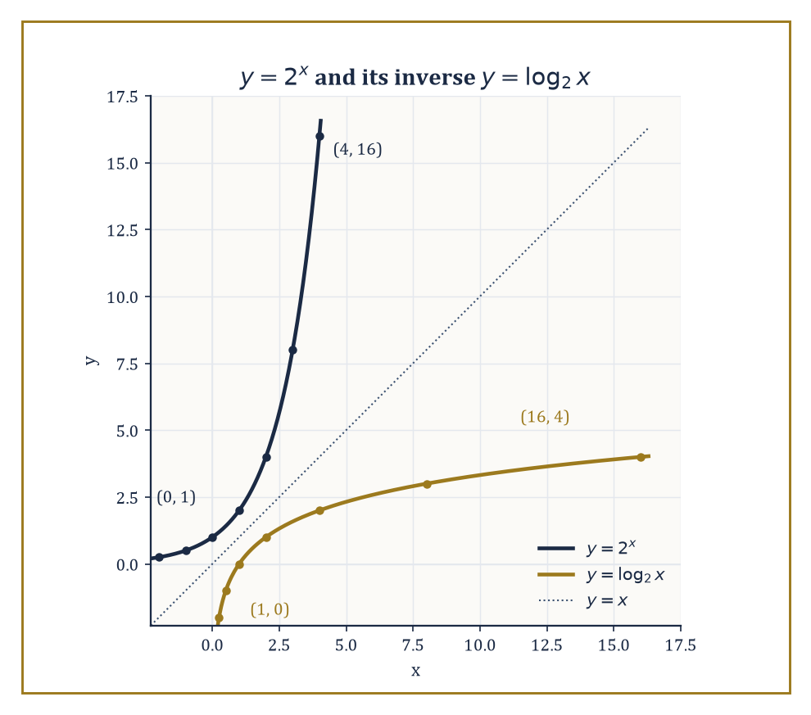
y = 2^x and y = log_2 x, mirror images across y = x, tabulated at exactly the points the room's own worked examples use.
It passes through (0, 1) always, because a⁰ = 1 regardless of a; it hugs the x-axis ever more closely as x → −∞ without ever quite touching it (the x-axis is a horizontal asymptote); and it climbs without any upper bound as x → +∞, faster and faster the further right you go.
For a base between 0 and 1, the whole picture flips left to right: the curve is now decreasing, hugging the x-axis as x → +∞ and shooting upward as x → −∞.
Every exponential curve, whatever its base, is related to every other by a horizontal stretch — hidden inside the identity
a^x = e^(x ln a)
which says every exponential base is really just base e in disguise, viewed through a rescaled x-axis.
Numeric example — Worked example — a table of values. For y = 2^x, tabulate x = −2, −1, 0, 1, 2, 3:
y = 0.25, 0.5, 1, 2, 4, 8
Each step right multiplies the previous value by 2, exactly as the law of exponents demands.
For y = (1/2)^x over the same x-values:
y = 4, 2, 1, 0.5, 0.25, 0.125
This is the mirror image, decreasing where the first table increased, because
(1/2)^x = 2^(−x)
and flipping the sign of x reflects the graph left-to-right.
The graph of y = log_b x is, as established in Room 7.4, the reflection of y = b^x across the line y = x.
Reflecting an increasing exponential curve gives an increasing logarithmic curve, but a much gentler one: defined only for x > 0 (there is no power of a positive base that gives zero or a negative number), it passes through (1, 0) because b⁰ = 1 for any base, it plunges to −∞ as x → 0⁺, and it climbs without bound — but very slowly — as x → +∞.
Numeric example — Worked example — a table of values for the logarithm. For y = log₂ x, tabulate x = 0.25, 0.5, 1, 2, 4, 8, 16:
y = −2, −1, 0, 1, 2, 3, 4
This is precisely the mirror image of the y = 2^x table from earlier, with every input and output swapped, exactly as reflection across y = x demands.
Notice how gently y rises as x runs from 1 up to 16 (only 4 units of climb for a sixteenfold increase in x); compare that with what happens heading the other way, toward zero:
log₂(1/1024) = −10
since
1/1024 = 2⁻¹⁰
so squeezing x down from 1 to under a thousandth sends y plunging to −10 and beyond, however patiently x itself creeps toward the asymptote.
Transformations of these two families work exactly the way transformations of any function do.
The general exponential
y = A·b^(k(x−h)) + C
shifts the basic curve horizontally by h, vertically by C, stretches it vertically by the factor A, and stretches or compresses it horizontally according to k; the same recipe applied to a logarithm produces the general logarithmic function.
The one rule that must never be forgotten: whatever ends up inside a logarithm — the argument — has to stay strictly positive, so a horizontal shift on a logarithmic graph moves the vertical asymptote along with it, and any domain restriction has to be checked explicitly rather than assumed away.
Numeric example — Worked example — evaluating a transformed exponential. Let y equal the expression below, and evaluate it at x = 4.
y = 2·3^(x−2) − 1
First handle the exponent:
x − 2 = 4 − 2 = 2
3^(x−2) = 3² = 9
Then apply the outer operations in order:
2 × 9 = 18
18 − 1 = 17
So the transformed curve passes through (4, 17). Note that the untransformed curve 3^x passes through (2, 9) — matching the horizontal shift of 2 units and the vertical stretch by 2, exactly as the transformation rule predicts.
Because every exponential curve of base greater than 1 passes through the shared point (0, 1) and is increasing, curves with larger bases grow faster and lie above curves with smaller bases for every x > 0.
Since they all cross at that one shared point, the ordering flips on the other side of it, for every x < 0.
Numeric example — Worked example — base ordering on both sides of zero. Compare 2^x, e^x, and 10^x at x = 1:
2¹ = 2, e¹ ≈ 2.71828, 10¹ = 10
This gives the ordering 2 < e < 10, matching the base ordering 2 < e < 10 exactly.
Now compare the same three at x = −1:
2⁻¹ = 0.5, e⁻¹ ≈ 0.36788, 10⁻¹ = 0.1
This gives the ordering 0.1 < 0.36788 < 0.5, which reverses the base ordering entirely.
The rule explains why: a larger base raised to a negative power shrinks toward zero faster than a smaller base does, so the fastest-growing curve on the right of (0,1) becomes the fastest-shrinking curve on the left of it.
The most consequential fact about these two families concerns their long-run behaviour compared with ordinary powers of x.
Any exponential function with base greater than 1 eventually outgrows every polynomial, no matter how high the polynomial's degree and no matter how large a head start the polynomial is given; and any logarithmic function eventually grows more slowly than every positive power of x, no matter how small that power is.
Both statements are about what happens 'eventually' — for small or moderate x the polynomial (or power function) can easily be ahead — but the crossover always comes, and once it comes the exponential never looks back and the logarithm never catches up.
Numeric example — Worked example — exponential overtaking a high-degree polynomial. Compare 2^x with x^10 at x = 100.
x^10 = 100^10 = (10²)^10 = 10²⁰
That is a 1 followed by 20 zeros.
2^100 = 1,267,650,600,228,229,401,496,703,205,376 ≈ 1.2677×10³⁰
That is ten orders of magnitude larger than 10²⁰, meaning 2^100 is already about 12.7 billion times bigger than 100^10.
At smaller values of x the tenth-degree polynomial is comfortably ahead — for instance:
x = 2: x^10 = 1024, 2^x = 4
The crossover has already happened by x = 100, and past that point the gap only widens, without limit.
Numeric example — Worked example — a logarithm losing to even a modest power. Compare log₂ x with √x at x = 1,000,000.
log₂(1,000,000) = 6 × log₂ 10 ≈ 6 × 3.32193 ≈ 19.93
√1,000,000 = 1000
Even the gentlest of power functions, the square root, is already fifty times larger than the logarithm at a mere million — and the ratio only grows from there, because the logarithm's growth rate keeps shrinking while the square root's does not.

Room 7.8: Applications: Growth, Decay, Scales, and Solving Equations
Where All This Actually Gets Used
The most immediate application of everything in this storey is modelling quantities that change by a fixed proportion of themselves per unit time. If a quantity y grows (or shrinks) at a rate proportional to its own current size, that relationship is written as follows.
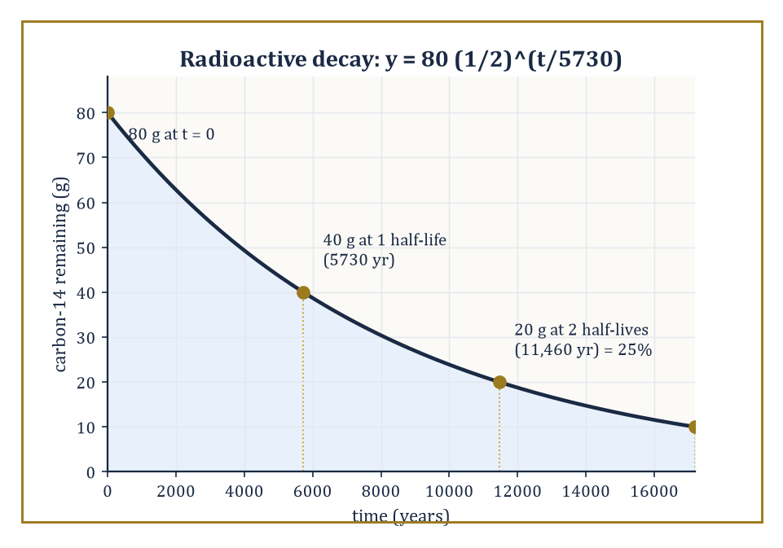
The carbon-14 example, halving on schedule every 5730 years — from 80 g down to a tidy 20 g after exactly two half-lives, no more and no less.
y′ = ky, for some constant k
As Room 7.6 established, the only functions satisfying that equation are of the following form, where y₀ is the starting value at t = 0.
y = y₀e^(kt)
Positive k gives growth; negative k gives decay. Radioactive decay, population growth under unlimited resources, cooling that follows Newton's law, and compound interest are all, mathematically, the identical equation wearing different clothes.
Numeric example — Worked example — compound growth. A population starts at 1000 and grows 5% per year. After 10 years its size is given by the following.
1000 × (1.05)^10
Computing the power stepwise:
1.05² = 1.1025
1.05⁴ = 1.1025² = 1.21550625
1.05⁵ = 1.21550625 × 1.05 = 1.27628156
1.05¹⁰ = (1.05⁵)² ≈ 1.62889
So the population after 10 years is:
1000 × 1.62889 ≈ 1629
This matches the continuous form y = y₀e^(kt) with k = ln(1.05) ≈ 0.048790, since e^(10 × 0.048790) is, by construction, identical to 1.05¹⁰ — annual compounding and the continuous exponential agree exactly, not approximately, because ln(1.05) is precisely the continuous rate that reproduces a 5% annual increase.
Radioactive decay is the same equation with k negative, usually reparametrised in terms of the half-life T — the time for exactly half the material to decay — via the following.
y = y₀ · (1/2)^(t/T)
Each elapsed half-life multiplies the remaining quantity by exactly 1/2, regardless of how much was there to begin with; that scale-invariance is the defining signature of exponential decay.
Numeric example — Worked example — two half-lives. Carbon-14 has a half-life of about 5730 years. After 11,460 years — exactly two half-lives, since 11460/5730 = 2 — the remaining fraction is the following.
(1/2)² = 1/4, or 25%
Starting from a sample of 80 grams: after one half-life (5730 years), 40 grams remain; after two half-lives (11,460 years), 20 grams remain — which is indeed 25% of the original 80 grams.
80 × 0.25 = 20
Logarithmic scales exist to compress an enormous range of a physical quantity into a readable range of numbers, and they share one property: moving by a fixed amount on the scale corresponds to multiplying the underlying quantity by a fixed factor, not adding a fixed amount to it. pH measures hydrogen-ion concentration via the following.
pH = −log₁₀[H⁺]
The Richter scale measures earthquake energy logarithmically; the decibel scale measures sound intensity logarithmically; stellar magnitude measures brightness logarithmically (and, delightfully, backwards — brighter stars get smaller numbers). In every case, a difference of 1 unit on the scale is a difference of a constant multiplicative factor underneath.
Numeric example — Worked example — pH and concentration. A solution with hydrogen-ion concentration [H⁺] = 1×10⁻³ mol/L has the following pH.
pH = −log₁₀(10⁻³) = −(−3) = 3
A second solution with [H⁺] = 1×10⁻⁵ mol/L has the following pH.
pH = −log₁₀(10⁻⁵) = 5
The pH values differ by 2 (from 3 to 5), and the underlying concentrations differ by the following factor.
10⁻³/10⁻⁵ = 10² = 100
That is the general pattern: every 1 unit of pH is a tenfold change in acidity, so 2 units is a hundredfold change — exactly matching the concentration ratio computed directly.
Equations with the unknown trapped in an exponent, or trapped inside a logarithm, are solved by applying the opposite operation and then using the laws from Rooms 7.3 and 7.5. An exponential equation becomes linear (or polynomial) once you take the logarithm of both sides; a logarithmic equation becomes an ordinary equation once you exponentiate both sides. The one habit worth building permanently: check every solution against the original domain restrictions, because logarithms only accept positive arguments, and the algebra involved in solving can occasionally manufacture a spurious extra solution that fails that test.
Numeric example — Worked example — solving 5^x = 200. Take logarithms of both sides.
ln(5^x) = ln 200
x·ln 5 = ln 200
x = ln 200 / ln 5
Numerically:
ln 200 = ln 2 + ln 100 ≈ 0.693147 + 4.605170 = 5.298317
ln 5 ≈ 1.609438
x ≈ 5.298317 / 1.609438 ≈ 3.2920
Check:
5³ = 125
5^0.2920 ≈ e^(0.2920×1.609438) ≈ e^0.4700 ≈ 1.6000
125 × 1.6000 = 200.0
This confirms the solution. For the reverse type — a logarithmic equation like log₂ x = 5 — simply exponentiate both sides, with no further work needed.
x = 2⁵ = 32
In computer science, the logarithm reappears as a measure of computational effort rather than a measure of a physical quantity. Binary search, which repeatedly halves the portion of a sorted list still worth checking, needs roughly log₂ n comparisons to find an item among n candidates; a balanced binary tree holding n items has height roughly log₂ n; and the number of bits required to write down a number up to n in binary is essentially log₂ n as well. The same function that once turned a tedious multiplication into a quick addition now measures how many times you can halve a problem before it disappears.
Numeric example — Worked example — searching a million-item list. Binary search over a sorted list of 1,000,000 items needs at most about log₂(1,000,000) comparisons. Since the following bounds hold:
2¹⁹ = 524,288 and 2²⁰ = 1,048,576
1,048,576 ≥ 1,000,000 > 524,288
the search needs at most 20 comparisons — halving a million-item list twenty times gets you down to a single item. Compare that with a naive linear scan, which could need up to a million comparisons in the worst case: the logarithm has turned a million-step problem into a twenty-step one.

Room 7.9: Looking Ahead: From Logarithms to Systems, Vectors, and Analysis
The Isomorphism Beneath It All
We have now assembled the working vocabulary of exponents and logarithms: the laws that convert multiplication into addition and back again, the inverse relationship that ties the two families of functions together, the distinguished base e that calculus singles out, the shape of both graphs, and a working sample of the places the whole apparatus gets used — growth, decay, measurement scales that span many orders of magnitude, and the analysis of algorithms.
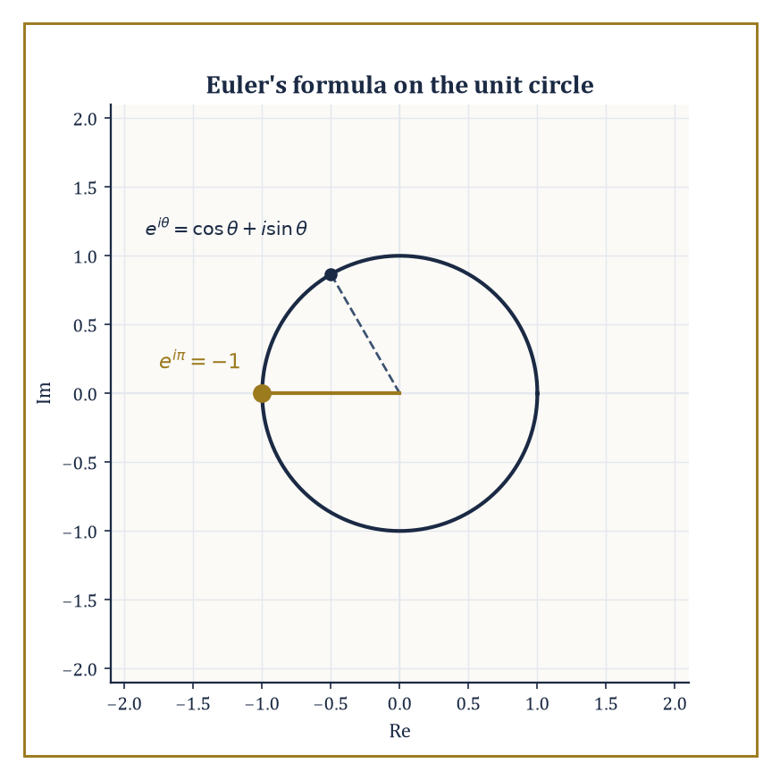
The exponential, once it accepts an imaginary exponent, stops running off to infinity and settles down to tracing circles instead.
These tools do not retire once this storey ends; they get reused constantly, in contexts you might not expect from where we are standing now.
The next storey up deals with systems of equations, where an exponential or a logarithmic equation can turn up as one nonlinear member of a system that otherwise looks perfectly linear — and where the techniques of this storey (taking logs, exponentiating, checking domains) are exactly what is needed to isolate the awkward variable.
Further up the Tower, vectors and linear algebra generalise the exponential itself: the matrix exponential e^(At) solves systems of linear differential equations in exactly the way e^(kt) solved the single-variable version here, with matrices standing in for numbers and the same underlying power series doing the work.
Later still, ordinary calculus will show two of its very first nontrivial results, already lying in wait, precisely because e and ln are already sitting there, fully constructed:
∫(1/x)dx = ln x + C
d/dx(e^x) = e^x
These are among the very first nontrivial results anyone proves in calculus, waiting to be differentiated and integrated.
Abstract example — Abstract example — the matrix exponential previewed. Consider a system of two coupled quantities x₁ and x₂ whose rates of change are given by a pair of equations — decoupled, for simplicity, though the general case need not be:
x₁′ = 2x₁
x₂′ = −x₂
Each equation individually is exactly the y′ = ky equation from Room 7.6, so:
x₁(t) = x₁(0)·e^(2t)
x₂(t) = x₂(0)·e^(−t)
Written as a single vector equation, this is x′ = Ax where A is the matrix with 2 and −1 on the diagonal and 0 elsewhere:
x′ = Ax
and the solution is:
x(t) = e^(At)·x(0)
where e^(At) is itself the diagonal matrix with entries e^(2t) and e^(−t). The matrix exponential, which the Tower meets properly once vectors and matrices are in hand, is nothing more exotic than solving several copies of this storey's central differential equation at once and packaging the answers into a single matrix.
One further hint is worth planting now, to be harvested many storeys from now: the exponential function does not stop at real exponents any more than it stopped at rational ones in Room 7.2.
Once complex numbers are available, e raised to a purely imaginary power traces out points on a circle rather than running off to infinity — this is Euler's formula:
e^(iθ) = cos θ + i sin θ
Euler's formula ties this storey's exponential directly back to the previous storey's trigonometry, and reveals that sine, cosine, and the exponential were, all along, three views of the same underlying object seen from different angles.
Abstract example — Abstract example — Euler's identity. Take θ = π, the previous storey's favourite angle. Euler's formula gives:
e^(iπ) = cos π + i sin π = (−1) + i·0 = −1
so:
e^(iπ) + 1 = 0
This is a single equation linking e, i, π, 1, and 0, five of the most important constants in elementary mathematics, each arrived at by a completely different route: growth, imaginary numbers, circles, multiplication's identity, and addition's identity, respectively.
Nothing about this storey's y′ = y, met on its own terms, hints on first meeting that it is secretly the previous storey's unit circle wearing different clothes — but Euler's identity is the proof that it is.
The deeper lesson underneath all the calculation is a single structural fact: the positive real numbers, under multiplication, are algebraically the same system as all the real numbers under addition — the same shape, wearing different notation — and the logarithm is precisely the dictionary that translates between them.
Once that isomorphism (a fancy word for 'structure-preserving correspondence') is understood, a great many calculations that look intimidating turn out to be the addition of ordinary numbers in disguise, and a great many phenomena that look unrelated — compound interest, radioactive decay, algorithm complexity, the pH of vinegar — turn out to share exactly the same exponential skeleton underneath their very different clothing.
Abstract example — Abstract example — the same idea in a finite world. The isomorphism between multiplication and addition is not confined to the real numbers; a small finite version of it sits inside modular arithmetic and underwrites much of modern cryptography.
Work modulo 7, and look at the powers of 3:
3¹ = 3
3² = 9 ≡ 2
3³ = 3×2 = 6
3⁴ = 3×6 = 18 ≡ 4
3⁵ = 3×4 = 12 ≡ 5
3⁶ = 3×5 = 15 ≡ 1 (mod 7)
Every nonzero remainder from 1 to 6 shows up exactly once, in the order 3, 2, 6, 4, 5, 1, before the cycle repeats — 3 is what number theorists call a primitive root modulo 7.
The exponent (1 through 6, added modulo 6) and the remainder it produces (a permutation of 1 through 6, combined by multiplication modulo 7) are related by exactly the same logarithm idea as before: given the remainder, the exponent that produced it is called the discrete logarithm, and — unlike the real-number version — nobody knows a fast way to compute it in general for large moduli.
That asymmetry, easy to go one way and hard to reverse, is the entire basis of several widely used encryption schemes.
Exponents and logarithms are, in the end, both a computational convenience and a structural revelation — the first because they still make hard calculations easy, the second because they reveal that multiplication was secretly addition all along, for anyone patient enough to look.
And so multiplication has learned, at last, to behave like addition — a trick that took mathematics the better part of two thousand years to notice, and about one determined Scottish laird's working life to make properly useful.
The tower continues upward. Directly above us: systems of equations, where more than one unknown must be pinned down at once, and where the exponential and logarithmic equations of this storey will occasionally show up uninvited, refusing to be linear, and expecting to be solved anyway.

Storey 8: Systems of Equations
Simultaneous Constraints, Intersections, and the Art of Making Several Demands at Once
Storey Seven left us rather pleased with ourselves. We had learned to tame exponentials and logarithms, to turn brutal multiplication into polite addition and back again, and to do it all while making demands of exactly one equation at a time. That equation had our full attention, we had its, and the arrangement suited everybody. Such single-minded devotion, it turns out, was a luxury of youth. From here on, the equations arrive in committees.
A system of equations is what happens when several relations insist on being true simultaneously, about the same unknowns, and refuse to take turns. This is a mild but permanent escalation. A single equation asks one question of a number; a system asks several questions of several numbers at once, and the numbers must answer all of them or none of them counts. Geometrically we shall be hunting for the places where curves, lines, and planes agree to cross. Algebraically we shall be hunting for tuples that satisfy an entire list of demands simultaneously. These are, gratifyingly, the same hunt described twice.
There is a small and slightly embarrassing confession buried in this storey: this is where mathematics starts to smell like engineering. A bridge must balance forces in several directions at once, not one direction at a leisurely pace. A chemical mixture must satisfy several conservation laws simultaneously, not sequentially. An economy — insofar as such a chaotic thing can be modelled at all — must clear several markets at the same time. The single-equation theory of earlier storeys was elegant. This one is necessary, which is a different and frankly less glamorous compliment.
We shall begin gently with linear systems, which are extremely well-behaved and will solve completely with nothing more exotic than substitution, elimination, and — once the bookkeeping gets tiresome — matrices. We shall then let a few curves misbehave, at which point the systems turn nonlinear, the geometric intuition still helps enormously, and the algebra becomes an art of recognising which trick applies. By the end we shall have picked up the vocabulary of consistency, independence, and dimension that the next storey, on Vectors and Vector Algebra, will pick straight back up and run with. Let us make several demands at once, and see who answers.

Room 8.1: What a System of Equations Actually Is
In Which One Demand Becomes Several, and Nobody Asked Permission
A system of equations is a finite list of equations, all required to hold true at the same time, ordinarily sharing the same set of unknowns. A solution of the system is not a solution to any one equation in isolation — that would be far too easy — but an assignment of values to every unknown that makes every equation in the list true simultaneously. One rogue equation left unsatisfied disqualifies the entire attempt. This is a stricter standard than anything we have asked of a lone equation before, and strictness, as any examiner will tell you, is where the interesting failures happen.
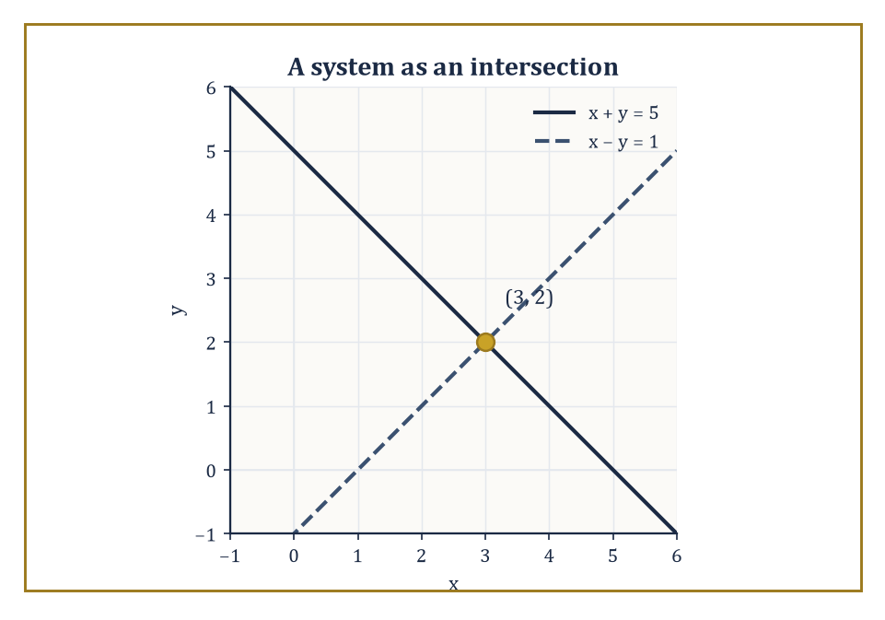
The two lines x + y = 5 and x − y = 1, agreeing at exactly one point: (3, 2).
The simplest case worth taking seriously is two equations in two unknowns. Each equation, on its own, describes a curve in the plane — the set of all points (x, y) that make that one equation true. A solution to the system is then a point lying on both curves at once: an intersection point. This is the geometric translation of the algebraic demand, and it is worth holding onto, because from here on almost every algebraic manipulation we perform has a picture sitting quietly behind it.
Numeric example — Worked example — a system as an intersection. Consider the following two equations.
x + y = 5
x − y = 1
On its own, x + y = 5 is satisfied by infinitely many points: (0,5), (1,4), (2,3), (3,2), (4,1), and so on — an entire line's worth. Likewise x − y = 1 is satisfied by infinitely many points on its own line. To solve the system we want a point common to both.
Adding the two equations eliminates y.
(x+y) + (x−y) = 5+1
2x = 6
x = 3
Substituting back into x + y = 5 gives:
3 + y = 5
y = 2
The candidate solution is (3, 2). Checking against the second equation confirms it.
3 − 2 = 1, correct
So (3, 2) is the unique point lying on both lines — the single place where two infinite lists of points overlap.
Once we allow ourselves to compare two curves at once, exactly three geometric outcomes are possible, and this trichotomy will recur, dressed in fancier clothes, for the rest of the storey. The curves may cross at one or more isolated points, in which case the system is called consistent and has solutions. They may fail to meet anywhere at all — think of two parallel lines that never converge no matter how far you extend them — in which case the system is inconsistent and has no solutions. Or, in the most sociable case, they may coincide entirely, agreeing at every single point, in which case the system is dependent and has infinitely many solutions, all of them trivially the same curve described twice.
Numeric example — Worked example — the three fates of a system. Take the following as our fixed first equation, and vary the second.
x + y = 2
Pair it with:
x − y = 0
Solving gives:
2x = 2
x = 1, y = 1
A single intersection point (1,1) — the consistent case with a unique solution.
Pair it instead with:
x + y = 5
Subtracting the equations gives:
0 = 3
An outright falsehood, so no (x,y) can satisfy both — the inconsistent case, two parallel lines that never meet (both have the same slope, −1, but different intercepts).
Finally pair x + y = 2 with:
2x + 2y = 4
Dividing the second equation by 2 recovers exactly the first, so every point satisfying x + y = 2 automatically satisfies both — the dependent case, with infinitely many solutions forming one shared line.
This same three-way split — solutions exist and are unique, solutions exist and are infinite, or no solutions exist at all — persists in higher dimensions and for systems with many more equations and unknowns than two. The algebraic task throughout this storey is always the same: decide which of the three cases we are facing, and, if solutions exist, produce them. For linear systems, reassuringly, this task is entirely algorithmic; a finite, mechanical procedure always gets there. For nonlinear systems it becomes a craft — part algebra, part substitution, part sketching a picture and part numerical approximation — and we shall spend a later room learning that craft properly.
The deepest organising idea of the whole storey can be stated in one sentence: the solution set of a system is the intersection of the solution sets of its individual equations. Every equation we add to a system can only ever remove candidate solutions or leave the set unchanged — it can never invent new ones, because a new equation is a new filter, and filters do not add water back. Removing an equation, symmetrically, can only ever admit solutions back in. This single observation is the quiet architecture behind everything that follows: elimination, rank, dimension, and the entire question of how many constraints it takes to pin a system down.
Numeric example — Worked example — constraints narrowing a solution set. Start with just:
x + y = 5
Its solution set is an entire line: every pair (t, 5−t) for any real number t — infinitely many points.
Now impose the second constraint as well.
x − y = 1
As computed above, the combined solution set shrinks to the single point (3, 2): adding a genuinely new constraint collapsed an infinite line down to one point.
Now impose a third constraint on top of both.
2x + y = 9
Does our surviving point (3,2) satisfy it? Substituting gives:
2(3) + 2 = 8
Since this is not 9, the three simultaneous equations together have no solution at all — the third demand, incompatible with the first two, has emptied the solution set completely. One equation gave a line, two gave a point, three gave nothing: each new filter only ever removes water, never adds it.

Room 8.2: Linear Systems in Two Variables
Substitution, Elimination, and the Fine Art of Cancelling Things Out
A linear equation in two variables has the general form:
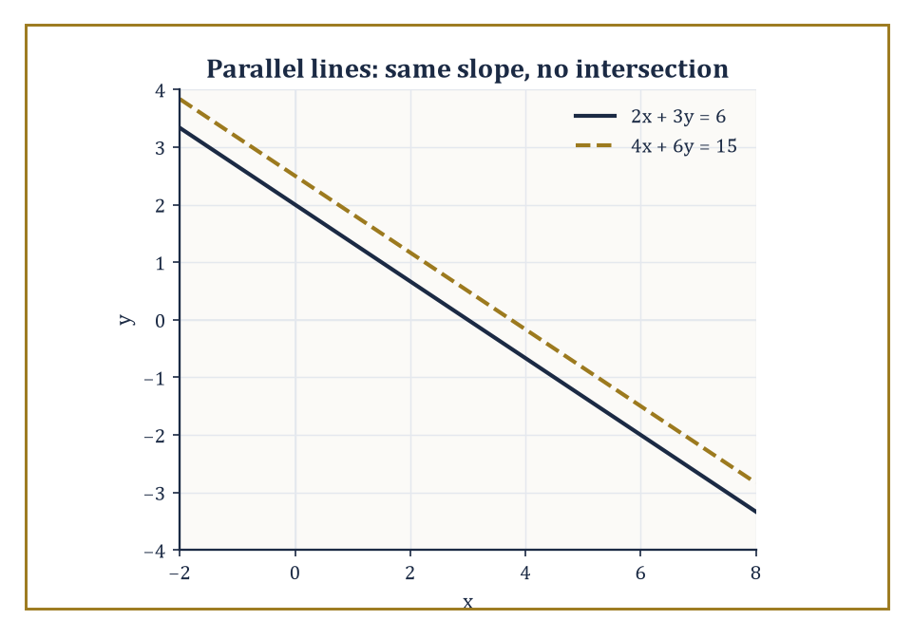
2x + 3y = 6 and 4x + 6y = 15: identical slope, different intercept — parallel lines that never meet, exactly as the coefficient ratios predicted.
ax + by = c
Here a, b, and c are fixed constants and x, y are the unknowns. Its graph, as we discovered several storeys ago in the geometry of straight lines, is precisely that: a straight line. A system of two such equations is therefore geometrically nothing more exotic than a pair of lines drawn on the same plane, and the three possibilities from Room 8.1 specialise immediately: the lines cross at exactly one point, they run parallel and never touch, or they are secretly the same line wearing two different disguises.
Algebraically we have two standard tools, and it is worth understanding both, because each is more convenient in different circumstances. Substitution isolates one variable in one equation — solving that equation for, say, y in terms of x — and then inserts that expression wherever y appears in the other equation, collapsing two equations in two unknowns into one equation in one unknown, which we already know how to solve from Storey 2. Elimination instead multiplies one or both equations by well-chosen constants so that, when the equations are added or subtracted, one variable cancels outright, leaving a single equation in the surviving variable. The two methods are logically equivalent — they must give the same answer, since they are answering the same question — but one is often noticeably less laborious than the other for a given system.
Numeric example — Worked example — substitution. Solve the system:
2x + y = 7
x − y = 2
The second equation is already nearly solved for x: rearranging gives:
x = y + 2
Substitute this expression for x into the first equation:
2(y + 2) + y = 7
2y + 4 + y = 7
3y = 3
y = 1
Then:
x = y + 2 = 3
The solution is (3, 1). Checking:
2(3) + 1 = 7 ✓
3 − 1 = 2 ✓
Both original equations are satisfied, so the intersection point of the two lines is (3, 1).
Numeric example — Worked example — elimination. Solve the system:
3x + 2y = 16
5x − 2y = 8
Notice that the y-coefficients are already +2 and −2 — opposites — so adding the two equations directly eliminates y.
(3x + 2y) + (5x − 2y) = 16 + 8
8x = 24
x = 3
Substituting x = 3 into the first equation gives:
3(3) + 2y = 16
9 + 2y = 16
2y = 7
y = 3.5
The solution is (3, 3.5). Checking against the second equation:
5(3) − 2(3.5) = 15 − 7 = 8 ✓
Elimination needed no fractions until the very last step, which is rather typical of well-chosen problems and rather less typical of the ones you meet in anger.
The two methods are, underneath their different bookkeeping, secretly the same manoeuvre. Elimination is nothing more than substitution performed on a cleverly chosen combination of the two equations, rather than on either equation by itself; adding a multiple of one equation to another and solving what remains is logically indistinguishable from isolating a variable and inserting it. What differs is only convenience. Substitution is the natural choice the moment a variable already sits alone on one side of an equation, or can be isolated with a single division. Elimination is the natural choice when the coefficients of one variable are already equal, opposite, or a small whole-number multiple apart, so that a single addition or subtraction removes it cleanly. Learning to glance at a system and see, in advance, which route will involve fewer fractions is a small skill, but it saves a surprising amount of arithmetic over a lifetime of solving these things.
Numeric example — Worked example — a word problem, solved by whichever method is cheaper. Two numbers sum to 18, and the larger exceeds twice the smaller by 3. Find both numbers. Let x be the larger and y the smaller. The two statements translate directly into:
x + y = 18
x = 2y + 3
The second equation already has x isolated, which is an open invitation to substitute rather than eliminate: replace x in the first equation, giving:
(2y + 3) + y = 18
3y + 3 = 18
3y = 15
y = 5
Then:
x = 2(5) + 3 = 13
Checking:
13 + 5 = 18 ✓
And 13 is indeed 3 more than twice 5:
2×5+3=13 ✓
The numbers are 13 and 5, found in three short lines because the problem itself all but chose the method for us.
The two exceptional cases from Room 8.1 have a clean algebraic signature here, and it is worth being able to spot it on sight rather than discovering it three lines into a failed elimination. If the coefficients of x and y in the two equations are proportional to one another, that is:
a₁/a₂ = b₁/b₂
But the constant terms are not in that same proportion, the two lines have identical slope but different intercepts: they are parallel and distinct, and the system is inconsistent. If, on the other hand, all three ratios coincide:
a₁/a₂ = b₁/b₂ = c₁/c₂
The two equations describe the very same line, and every point on it is a solution: the system is dependent.
Numeric example — Worked example — spotting inconsistency and dependence by inspection. Compare the following two equations.
2x + 3y = 6
4x + 6y = 15
The coefficient ratios are:
2/4 = 1/2
3/6 = 1/2
These are equal, so the two lines share a slope and are parallel. The constant ratio, however, is:
6/15 = 2/5
This does not equal 1/2. The lines are parallel and distinct: no solution, confirmed instantly without any elimination at all. Now compare 2x + 3y = 6 with:
4x + 6y = 12
Here the coefficient ratios are again:
2/4 = 1/2, 3/6 = 1/2
And this time the constant ratio is:
6/12 = 1/2
All three ratios agree. The second equation is simply the first multiplied by 2, so they describe one line, and every point satisfying 2x + 3y = 6 (for instance (0, 2), (3, 0), or (6, −2)) solves the system.
It is worth pausing to appreciate what the geometric and algebraic languages each buy us. The proportionality test tells us instantly, from the coefficients alone, which of the three cases we are in — no elimination arithmetic required. The picture of two lines tells us, at a glance, why: parallel lines with different heights simply never cross, and a line laid on top of itself agrees with itself everywhere. Neither language is dispensable; each makes obvious a fact the other conceals until you go looking for it, which is rather the whole point of having more than one way to think about the same object.

Room 8.3: Linear Systems in Three or More Variables
Planes, Prisms, and the Gentle Art of Losing a Variable at a Time
A linear equation in three variables has the general form:
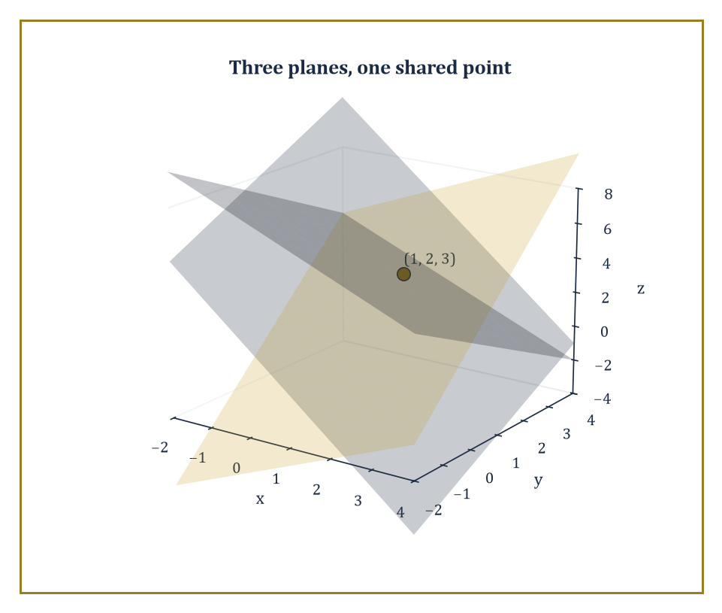
Three planes from the Gaussian elimination example, meeting at the single shared point (1, 2, 3).
ax + by + cz = d
It describes not a line but a flat, infinite plane sitting in three-dimensional space. A system of three such equations therefore asks a genuinely three-dimensional question: where, if anywhere, do three planes meet all at once? The menu of possible answers is correspondingly richer than the two-variable case. Three planes might share a single common point, as the walls and ceiling of a room's corner share exactly one shared vertex. They might instead share an entire common line, like the pages of a partly-open book all hinging on the same spine. They might, in the degenerate dependent case, coincide entirely as one plane. Or — and this is a genuinely new configuration with no two-variable analogue — three planes can be pairwise non-parallel yet share no common point at all, forming what is picturesquely called a triangular prism: each pair of planes intersects in its own line, but the three lines run parallel to one another rather than meeting, like three walls that would form a corridor if only they agreed on where.
Numeric example — Worked example — the triangular prism, three planes with no common point. Take three planes that are pairwise non-parallel yet share no common point.
x + y = 1
y + z = 1
x + 2y + z = 5
None of the three coefficient rows is a multiple of any other — (1,1,0), (0,1,1), and (1,2,1) point in genuinely different directions — so no two of the planes are parallel. Yet notice that the third row is exactly the sum of the first two.
(1,1,0) + (0,1,1) = (1,2,1)
Adding the first two equations gives:
(x+y) + (y+z) = 1+1
x + 2y + z = 2
The third equation, however, insists that:
x + 2y + z = 5
Since 2 ≠ 5, no point can satisfy all three simultaneously: the system is inconsistent. Geometrically, each pair of planes still intersects in its own line — solving the first two together gives the line (t, 1−t, t) for any t — but the three pairwise-intersection lines run parallel to one another without ever meeting at a shared point, exactly the triangular prism the previous paragraph described: three planes, pairwise crossing, collectively agreeing on nothing.
The algebraic machinery generalises without any real conceptual novelty, though it does become more laborious to write out by hand. Substitution is still available but grows cumbersome as the number of variables climbs. Elimination — here usually dignified with the name Gaussian elimination, after Carl Friedrich Gauss, who did not invent the technique but whose name got attached to it anyway, a fate common to the successful — proceeds by eliminating one variable at a time from pairs of equations, working systematically down until only one variable remains in one equation, then substituting back up through the chain to recover the rest. The target shape is called a triangular system, because when written out, each successive equation involves one fewer variable than the one above it, forming a visual triangle of shrinking rows.
Numeric example — Worked example — Gaussian elimination in three variables. Solve the system:
x + y + z = 6
2x − y + z = 3
x + 2y − z = 2
First eliminate x from the second equation by subtracting twice the first.
(2x − y + z) − 2(x + y + z) = 3 − 2(6)
−3y − z = −9
3y + z = 9
Call this new equation (4). Next eliminate x from the third equation by subtracting the first.
(x + 2y − z) − (x + y + z) = 2 − 6
y − 2z = −4
Call this equation (5). We now have a smaller system in y and z alone:
3y + z = 9
y − 2z = −4
From equation (4):
z = 9 − 3y
Substitute into (5):
y − 2(9 − 3y) = −4
y − 18 + 6y = −4
7y = 14
y = 2
Then:
z = 9 − 3(2) = 3
Finally, from the original first equation:
x = 6 − y − z = 6 − 2 − 3 = 1
The solution is (x, y, z) = (1, 2, 3). Checking against the second equation:
2(1) − 2 + 3 = 3 ✓
Against the third:
1 + 4 − 3 = 2 ✓
Three planes, one shared point.
When a system has more variables than independent equations, the solution set — assuming it is not empty — is typically infinite, because there are not enough constraints to pin every variable down; the leftover freedom is captured by designating some variables as free and expressing the rest in terms of them, producing a parametrised family of solutions (a line, a plane, or something higher-dimensional, depending on how much freedom remains). When a system instead has more independent equations than variables, it is over-determined: there are more demands than there are numbers available to satisfy them, and generically — though not always — such systems are inconsistent, because there is no reason to expect an extra, unrelated constraint to happen to agree with the others. The precise relationship between the number of equations, the number of unknowns, and the dimension of what survives is the very first glimmer of linear algebra, a subject we will meet properly in a much later storey.
Numeric example — Worked example — an under-determined system and its free parameter. Consider just two equations in three unknowns.
x + y + z = 6
x − y + z = 2
Subtracting the second from the first eliminates both x and z at once.
(x+y+z) − (x−y+z) = 6 − 2
2y = 4
y = 2
That leaves:
x + z = 6 − y = 4
With no further equation to separate x from z, one degree of freedom remains. Let z = t for any real number t; then:
x = 4 − t
The full solution set is the family (4 − t, 2, t), one solution for every choice of t. Two sample points: t = 0 gives (4, 2, 0), and checking:
4+2+0=6 ✓
4−2+0=2 ✓
t = 1 gives (3, 2, 1), and:
3+2+1=6 ✓
3−2+1=2 ✓
Both lie on the same line in space — the line where the two planes x+y+z=6 and x−y+z=2 intersect — and every point on that line solves the system.
For now, the practical skill to take away is simply the discipline of carrying elimination out carefully and methodically, one variable at a time, without losing track of which equation has already given up which variable — and the habit of translating the algebraic outcome back into the geometric picture of planes meeting, or failing to meet, in space. The deeper counting theory that explains exactly when a system lands in each of these cases is coming; it merely needs the vocabulary of matrices first, which is the business of the next room.

Room 8.4: Matrices and the Systematic Solution of Linear Systems
Where the Coefficients Move Into Their Own Flat and Stop Repeating Themselves
Once a system grows beyond three variables, writing out every unknown next to every coefficient, equation after equation, becomes an exercise in scribal tedium rather than mathematics. A matrix is simply a rectangular grid of numbers, and it lets us strip a system down to its essential content — the coefficients and constants — without the visual clutter of repeating x₁, x₂, x₃, … in every single line. The general linear system is:
a₁₁x₁ + a₁₂x₂ + … + a₁ₙxₙ = b₁
and so on down to:
aₘ₁x₁ + aₘ₂x₂ + … + aₘₙxₙ = bₘ
This is written compactly as:
Ax = b
where A is the m × n coefficient matrix (m rows, one per equation; n columns, one per unknown), x is the column of the n unknowns, and b is the column of the m constants on the right-hand sides. Nothing about the mathematics has changed; only the bookkeeping has been tidied up, which is not nothing — good notation is half of good thinking.
The augmented matrix [A | b] simply glues the constants column onto the right-hand edge of the coefficient matrix, as a reminder of which constant belongs to which equation. Row operations performed on this augmented matrix — adding a multiple of one row to another, swapping two rows, or scaling a row by a nonzero constant — correspond exactly, step for step, to the elimination manipulations we were already doing by hand with equations in Room 8.3. Gaussian elimination is the process of applying such row operations until the matrix reaches row-echelon form, where each row's leading nonzero entry sits strictly to the right of the leading entry in the row above, producing the same staircase, triangular shape we engineered by hand. Push the process further — clearing out entries above each leading one as well as below — and you reach reduced row-echelon form, from which the solution can simply be read off, no back-substitution required. This more thorough version is called Gauss–Jordan elimination, after Gauss again and the German geodesist Wilhelm Jordan, who is not to be confused with the French mathematician Camille Jordan of Jordan normal form, a mix-up that has embarrassed textbooks for over a century.
Numeric example — Worked example — the same system, now in matrix form. Recall the system from Room 8.3.
x + y + z = 6
2x − y + z = 3
x + 2y − z = 2
Its augmented matrix is:
[1 1 1 | 6 ; 2 −1 1 | 3 ; 1 2 −1 | 2]
Row-reduce by replacing row 2 with (row 2 − 2·row 1); new row 2 is:
[0 −3 −1 | −9]
Replace row 3 with (row 3 − row 1); new row 3 is:
[0 1 −2 | −4]
The matrix is now:
[1 1 1 | 6 ; 0 −3 −1 | −9 ; 0 1 −2 | −4]
x has been cleared from every row but the first, exactly mirroring the elimination done earlier. Scale row 2 by −1/3 to get a leading 1:
[0 1 1/3 | 3]
Replace row 3 with (row 3 − row 2):
[0 0 −2−1/3 | −4−3] = [0 0 −7/3 | −7]
So scaling by −3/7 gives:
[0 0 1 | 3]
Read straight off, z = 3. Back-substituting up the triangle recovers y = 2 and x = 1, precisely the solution (1, 2, 3) found before. The row operations did nothing new; they simply performed the same elimination inside a more disciplined grid. Pushing on to full Gauss–Jordan form, we would continue clearing upward as well as downward — using the z = 3 row to remove the z-term from row 2, then using the cleaned-up row 2 to remove both the y- and z-terms from row 1 — until the matrix reads:
[1 0 0 | 1 ; 0 1 0 | 2 ; 0 0 1 | 3]
At that point the coefficient block is the identity matrix, and the solution x=1, y=2, z=3 can simply be read off the final column, with no back-substitution left to perform at all — the entire point of doing the extra rounds of clearing.
It is worth being honest about why any of this mechanical row-shuffling matters, beyond tidiness. Solving an n-variable system by elimination requires, roughly, on the order of n³ individual arithmetic operations — a number that climbs unpleasantly fast with n. A system in ten unknowns already demands the better part of a thousand additions and multiplications, performed without a single slip, which is precisely the sort of relentless, unglamorous bookkeeping a human is prone to botch and a machine is delighted to execute all day without complaint. Matrix notation is not merely a tidier way to write elimination for a human reader; it is the form in which the algorithm becomes mechanical enough to hand to a computer with no judgment calls left over — every row operation is fully specified by which rows, which multiple, and nothing else.
Matrices also open the door to structural questions that a single system, considered in isolation, does not naturally invite. Is the coefficient matrix A invertible — does it admit a matrix A⁻¹ that undoes it, so that:
x = A⁻¹b
solves the system directly for any b whatsoever? What is the rank of A — informally, how many of its rows are genuinely independent, carrying new information, rather than being combinations of the others? What is its null space — the set of nonzero vectors x for which:
Ax = 0
describing exactly the freedom left over when a system is under-determined? These questions belong properly to linear algebra, a subject with its own storey much later in the Tower, but the computational engine that powers all of them — row reduction — is already fully visible here, doing honest work on ordinary systems, long before it gets dressed up in that grander vocabulary.
It would be a mistake to think of matrix notation as mere shorthand, a convenience for saving ink. It exposes the uniformity of the method in a way that equation-by-equation elimination, however careful, tends to obscure: the same handful of row operations, applied in the same order regardless of how large the system grows, always march toward an answer. That uniformity — one procedure, endlessly reusable, indifferent to the specific numbers involved — is precisely the seed from which the abstract theory of linear maps eventually grows. We are, without quite admitting it yet, already doing linear algebra; we have simply not yet been told its name.

Room 8.5: Consistency, Independence, and the Geometry of Solution Sets
Counting Constraints Before They Count You
A system is called consistent if it has at least one solution, and inconsistent if it has none — vocabulary we have been using informally since Room 8.1 and are now ready to pin down precisely. A set of equations is linearly dependent if at least one of them can be written as a combination of the others (multiplying some equations by constants and adding them together reproduces a different equation already in the list); otherwise the equations are independent, each contributing information that none of the others could supply. Dependence is not a flaw exactly, but it is a kind of redundancy: a dependent equation adds no new constraint, however many additional lines of algebra it costs you to notice.
For linear systems specifically, these questions are settled completely — no guesswork required — by comparing two numbers: the rank of the coefficient matrix A (how many independent rows, i.e. independent equations, it actually contains) and the rank of the augmented matrix [A | b] (the same question, but now including the constants column). If the two ranks are equal, the system is consistent. If that common rank equals the number of unknowns, every variable is pinned down and the solution is unique. If the common rank is smaller than the number of unknowns, the system has infinitely many solutions, and the shortfall — the number of unknowns minus the rank — counts exactly the degrees of freedom, the number of free parameters needed to describe the whole solution set.
Numeric example — Worked example — three systems, three ranks. First, the unique-solution case: the 3×3 system from Room 8.3 row-reduced to a full staircase with a leading entry in every row and every column, so:
rank(A) = 3, rank([A|b]) = 3
The ranks matched throughout the reduction — no row ever collapsed to zero — and since this common rank equals the number of unknowns (3), the solution (1,2,3) is unique, as we found.
Second, the infinite-solutions case: the under-determined system:
x+y+z=6
x−y+z=2
row-reduces to two independent rows (they are not proportional to each other), so:
rank(A) = 2, rank([A|b]) = 2
with no contradiction appearing. The ranks match, so the system is consistent, but the common rank 2 is less than the number of unknowns, 3 — one degree of freedom, matching exactly the single free parameter t we needed earlier.
Third, the inconsistent case: take:
x + y = 3
2x + 2y = 5
Here:
A = [[1,1],[2,2]]
whose second row is exactly twice the first, so rank(A) = 1. But the augmented matrix:
[[1,1,3],[2,2,5]]
has a second row that is not twice the first row overall — twice the first row would be [2,2,6], not [2,2,5] — so the augmented rank is 2. The ranks disagree (1 ≠ 2), so the system is inconsistent: no (x,y) can satisfy both, confirming what proportionality-of-coefficients-but-not-constants told us back in Room 8.2, now stated in fully general language.
The geometric reading of all this rank-counting is pleasantly intuitive once you have the numeric machinery in hand. Working in n-dimensional space, each genuinely independent equation slices away one dimension from the space of candidate solutions — a single equation in the plane cuts it down from a 2-dimensional region to a 1-dimensional line; a second independent equation cuts that line down to a 0-dimensional point, and so on. This is the generic behaviour, the outcome you should expect absent special coincidences. A dependent equation, having no new information to contribute, cuts nothing further away — it simply restates a constraint already imposed. An inconsistent equation, rather than cutting the solution set down to a smaller shape, obliterates it entirely, because it demands something the surviving equations have already ruled out.
A useful mental picture for degrees of freedom is a mechanical one. Think of each unknown as a hinge, free to swing until something stops it, and each independent equation as a rigid rod bolted across some of the hinges, locking their relative positions together. A single rod removes exactly one degree of freedom from the frame. A redundant rod — one bolted across a relationship the frame already had locked — removes nothing further; the frame was already rigid there, and the extra rod is decoration. Bolt on strictly more rods than there are independent relationships to constrain, and eventually two rods disagree about where the same hinge ought to sit: the frame seizes and refuses to assemble at all, which is the mechanical shadow of the algebraic word inconsistent.
There is also a hard ceiling on rank worth stating plainly: the rank of an m × n matrix can never exceed the smaller of m and n. You cannot extract more independent rows than there are rows to begin with, and you cannot point in more independent directions than there are columns available to point along. This one fact quietly governs the whole table of outcomes above — it is exactly why an under-determined system, with fewer equations than unknowns, can never reach a rank large enough to pin every variable down, and exactly why an over-determined system, with more equations than unknowns, so easily trips into contradiction the moment one equation asks for something the others have not already agreed to.
Abstract example — Worked example — the rank ceiling in action. Return to the under-determined system from Room 8.3.
x+y+z=6
x−y+z=2
Two equations in three unknowns. Its coefficient matrix has only 2 rows, so its rank cannot possibly exceed 2, however independent those two rows are — and however many columns (three, here) sit beside them. That ceiling of 2 is reached exactly (the two rows are not proportional), but it is still only 2, one short of the 3 unknowns needing to be pinned down. The shortfall of exactly one degree of freedom, computed abstractly from the shape of the matrix before doing any arithmetic at all, is precisely the single free parameter t that turned up when the system was solved by hand. The ceiling on rank told us the answer's shape before we ever calculated the answer itself.
These counting principles — comparing the number of independent constraints against the number of unknowns, and reading off a dimension from the shortfall — are the first appearance in the Tower of what will later be called dimension theory. They return in full formal dress in linear algebra, where rank and dimension become theorems rather than observations, and they return again, transformed almost beyond recognition, in algebraic geometry, where the 'dimension' of a solution set to polynomial equations becomes one of the subject's central invariants. It is rather touching, in a mathematical sort of way, that the habit of counting how many demands you have made, compared to how many numbers are available to satisfy them, turns out to be one of the load-bearing ideas of the entire discipline.

Room 8.6: Nonlinear Systems: When Curves Meet
In Which Straight Lines Are Revealed to Have Been Doing Us a Favour All Along
The moment at least one equation in a system stops being linear, the tidy geometric world of lines and planes gives way to the far wilder world of arbitrary curves in the plane, or arbitrary surfaces in space. A line and a circle, for instance, can intersect in zero points (the line misses the circle entirely), one point (the line is tangent, grazing the circle at a single point), or two points (the line cuts straight through). Two conic sections — circles, ellipses, parabolas, hyperbolas, the shapes we met in the geometry storeys — can intersect in as many as four points, a genuinely new richness with no counterpart among straight lines, which can only ever manage the humble maximum of one. Higher-degree polynomial systems can produce still more intersection points, or, with equally little warning, none at all.
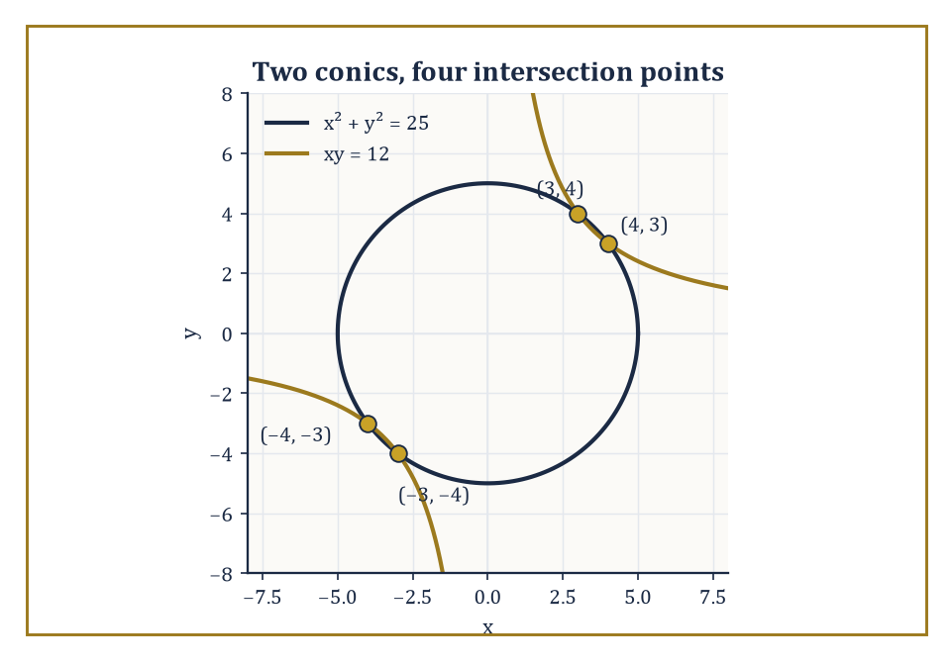
The circle x² + y² = 25 and the hyperbola xy = 12, crossing at all four points the theory allows.
Numeric example — Worked example — a line meeting a circle. Solve the system:
x² + y² = 25
y = x − 1
Substitute the second equation into the first:
x² + (x−1)² = 25
Expanding:
x² + x² − 2x + 1 = 25
2x² − 2x − 24 = 0
Dividing through by 2 gives:
x² − x − 12 = 0
This factors as:
(x − 4)(x + 3) = 0
So x = 4 or x = −3. Correspondingly, y = x − 1 gives y = 3 or y = −4. The two intersection points are (4, 3) and (−3, −4). Checking the first against the circle:
4² + 3² = 16 + 9 = 25 ✓
Checking the second:
(−3)² + (−4)² = 9 + 16 = 25 ✓
A line and a circle, true to the general rule, met in exactly two points.
Numeric example — Worked example — a line tangent to a circle. Take the same circle:
x² + y² = 25
and the line:
3x + 4y = 25
Solving for y gives:
y = (25 − 3x)/4
Substituting into the circle's equation:
x² + [(25−3x)/4]² = 25
Multiplying through by 16 clears the fraction:
16x² + (25−3x)² = 400
Expanding (25−3x)² = 625 − 150x + 9x² gives:
16x² + 625 − 150x + 9x² = 400
25x² − 150x + 225 = 0
Dividing by 25:
x² − 6x + 9 = 0
which factors as:
(x − 3)² = 0
A repeated root, x = 3 only, with no second value to pair with it. Then:
y = (25 − 9)/4 = 4
The line touches the circle at the single point (3, 4) and nowhere else: checking,
3² + 4² = 9 + 16 = 25 ✓
confirming the point lies on the circle, while the doubled root confirms the line does not cross through to a second point. This is tangency: the discriminant of the reduced quadratic is:
(−6)² − 4(1)(9) = 36 − 36 = 0
Vanishing exactly, this is the algebraic signature of a line that grazes a curve rather than piercing it.
Numeric example — Worked example — a line missing a circle entirely. For contrast, take the circle:
x² + y² = 4
(radius 2, centred at the origin) and the line:
y = x + 5
Substituting:
x² + (x+5)² = 4
x² + x² + 10x + 25 = 4
2x² + 10x + 21 = 0
The discriminant is:
b² − 4ac = 10² − 4(2)(21) = 100 − 168 = −68
This is negative, so no real value of x satisfies the equation. The line and circle simply never meet — and this is visible without any algebra at all, since the line y = x+5 passes no closer to the origin than 5/√2 ≈ 3.54, comfortably outside the circle's radius of 2. Zero intersections, exactly as the general count for a line and a circle allows.
There is no longer a single finite recipe guaranteed to decide consistency and hand you every solution written neatly in radicals, the way elimination did for linear systems without fail. We already learned, in the storey on polynomials, that the Abel–Ruffini theorem forbids even a single polynomial equation of degree five or higher from being solved by radicals in general — no formula exists, full stop, not merely one we haven't yet found. A system of nonlinear equations inherits this difficulty and typically compounds it, since eliminating variables between nonlinear equations tends to raise the degree of whatever equation survives at the end. Nonetheless, many systems one meets in practice remain perfectly tractable by hand, through substitution, through elimination when the degrees happen to cooperate, or through factoring — and it is worth developing an eye for when a system is one of the tractable ones before reaching for heavier machinery.
Worked example — Worked example — two conics meeting in four points. Take the circle:
x² + y² = 25
and the hyperbola:
xy = 12
From the second equation:
y = 12/x
(x ≠ 0). Substitute into the first:
x² + (12/x)² = 25
x² + 144/x² = 25
Let u = x²; multiplying through by u gives:
u² + 144 = 25u
u² − 25u + 144 = 0
The quadratic formula gives:
u = (25 ± √(625 − 576))/2 = (25 ± √49)/2 = (25 ± 7)/2
u = 16 or u = 9
Since u = x², this gives x² = 16 (so x = 4 or x = −4) and x² = 9 (so x = 3 or x = −3) — four values of x in total. Using y = 12/x for each: x = 4 gives y = 3; x = −4 gives y = −3; x = 3 gives y = 4; x = −3 gives y = −4. The four intersection points are (4,3), (−4,−3), (3,4), (−3,−4). Checking (4,3):
4²+3² = 25 ✓
4·3 = 12 ✓
The other three check identically by the same symmetry. Two conics, four honest intersection points — the maximum the theory allows, achieved with numbers to spare.
Numeric example — Worked example — a homogeneous equation solved by a substitution ratio. Solve:
x² − 3xy + 2y² = 0
together with:
x + y = 3
The first equation is homogeneous — every term has total degree 2 — so divide through by y² (y = 0 would force x = 0 too, which fails the second equation, so y ≠ 0 here):
(x/y)² − 3(x/y) + 2 = 0
Let r = x/y:
r² − 3r + 2 = 0
which factors as:
(r − 1)(r − 2) = 0
so r = 1 or r = 2 — that is, x = y or x = 2y. Pairing x = y with x + y = 3 gives:
2x = 3
so x = y = 1.5. Pairing x = 2y with x + y = 3 gives:
2y + y = 3
so y = 1 and x = 2. Checking both in the original quadratic:
1.5² − 3(1.5)(1.5) + 2(1.5)² = 2.25 − 6.75 + 4.5 = 0 ✓
2² − 3(2)(1) + 2(1)² = 4 − 6 + 2 = 0 ✓
Both also satisfy x + y = 3 by construction. Dividing by y² turned a genuinely two-variable quadratic into a one-variable quadratic in the ratio x/y — the single trick that homogeneity buys you.
When exact algebraic methods genuinely fail — and for many nonlinear systems arising from real applications, they simply do — numerical methods step in to approximate the solutions to whatever accuracy is required. Newton's method, which storey readers met in one variable already, generalises to several variables at once, iteratively improving a guessed solution by following the local slope (now a matrix of partial slopes) downhill toward a root. Homotopy continuation takes a bolder approach still: it starts from a related system whose solutions are already known, and deforms that system continuously into the target system, tracking how the solutions move as the deformation proceeds, arriving at the target's solutions by having watched them travel there. Neither approach is a concession or a defeat; they are simply the appropriate tools once radicals have exhausted their welcome.
Through all of this, the geometric intuition earns its keep. Before touching algebra, it is almost always worth a rough sketch: plot both curves approximately, notice how many times they appear to cross and roughly where, and only then let algebra or numerics sharpen that rough estimate into an exact or precise answer. A sketch will not solve the system for you, but it will tell you, cheaply and in advance, whether the tidy answer you are about to compute ought to have two solutions or four — and catching an arithmetic slip because the algebra produced three solutions when the picture clearly showed two is a small, satisfying pleasure that never quite gets old.

Room 8.7: Methods for Nonlinear Systems
A Toolkit, Not a Recipe
Substitution remains the first tool to reach for, exactly as in the linear case: solve one equation for one variable, in terms of the others, and insert that expression wherever the variable appears elsewhere. If the resulting single equation is manageable — a quadratic, say, or something that factors nicely — the whole system collapses to a problem we already know how to solve. The chief difficulty in the nonlinear setting is that 'manageable' is no longer guaranteed the way it was for linear systems; substitution can just as easily hand you a degree-six monster as a friendly quadratic, and part of the craft is choosing which variable to isolate, and in which equation, to keep the resulting mess as small as possible.
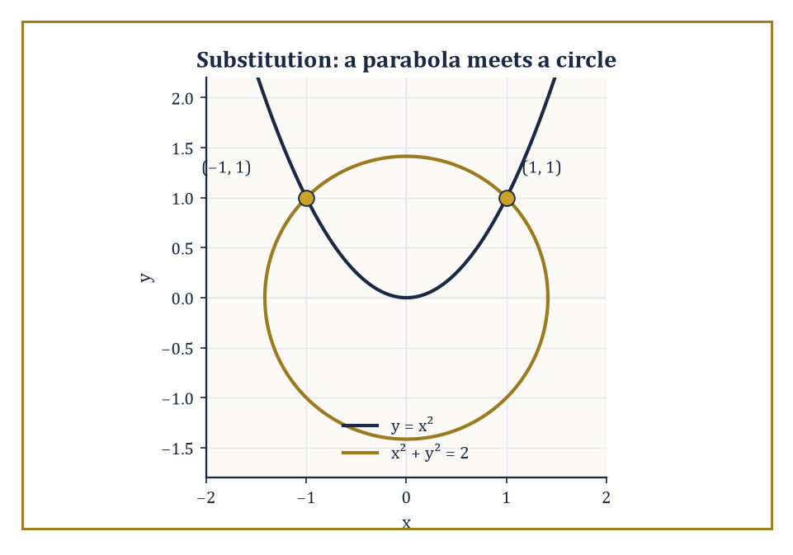
The parabola y = x² and the circle x² + y² = 2, meeting at (1, 1) and (−1, 1) after u = x² tamed the substitution.
Numeric example — Worked example — substitution on a nonlinear system. Solve:
y = x²
together with:
x² + y² = 2
Substitute y = x² into the second equation:
x² + (x²)² = 2
x² + x⁴ = 2
Let u = x²: this becomes:
u² + u − 2 = 0
which factors as:
(u + 2)(u − 1) = 0
giving u = −2 or u = 1. Since u = x² can never be negative, u = −2 is rejected outright — a reminder that substitution can manufacture algebraically valid but geometrically meaningless roots, which must be screened out by hand. From u = 1, x² = 1, so x = 1 or x = −1, and in both cases y = x² = 1. The solutions are (1, 1) and (−1, 1). Checking the first:
1 = 1² ✓
x² + y² = 1 + 1 = 2 ✓
The parabola y = x² and the circle x² + y² = 2 meet at exactly these two points, symmetric about the y-axis, as the picture would have predicted.
Elimination survives into the nonlinear world too, whenever the degrees of the two equations cooperate. The classic case is two quadratic equations: adding or subtracting suitably scaled copies of the equations can sometimes cancel the quadratic (squared) terms entirely, leaving a purely linear relation between the variables, which substitution then finishes off in the usual way. Even when the quadratic terms do not vanish completely, a well-chosen combination can still simplify a system enormously, isolating one squared variable at a time rather than tackling both simultaneously.
Numeric example — Worked example — elimination on two quadratics. Solve:
x² + y² = 13
x² − y² = 5
Adding the two equations cancels y² entirely.
(x²+y²) + (x²−y²) = 13+5
2x² = 18
x² = 9, x = 3 or x = −3
Subtracting instead cancels x².
(x²+y²) − (x²−y²) = 13−5
2y² = 8
y² = 4, y = 2 or y = −2
Because the original system only ever mentions x² and y² — never x or y alone — every combination of the recovered signs is valid: (3,2), (3,−2), (−3,2), and (−3,−2) all solve the system. Checking (3,2):
9+4=13 ✓
9−4=5 ✓
checking (−3,−2):
9+4=13 ✓
9−4=5 ✓
Four solutions, found without ever solving a quartic — elimination did the heavy lifting by cancelling one squared variable at a time.
Beyond substitution and elimination, an alert eye for special algebraic forms often shortcuts a great deal of grinding. A difference of squares factors instantly:
a² − b² = (a−b)(a+b)
and equations secretly built from that pattern collapse at once.
Numeric example — Worked example — spotting a difference of squares. Solve:
x² − y² = 16
together with:
x + y = 8
The left side of the first equation is a difference of squares:
x² − y² = (x − y)(x + y)
The second equation already tells us x + y = 8, so substitute that directly into the factored form:
(x − y)(8) = 16
x − y = 2
Now we have a purely linear pair, x + y = 8 and x − y = 2: adding gives:
2x = 10
x = 5
and then y = 8 − 5 = 3. Checking against the original nonlinear equation:
5² − 3² = 25 − 9 = 16 ✓
5 + 3 = 8 ✓
Recognising the factorable pattern turned a nonlinear system into an ordinary linear one in a single step, without elimination, substitution of the messier kind, or a single squared term surviving past the first line.
Homogeneous equations — where every term has the same total degree — can often be simplified by dividing through by a power of one variable, effectively reducing the number of unknowns by one. Equations that are linear in one variable, even while nonlinear in another, can simply be solved for that one linear variable directly, sidestepping a substitution that would otherwise look intimidating. And trigonometric or exponential substitutions — replacing, say, sin θ and cos θ with new variables constrained by:
sin²θ + cos²θ = 1
can sometimes linearise a system that looks utterly hopeless when written in the original variables, turning a transcendental mess into ordinary algebra.
When every algebraic trick has genuinely been exhausted, graphing and numerical approximation are not a retreat but legitimate, respectable mathematics in their own right — the same tools met in Room 8.6, now formally added to the toolkit. Existence of a solution can sometimes be proved rigorously without ever writing the solution down explicitly, using intermediate-value arguments (if a continuous quantity is negative here and positive there, it must be zero somewhere between) or, in more advanced settings, topological degree theory, which counts solutions by a kind of generalised winding number rather than by displaying them. The practical skill this room has been building, more than any single formula, is judgement: recognising which method fits the shape of a given system, and having the patience to try a second approach when the first one produces a mess rather than an answer.

Room 8.8: Applications and Modeling with Systems
Where the Algebra Finally Has to Answer to Reality
Mixture problems, distance–rate–time problems, and break-even analyses are the traditional first applications, and for good reason: each translates a verbal description directly into a system of linear, or mildly nonlinear, equations, giving the algebra of this storey an immediate and satisfying job to do. The translation step — reading a paragraph of prose and extracting from it exactly which quantities are unknown and exactly which relations among them are asserted — is itself a skill, distinct from the algebra that follows, and it is very often where the actual difficulty of a 'word problem' hides.
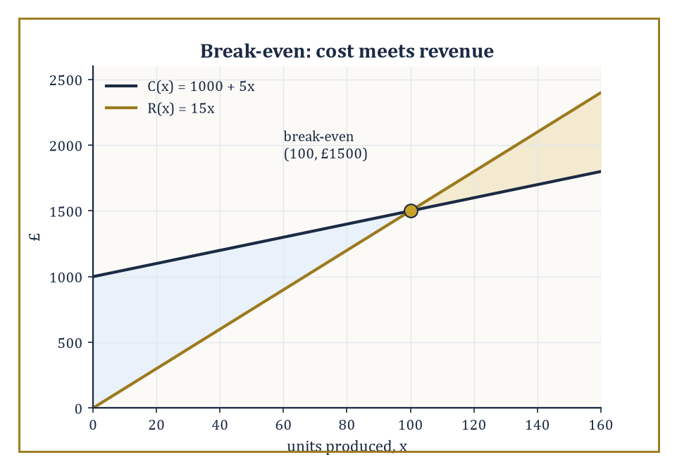
Cost and revenue crossing at the workshop's break-even point, 100 units and £1500 — loss below the crossing, profit above it.
Numeric example — Worked example — a mixture problem. A chemist has a 10% acid solution and a 40% acid solution, and needs 30 litres of a 25% acid solution. How many litres of each should be mixed? Let x be the litres of the 10% solution and y the litres of the 40% solution. The total volume gives one equation:
x + y = 30
The total amount of pure acid gives the second:
0.10x + 0.40y = 0.25(30) = 7.5
From the first equation:
x = 30 − y
Substituting into the second:
0.10(30 − y) + 0.40y = 7.5
3 − 0.10y + 0.40y = 7.5
3 + 0.30y = 7.5
0.30y = 4.5
y = 15
Then:
x = 30 − 15 = 15
Checking:
15 + 15 = 30 ✓
0.10(15) + 0.40(15) = 1.5 + 6 = 7.5 ✓
Exactly 15 litres of each solution produces the required mixture — a pleasingly symmetric answer for a problem with no obvious symmetry built in.
Numeric example — Worked example — distance, rate, and time. Two trains start 350 km apart on the same track and travel toward one another, one at 60 km/h and the other at 80 km/h. How long until they meet? Let t be the time in hours until they meet. Each train's distance travelled is its rate times that same time t, and since they are closing the gap between them, their two distances must together add up to the full 350 km originally separating them:
60t + 80t = 350
Combining the left side gives:
140t = 350
t = 2.5 hours
Checking: in 2.5 hours the first train covers 60 × 2.5 = 150 km, and the second covers 80 × 2.5 = 200 km, and:
150 + 200 = 350 km ✓
precisely the starting distance, now closed. It is worth noticing that this 'system' collapsed to a single equation the moment both rate–time relations were substituted in; the two original unknown distances were still there, constrained by two relations, but the modelling step folded them together before any elimination was needed — a reminder that a system is sometimes present in the setup even when it never appears on the page in more than one line.
The same translate-then-solve pattern recurs across an enormous range of subjects, which is precisely why this room earns its place. In chemistry, balancing a chemical reaction so that atoms of each element are conserved on both sides produces a linear system in the unknown reaction coefficients; computing the equilibrium concentrations of a reacting mixture produces another. In economics, ensuring that supply equals demand simultaneously across several interconnected markets — the price of one good affecting demand for another — produces a system relating multiple prices and quantities at once. In geometry, finding the intersection points of two curves, or the so-called radical centre of three circles (the single point equidistant, in a specific algebraic sense, from all three), is nothing but a system of equations wearing a geometric costume. In physics, balancing forces in several directions at a joint, or writing down conservation of momentum and energy together, produces a system whose unknowns are velocities, tensions, or masses rather than bare x and y.
Numeric example — Worked example — break-even analysis. A small workshop has fixed costs of £1000 plus a variable cost of £5 per unit produced, so total cost is:
C(x) = 1000 + 5x
Each unit sells for £15, so revenue is:
R(x) = 15x
Break-even occurs where cost equals revenue:
1000 + 5x = 15x
Subtracting 5x from both sides gives:
1000 = 10x
x = 100
At 100 units, revenue is:
R(100) = 15(100) = £1500
and cost is:
C(100) = 1000 + 5(100) = £1500
The two agree, confirming the break-even point. Below 100 units the workshop loses money on the venture; above it, every additional unit is pure profit at £10 apiece (the £15 sale price less the £5 variable cost). A single linear system, solved in two lines, tells the whole story of when the venture turns a corner.
The modelling step — turning a real, messy situation into a clean system of equations in the first place — is very often harder, and more consequential, than any algebra that follows it. The mathematics is scrupulously honest but entirely incurious: it solves exactly the problem that was written down, and it has no opinion whatsoever about whether that written-down problem is actually the problem that needed solving. Once a solution has been produced, it must always be carried back into the original context and checked for sense there — a negative concentration, a negative distance, or a fractional number of buses is not a valid answer merely because the algebra that produced it was flawless; it is a signal that some assumption in the modelling step needs revisiting. Extraneous solutions introduced by squaring, cross-multiplying, or other algebraic manoeuvres along the way are discarded at exactly this stage, on physical or logical grounds, not on algebraic ones — the algebra, left to its own devices, would happily hand you an acid concentration of minus four percent and consider its job well done.

Room 8.9: Looking Ahead: From Systems to Vectors, Linear Algebra, and Beyond
The Constraints Learn to Talk to One Another
We have, over the course of this storey, assembled the basic working vocabulary of systems of equations: linear and nonlinear systems; substitution and elimination as the two workhorse methods; matrices and row reduction as the systematic engine underneath elimination; consistency, dependence, and rank as the language for deciding, in advance, what kind of solution set to expect; and a sample of the applications — mixtures, break-even points, balanced reactions, cleared markets — where these ideas earn their keep outside the classroom. None of this vocabulary is going into storage. It resurfaces constantly, in forms that will feel more and more abstract even as the underlying computations stay recognisably the same.
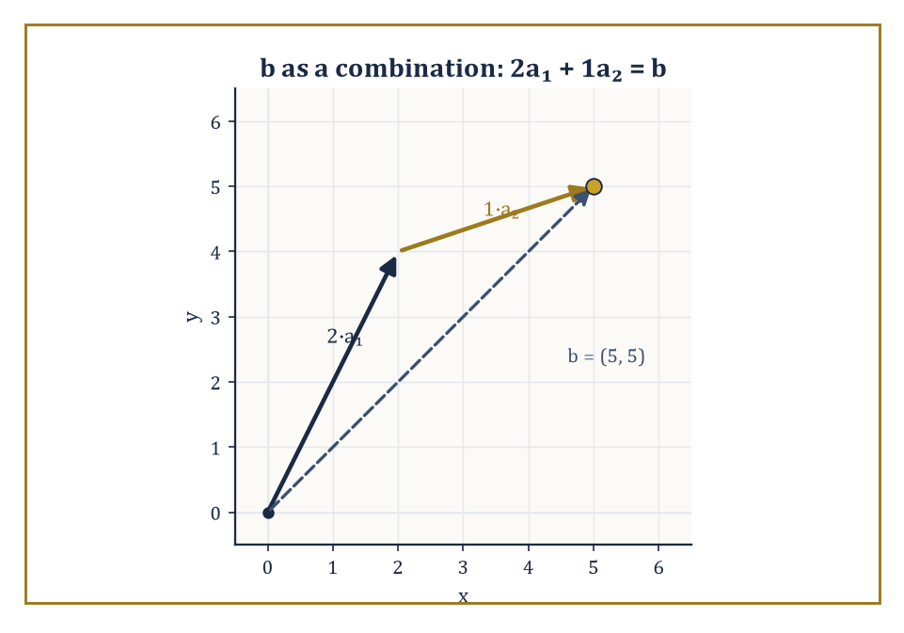
Solving the system and building b from a₁ and a₂ turn out to be the same arrow, drawn tip to tail.
The very next storey, on Vectors and Vector Algebra, will pick up linear systems again almost immediately, but ask a subtly different question about them: not 'where do these lines or planes intersect?' but 'can this target vector be built by combining these other vectors, scaled and added together?' It turns out to be the same question in a different accent. Consider the system:
Ax = b
Read in vector language, this is asking whether b can be written as a linear combination of the columns of A — and solving the system is exactly the act of finding the combining weights.
Worked example — Worked example — a system as a linear combination, previewed. Let a₁ = (1, 2) and a₂ = (3, 1) be two vectors, and let b = (5, 5). Can b be written as:
c₁·a₁ + c₂·a₂
for some numbers c₁, c₂? Writing this out coordinate by coordinate gives exactly a linear system:
c₁ + 3c₂ = 5
2c₁ + c₂ = 5
(first and second coordinates respectively) — the same two-equations-in-two-unknowns problem this storey has solved a dozen times, merely relabelled. From the second equation:
c₁ = (5 − c₂)/2
Substituting into the first:
(5 − c₂)/2 + 3c₂ = 5
Multiplying through by 2 gives:
5 − c₂ + 6c₂ = 10
5c₂ = 5
c₂ = 1, c₁ = 2
Checking:
2·(1,2) + 1·(3,1) = (2,4) + (3,1) = (5,5) = b ✓
Solving the system and expressing b as a combination of a₁ and a₂ turn out to be the exact same act of arithmetic, viewed from two different rooms of the Tower.
Linear algebra proper, several storeys further up, elevates the row-reduction methods of this storey into a full theory of linear maps, eigenvalues, and canonical forms — machinery that, among a great many other things, finally explains rigorously why the rank-counting rules of Room 8.5 work at all, rather than merely observing, as we have done here, that they do. An eigenvalue, to give the barest possible preview, is a number attached to a matrix that tells you which special directions that matrix merely stretches or shrinks rather than rotates — a question with no honest analogue anywhere in this storey, but one that turns out to be built, brick by brick, from exactly the row operations practised in Room 8.4. Nonlinear systems, for their part, resurface in multivariable calculus as the setting for the implicit function theorem, which answers a question this storey could only gesture at through worked examples: under precisely what conditions can a system of equations be solved locally for some variables in terms of the others, even when no explicit closed-form formula for the solution exists anywhere? Roughly speaking, the theorem trades the impossible demand for an exact global formula for the much more modest and far more often achievable promise of a well-behaved local one, valid in some neighbourhood of a known solution — which is often all an engineer or a physicist actually needs. Nonlinear systems resurface once more in numerical analysis, as the natural proving ground for the iterative solvers — Newton's method in several variables, and its many descendants — that Room 8.6 introduced only in outline; there, questions of convergence, stability, and error accumulate their own substantial theory, built on the same intuition of following a local slope downhill toward a root.
The deeper lesson of this storey, underneath all the substitution and elimination, is that a single equation is something of a rare luxury, generally available only in textbooks and other artificially tidy environments. Most interesting constraints in the world arrive in families, all insisting on being satisfied together, and the mathematics of negotiating simultaneous constraints is richer, harder, and — this is the part worth sitting with — considerably more representative of actual scientific and engineering work than the tidy mathematics of equations considered one at a time. Systems of equations have therefore been both a technical room-by-room toolkit and, taken as a whole, a change of perspective: from solving one relation in isolation to negotiating many relations at once, none of which is willing to go first.
It is worth noticing, too, how far the same three-way trichotomy from Room 8.1 has travelled without ever changing its essential shape. Whether the question was two lines in a plane, three planes in space, two conics chasing four intersection points, or a chemist's mixture pinned down by conservation of volume and of acid, the answer always sorted itself into the same three bins: a unique compromise, an infinite family of compromises, or the flat discovery that no compromise existed at all. That a single trichotomy, first noticed for the most pedestrian possible pair of lines, turns out to organise mixture problems, matrix rank, and the intersection of curves alike is not a coincidence to be shrugged off — it is the first real evidence, this early in the Tower, that the same small number of structural ideas keep reappearing beneath wildly different costumes, which is more or less the entire promise the rest of the climb is making.
The constraints, over the course of nine rooms, have learned to talk to one another — to be added, subtracted, scaled, and arranged into matrices that make their collective demands legible at a glance. A lone equation asks a single question; a system holds a negotiation, and this storey has been a course in chairing that negotiation competently, whether it ends in a single tidy point, an entire line of compromises, or the polite discovery that no agreement was ever possible.
The tower continues upward, and it does so, appropriately enough, by generalising the very idea this storey has been quietly rehearsing. Vectors and Vector Algebra, immediately next, will take the columns of numbers we have been calling x and b and give them a life, and an algebra, of their own — arrows with length and direction, added tip to tail, scaled, and combined, with the humble linear system revealed as merely one particular question one can ask of them.
Onward, then, to arrows.

Storey 9: Vectors & Vector Algebra
Direction, Magnitude, and the Art of Adding Arrows
The systems of equations behind us in the last storey were, when you strip away the notation, negotiations: several unknowns, pinned down by several simultaneous demands, until number by stubborn number a unique solution emerged (or didn't, and we learned to shrug about that too). Every unknown in that negotiation, however many of them there were, was still just a number — magnitude, full stop, no sense of which way it was facing. This storey introduces a quantity that refuses to answer only 'how much': the vector, which insists on also answering 'which way.'
A vector is the mathematical embodiment of a directed quantity — a displacement, a velocity, a force, an acceleration, anything that isn't fully described until you've said both its size and its direction. It is not merely a number, and not merely a geometric arrow drawn on a page; it is the deliberate marriage of the two, built precisely so that the geometric picture and the algebraic calculation can be trusted to agree. Vector algebra is the resulting rulebook: how to add such quantities, how to scale them, how to multiply them (in two entirely different ways, as we'll see), and how to extract purely geometric information — lengths, angles, areas, volumes — by purely algebraic means, no compass or protractor required.
This storey climbs from the geometric idea of a directed line segment, through the coordinate representation that turns geometry into arithmetic, to the four central operations — addition, scalar multiplication, the dot product, and the cross product — that do essentially all the work vectors are ever asked to do. Along the way we will meet linear combinations, spans, and bases, and catch the first, unmistakable silhouette of the abstract vector spaces that later storeys will treat with full rigour and considerably less patience for hand-waving.
A small confession, before we begin: vectors are the moment geometry and algebra stop being parallel subjects, each minding its own business, and become a single language with two accents. Once a force can be written as a list of numbers, resolved into components, and added by adding the numbers, the old arguments with similar triangles become optional rather than obligatory — a great gain in power, purchased at the cost of always keeping the picture in your head, lest the algebra curdle into meaningless symbol-shuffling. If the last storey taught us to negotiate several constraints at once, this one teaches us to negotiate several directions at once. Let's start adding arrows.

Room 9.1: What a Vector Actually Is
In Which Arrows Turn Out to Have No Fixed Address
A vector is a quantity that possesses both magnitude and direction — a number with a sense of purpose, if you like your definitions faintly anthropomorphic. Geometrically we draw it as an arrow: the tail is where it starts, the tip is where it points, and the length of the arrow is its magnitude.
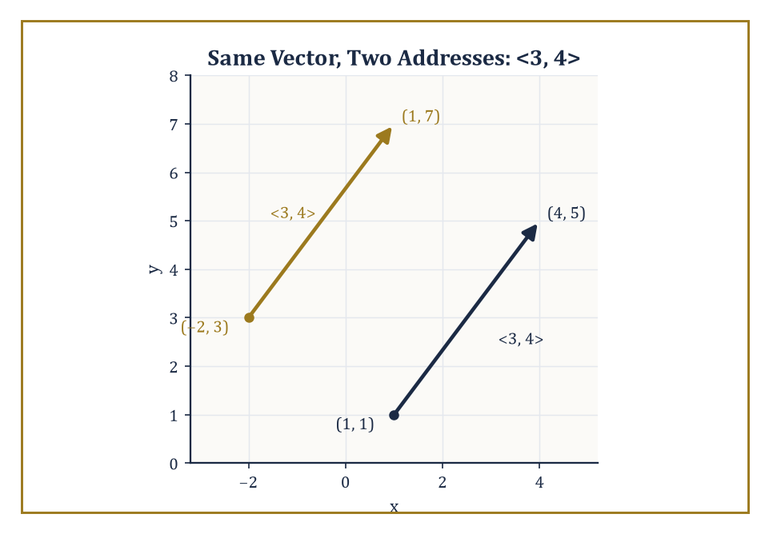
The arrow from (1, 1) to (4, 5) and the arrow from (−2, 3) to (1, 7) share not a single point on the page, yet both are the vector ⟨3, 4⟩.
The crucial and slightly disorienting rule is that two arrows represent the same vector whenever they have the same length and the same direction, no matter where in space they happen to be sitting. Slide an arrow sideways, lift it up, plant it on the far side of the page — so long as you don't stretch it or turn it, it is still the same vector.
Vectors, in short, are free: they have no fixed address. Only the displacement from tail to tip matters, never the tail's own coordinates.
Numeric example — Worked example — same vector, two addresses. Draw an arrow from the point (1, 1) to the point (4, 5). Its horizontal run is 4 − 1 = 3 and its vertical rise is 5 − 1 = 4, so it represents the vector ⟨3, 4⟩, with magnitude:
√(3² + 4²) = √25 = 5
That's the reliable old 3-4-5 triangle, turning up on page one of the vector business as it will turn up everywhere else. Now draw a second, entirely unrelated-looking arrow from (−2, 3) to (1, 7). Its run is 1 − (−2) = 3 and its rise is 7 − 3 = 4 — again ⟨3, 4⟩.
Two arrows, planted in completely different parts of the plane, sharing not a single point, and yet they are the same vector. If that feels like cheating, good: that is exactly the conceptual leap vectors ask you to make.
Two special cases round out the picture. The zero vector, written 0, has magnitude zero — it is the arrow that never got drawn — and its direction is considered undefined, or by convention arbitrary, since an arrow of no length points nowhere in particular.
The negative of a vector v, written −v, has exactly the same magnitude as v but points the opposite way: same arrow, tail and tip swapped. These are not arbitrary conventions invented to be fussy; they are exactly what is needed to make vector addition behave like ordinary arithmetic, with 0 acting as the identity and −v acting as the thing that cancels v. We will see the mechanics of that cancellation properly in the next room, but the idea can be checked immediately with numbers.
Numeric example — Worked example — a vector and its negative. Let v = ⟨4, −3⟩. Its magnitude is:
√(4² + (−3)²) = √(16 + 9) = √25 = 5
Its negative is −v = ⟨−4, 3⟩ — same length, opposite direction. Adding them component by component gives:
v + (−v) = ⟨4 + (−4), −3 + 3⟩ = ⟨0, 0⟩
This is the zero vector, exactly as advertised. The arrow and its mirror image cancel perfectly, which is a rather more satisfying kind of cancellation than the one that happens to your bank balance.
Vectors must also be kept apart from two other kinds of mathematical citizen: scalars and points. A scalar is an ordinary number — it has size but no direction, and multiplying a vector by a scalar is a different operation from adding two vectors, a distinction we formalise in the next room.
A point, meanwhile, has position but no direction and no length of its own; it simply marks a location. A vector has direction and magnitude but famously no fixed position, as we've just seen. The displacement from point A to point B — how far, and which way, you'd have to walk to get from one to the other — is a vector. The point A itself, sitting quietly at its coordinates, is not.
Numeric example — Worked example — points are not vectors. Let A = (2, −1) be a point — just a location, nothing more. Let C = (5, 3) be another point. Neither A nor C, alone, has a direction; asking 'which way does the point A point' is a category error, like asking what colour Tuesday is.
But the displacement from A to C is a bona fide vector: it runs across and up by the following amounts.
5 − 2 = 3, 3 − (−1) = 4
This gives the vector ⟨3, 4⟩, magnitude 5. The two points are static; the arrow between them is not.
This distinction is not pedantry for pedantry's sake — it is where a great many otherwise competent students start writing nonsense once coordinates enter the picture, adding a point to a vector as though the two were interchangeable, or asking for 'the direction of' a point.
We will keep the language scrupulously separate throughout this storey: points are points, vectors are vectors, and the vector running from point A to point B is written as follows, tip minus tail, the instant coordinates are available.
vector from A to B = B − A
Fix that formula now and a great deal of later bookkeeping — projections, lines, planes — becomes automatic rather than mysterious.
Numeric example — Worked example — the B − A convention. Take A = (−1, 4) and B = (2, −2). The vector from A to B is:
B − A = (2 − (−1), −2 − 4) = ⟨3, −6⟩
Its magnitude is:
√(3² + (−6)²) = √(9 + 36) = √45 = 3√5 ≈ 6.71
Notice the order matters: the vector from B to A would be A − B = ⟨−3, 6⟩ — same length, exactly reversed, which is just the negative-vector rule from a moment ago wearing a different hat.

Room 9.2: Vector Addition and Scalar Multiplication
Arithmetic for Arrows
With the objects defined, we need rules for combining them. Vectors are added by what is variously called the triangle law or the parallelogram law, and both names describe the same picture.
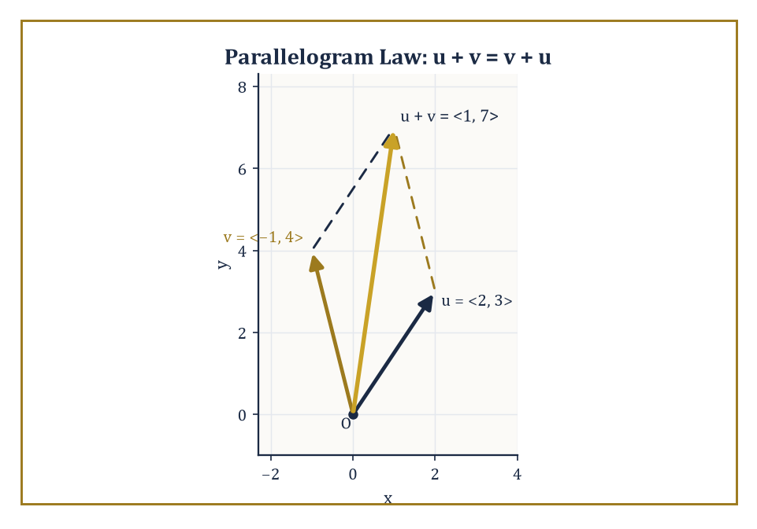
u = ⟨2, 3⟩ and v = ⟨−1, 4⟩ complete a parallelogram whose diagonal is their sum, ⟨1, 7⟩.
Triangle version: place the tail of the second vector at the tip of the first; the sum is the single arrow running from the first vector's free tail to the second vector's free tip. Parallelogram version: place both vectors tail to tail, complete the parallelogram they span, and the sum is the diagonal from the shared tail to the opposite corner. The two constructions agree, because a parallelogram is just two copies of the same triangle glued along a diagonal.
Addition defined this way is commutative — walking east-then-north gets you to the same spot as north-then-east:
u + v = v + u
It is also associative — it doesn't matter how you parenthesise a sequence of legs on a journey:
(u + v) + w = u + (v + w)
The zero vector is the identity (add it and nothing happens), and every vector v has an additive inverse −v with v + (−v) = 0, exactly as we saw in the last room.
Numeric example — Worked example — addition is commutative. Let u = ⟨2, 3⟩ and v = ⟨−1, 4⟩. Adding component by component:
u + v = ⟨2 + (−1), 3 + 4⟩ = ⟨1, 7⟩
Now add them the other way round:
v + u = ⟨−1 + 2, 4 + 3⟩ = ⟨1, 7⟩
Identical, confirming commutativity with actual numbers rather than a hand-wave about east and north. Geometrically: walk 2 across and 3 up, then from there walk 1 back and 4 up, and you land at the same spot as walking 1 back and 4 up first, then 2 across and 3 up. Either route, same destination — which is, when you think about it, the entire point of a parallelogram.
Scalar multiplication takes a vector v and a real number (scalar) a and produces the vector av, which points in the same direction as v if a is positive, the opposite direction if a is negative, and has magnitude |a| times that of v.
Multiplying by 2 doubles the arrow; multiplying by −1 flips it without changing its length (this is exactly how −v was defined above — it is 'multiply by −1' in disguise); multiplying by 0 crushes the arrow down to the zero vector, direction undefined, as tends to happen to things of zero magnitude.
Scalar multiplication distributes over vector addition, and over scalar addition:
a(u + v) = au + av
(a + b)v = av + bv
These two operations — vector addition and scalar multiplication, obeying exactly these distributive and associative laws — are, verbatim, the axioms that will later define an abstract vector space. We are not abstracting yet; we are simply noting, with some satisfaction, that arrows in the plane already obey the rules the whole theory will eventually be built on.
Numeric example — Worked example — scaling and distributing. Let v = ⟨2, −1⟩, with magnitude √(4 + 1) = √5. Then:
3v = ⟨6, −3⟩
Same direction, three times as long, magnitude 3√5. And:
−2v = ⟨−4, 2⟩
Opposite direction, twice as long as the original, magnitude 2√5. Check the distributive law with a = 2, b = 3:
(2 + 3)v = 5v = ⟨10, −5⟩
And separately:
2v + 3v = ⟨4, −2⟩ + ⟨6, −3⟩ = ⟨10, −5⟩
They agree, as the axiom promised they would.
Once you can add vectors and scale them, you can combine several vectors with several scalars at once: an expression like the one below is called a linear combination of v₁, …, vₖ.
a₁v₁ + a₂v₂ + … + aₖvₖ
The set of every linear combination you can form from a given collection of vectors is called their span. Geometrically, the span is 'every point you can reach by travelling along the given directions, any distance you like, forward or backward, in any mixture.'
The span of a single nonzero vector is a line through the origin (just that vector, stretched and flipped every possible amount). The span of two vectors that don't lie along the same line, in the plane, is the entire plane — because between them they can reach anywhere. We will make this precise, with the vocabulary of independence and dependence, in Room 9.7; for now, span is simply 'everywhere these arrows can take you.'
Numeric example — Worked example — a line's worth of span versus a plane's worth. Let u = ⟨1, 0⟩ and v = ⟨0, 1⟩ — the two axis directions. The linear combination 2u − 3v is:
2⟨1, 0⟩ − 3⟨0, 1⟩ = ⟨2, 0⟩ + ⟨0, −3⟩ = ⟨2, −3⟩
By varying the two coefficients you can produce any pair ⟨a, b⟩ whatsoever, so span{u, v} is the whole plane.
Contrast this with w = ⟨1, 2⟩ alone: its span is only the line of points:
t⟨1, 2⟩ = ⟨t, 2t⟩ for real t
t = 3 gives (3, 6), but the point (3, 7) is not reachable from w alone, however you scale it, since 7 ≠ 2 × 3. One direction gives you a line; two independent directions give you a plane.
These two operations, modest as they look, are already enough to settle real geometric questions without a single appeal to similar triangles or circle theorems: finding the missing vertex of a parallelogram, splitting a displacement into a sequence of shorter legs, or writing one vector as a combination of two others.
The method is always the same — translate the geometric condition into a vector equation, then solve it with addition, subtraction, and scalar multiplication, the way one solves any equation.
Numeric example — Worked example — the missing vertex of a parallelogram. A parallelogram ABCD has vertices A = (0, 0), B = (4, 0), C = (6, 3), listed in order around the shape, and we want the fourth vertex D. In a parallelogram, opposite sides are equal as vectors:
B − A = C − D
Rearranging:
D = C − (B − A) = (6, 3) − (4, 0) = (2, 3)
A quick sanity check: side AD should equal side BC.
AD = D − A = ⟨2, 3⟩, BC = C − B = ⟨2, 3⟩
They match, so D = (2, 3) — found without measuring a single angle.

Room 9.3: Components and the Coordinate Representation
Giving Arrows a Postcode
Everything so far has been coordinate-free: arrows floating in space, defined only by length and direction. That's philosophically clean but computationally useless — try adding two arrows by eye with a protractor and see how far you get.
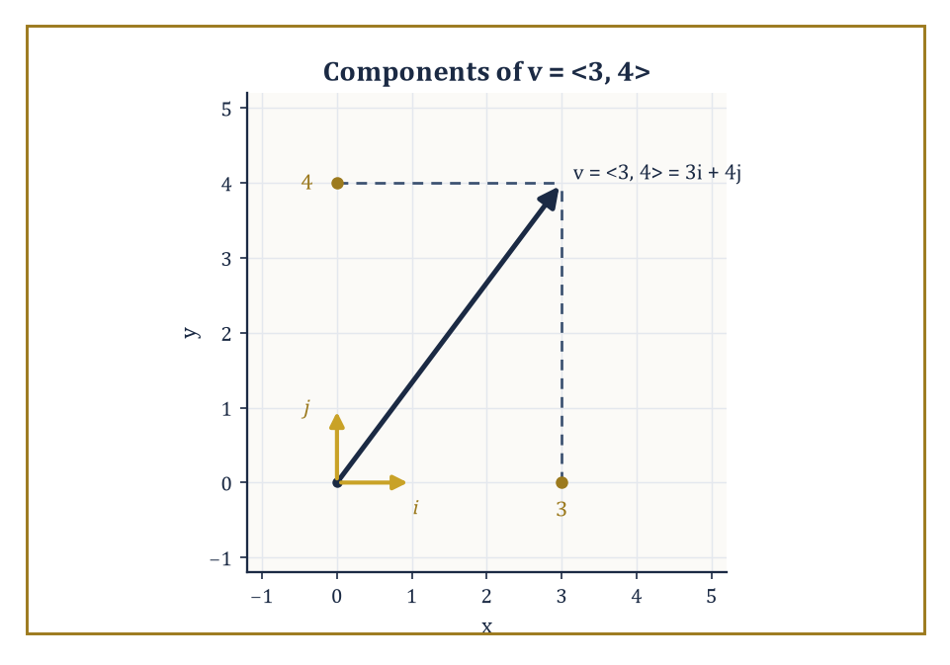
v = ⟨3, 4⟩ resolved into 3 units along i and 4 units along j — the Pythagorean triangle hiding inside every pair of components.
The fix is to choose a coordinate system, at which point every vector acquires components: an ordered pair ⟨v₁, v₂⟩ in the plane, or a triple ⟨v₁, v₂, v₃⟩ in space, recording how far the vector runs along each axis.
Addition and scalar multiplication, once you have components, become exactly the component-wise operations we were already quietly using in the last room's examples — add corresponding entries, scale every entry by the same factor.
And the magnitude of a vector — its length as an arrow — is the square root of the sum of the squares of its components. That is simply the Pythagorean theorem, dressed in vector notation, applied to the right-angled triangle formed by the vector and its projections onto the axes.
Numeric example — Worked example — magnitude in two and three dimensions. For v = ⟨3, 4⟩, magnitude:
‖v‖ = √(3² + 4²) = √25 = 5
In three dimensions, for w = ⟨1, 2, 2⟩, magnitude:
‖w‖ = √(1² + 2² + 2²) = √(1 + 4 + 4) = √9 = 3
Notice the formula extends without fuss from two dimensions to three (and, as later storeys will show, to any number of dimensions): just keep squaring and adding.
Three particular vectors are worth naming, because everything else in three-dimensional space can be built from them:
i = ⟨1, 0, 0⟩, j = ⟨0, 1, 0⟩, k = ⟨0, 0, 1⟩
Each one unit long, each pointing along a single axis. Any vector v = ⟨v₁, v₂, v₃⟩ can then be written as follows — a linear combination, in exactly the sense of the previous room, of these three special vectors.
v = v₁i + v₂j + v₃k
This is more than a notational trick. It is the first proper example of a basis: a set of vectors that is linearly independent (none of them is a combination of the others — a notion we make precise in Room 9.7) and spans the whole space (every vector is reachable as some combination of them). Once you have a basis, 'the vector' and 'its list of components' become genuinely interchangeable, and most of vector algebra from here on is arithmetic on those lists.
Numeric example — Worked example — a vector in basis notation. The vector v = ⟨5, −2, 7⟩ is, in basis notation:
v = 5i − 2j + 7k
There is nothing more to it than relabelling — 5 units along the first axis, −2 along the second, 7 along the third — but the relabelling is what lets you write vector equations that look exactly like ordinary algebra, factor them, and manipulate them with the same rules you already trust.
A unit vector is simply a vector of length exactly one. Given any nonzero vector v, you can manufacture a unit vector pointing the same way by dividing v by its own magnitude:
v / ‖v‖
This process is called normalising the vector, and it's useful precisely because it separates a vector's direction from its magnitude — you can specify 'which way' with a unit vector and 'how much' with a separate scalar, multiply them back together, and recover the original.
Resolving a vector into components along chosen directions — asking 'how much of this vector points north, and how much points east' — is the practical, everyday use of this idea, and it becomes a fully general tool once we meet the dot product in the next room.
Numeric example — Worked example — normalising a vector. Take v = ⟨3, 4⟩, magnitude 5 (as computed above). The unit vector in its direction is:
v / ‖v‖ = ⟨3/5, 4/5⟩ = ⟨0.6, 0.8⟩
Check its length:
√(0.6² + 0.8²) = √(0.36 + 0.64) = √1 = 1
Exactly as required. Any vector along the same ray as v — say 20v = ⟨60, 80⟩ — normalises to precisely the same unit vector ⟨0.6, 0.8⟩, because normalising throws away magnitude and keeps only direction.
One warning before we move on. Choosing coordinates is a convenience, not a change in the underlying geometry, and it's worth being honest about what it does and doesn't alter.
The same vector will have different components if you rotate or shift your coordinate axes — the numbers in the ⟨,⟩ brackets are not sacred, they depend on where you decided to put your axes.
But the geometric relationships the vector participates in — its length, the angle it makes with another vector, whether two vectors are perpendicular — do not change when you rotate your axes, because you haven't touched the arrows themselves, only the ruler you're measuring them with. This is the first hint of a theme that recurs throughout the tower: a good piece of mathematics distinguishes sharply between the object and the coordinates used to describe it.
Numeric example — Worked example — same length, different components. Let v = ⟨3, 4⟩ in the usual x-y axes, magnitude 5. Now rotate the axes by 90° (so the new x′-axis points where the old y-axis pointed, and the new y′-axis points where the old negative x-axis pointed). Under this rotation the same arrow acquires new components:
⟨4, −3⟩
Its magnitude in the new coordinates is:
√(4² + (−3)²) = √(16 + 9) = √25 = 5
Unchanged, as it must be, since we rotated the axes, not the arrow. The components scrambled; the length, being a genuine geometric property of the vector rather than an artefact of the coordinate grid, did not.

Room 9.4: The Dot Product: Angles and Projections
Multiplying Two Arrows Into One Number
We now introduce the first of two ways to multiply vectors together, and it is, perhaps surprisingly, the one that produces a plain number rather than another vector.
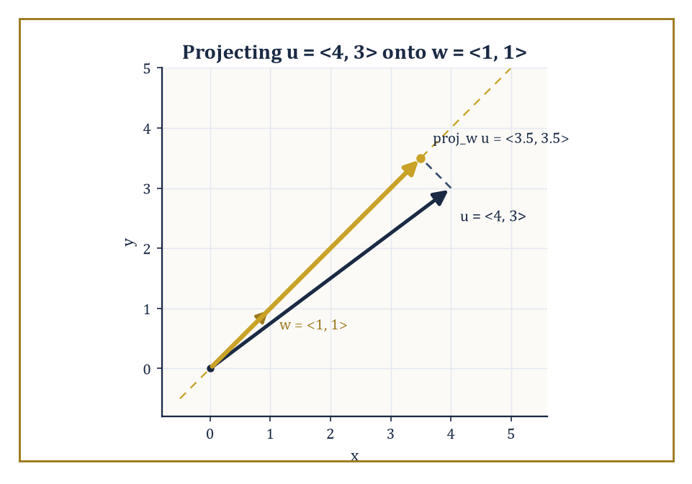
The shadow u = ⟨4, 3⟩ casts along the direction w = ⟨1, 1⟩ is the projection vector ⟨3.5, 3.5⟩ — everything the dot product knows about 'how much of u lies along w', drawn out.
The dot product (or scalar product) of two vectors u and v is defined geometrically as follows, where θ is the angle between them when placed tail to tail:
u · v = ‖u‖ ‖v‖ cos θ
Equivalently — and this is the version you will actually use for calculation — in components it is the sum of the products of corresponding entries:
u · v = u₁v₁ + u₂v₂ + u₃v₃
(or the obvious two-term version in the plane). These two definitions, one geometric and one algebraic, agree exactly; the proof is a short application of the law of cosines to the triangle formed by u, v, and u − v, and we take that agreement on faith here so as not to interrupt the momentum with a trigonometric detour.
The component formula is what you compute with; the geometric formula is what you interpret with — and the entire usefulness of the dot product comes from being able to move freely between the two.
Numeric example — Worked example — from components to angle. Let u = ⟨1, 2, 2⟩ and v = ⟨3, 0, 4⟩. The component formula gives:
u · v = (1)(3) + (2)(0) + (2)(4) = 3 + 0 + 8 = 11
To interpret this via the angle between them, first find the magnitudes:
‖u‖ = √(1 + 4 + 4) = √9 = 3, ‖v‖ = √(9 + 0 + 16) = √25 = 5
From u · v = ‖u‖ ‖v‖ cos θ we get:
cos θ = 11 / (3 × 5) = 11/15 ≈ 0.733
So:
θ = arccos(0.733) ≈ 42.8°
Two arrows in space, described only by their components, and we've extracted the angle between them without drawing anything.
Because cos θ is zero exactly when θ = 90°, the dot product is zero precisely when the two vectors are orthogonal (the proper word for perpendicular once you're no longer confined to two dimensions) — this single fact is what makes the dot product the workhorse of the entire storey, since 'are these two things at right angles' is one of the most common questions in geometry and physics alike.
When the angle between the vectors is acute (less than 90°), cos θ is positive and so is u · v; when the angle is obtuse, u · v is negative.
There is also a precise geometric meaning for 'how much of u lies along v': the projection of u onto v is the vector below, and its length is |u · v| / ‖v‖.
(u · v / ‖v‖²) v
This turns 'resolve this vector into a component along that direction' — the promise made at the end of the last room — into a two-line calculation.
Numeric example — Worked example — projecting one vector onto another. Let u = ⟨4, 3⟩ and v = ⟨1, 0⟩ (the x-axis direction). Then:
u · v = (4)(1) + (3)(0) = 4, ‖v‖² = 1² = 1
So the projection of u onto v is:
(4/1)⟨1, 0⟩ = ⟨4, 0⟩
Exactly the x-component of u, as it should be, since projecting onto the x-axis direction should just read off the x-coordinate. The length of the projection is |4|/‖v‖ = 4/1 = 4.
For a less trivial direction, project u = ⟨4, 3⟩ onto w = ⟨1, 1⟩:
u · w = 4 + 3 = 7, ‖w‖² = 1² + 1² = 2
So the projection is:
(7/2)⟨1, 1⟩ = ⟨3.5, 3.5⟩
The 'shadow' u casts along the 45° line.
The dot product has three algebraic properties worth naming, because they will resurface, verbatim, as the defining axioms of something far more general later in the tower.
It is bilinear: the dot product plays nicely with linear combinations, in either slot.
(au + bw) · v = a(u · v) + b(w · v)
It is symmetric, since multiplication of real numbers doesn't care about order:
u · v = v · u
And it is positive-definite: u · u = ‖u‖² is always zero or positive, and it equals zero only when u itself is the zero vector — a length can't be negative, and only the vector of no length has length zero.
When we eventually meet abstract vector spaces (matrices, not arrows; polynomials, not points), these three properties become the very definition of an inner product, the general tool for measuring angles and lengths in spaces where there is no picture to draw. For now, they simply certify that the algebra and the geometry can never contradict each other.
Numeric example — Worked example — checking bilinearity and positive-definiteness. Take u = ⟨1, 2⟩, w = ⟨3, −1⟩, v = ⟨2, 0⟩, and scalars a = 2, b = 5. First compute directly:
au + bw = 2⟨1, 2⟩ + 5⟨3, −1⟩ = ⟨2, 4⟩ + ⟨15, −5⟩ = ⟨17, −1⟩
So:
(au + bw) · v = (17)(2) + (−1)(0) = 34
Now compute the other side of bilinearity separately:
u · v = (1)(2) + (2)(0) = 2, w · v = (3)(2) + (−1)(0) = 6
So:
a(u · v) + b(w · v) = 2(2) + 5(6) = 4 + 30 = 34
The two routes agree, as bilinearity promises.
For positive-definiteness:
u · u = 1² + 2² = 5
Positive, matching ‖u‖² = (√5)² = 5; and the zero vector satisfies 0 · 0 = 0, the one case where the dot product of a vector with itself vanishes.

Room 9.5: The Cross Product: Perpendicularity and Area
Multiplying Two Arrows Into a Third
The second way to multiply two vectors is available only in three dimensions, and unlike the dot product it produces another vector, not a number — which makes it stranger, more powerful, and rather more fussy about which dimension it's willing to work in.
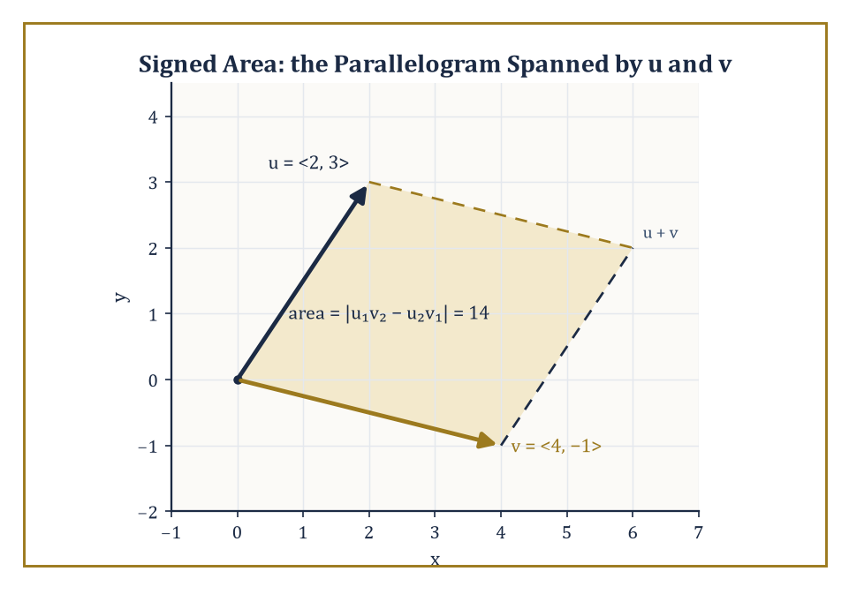
The parallelogram spanned by u = ⟨2, 3⟩ and v = ⟨4, −1⟩ has area 14 — the two-dimensional shadow of the cross product, computed without ever leaving the plane.
Given vectors u and v in three-dimensional space, the cross product u × v is the vector perpendicular to both u and v (there are, in three dimensions, exactly two directions perpendicular to a given plane, and the cross product picks one of them by a convention called the right-hand rule: curl the fingers of your right hand from u toward v, and your thumb points along u × v).
Its magnitude is given below, which is precisely the area of the parallelogram that u and v span when placed tail to tail — so the cross product packages 'perpendicular direction' and 'area of the parallelogram' into a single object.
‖u × v‖ = ‖u‖ ‖v‖ sin θ
Numeric example — Worked example — the unit square, crossed. Let u = i = ⟨1, 0, 0⟩ and v = j = ⟨0, 1, 0⟩, the two horizontal axis directions. They are perpendicular, so θ = 90° and sin θ = 1; the parallelogram they span is the unit square, area 1.
The right-hand rule (curl from i toward j) points straight up, so we expect:
u × v = k = ⟨0, 0, 1⟩
Magnitude 1 — matching the area exactly, as promised.
For calculation, the cross product is given by the formal determinant below.
u × v = i(u₂v₃ − u₃v₂) − j(u₁v₃ − u₃v₁) + k(u₁v₂ − u₂v₁)
It looks like a small monster on first sight, but the pattern is mechanical once you see it: for each component, cover up that component's row in both vectors, cross-multiply the remaining two entries diagonally, subtract, and mind the minus sign sitting in front of the j term (a small piece of bookkeeping that trips up almost everyone the first three or four times).
Numeric example — Worked example — the determinant formula, step by step. Let u = ⟨2, 3, 4⟩ and v = ⟨5, 6, 7⟩. The i-component:
u₂v₃ − u₃v₂ = (3)(7) − (4)(6) = 21 − 24 = −3
The j-component (remember the minus sign out front):
−(u₁v₃ − u₃v₁) = −[(2)(7) − (4)(5)] = −[14 − 20] = −(−6) = 6
The k-component:
u₁v₂ − u₂v₁ = (2)(6) − (3)(5) = 12 − 15 = −3
So:
u × v = ⟨−3, 6, −3⟩
As a check, this should be perpendicular to both original vectors:
u · (u × v) = (2)(−3) + (3)(6) + (4)(−3) = −6 + 18 − 12 = 0
v · (u × v) = (5)(−3) + (6)(6) + (7)(−3) = −15 + 36 − 21 = 0
Both dot products vanish, confirming perpendicularity.
The cross product is anticommutative — swap the order and the result flips direction, since curling your fingers the other way sends your thumb the other way too:
v × u = −(u × v)
It is also bilinear, and, as just demonstrated, orthogonal to each of its two factors. It is the zero vector precisely when u and v are parallel (including when either is zero), since parallel vectors span no parallelogram at all, only a degenerate sliver of zero area.
Stack a third vector on top and you get the scalar triple product below: first take the cross product of two vectors to get a vector perpendicular to the plane they span, then dot that with the third vector.
u · (v × w)
The result is a single number equal to the (signed) volume of the parallelepiped — the slanted brick — spanned by the three vectors, and it vanishes exactly when the three vectors are coplanar, i.e. when the 'brick' has been squashed flat and has no volume to speak of.
Numeric example — Worked example — a unit-cube volume, and a squashed one. Volume case: let u = i = ⟨1, 0, 0⟩, v = j = ⟨0, 1, 0⟩, w = k = ⟨0, 0, 1⟩. First find v × w = j × k using the determinant rule. The i-component:
(1)(1) − (0)(0) = 1
The j-component:
−[(0)(1) − (0)(0)] = 0
The k-component:
(0)(0) − (1)(0) = 0
So:
j × k = ⟨1, 0, 0⟩ = i
Then the triple product is:
u · (v × w) = i · i = 1
The volume of the unit cube spanned by i, j, k, exactly as expected.
Coplanar case: let u = ⟨1, 0, 0⟩, v = ⟨0, 1, 0⟩, w = ⟨1, 1, 0⟩ — all three lying flat in the plane z = 0. Compute v × w. The i-component:
(1)(0) − (0)(1) = 0
The j-component:
−[(0)(0) − (0)(1)] = 0
The k-component:
(0)(1) − (1)(1) = −1
So:
v × w = ⟨0, 0, −1⟩
And:
u · (v × w) = (1)(0) + (0)(0) + (0)(−1) = 0
The triple product vanishes, confirming what's visually obvious — three vectors stuck in the same flat plane enclose no volume at all.
A word of caution the cross product itself will not offer: it is a creature of exactly three dimensions. The right-hand rule needs three dimensions to have a 'perpendicular direction' be unique up to sign in the first place — in four dimensions there is a whole plane of directions perpendicular to any two given vectors, and 'the' cross product stops making sense.
Later storeys handle this properly with a more general construction (the wedge product, part of what's called exterior algebra), which agrees with the familiar cross product exactly in three dimensions and generalises gracefully beyond it.
In two dimensions, meanwhile, there's a useful shadow of the idea: for u = ⟨u₁, u₂⟩ and v = ⟨v₁, v₂⟩, the following quantity (the determinant of the 2×2 matrix with rows u and v) gives the signed area of the parallelogram they span — positive if v is counterclockwise from u, negative otherwise.
u₁v₂ − u₂v₁
It's a scalar, not a vector (there's no 'perpendicular to the plane, but still in the plane' direction to point along), but it's exactly the number you'd get by computing a genuine 3D cross product of the same two vectors padded with a zero third component, and reading off the k-component.
Numeric example — Worked example — signed area in the plane. Let u = ⟨2, 3⟩ and v = ⟨4, −1⟩. The signed area is:
u₁v₂ − u₂v₁ = (2)(−1) − (3)(4) = −2 − 12 = −14
The magnitude, 14, is the actual area of the parallelogram spanned by u and v; the negative sign tells us v sits clockwise from u rather than counterclockwise.
Between them, the dot product and the cross product let us extract every metric and orientational fact about a pair of vectors — length, angle, perpendicularity, area, volume, orientation — by nothing more exotic than arithmetic on their components. That completeness is what makes the next room, on lines and planes, almost disappointingly straightforward.

Room 9.6: Lines and Planes in Vector Form
Flat Things, Described Honestly
A line in space is determined by a point it passes through and a direction it runs in — which is exactly the information a point plus a vector provides.
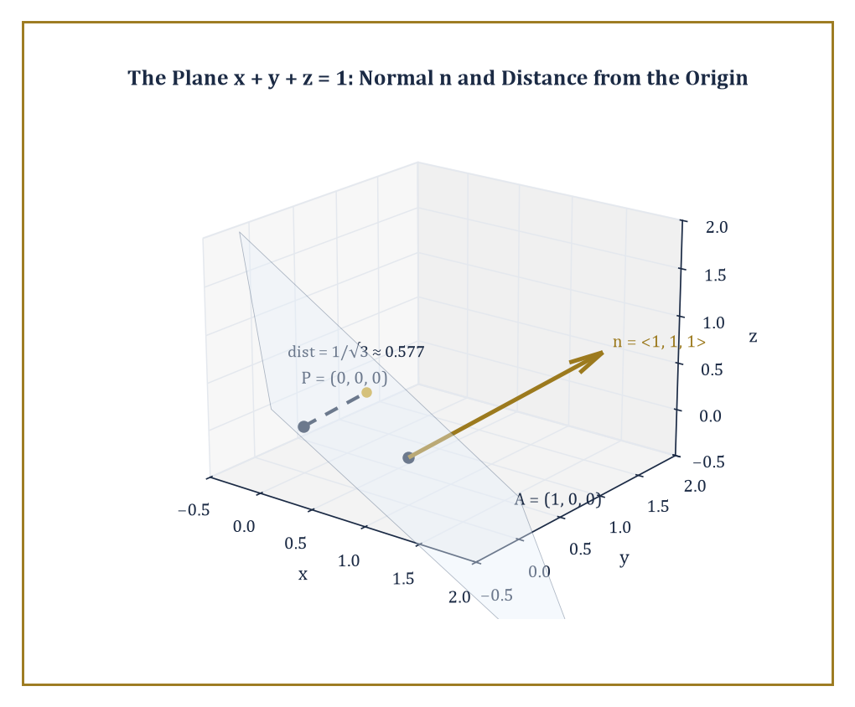
The plane x + y + z = 1, its normal n = ⟨1, 1, 1⟩ anchored at A, and the perpendicular drop from the origin P that measures the distance 1/√3.
The line through point A with direction vector d is the set of all points X below, where t ranges over all real numbers: start at A, and walk any multiple (forward or backward) of d.
X = A + t d
This is the vector version of the parametric equations you may already have met in coordinate geometry — one equation per coordinate, all bundled into a single vector equation.
Two direction vectors describe the same line if and only if one is a scalar multiple of the other — which is only sensible, since a line has one direction, not many, however you choose to scale the arrow that represents it.
Numeric example — Worked example — plotting points on a line. Let A = (1, 2, 3) and d = ⟨2, −1, 1⟩. The line is:
X(t) = (1 + 2t, 2 − t, 3 + t)
At t = 0 we recover A = (1, 2, 3), as we must. At t = 2:
X(2) = (1 + 4, 2 − 2, 3 + 2) = (5, 0, 5)
A specific point on the line, produced by nothing more than substitution. At t = −1:
X(−1) = (1 − 2, 2 + 1, 3 − 1) = (−1, 3, 2)
A point on the other side of A. One formula, every point on the line, on demand.
A plane needs a slightly different kind of anchor: a point A on the plane, and a normal vector n perpendicular to the entire plane (rather than a direction lying within it). The plane is then the set of points X satisfying the equation below.
n · (X − A) = 0
The geometric content being that the vector from A to any other point on the plane, X − A, must lie entirely within the plane and is therefore perpendicular to n, so their dot product vanishes.
Equivalently, if you'd rather generate points than test them, pick two direction vectors u and v that lie in the plane (and aren't parallel to each other), and write the parametric form below for real s and t — sweep out the whole plane with two independent 'along the plane' directions instead of describing it by what's perpendicular to it.
X = A + s u + t v
The normal form is usually the quicker route to a distance calculation; the parametric form is the quicker route to listing points.
Numeric example — Worked example — building and checking a plane. Let A = (1, 0, 0) and n = ⟨1, 1, 1⟩. The plane equation is n · (X − A) = 0, i.e.:
(x − 1) + y + z = 0
Which simplifies to:
x + y + z = 1
Check that A itself satisfies it:
1 + 0 + 0 = 1
Check a different point, (0, 1, 0):
0 + 1 + 0 = 1
It lies on the same plane, since the vector from A to it, ⟨−1, 1, 0⟩, dotted with n gives:
(−1)(1) + (1)(1) + (0)(1) = 0
Confirming perpendicularity to n as required.
Once lines and planes are vector equations, a whole family of classical distance and angle problems collapse into short calculations with the tools of the last two rooms.
The distance from a point P to a plane with normal n through A is given below — project the displacement from A to P onto the (unit) normal direction, and the length of that projection is exactly how far P sits off the plane.
|n · (P − A)| / ‖n‖
The distance from a point to a line, and the distance between two skew lines that never meet in space, are handled by closely related projection-and-cross-product formulas that we won't derive in full here, but which follow the same spirit: turn 'how far apart' into 'the length of the part of some displacement vector that points the wrong way to be absorbed by the line or plane.'
Likewise, the angle between two lines, two planes, or a line and a plane is simply the angle between their direction vectors or normal vectors — recovered, as ever, via the dot product.
Numeric example — Worked example — distance from a point to a plane. How far is the origin, P = (0, 0, 0), from the plane x + y + z = 1 (the same plane as above, with A = (1, 0, 0) and n = ⟨1, 1, 1⟩)? Compute:
P − A = (0 − 1, 0 − 0, 0 − 0) = ⟨−1, 0, 0⟩
Then:
n · (P − A) = (1)(−1) + (1)(0) + (1)(0) = −1
The magnitude of n is:
‖n‖ = √(1 + 1 + 1) = √3
So the distance is:
|−1| / √3 = 1/√3 = √3/3 ≈ 0.577
A single dot product and a square root, no perpendicular-foot construction required.
None of this retires the classical geometric theorems — Thales, Ceva, the intersecting chords theorem, and their many relatives remain perfectly true. What vector methods provide is a single, uniform computational language in which those theorems stop needing separate, cunning proofs and instead fall out of the same handful of algebraic operations, applied patiently.

Room 9.7: Linear Combinations, Span, and Dependence
Redundancy, Named and Shamed
We touched span informally in Room 9.2; now we make the companion idea, linear (in)dependence, precise, because it is the concept that will govern everything from 'how many vectors do I need to describe this space' to, many storeys hence, the rank and dimension theorems of linear algebra proper.
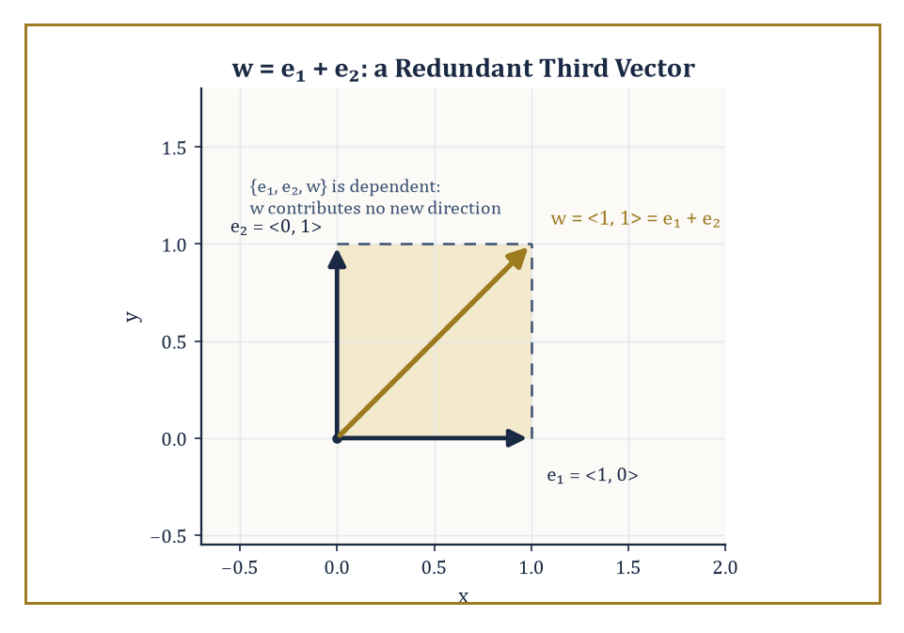
w = e₁ + e₂ sits inside the parallelogram e₁ and e₂ already span — a picture of exactly what it means for a third vector to be redundant.
A set of vectors is linearly dependent if at least one of them can be written as a linear combination of the others — equivalently, and this is the version that's easiest to compute with, if there exist scalars c₁, …, cₖ, not all zero, such that the combination below vanishes.
c₁v₁ + c₂v₂ + … + cₖvₖ = 0
('Not all zero' is doing real work in that sentence: the equation is trivially satisfiable by setting every scalar to zero, so the interesting question is always whether a nontrivial solution exists.) A set that is not linearly dependent — where the only way to make the combination vanish is to set every coefficient to zero — is called linearly independent.
Numeric example — Worked example — spotting dependence. Let v₁ = ⟨1, 2⟩ and v₂ = ⟨2, 4⟩. Notice v₂ = 2v₁, so these are dependent: take c₁ = 2, c₂ = −1 (not both zero), and check:
2v₁ − v₂ = ⟨2, 4⟩ − ⟨2, 4⟩ = ⟨0, 0⟩
Geometrically, v₂ points in exactly the same direction as v₁ (just twice as far), so between them they only ever reach points along a single line — v₂ contributes nothing that v₁ didn't already offer.
This has an immediate and useful consequence: in the plane, any three vectors are automatically dependent, and in space, any four vectors are automatically dependent — there simply isn't room for more independent directions than the dimension allows.
A basis is defined as a linearly independent set that also spans the whole space; it is, so to speak, the minimum equipment needed to reach everywhere with nothing wasted. In ℝⁿ (n-dimensional space with real-number coordinates), every basis has exactly n vectors — no more, no fewer, however differently two different bases might look.
Given a basis, the components of any vector with respect to it are the unique coefficients expressing that vector as a linear combination of the basis vectors — 'unique' being the crucial word, since a basis is precisely the setup in which there is only one honest way to build any given vector.
Numeric example — Worked example — three vectors, one redundant. In the plane, take e₁ = ⟨1, 0⟩, e₂ = ⟨0, 1⟩, and a third vector w = ⟨1, 1⟩. Three vectors in the plane, so they must be dependent — let's find the scalars. We need a, b, c, not all zero, with:
a e₁ + b e₂ + c w = 0, i.e. (a + c, b + c) = (0, 0)
Choosing c = 1 forces a = −1 and b = −1. Check:
−1⟨1, 0⟩ − 1⟨0, 1⟩ + 1⟨1, 1⟩ = ⟨−1, 0⟩ + ⟨0, −1⟩ + ⟨1, 1⟩ = ⟨0, 0⟩
Any one of the three, here, is already a combination of the other two — w, for instance, is simply e₁ + e₂ — so {e₁, e₂, w} is redundant as a description of the plane, even though {e₁, e₂} alone is a perfectly good basis for it.
Notice what actually happened in that last calculation: testing three vectors for dependence came down to solving a system of linear equations for the unknown scalars a, b, c, and asking whether the only solution is the trivial one.
This is not a coincidence, and it is not a new skill — it is exactly the negotiation between simultaneous constraints that occupied the whole of the previous storey, redeployed here to answer a geometric question. Independence, in practice, is always a systems-of-equations question wearing a geometric hat.
Numeric example — Worked example — independence in space, by solving a system. Let v₁ = ⟨1, 0, 1⟩, v₂ = ⟨0, 1, 1⟩, v₃ = ⟨1, 1, 0⟩. Are they independent? Set a v₁ + b v₂ + c v₃ = 0 and expand coordinate by coordinate, giving the system:
a + c = 0, b + c = 0, a + b = 0
From the first two equations, a = −c and b = −c. Substituting into the third:
(−c) + (−c) = 0, so −2c = 0
Forcing c = 0, and then a = 0, b = 0 as well. The only solution is the trivial one, so v₁, v₂, v₃ are linearly independent — and since there are three of them in three-dimensional space, they automatically form a basis for ℝ³, no additional check required.
Strip away the algebra and the geometric content is almost embarrassingly simple: linear independence means every vector in the set points in a genuinely new direction, one that none of the others, however combined and scaled, could have reached. Linear dependence means at least one vector is redundant — already sitting in the span of the rest, contributing no new territory.
This is the precise sense in which 'two independent directions span the plane' and 'three independent directions span space': it isn't a coincidence about triangles, it's a headcount. You need exactly as many independent directions as the dimension you're trying to cover, and not one more.
Abstract example — Abstract example — why a fourth vector in ℝ³ is always redundant. Consider the standard basis of ℝ³: e₁ = ⟨1, 0, 0⟩, e₂ = ⟨0, 1, 0⟩, e₃ = ⟨0, 0, 1⟩ — three independent directions, spanning all of space. Take any fourth vector at all, say v = ⟨a, b, c⟩ for arbitrary real numbers a, b, c. By definition of the basis:
v = a e₁ + b e₂ + c e₃
v is already, automatically, a linear combination of the first three, for every possible choice of a, b, c. So {e₁, e₂, e₃, v} is dependent no matter what v is; there was never any hope of a fourth genuinely independent direction in three-dimensional space, because the first three had already accounted for every direction there is.

Room 9.8: Applications: Physics, Geometry, and Beyond
Where the Arrows Actually Work
With the algebra in hand, it's worth pausing to see how much of it is already load-bearing in the outside world, starting with physics, where vectors were arguably invented to live.
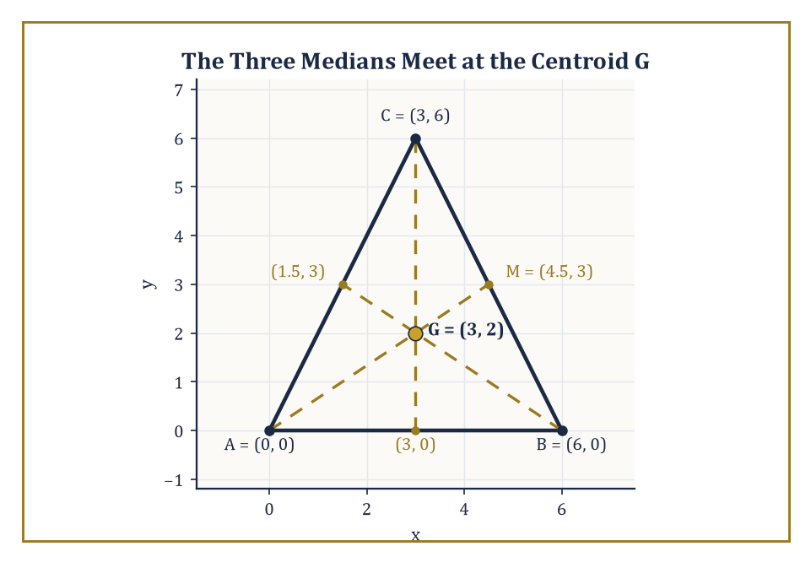
Triangle A(0, 0), B(6, 0), C(3, 6): all three medians pass through the centroid G = (3, 2), found by nothing more than averaging the vertices.
Forces, velocities, accelerations, and momenta are all vectors — quantities that genuinely have a direction as well as a size, so that 'ten newtons' is meaningless until you say which way. Newton's second law is a vector equation: force and acceleration point the same way, and the equation holds component by component.
F = ma
The work done by a force F moving an object through a displacement d is the dot product below — which is exactly why pushing something sideways to its direction of travel (force perpendicular to displacement) does zero work, however hard you push, since cos 90° = 0.
F · d
The torque of a force about a point, meanwhile, is a cross product below, where r is the position of the force's point of application relative to the pivot — capturing both 'how hard' and 'how effectively angled' the twist is.
r × F
A rigid body is in equilibrium precisely when both the total force vector and the total torque vector vanish simultaneously — two vector equations, six scalar equations in three dimensions, and the entire content of statics.
Numeric example — Worked example — work and torque. Work: a force F = ⟨10, 0⟩ newtons pushes an object through a displacement d = ⟨5, 3⟩ metres. The work done is:
F · d = (10)(5) + (0)(3) = 50 joules
Only the component of displacement along the force's direction (the 5 metres) contributes; the 3 metres of sideways drift costs nothing.
Torque: a force F = ⟨0, −10, 0⟩ newtons (ten newtons straight down) is applied at a point with position r = ⟨2, 0, 0⟩ metres relative to a pivot. The torque is r × F. The i-component:
(0)(0) − (0)(−10) = 0
The j-component:
−[(2)(0) − (0)(0)] = 0
The k-component:
(2)(−10) − (0)(0) = −20
So:
torque = ⟨0, 0, −20⟩ newton-metres
Magnitude 20, direction along the negative z-axis, meaning (by the right-hand rule) the force is trying to rotate the body clockwise when viewed from above.
In pure geometry, vector methods prove concurrency theorems (three lines meeting at a point) and collinearity theorems (three points lying on a line) by showing the relevant combinations of vectors vanish or coincide, compute areas and volumes via the cross and triple products of the last two rooms, and describe isometries — rotations, reflections, translations — as operations on vectors.
One especially satisfying party trick: the vector proof of the Pythagorean theorem is a single line. If u and v are perpendicular (u · v = 0), then:
‖u + v‖² = (u + v) · (u + v) = u · u + 2u · v + v · v = ‖u‖² + 0 + ‖v‖² = ‖u‖² + ‖v‖²
The whole theorem, dropping out of expanding a dot product with itself, no diagram of squares glued to a right triangle required (though the diagram remains, of course, the more memorable way to first meet the idea).
Numeric example — Worked example — Pythagoras, by dot product. Let u = ⟨3, 0⟩ and v = ⟨0, 4⟩. These are perpendicular:
u · v = (3)(0) + (0)(4) = 0
Their sum is u + v = ⟨3, 4⟩, with:
‖u + v‖² = 3² + 4² = 9 + 16 = 25
Separately:
‖u‖² + ‖v‖² = 3² + 4² = 9 + 16 = 25
The same number, confirming the one-line proof above with the same faithful 3-4-5 triangle that opened this storey.
Numeric example — Worked example — the medians of a triangle, concurring. A classical concurrency theorem, settled by nothing more than averaging: the three medians of a triangle (each joining a vertex to the midpoint of the opposite side) meet at a single point, the centroid, two-thirds of the way along each median from its vertex.
Take a triangle with A = (0, 0), B = (6, 0), C = (3, 6). The midpoint of BC is:
M = ((6+3)/2, (0+6)/2) = (4.5, 3)
So the median from A runs from A to M. The centroid, defined as the average of the three vertices, is:
G = ((0+6+3)/3, (0+0+6)/3) = (3, 2)
Now compare two displacements from A: the full median AM = M − A = ⟨4.5, 3⟩, and the shorter hop to the centroid AG = G − A = ⟨3, 2⟩. Is AG exactly two-thirds of AM?
(2/3)⟨4.5, 3⟩ = ⟨3, 2⟩
Yes, precisely. The same averaging argument works from B and from C, so all three medians pass through G, and a theorem that classically needs a careful synthetic argument falls out of one vector addition and a scalar multiplication.
In computer graphics, positions and displacements of objects, and the normals (perpendicular directions) of surfaces, are all vectors; illumination calculations lean on the dot product, since how brightly a surface is lit depends on the angle between the surface's normal and the direction to the light source (a surface facing the light head-on, angle zero, gets full brightness; a surface facing away gets none); orientation and camera calculations lean on the cross product and its descendants, rotation matrices, to keep track of which way things are pointing as they spin.
Numeric example — Worked example — shading a surface. A flat surface has unit normal n = ⟨0, 0, 1⟩ (pointing straight up). Light arrives from direction l = ⟨0, 1, 1⟩ normalised:
‖⟨0, 1, 1⟩‖ = √2, so l = ⟨0, 1/√2, 1/√2⟩
Brightness is modelled as proportional to n · l (clamped at zero if negative, since light can't un-illuminate a surface facing away). Here:
n · l = (0)(0) + (0)(1/√2) + (1)(1/√2) = 1/√2 ≈ 0.707
The surface receives about 70.7% of the brightness it would get from light shining directly down on it, a number a graphics engine computes millions of times per second without ever drawing a single triangle to check the angle by eye.
In every one of these settings — mechanics, pure geometry, rendered pixels — the same handful of operations does the work. That domain-independence is the real power of the vector language: master addition, scalar multiplication, the dot product, and the cross product once, and they apply wherever a directed quantity turns up, with no translation required.

Room 9.9: Looking Ahead: From Vectors to Linear Algebra and Calculus
Handing the Arrows Upstairs
Let's take stock of the toolkit this storey has built. We started with the purely geometric idea of a vector — an arrow, free to roam, indifferent to where it's planted, characterised only by length and direction.
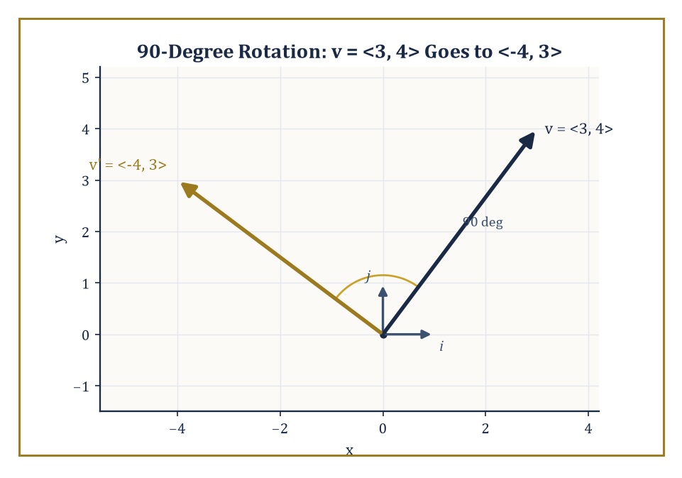
The 90° rotation sends v = ⟨3, 4⟩ to ⟨−4, 3⟩ — and, built from nothing but where it sends i and j, is already wearing its first matrix in disguise.
We added addition and scalar multiplication, and noticed they already obeyed the axioms of something bigger waiting in the wings. We introduced coordinates and components, which turned geometric intuition into arithmetic you can hand to a machine.
We met the dot product, for angles and lengths, and the cross product, for perpendicularity, area, and volume. We wrote lines and planes as vector equations, and we made precise what it means for a set of directions to be independent, dependent, or a basis. Not a bad haul for one storey.
It's worth pausing on something almost sneaky about the last eight rooms: at no point did the addition and scalar-multiplication rules we wrote down actually require the things being added to be arrows.
We proved (u + v) + w = u + (v + w) and a(u + v) = au + av using pictures of directed line segments, but nothing in the proof used the fact that a directed line segment was, specifically, a directed line segment.
Any collection of objects equipped with an addition and a scalar multiplication that obey those same rules earns the right to be called a vector space, arrows or not — and mathematicians, being incorrigible generalisers, promptly went looking for other collections that qualified.
Worked example — Abstract example — polynomials as vectors. Consider polynomials of degree at most 2: expressions like p(x) = 1 + 2x − x² and q(x) = 3 − x + 4x². Add them the obvious way, coefficient by coefficient:
p(x) + q(x) = (1 + 3) + (2 − 1)x + (−1 + 4)x² = 4 + x + 3x²
Scale p by 2:
2p(x) = 2 + 4x − 2x²
Every axiom this storey checked for arrows — commutativity, associativity, a zero element (the polynomial that is identically 0), an additive inverse for each polynomial, distributivity over scalars — holds here too, verified the same mechanical way, coefficient by coefficient. There is no arrow anywhere in sight, and yet the algebra is, structurally, identical to Room 9.2. That structural sameness, not any coincidence of notation, is what the word 'vector' will come to mean once the tower reaches the storeys built on the abstract axioms rather than on arrows.
None of this vocabulary is going into storage. Several storeys up the tower, we will introduce matrices and linear algebra proper, in which vectors become the elements of abstract spaces and linear maps between spaces are represented, once a basis is chosen, by grids of numbers called matrices — the natural next step once you've noticed, as we did in Room 9.2, that arrows already obey vector-space axioms whether or not you call them that.
Multivariable calculus, further up still, treats vector-valued functions, derivatives of curves traced out in space, and the differential operators gradient, divergence, and curl — all of them built, without exception, on the algebra developed here.
Differential geometry and physics, near the top of the tower, will treat vector fields living on curved spaces called manifolds, where 'a vector' at one point can no longer simply be slid over to another point the way we so blithely slid arrows around back in Room 9.1. But that difficulty, when it arrives, will be a difficulty about curvature, not about vectors — the algebra you've just learned survives intact as the local, flat-space building block underneath it.
Worked example — Preview — a linear map, and its first matrix. Consider the linear map that rotates every vector in the plane by 90° counterclockwise. It sends i = ⟨1, 0⟩ to ⟨0, 1⟩, and it sends j = ⟨0, 1⟩ to ⟨−1, 0⟩.
Because the map is linear — it respects addition and scalar multiplication, exactly the two operations at the heart of this storey — knowing where it sends the two basis vectors is enough to know where it sends every vector whatsoever:
v = ⟨v₁, v₂⟩ = v₁i + v₂j maps to v₁⟨0, 1⟩ + v₂⟨−1, 0⟩ = ⟨−v₂, v₁⟩
Check it on v = ⟨3, 4⟩: the rotated vector is ⟨−4, 3⟩, which has the same magnitude as the original:
√(16 + 9) = 5 = √(9 + 16)
And sits 90° round from it. Write the images of i and j as the columns of a grid, [[0, −1], [1, 0]], and you have just built your first matrix — a linear map, fully specified by what it does to a basis. That grid, and the machinery for multiplying it against vectors, is the entire subject waiting a little further up the tower.
The deeper lesson of this storey is that direction is exactly as fundamental as magnitude — arguably it always was, and it is arithmetic, not nature, that took this long to catch up and give it proper notation.
Once both magnitude and direction are encoded in a single object, equipped with sensible operations for combining and scaling it, geometry and algebra stop being two separate subjects you translate between and become one language with two accents. Vectors are, in that sense, doing double duty: they are a thoroughly concrete computational tool, useful the moment you need to add two forces or find a plane through three points, and simultaneously the first, gentlest step into the abstract theory of linear spaces that will occupy a great many storeys still to come.
And so the arrows, which arrived a few pages ago as mere decorations on geometry diagrams, have learned to calculate: added and scaled by simple rules, resolved into components, dotted for angles and projections, crossed for perpendicularity and area and volume, assembled into lines and planes, and sorted into independent and dependent, basis and redundancy.
The next storey changes register almost completely, trading the discrete arithmetic of directions for the altogether stranger business of getting arbitrarily close to something without ever quite arriving — the idea of a limit, and with it the foundation stone of the whole of calculus. It will feel, for a room or two, as though we've left vectors behind entirely. We haven't, not really: every derivative of a curve and every gradient of a surface that later storeys compute will turn out to be a vector in disguise, and the algebra developed here will be waiting, patiently, to do the actual work once the limits have finished their business of making the definitions rigorous.
The tower continues upward. The arrows have learned to calculate.

Storey 10: Limits
Approaching, Hovering, and the Art of Getting Arbitrarily Close
Storey Nine left us standing among vectors — arrows with both a magnitude and a direction, sturdy little objects that pointed somewhere and meant it. Everything we built there, and in the eight storeys before it, shared one quiet, comforting property: it was finite. You added two vectors, you got a vector, in one step, exactly, with no residue of doubt. Arithmetic, algebra, functions, trigonometry, exponents, logarithms, systems of equations, vectors — all of it computable in finitely many operations, all of it exact if you were careful.
This storey breaks that comfort, on purpose. We are about to ask what happens not at a point, but near a point — not what a function does when you feed it a value, but what it does as you sneak up on that value without ever quite touching it. It sounds like a small shift. It is, in fact, the shift: the one that separates the mathematics of counting and measuring from the mathematics of continuous change, and the one on which every derivative, every integral, and every infinite sum in the rest of the Tower will be built.
There will be a moment, a few rooms from now, where the informal comfort of 'gets closer and closer' has to be replaced by a definition involving two Greek letters, a challenge, and a response — the sort of thing that has induced mild despair in undergraduates since roughly 1861. Take it as a rite of passage rather than a punishment. Every generation of mathematicians has grumbled through it and come out the other side able to prove things their ancestors could only gesture at with a diagram and a hopeful expression.
By the end we will have the vocabulary — approaching, hovering, one-sided, infinite, squeezed — to describe precisely what it means to get arbitrarily close to something without arriving. Storey Eleven then puts this vocabulary to work and asks what happens when a secant line is squeezed close enough that it becomes a tangent. For now, we only need to learn to approach.

Room 10.1: What a Limit Actually Is
In Which We Approach Without Arriving, and Nobody Is Fired For It
The informal idea is disarmingly simple, once you strip away the notation. We say that the limit of f(x) as x approaches a is L if the outputs of f get arbitrarily close to L whenever the input x gets sufficiently close to a — while pointedly never actually being a.
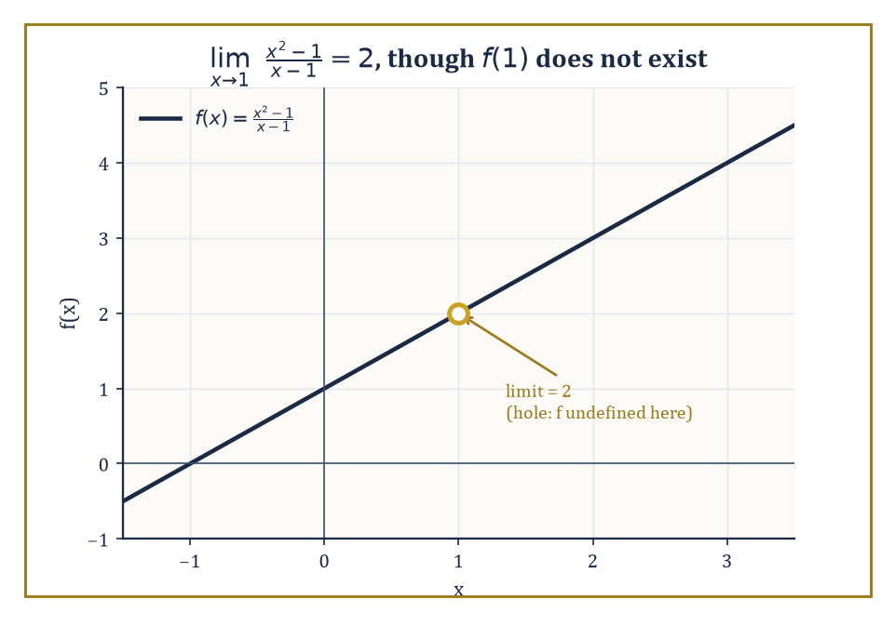
A line with one point removed: the function refuses to exist at x = 1, but the limit does not notice.
The function need not be defined at a at all; the limit does not care what happens at the point, only what happens in every neighbourhood around it, however small. This is the first and most important thing to internalise: a limit is a statement about the neighbourhood of a point, not about the point itself.
Two phrases are doing all the work here — 'arbitrarily close' describes the target's tolerance, and 'sufficiently close' describes how tightly we must control the input to meet it — and the entire point of Room 10.3 is to turn those two phrases into numbers you can actually compute with, rather than adjectives you merely trust.
Numeric example — Worked example — the hole that doesn't matter. Take the function
f(x) = (x² − 1)/(x − 1)
Plug in x = 1 directly and you get 0/0, which is not a number — the function is simply undefined at x = 1. But watch what happens nearby, since x² − 1 factors as follows:
x² − 1 = (x − 1)(x + 1)
So for every x ≠ 1 we have:
f(x) = (x − 1)(x + 1)/(x − 1) = x + 1
So:
at x = 0.9, f(x) = 1.9
at x = 0.99, f(x) = 1.99
at x = 0.999, f(x) = 1.999
at x = 1.1, f(x) = 2.1
at x = 1.01, f(x) = 2.01
at x = 1.001, f(x) = 2.001
From both sides the outputs are homing in on 2, even though f(1) itself does not exist. We write
lim_{x→1} f(x) = 2
and the function's refusal to be defined at x = 1 is simply irrelevant to that statement.
Numeric example — Worked example — the limit that disagrees with the value. Let f(x) = x + 1 for every x ≠ 2, and separately define
f(2) = 100
by fiat — a legal but eccentric thing to do to a function. What is lim_{x→2} f(x)? The limit only cares about x near 2, not at 2, so we ignore the bizarre decree entirely:
at x = 1.9, f(x) = 2.9
at x = 1.99, f(x) = 2.99
at x = 2.01, f(x) = 3.01
at x = 2.1, f(x) = 3.1
The outputs converge on 3, regardless of the fact that f(2) itself is 100. So
lim_{x→2} f(x) = 3
even though
f(2) = 100 ≠ 3
The limit and the function's actual value at the point are, in general, two entirely different numbers — a fact Room 10.5 will turn into the precise definition of continuity.
This is not a modern obsession. The ancient Greeks were already doing something limit-like when they estimated the area of a circle by inscribing polygons with more and more sides — each polygon computable exactly, and the sequence of areas creeping toward a number nobody could quite reach by polygons alone.
Archimedes' method of exhaustion and the seventeenth-century work on tangents and areas (Fermat, Newton, Leibniz, and a supporting cast of the mildly obsessive) are both, in retrospect, limit arguments wearing period costume. What the nineteenth century added — Weierstrass gets most of the credit, or blame, depending on your temperament — was a way to make 'creeping toward' into something you could pin down with total precision rather than gesture at with a diagram.
Augustin-Louis Cauchy had already sharpened the language considerably earlier in the century, speaking of quantities that could be made to differ from a fixed value by as little as one wished — remarkably close to the modern idea, if still resting on words like 'as little as one wished' rather than a hard inequality. Weierstrass's contribution was to replace even that residual vagueness with the ε and δ of Room 10.3, at which point the definition stopped being a description and became something you could, in cold blood, use in a proof.
Numeric example — Worked example — Archimedes closes in on π. Inscribe a regular n-sided polygon in a circle of radius 1; its area is
(1/2)·n·sin(2π/n)
At n = 6 (a hexagon) the area is
3·sin(60°) = 3·(√3/2) ≈ 2.598
At n = 12 it is
6·sin(30°) = 6·(0.5) = 3.000
At n = 24 it is
12·sin(15°) ≈ 12·(0.2588) ≈ 3.106
At n = 96 — roughly where Archimedes himself stopped, having presumably run out of patience — it is
48·sin(3.75°) ≈ 48·(0.06540) ≈ 3.139
The true area of the circle is
π ≈ 3.14159
No single polygon ever equals it, however many sides you draw, but the sequence of areas is visibly, measurably closing in on π. That closing-in is a limit, two thousand years before anyone wrote the word down.
Limits earn their keep by answering questions that exact evaluation simply cannot touch. What is the instantaneous velocity of a falling object, when 'velocity' as ordinarily defined (distance divided by time) needs an interval, not an instant?
What is the slope of a curve at a single point, when 'slope' as ordinarily defined needs two points and the curve only ever gives you one at a time? What is the sum of infinitely many numbers, when addition is defined for finitely many terms and stubbornly refuses to say what infinitely many means?
In each case, the honest answer is: take a sequence of well-defined finite approximations, and ask what they approach. This is, incidentally, close to the ancient puzzle Zeno posed about motion being impossible because an arrow must first cross half the distance, then half of what remains, and so on forever: Zeno's error was assuming infinitely many steps cannot add up to a finite answer, and the limit is precisely the tool that proves him wrong.
Numeric example — Worked example — sneaking up on instantaneous velocity. Suppose an object's position is
s(t) = t²
metres at time t seconds, and we want its velocity at exactly t = 2. Average velocity over the interval [2, 2+h] is
[s(2+h) − s(2)]/h
With h = 1:
[s(3) − s(2)]/1 = (9 − 4)/1 = 5 m/s
With h = 0.1:
[s(2.1) − s(2)]/0.1 = (4.41 − 4)/0.1 = 4.1 m/s
With h = 0.01:
(4.0401 − 4)/0.01 = 4.01 m/s
With h = 0.001:
(4.004001 − 4)/0.001 = 4.001 m/s
As h shrinks toward (but never reaches) zero, the average velocity is homing in on 4 m/s. That number — the limit of the average velocities as the interval shrinks to nothing — is what we mean by the instantaneous velocity at t = 2. Storey Eleven will give this quantity a name: the derivative.
None of this is a technicality bolted onto respectable mathematics. It is the bridge from the finite, exact world of the first nine storeys to the continuous world of everything still to come — derivatives, integrals, infinite series, and eventually the whole edifice of analysis.
Every later storey that mentions 'continuous' or 'smooth' or 'converges' is quietly leaning on the idea we are about to make precise. Get comfortable with it now, because from here to the top of the Tower, there is scarcely a theorem that does not, somewhere in its proof, quietly invoke a limit and hope nobody asks to see the ε–δ argument in full.

Room 10.2: Informal Limits and Numerical Exploration
Reconnaissance Before the Battle of Rigour
Before wrestling with the formal definition, it pays to simply compute. Given a candidate limit point a and a function f, evaluate f at a sequence of points marching toward a from the left, and another marching toward a from the right, and watch whether the outputs settle toward a single number L.
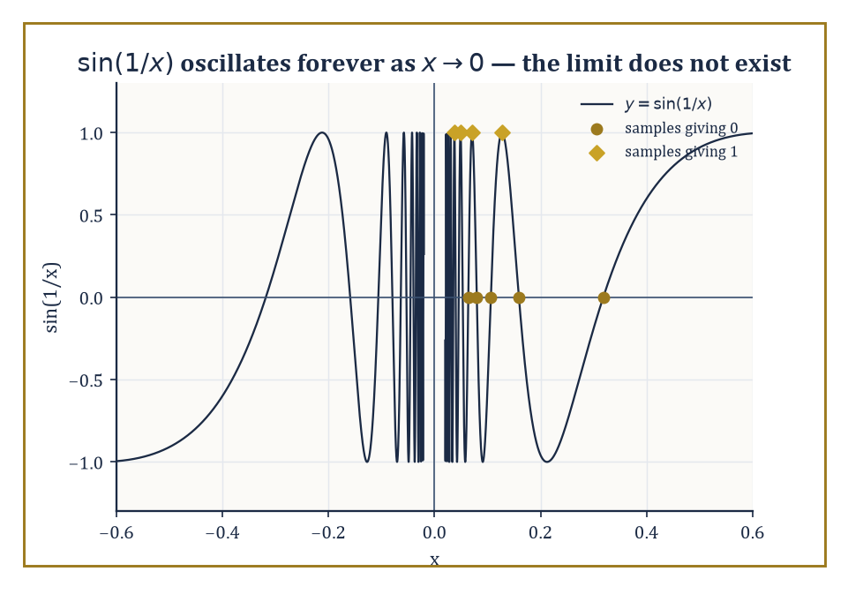
The function that ruins every table: sin(1/x) oscillates infinitely often as x approaches 0, no matter how you sample it.
This is not rigorous — no finite table of numbers ever proves anything about what happens at every point of an infinite neighbourhood — but it is an excellent guide to the truth, and a remarkably efficient way to catch yourself before you assert something false in front of an examiner. Before electronic calculators this meant literal pencil-and-paper tables, the sort Victorian computers (a job title, not a machine, before the 1940s) filled by the thousand; today it means typing a function into anything with a screen and watching the decimals scroll past. The method has not changed in two centuries, only the labour involved in doing it.
Numeric example — Worked example — the most famous limit in trigonometry. Consider (sin x)/x as x → 0, with x measured in radians (degrees would silently ruin the result, as they ruin most things involving π).
x = 0.1: sin(0.1) ≈ 0.099833, so (sin x)/x ≈ 0.099833/0.1 = 0.99833
x = 0.01: sin(0.01) ≈ 0.0099998, so (sin x)/x ≈ 0.99998
x = 0.001: sin(0.001) ≈ 0.00099999983, so (sin x)/x ≈ 0.99999983
The values are climbing steadily toward 1, from below, on both sides of zero (the function is even, so negative x gives an identical pattern). We will prove
lim_{x→0} (sin x)/x = 1
properly in Room 10.7; for now, the table alone should make you believe it.
Tables can also reveal when a two-sided limit fails to exist — when the values approach one number from the left and a different number from the right. In that situation there is no single L that both sides are converging to, and the honest verdict is that the two-sided limit does not exist, even though each one-sided approach is perfectly well-behaved on its own.
Room 10.5 will give this situation a formal home under the heading of one-sided limits; for now it is enough to notice the mismatch numerically and resist the temptation to average the two answers into something that looks tidy but means nothing.
Numeric example — Worked example — a function that can't make up its mind. Let f(x) = |x|/x for x ≠ 0 (this is the sign function: it returns +1 for positive x and −1 for negative x). Approaching from the right:
x = 0.1: f(x) = 0.1/0.1 = 1
x = 0.01: f(x) = 1
Every positive x gives exactly 1, so the right-hand values approach (indeed equal) 1. Approaching from the left:
x = −0.1: f(x) = 0.1/(−0.1) = −1
x = −0.01: f(x) = −1
Every negative x gives exactly −1. Since 1 ≠ −1, the two-sided limit at x = 0 does not exist — no amount of further zooming in will reconcile a function that jumps.
Numerical evidence is also the fastest way to expose the classic beginner's errors: cancelling a factor that is actually zero at the point in question, assuming a limit exists merely because the function is defined nearby, or quietly conflating one-sided behaviour with two-sided behaviour. A few careful evaluations, done honestly, will out any of these before they do real damage.
Numeric example — Worked example — a table that vindicates the algebra. Consider
lim_{x→2} (x² − 4)/(x − 2)
Direct substitution gives 0/0 — undefined, but not necessarily meaningless, as Room 10.1 already taught us. Factor:
(x² − 4)/(x − 2) = (x − 2)(x + 2)/(x − 2) = x + 2 for x ≠ 2
A table confirms this without needing to trust the algebra blindly:
x = 1.9: f(x) = 3.9
x = 1.99: f(x) = 3.99
x = 2.01: f(x) = 4.01
x = 2.1: f(x) = 4.1
Both sides converge on 4, exactly as x + 2 predicts at x = 2. The moral: cancelling the (x − 2) factor was legitimate everywhere except at the single point x = 2 itself, which is precisely the one point the limit doesn't need.
There is a sting in the tail of 'numerical evidence is never a proof', and it deserves its own illustration before we move on, because a poorly chosen table can manufacture false confidence just as easily as a good one earns real confidence.
Worked example — Worked example — a table that lies by omission. Consider
lim_{x→0} sin(1/x)
and suppose we sample only at x = 1/(kπ) for k = 1, 2, 3, …, values that do march obediently toward 0.
x = 1/π ≈ 0.3183: sin(1/x) = sin(π) = 0
x = 1/(2π) ≈ 0.1592: sin(1/x) = sin(2π) = 0
x = 1/(3π) ≈ 0.1061: sin(1/x) = sin(3π) = 0
Every single sample gives exactly 0, and a hasty conjecture would declare the limit to be 0. But sample instead at x = 1/(π/2 + 2kπ):
k = 0: x = 2/π ≈ 0.6366, and sin(1/x) = sin(π/2) = 1
k = 1: x = 2/(5π) ≈ 0.1273, and sin(1/x) = sin(5π/2) = 1
These samples, also marching toward 0, give exactly 1 every time. Two equally valid tables, two entirely different conjectures — and the honest conclusion, confirmed rigorously in Room 10.8, is that the limit does not exist at all. The function oscillates infinitely often as x → 0, and no table, however long, can be trusted to catch that unless you already suspect it.
This numerical stage is also where you should meet, informally, the standard cast of characters that recur throughout the rest of analysis: the sine-over-x limit above, the limit that defines the number e, the rational function with a removable hole, and the step function with an unavoidable jump. All will be revisited with full rigour in due course; for now, familiarity is the goal, not proof.
Think of this room as the reconnaissance mission before the siege in Room 10.3: you are not yet required to prove anything, only to recognise the shape of the battlefield when the formal weapons arrive.
Numeric example — Worked example — meeting e before it has a name. Consider (1 + 1/n)ⁿ as n grows.
n = 1: (1 + 1)¹ = 2
n = 10: (1.1)¹⁰ ≈ 2.5937
n = 100: (1.01)¹⁰⁰ ≈ 2.7048
n = 1000: (1.001)¹⁰⁰⁰ ≈ 2.7169
The values are climbing, slowing down, but not stopping — and they are climbing toward a specific irrational number, roughly 2.71828, which mathematics eventually dignifies with its own letter: e. We will not prove this limit exists in this storey (that requires tools — monotonicity and boundedness — from Room 10.8), but the table is already suggestive enough to be worth remembering.

Room 10.3: The Precise Definition: ε and δ
A Game for Two Players, One of Whom Is Always You
Here is the definition, essentially as Weierstrass left it, and worth reading slowly the first three or four times. We say lim_{x→a} f(x) = L if the following holds:
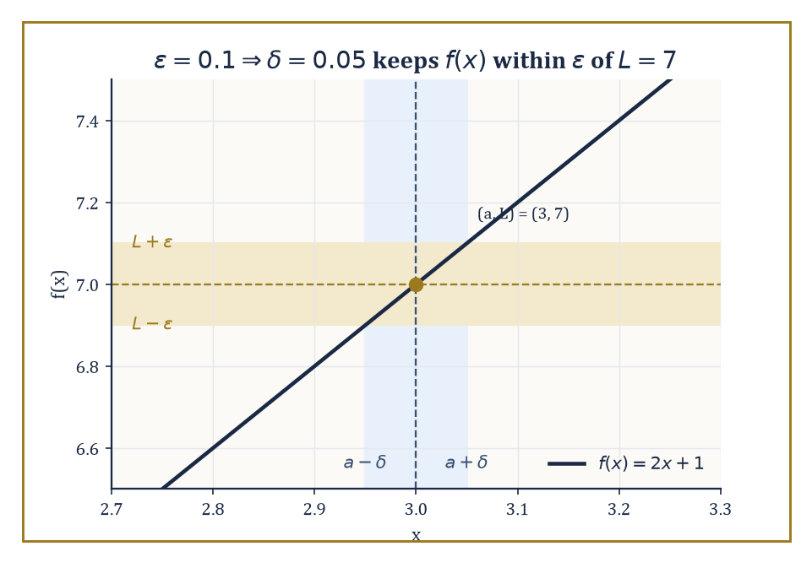
The Sceptic demands ε = 0.1; the recipe δ = ε/2 answers that challenge, and every one still to come.
for every ε > 0, there exists a δ > 0 such that whenever 0 < |x − a| < δ, it follows that |f(x) − L| < ε
Translated out of symbols: no matter how tight a tolerance ε you demand around L, I can always find a punctured neighbourhood of a — punctured meaning a itself is excluded — inside which f is guaranteed to stay within that tolerance. The order of the quantifiers is not decorative: δ is allowed — indeed required — to depend on ε (a tighter tolerance typically demands a smaller neighbourhood), but it may also depend on a itself. When a single δ can be found that works simultaneously for every point in a whole region, for the same ε, something stronger than ordinary continuity is going on, and it earns its own name (uniform continuity) much later in the Tower.
Think of it as a game between two players, played out an infinite number of times in principle but usually only a handful of times in practice before the pattern becomes clear. Player One (call them the Sceptic) issues a challenge: 'I demand the output stay within ε of L — try ε = 0.001, or ε = 0.0000001, or anything else I fancy.' Player Two (call them, generously, You) must respond with a workable δ: an input-window around a small enough that the challenge is satisfied.
You win the whole game — the limit genuinely equals L — only if you have a strategy that answers every possible ε the Sceptic could throw at you, not merely the ones you happened to try. In practice nobody actually plays the game move by move for every ε; instead you prove, once and for all, that a particular recipe — a formula for δ in terms of ε — wins regardless of which ε is named, and retire from the table having won every future round in advance.
Numeric example — Worked example — proving a straight-line limit from scratch. Claim:
lim_{x→3} (2x + 1) = 7
Proof: let ε > 0 be given (the Sceptic's challenge — we do not get to pick it). We need |(2x + 1) − 7| < ε whenever 0 < |x − 3| < δ, for a δ we get to choose in response. Simplify the target inequality:
|2x + 1 − 7| = |2x − 6| = 2|x − 3|
We want 2|x − 3| < ε, i.e. |x − 3| < ε/2. So take δ = ε/2 — that is our response, valid for every ε the Sceptic can name.
Check with actual numbers: suppose the Sceptic demands ε = 0.1. Our recipe gives δ = 0.05. Take any x within that window, say x = 3.03 (so |x − 3| = 0.03 < 0.05). Then:
f(x) = 2(3.03) + 1 = 7.06
|7.06 − 7| = 0.06
which is indeed less than 0.1. The recipe works for this ε, and — because the algebra was done for a general ε, not just 0.1 — it works for every ε. Hence the limit is genuinely 7, not merely plausibly 7.
It is worth seeing the game lost as well as won, because the negative case teaches the definition just as effectively as the positive one — arguably more so, since it shows what 'the limit is not L' actually asserts. Losing the game for one particular L, incidentally, does not mean the limit does not exist at all — only that L was the wrong candidate. To show a limit truly fails to exist, you must rule out every candidate L simultaneously, which is exactly what the sign-function example below manages to do in one stroke, since the argument never mentions a specific L at all.
Numeric example — Worked example — a challenge with no answer. Consider again the sign function s(x) = x/|x| for x ≠ 0, and the candidate L = 0 at a = 0. Try ε = 0.5. We would need a δ > 0 such that 0 < |x| < δ forces |s(x) − 0| < 0.5. But s(x) is always exactly +1 or exactly −1, so:
|s(x)| = 1 for every nonzero x
however close to zero. That means:
|s(x) − 0| = 1 for every candidate x
and 1 is never less than 0.5, regardless of how small a δ we choose. The Sceptic's challenge of ε = 0.5 has no answer — so the limit is not 0. This function in fact has no limit at all at x = 0, as Room 10.2 already showed numerically; here we have simply confirmed it rigorously rather than by table-reading.
Proving limits directly from the definition usually reduces to algebraic manipulation: massage the inequality |f(x) − L| < ε until a condition of the shape |x − a| < (something in terms of ε) falls out, and that something becomes your δ, or at least a workable lower bound for it. For anything beyond straight lines the algebra gets fiddlier — quadratics, in particular, need a preliminary restriction on δ to keep an extra factor bounded — but the process remains entirely mechanical once you have seen the trick once.
Numeric example — Worked example — a quadratic, and the standard trick. Claim:
lim_{x→2} x² = 4
We need |x² − 4| < ε. Factor:
|x² − 4| = |x − 2||x + 2|
The |x − 2| part we can make small by choosing δ; the |x + 2| part is a nuisance, because it depends on x too. Standard fix: agree in advance to never let δ exceed 1. Then |x − 2| < 1 forces 1 < x < 3, so |x + 2| < 5. Under that restriction:
|x² − 4| = |x − 2||x + 2| < 5|x − 2|
We want this less than ε, so we want |x − 2| < ε/5. Combining both requirements, take δ = min(1, ε/5).
Check: with ε = 0.1, δ = min(1, 0.02) = 0.02. Take x = 2.01 (within the window):
x² = 4.0401
|4.0401 − 4| = 0.0401
which is indeed less than 0.1. The min(1, ε/5) construction is not elegant, but it is honest, and it is the standard shape every quadratic (and worse) limit proof takes.
Notice throughout that the definition never once mentions f(a) — the value of the function at the point itself. That silence is deliberate. The limit only ever describes behaviour in the punctured neighbourhood around a; whether f is even defined at a, let alone what value it takes there, is a separate question entirely.
Room 10.5 reintroduces that question under the name continuity, and there — and only there — does f(a) finally get to matter. Keep this in mind as a running joke of the subject: for two whole rooms we insisted the value at the point was irrelevant, and the very next room reintroduces it as the single most important number in the definition of continuity. Mathematics is allowed to change its mind, provided it tells you exactly when and why.

Room 10.4: Limit Laws and Algebraic Computation
Turning Tedium Into Arithmetic
Once the ε–δ definition is nailed down, a whole toolkit of limit laws follows from it, and — this is the point of proving them once, carefully — you never need to touch ε or δ again for ordinary computation.
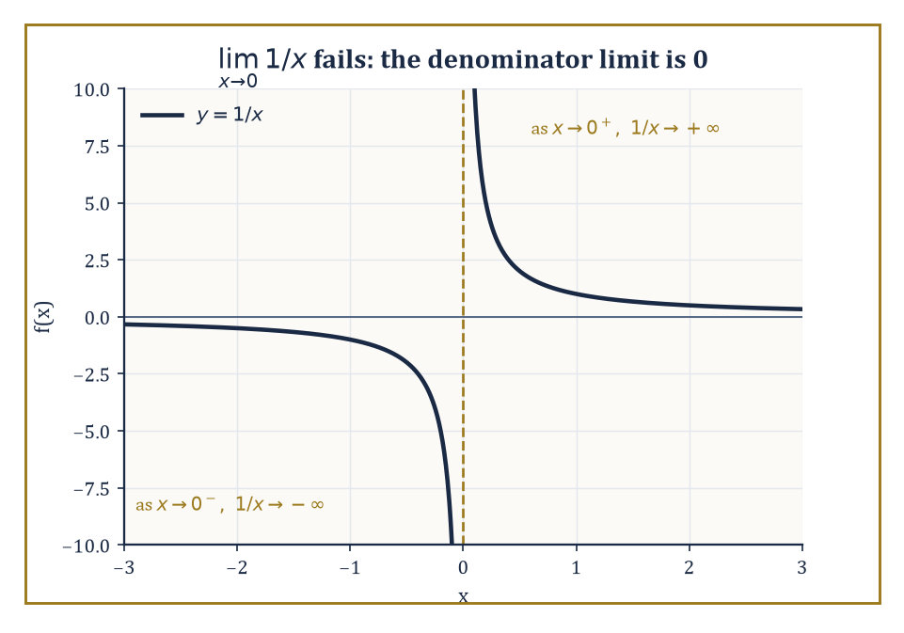
Why the quotient law carries a proviso: 1/x refuses to settle on either side of zero.
The limit of a sum is the sum of the limits. The limit of a product is the product of the limits.
The limit of a quotient is the quotient of the limits, provided the limit of the denominator is not zero (division by a limit of zero remains exactly as forbidden as division by zero always was).
Constant multiples pass straight through a limit, and powers and roots behave exactly as you would hope, subject to mild restrictions.
These laws are not a grab-bag of unrelated facts; they are exactly the operations you would expect arithmetic to have, ported faithfully from finite numbers to the limiting process, and proving them once (which we do below) licenses you to stop thinking about ε and δ for the rest of your working life as a calculus student.
Numeric example — Worked example — limit laws as arithmetic. Find lim_{x→2} (3x² + 1)/(x − 5).
By the quotient law, this equals the quotient of the two limits, provided the denominator's limit is nonzero:
[lim(3x² + 1)] / [lim(x − 5)]
Numerator, using the sum, constant-multiple, and power laws:
lim(3x² + 1) as x → 2 = 3(2²) + 1 = 3(4) + 1 = 13
Denominator:
lim(x − 5) as x → 2 = 2 − 5 = −3
which is indeed nonzero, so the quotient law applies cleanly. Result:
13/(−3) = −13/3
Because this rational function is defined at x = 2 (the denominator there is −3, not 0), the limit laws have simply reduced the whole computation to plugging x = 2 straight in — which is exactly what should happen for any function with no bad behaviour at the point in question.
The quotient law's proviso — that the denominator's limit must be nonzero — is not bureaucratic caution; ignore it and the law gives nonsense.
Numeric example — Worked example — why the proviso is not optional. Attempt to apply the quotient law to lim_{x→0} 1/x. The numerator's limit is 1; the denominator's limit is 0.
The quotient law simply does not apply here — it is not that it gives the answer 'undefined' or 'infinity', it gives no answer at all, because its hypothesis has failed.
And indeed the limit itself does not exist as a finite number:
x = 0.01, 1/x = 100
x = 0.001, 1/x = 1000
x = −0.01, 1/x = −100
The function grows without bound on one side and plunges without bound on the other, so not even an infinite one-sided limit is shared by both directions.
Compare this with lim_{x→0} (x² + 3x)/x from Room 10.6, where the numerator's limit is also 0 — there the 0/0 form is resolved by cancellation, precisely because both numerator and denominator vanish together rather than only the denominator.
Rational functions with a common factor in numerator and denominator are the interesting case, precisely because direct substitution fails there (it produces 0/0) even though the limit perfectly well exists.
The fix is always the same: simplify the algebraic expression by cancelling the shared factor, note that the simplified function agrees with the original everywhere except at the offending point, and then read the limit off the simplified function by substitution — since the simplified function, unlike the original, is continuous there.
Numeric example — Worked example — cancel, then substitute. Find lim_{x→3} (x² − 9)/(x − 3). Substitution gives 0/0.
Factor the numerator, a difference of squares:
x² − 9 = (x − 3)(x + 3)
So for x ≠ 3:
(x² − 9)/(x − 3) = (x − 3)(x + 3)/(x − 3) = x + 3
The simplified function x + 3 is continuous everywhere, including at x = 3, so
lim_{x→3} (x + 3) = 3 + 3 = 6
Hence the original limit is also 6 — the cancellation was valid for every x near 3 except 3 itself, and the limit, as ever, has no interest in x = 3 itself.
The same trick generalises to any factor common to both numerator and denominator, polynomial or otherwise: find what is making both sides vanish simultaneously, remove it algebraically, and trust that the resulting simpler function tells the truth everywhere except at the one point it was never allowed to speak for anyway.
The limit laws are not asserted by decree; each one is proved from the ε–δ definition using what is affectionately (or otherwise) known as the ε/2 trick — split the tolerance budget between the two pieces being combined, control each piece separately, and add the pieces back together at the end.
It is worth seeing done once, in the abstract, so that the arithmetic-looking laws you use forever after do not feel like an act of faith.
Abstract example — Worked example — proving the sum law, in general. Claim: if lim_{x→a} f(x) = L and lim_{x→a} g(x) = M, then lim_{x→a} [f(x) + g(x)] = L + M.
Proof sketch: let ε > 0 be given.
Since lim f = L, there is a δ₁ > 0 such that 0 < |x − a| < δ₁ implies |f(x) − L| < ε/2.
Since lim g = M, there is a δ₂ > 0 such that 0 < |x − a| < δ₂ implies |g(x) − M| < ε/2.
Let δ = min(δ₁, δ₂) — the smaller of the two windows, so both conditions hold simultaneously.
Then for 0 < |x − a| < δ, using the triangle inequality on the middle step:
|(f(x) + g(x)) − (L + M)| = |(f(x) − L) + (g(x) − M)| ≤ |f(x) − L| + |g(x) − M| < ε/2 + ε/2 = ε
This δ works for an arbitrary ε, so the sum law holds.
Every other algebraic limit law — products, quotients, constant multiples — is proved by the same recipe: split the budget, bound each piece, recombine.
The practical upshot, and the skill actually worth drilling, is to alternate algebraic simplification with the limit laws until the expression in front of you is continuous at the target point — at which stage substitution simply finishes the job.
This applies even to expressions that do not look like rational functions at all.
Numeric example — Worked example — rationalising a radical. Find lim_{x→0} [√(x + 4) − 2]/x. Substitution gives:
(√4 − 2)/0 = 0/0
Multiply numerator and denominator by the conjugate √(x + 4) + 2:
[√(x+4) − 2][√(x+4) + 2] / [x(√(x+4) + 2)] = [(x + 4) − 4] / [x(√(x+4) + 2)] = x / [x(√(x+4) + 2)]
For x ≠ 0, cancel the x:
1/(√(x+4) + 2)
This simplified function is continuous at x = 0, so the limit is
1/(√4 + 2) = 1/(2 + 2) = 1/4
Numerical check: at x = 0.01, √4.01 ≈ 2.0025, and
(2.0025 − 2)/0.01 = 0.0025/0.01 = 0.25
— matching 1/4 exactly, as it should.
The pattern across every example in this room is the same: an expression that looks broken at the point in question is, underneath, a perfectly good continuous function wearing a temporary disguise — factor it, rationalise it, or otherwise unmask it, and the limit laws do the rest.

Room 10.5: One-Sided Limits and Continuity
On Not Falling Through the Floor
Sometimes a function behaves differently depending on which side you approach from — creeping up to one value as x sneaks in from below a, and to a different value as x sneaks in from above. To describe this we split the definition in two.
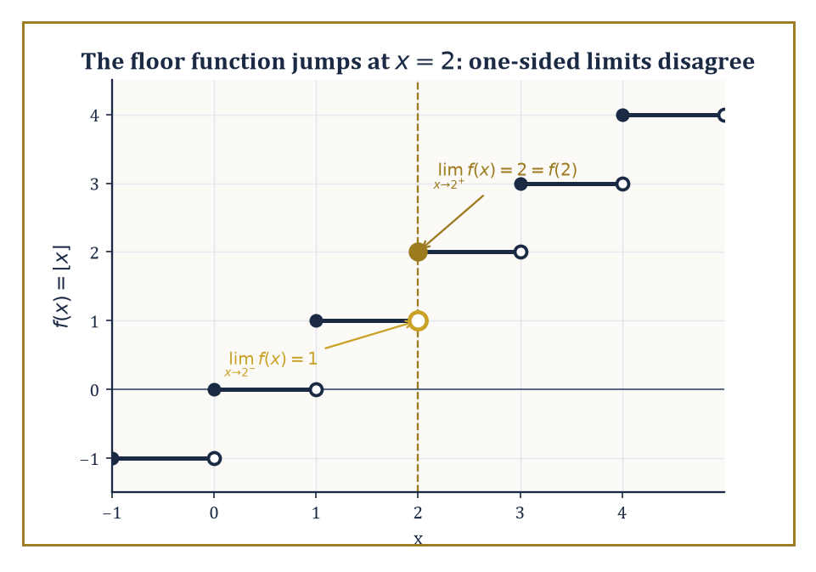
The floor function's verdict at x = 2: two perfectly good one-sided limits that simply refuse to agree.
The left-hand limit holds when the ε–δ condition applies with x restricted to values less than a.
lim_{x→a⁻} f(x) = L
The right-hand limit is the mirror image, restricted to values greater than a.
lim_{x→a⁺} f(x) = L
The ordinary two-sided limit exists exactly when both one-sided limits exist and agree; if they disagree, or if either fails to exist, the two-sided limit simply does not exist, and no amount of squinting will manufacture one. One-sided limits use exactly the same ε–δ machinery as before, restricted to a half-neighbourhood; nothing new is invented here, only the domain over which the old game is played.
Numeric example — Worked example — the floor function refuses to commit. Let f(x) = ⌊x⌋, the floor function (round down to the nearest integer), and consider a = 2.
Approaching from the left: at x = 1.9, ⌊1.9⌋ = 1; at x = 1.99, ⌊1.99⌋ = 1; at x = 1.999, ⌊1.999⌋ = 1 — every value strictly below 2 but close to it floors to 1, so
lim_{x→2⁻} f(x) = 1
Approaching from the right: at x = 2.1, ⌊2.1⌋ = 2; at x = 2.01, ⌊2.01⌋ = 2 — every value at or above 2 (up to 3) floors to 2, so
lim_{x→2⁺} f(x) = 2
Since 1 ≠ 2, the two-sided limit at x = 2 does not exist, even though f(2) = 2 is perfectly well-defined. The floor function jumps at every integer, and this is exactly what a jump looks like in ε–δ language.
Continuity is what happens when a function's limit at a point agrees with the function's actual value there — no more, no less. Formally:
f is continuous at a if lim_{x→a} f(x) = f(a)
Unpacked, this is really three separate requirements bundled into one tidy equation: the limit must exist, the function must be defined at a, and the two resulting numbers must coincide.
A function is continuous on an interval if it is continuous at every point of that interval (with the obvious one-sided adjustment at the endpoints, where you can only approach from one direction anyway). This matters well beyond bookkeeping: continuity is the standing assumption behind almost every guarantee later analysis offers — that a root can be found by narrowing an interval, that an optimisation problem actually has a best answer to find, that a physical quantity varying smoothly in time cannot secretly teleport between values.
Numeric example — Worked example — a hole that spoils continuity. Let g(x) = (x² − 4)/(x − 2) for x ≠ 2, and define g(2) = 5 by explicit (if perverse) decree.
From Room 10.2 we already know lim_{x→2} g(x) = 4, via the cancellation
(x−2)(x+2)/(x−2) = x+2 → 4
But g(2) was defined to be 5, not 4. Since the limit (4) and the function's actual value (5) disagree, g is discontinuous at x = 2 — specifically a removable discontinuity, so called because the fix is trivially available: simply redefine g(2) to be 4 instead of 5, and the discontinuity vanishes. Compare this with the floor function above, whose discontinuity at each integer is a jump — no single redefinition of one point can repair a genuine disagreement between two different one-sided limits.
Continuous functions are, in a precise sense, the well-behaved citizens of analysis. They satisfy the Intermediate Value Theorem (if a continuous function takes two values, it takes every value in between, somewhere on the way), they attain an actual maximum and minimum on any closed interval, and they may be integrated without fuss.
Discontinuities, when they occur, are classified by how badly the one-sided limits misbehave: removable (the limit exists but disagrees with, or is absent from, the function's value), jump (the one-sided limits both exist but disagree with each other), or infinite (at least one one-sided limit blows up, a case Room 10.6 treats properly). It is worth noting that only the removable kind is a mere cosmetic flaw; jump and infinite discontinuities are structural, and no redefinition of a single point will ever repair them.
Continuity at an endpoint of a domain is necessarily one-sided, simply because there is no 'other side' to approach from — a fact worth making concrete rather than leaving as a parenthetical remark.
Numeric example — Worked example — continuity that can only look one way. Let f(x) = √x, defined only for x ≥ 0. At x = 0 there is no left-hand neighbourhood to speak of — negative x are not in the domain at all — so continuity at 0 can only mean right-continuity:
lim_{x→0⁺} f(x) = f(0)
Check numerically: at x = 0.01, f(x) = 0.1; at x = 0.0001, f(x) = 0.01; at x = 0.000001, f(x) = 0.001. The values shrink toward 0 as x → 0⁺, matching
f(0) = √0 = 0
exactly. So √x is (right-)continuous at its left endpoint, and the one-sided qualifier is not pedantry — it is the only kind of continuity the domain permits.
Numeric example — Worked example — the Intermediate Value Theorem finds a root without solving anything. Let f(x) = x³ − x − 1, a continuous function (all polynomials are continuous everywhere — a fact that follows immediately from the sum, product, and constant-multiple limit laws of Room 10.4). Evaluate:
f(1) = 1 − 1 − 1 = −1
which is negative.
f(2) = 8 − 2 − 1 = 5
which is positive. Since f is continuous on [1, 2] and takes a negative value at one end and a positive value at the other, the Intermediate Value Theorem guarantees at least one point c in (1, 2) where f(c) = 0 — a root of x³ − x − 1 — without our having done a single step of algebra to find it. (For the curious: the actual root is irrational, approximately 1.3247, and has no tidy closed form worth memorising. The IVT does not care; it only promises existence, not a formula.)
All the algebraic limit laws from Room 10.4 translate immediately into continuity laws: sums, products, quotients (away from zero denominators), and compositions of continuous functions are themselves continuous wherever they are defined.
This is why you were allowed, for the entire eight storeys before this one, to evaluate polynomials, rational functions, and trigonometric functions simply by plugging in numbers — you were unknowingly relying on their continuity the whole time. It is a small, satisfying reversal: the definition that once excluded the value at the point (Room 10.3) now exists solely to reinstate it, and every polynomial you ever evaluated by simple substitution was, without your noticing, a continuity argument in miniature.

Room 10.6: Limits Involving Infinity
Where the Graph Runs Off, and We Follow, Politely
We also want language for two related but distinct situations: what happens to f(x) as x itself grows without bound, and what happens when f(x) grows without bound as x approaches some ordinary finite point. The first is a limit at infinity: we write lim_{x→∞} f(x) = L if for every ε > 0 there exists an M such that x > M guarantees |f(x) − L| < ε — the same game as before, except the Sceptic's challenge is now answered with a large threshold M rather than a small window δ.
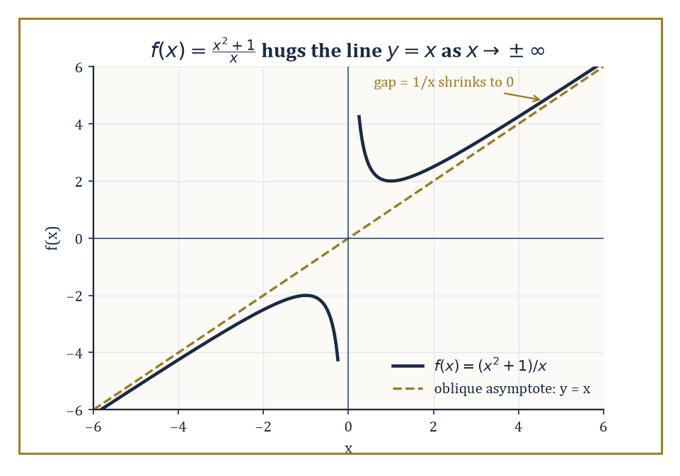
The curve never touches the line, but the gap between them vanishes at infinity — an asymptote caught in the act.
The second is an infinite limit: lim_{x→a} f(x) = ∞ if for every N (however large) there exists a δ > 0 such that 0 < |x − a| < δ guarantees f(x) > N.
Both definitions extend the original ε–δ idea rather than break it — infinity here is not a number you plug in, but a way of describing unbounded growth precisely. Notice the family resemblance to Room 10.3's original game: only the currency has changed, from a small window δ around a finite point to a large threshold M or N describing how far out, or how high up, you must go.
Numeric example — Worked example — a limit at infinity, computed. Find lim_{x→∞} (3x² + 2x)/(x² − 5). Direct reasoning about ∞/∞ is not permitted (see below), so divide numerator and denominator by the highest power of x present, x²:
(3x² + 2x)/(x² − 5) = (3 + 2/x)/(1 − 5/x²)
As x → ∞, both 2/x and 5/x² shrink toward 0, leaving
(3 + 0)/(1 − 0) = 3
Numerical check at x = 1000: numerator = 3(1,000,000) + 2(1000) = 3,002,000; denominator = 1,000,000 − 5 = 999,995;
ratio ≈ 3.002
already within 0.002 of the predicted limit of 3, and closing in further as x grows. The line y = 3 is a horizontal asymptote of this function.
Every asymptote you have ever drawn on a graph is, in fact, secretly a limit statement, rendered as a picture instead of an inequality. A horizontal asymptote is exactly a limit at infinity, as above. A vertical asymptote is an infinite limit at a finite point — the function shoots off to +∞ or −∞ as x approaches some forbidden value, usually where a denominator vanishes.
An oblique (slanted) asymptote appears when a function grows linearly, rather than settling to a constant, as x → ∞ — a rational function where the numerator's degree exceeds the denominator's by exactly one, for instance.
Numeric example — Worked example — an oblique asymptote, up close. Let f(x) = (x² + 1)/x. Polynomial division gives
f(x) = x + 1/x, valid for x ≠ 0
As x → ∞, the term 1/x shrinks toward 0, so f(x) behaves more and more like the straight line y = x, without ever actually landing on it — the line y = x is an oblique asymptote.
Numerical check at x = 100:
f(100) = 100 + 1/100 = 100.01
a difference of exactly 0.01 from the line y = x. At x = 10,000:
f(10,000) = 10,000 + 0.0001
a difference of just 0.0001. The gap between the curve and the line, namely 1/x, is itself heading to 0 as x → ∞ — precisely the statement
lim_{x→∞} [f(x) − x] = 0
which is the rigorous meaning of 'the curve hugs the line at infinity'.
Numeric example — Worked example — a vertical asymptote, from both sides. Let f(x) = 1/(x − 2), and examine x = 2. Approaching from the right: at x = 2.001, x − 2 = 0.001, so
f(x) = 1/0.001 = 1000
At x = 2.0001,
f(x) = 10,000
The function is racing toward +∞. Approaching from the left: at x = 1.999, x − 2 = −0.001, so
f(x) = 1/(−0.001) = −1000
At x = 1.9999,
f(x) = −10,000
The function is racing toward −∞. So
lim_{x→2⁺} f(x) = +∞ while lim_{x→2⁻} f(x) = −∞
the one-sided infinite limits disagree in sign, which is precisely what produces the two-branched vertical asymptote familiar from the graph of 1/x shifted two units right.
Finally, a warning that saves a great deal of grief: expressions like 0/0, ∞/∞, 0·∞, ∞ − ∞, 1^∞, 0^0, and ∞^0 are called indeterminate forms, and the crucial thing to understand about them is that they are not values. They are not some exotic extension of arithmetic where 0/0 secretly equals something.
They are signals — flashing, insistent signals — that the ordinary limit laws do not apply directly to the expression as written, and that some further rewriting (factoring, rationalising, dividing through by the dominant term, or tools not yet available to us) is required before a genuine value can be extracted. Treat them as an instruction to keep working, never as an answer in themselves.
The form 1^∞ deserves a particular note of suspicion, because it looks harmless — surely 1 to any power is 1? — and yet it is exactly the form behind the e-limit of Room 10.2: (1 + 1/n)ⁿ has a base creeping toward 1 and an exponent racing toward ∞ at rates that, worked out properly, produce neither 1 nor ∞ but the specific irrational number e. The lesson generalises: an indeterminate form's actual value depends entirely on the relative speeds of the pieces racing toward their individual limits, which is precisely why no blanket rule can ever replace doing the algebra.
Numeric example — Worked example — resolving 0/0. Find lim_{x→0} (x² + 3x)/x. Substitution gives
(0 + 0)/0 = 0/0
an indeterminate form — not an answer, an invitation. Factor:
(x² + 3x)/x = x(x + 3)/x = x + 3, valid for x ≠ 0
This simplified function is continuous at x = 0, so the limit is
0 + 3 = 3
Numerical check at x = 0.001:
(0.000001 + 0.003)/0.001 = 0.003001/0.001 = 3.001
closing in on 3 exactly as promised.
Numeric example — Worked example — resolving ∞ − ∞. Find lim_{x→∞} [√(x² + x) − x]. Both terms individually grow without bound, and their difference is the indeterminate form ∞ − ∞ (you cannot simply say 'infinity minus infinity is zero' — the two infinities may grow at different rates, and here they very nearly, but not exactly, cancel). Multiply by the conjugate over itself:
[√(x²+x) − x]·[√(x²+x) + x]/[√(x²+x) + x] = [(x² + x) − x²]/[√(x²+x) + x] = x/[√(x²+x) + x]
Divide numerator and denominator by x (valid for x > 0):
= 1/[√(1 + 1/x) + 1]
As x → ∞, 1/x → 0, giving
1/(√1 + 1) = 1/(1 + 1) = 1/2
Numerical check at x = 1000: √(1,001,000) ≈ 1000.4999, and 1000.4999 − 1000 = 0.4999 — closing in on 0.5, exactly as predicted.
Every technique in this room — dividing by the dominant power, factoring away a shared zero, or multiplying by a conjugate — is really the same manoeuvre performed under three different aliases: rewrite the expression until whatever was causing the indeterminacy visibly cancels, and only then invoke the limit laws.

Room 10.7: Special Limits and the Squeeze Theorem
Trapped Between Two Functions, Rescued by Geometry
A handful of limits refuse to yield to algebraic simplification alone — no amount of factoring, cancelling, or rationalising will crack them, because there is no algebraic identity hiding inside.
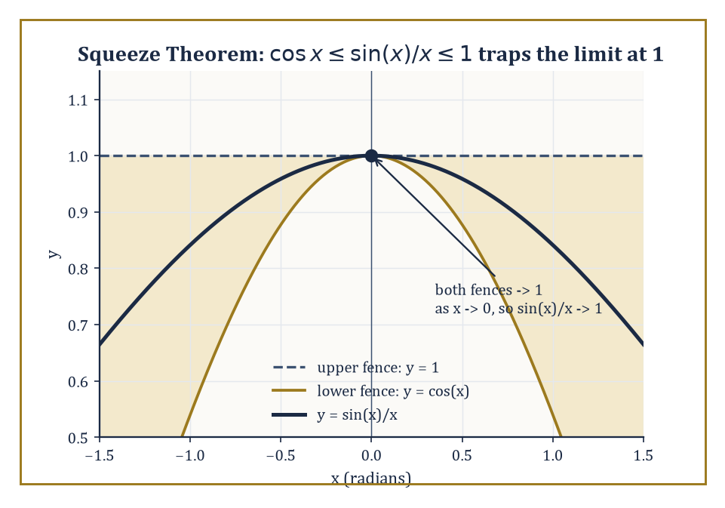
Trapped between cos x and 1, sin(x)/x has nowhere left to go but 1.
The most important of these is the following, with x measured in radians (degrees would silently break the proof, since it relies on radian measure being literally equal to arc length on the unit circle):
lim_{x→0} (sin x)/x = 1
It is proved not by algebra but by geometry: comparing the area of a thin circular sector to the areas of two triangles that sandwich it, for small x, and then squeezing the sector's area between them. Concretely, for a small positive angle x (in radians) on the unit circle, the area of the triangle inscribed under the angle is (1/2)sin x, the area of the circular sector itself is (1/2)x, and the area of the larger triangle circumscribed about the sector (using the tangent line) is (1/2)tan x.
Since the small triangle sits inside the sector, which sits inside the large triangle, their areas satisfy:
(1/2)sin x ≤ (1/2)x ≤ (1/2)tan x
Multiply through by 2/sin x (positive, since x is small and positive) to get:
1 ≤ x/sin x ≤ 1/cos x
Take reciprocals throughout — which flips the inequalities — to land on:
cos x ≤ (sin x)/x ≤ 1
This is exactly the sandwich used in the worked example below.
That squeezing move deserves its own name, because it recurs constantly: the Squeeze Theorem (also called the Sandwich Theorem, for reasons that will not surprise anyone who has attended a school assembly). It states that if g(x) ≤ f(x) ≤ h(x) for all x near a (except possibly at a itself), and the two bounding limits agree:
lim_{x→a} g(x) = lim_{x→a} h(x) = L
then lim_{x→a} f(x) = L as well. The intuition is exactly as blunt as the name suggests: a function trapped between two others that both converge to the same value has nowhere else to go — it is squeezed into converging there too.
The theorem asks for surprisingly little: g and h need only trap f near a, not everywhere, and they need not even be simple functions themselves, provided their own limits are already known or easy to establish.
Numeric example — Worked example — watching the squeeze happen. For x near (but not equal to) 0, geometry gives the bound:
cos x ≤ (sin x)/x ≤ 1
Check it numerically at x = 0.3 radians: cos(0.3) ≈ 0.9553, and (sin 0.3)/0.3 ≈ 0.29552/0.3 ≈ 0.9851.
0.9553 ≤ 0.9851 ≤ 1
Indeed, as the inequality demands. Now let x shrink further: at x = 0.05, cos(0.05) ≈ 0.99875, and (sin 0.05)/0.05 ≈ 0.99958. The lower fence cos x is itself climbing toward 1 as x → 0 (since cosine is continuous and cos 0 = 1), and the upper fence is the constant 1. With both fences converging to 1, the trapped quantity (sin x)/x has no room left to be anything but 1 in the limit — which is exactly the Squeeze Theorem's conclusion, and exactly what Room 10.2's numerical table already suggested informally.
The Squeeze Theorem is also the standard tool for taming functions that oscillate wildly but are pinned down by a shrinking envelope — situations where direct substitution is hopeless because the function does not settle down to any particular value on its own, but is nonetheless forced to converge by whatever is squeezing it.
Worked example — Worked example — an oscillation crushed by its own envelope. Find the following limit:
lim_{x→0} x²·sin(1/x)
The factor sin(1/x) oscillates forever between −1 and 1 as x → 0, never settling — direct substitution and ordinary algebra are both powerless here. But since sin(1/x) is always between −1 and 1 (for any x ≠ 0, however wildly it is oscillating), we have:
−x² ≤ x²·sin(1/x) ≤ x²
for all x ≠ 0. Both fences, −x² and x², converge to 0 as x → 0 (they are just parabolas). By the Squeeze Theorem, the trapped function also converges to 0:
lim_{x→0} x²·sin(1/x) = 0
Numerical spot check at x = 0.01: x² = 0.0001, and sin(1/0.01) = sin(100) ≈ −0.5064 (radians), so the product ≈ −0.0000506 — safely inside the shrinking envelope [−0.0001, 0.0001], and visibly close to 0.
A family of other standard limits follow from the sine limit by algebraic manipulation, and are worth meeting now because they will resurface, verbatim, when Storey 11 derives the differentiation rules for the trigonometric functions.
Numeric example — Worked example — the cosine cousin. Find the following limit:
lim_{x→0} (1 − cos x)/x²
Multiply numerator and denominator by (1 + cos x):
(1 − cos x)(1 + cos x)/[x²(1 + cos x)] = (1 − cos²x)/[x²(1 + cos x)] = sin²x/[x²(1 + cos x)]
using the Pythagorean identity sin²x + cos²x = 1. Rewrite as:
[(sin x)/x]² · 1/(1 + cos x)
As x → 0, (sin x)/x → 1 (our main special limit), so the first factor squares to 1, and 1/(1 + cos x) → 1/(1 + 1) = 1/2. The product is:
1 · 1/2 = 1/2
Numerical check at x = 0.1: cos(0.1) ≈ 0.995004, so 1 − cos(0.1) ≈ 0.004996, and 0.004996/0.01 = 0.4996, closing in on 0.5 exactly as derived.
A close cousin follows almost for free once (sin x)/x is known.
Numeric example — Worked example — the tangent version. Find the following limit:
lim_{x→0} (tan x)/x
Since tan x = sin x / cos x, we can write:
(tan x)/x = [(sin x)/x] · [1/cos x]
As x → 0, (sin x)/x → 1 and 1/cos x → 1/cos(0) = 1/1 = 1 (cosine is continuous, so this is just substitution). The product limit is:
1 · 1 = 1
Numerical check at x = 0.1: tan(0.1) ≈ 0.100335, and 0.100335/0.1 = 1.00335, closing in on 1 exactly as the algebra predicts.
None of these special limits are worth committing to rote memory in isolation; what matters is the two techniques they teach — trigonometric identity plus algebra, or geometric sandwiching — since both will be reused endlessly.
The limit that defines the number e, met informally in Room 10.2, is proved to exist by yet another route (monotone convergence, which Room 10.8 introduces) rather than by squeezing:
lim_{n→∞} (1 + 1/n)ⁿ
but it belongs to the same family of results that turn geometric or structural facts into the raw material for differentiation rules. Room 10.9 will show exactly how: the derivative of sine, in particular, falls out of the sine and cosine special limits with barely any additional work, which is as close as this storey comes to a magic trick.

Room 10.8: Limits of Sequences
The Same Idea, One Integer at a Time
A sequence is simply a function whose domain is restricted to the positive integers: a₁, a₂, a₃, and so on, rather than a continuous stretch of real numbers. The limit of a sequence is defined by the same game as before, with one cosmetic change — since the domain is now discrete, δ (a window of real numbers) is replaced by N (a threshold integer).
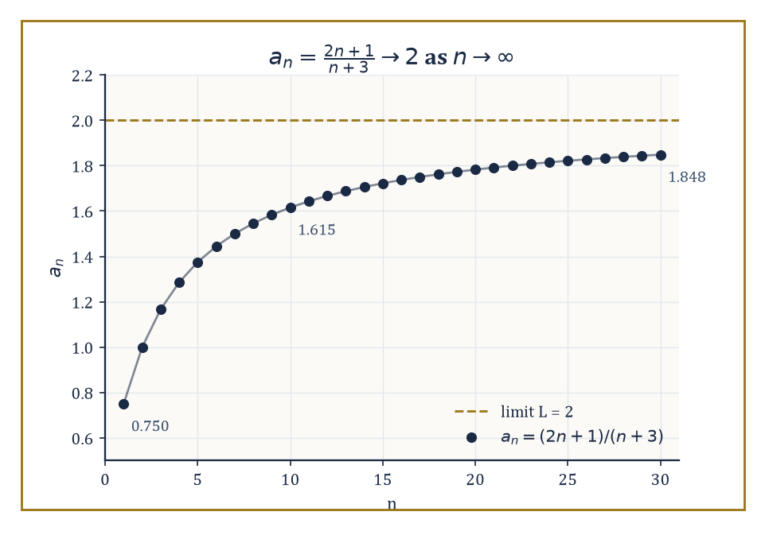
Thirty terms in, still short of 2 — and yet the limit, provably, is exactly 2.
lim_{n→∞} aₙ = L if for every ε > 0 there exists an N such that n > N implies |aₙ − L| < ε
The logic is identical to the ε–δ definition; only the vocabulary of 'how close' has swapped a continuous variable for a discrete counting index.
This is a deliberate simplification, not a different subject: a sequence is a function like any other, just one whose domain happens to be {1, 2, 3, …} instead of an interval of real numbers, so every intuition built for functions in Rooms 10.1 through 10.7 transfers across with barely a change of notation.
Numeric example — Worked example — pinning down N by hand. Claim: lim_{n→∞} 1/n = 0. Let ε = 0.01 be the Sceptic's challenge.
We need to find N such that n > N guarantees the following:
|1/n − 0| < 0.01, i.e. 1/n < 0.01, i.e. n > 100
So N = 100 works: for any n > 100, 1/n < 0.01, as required.
Check at n = 101:
1/101 ≈ 0.009901
which is indeed less than 0.01.
Check at n = 100 itself (just outside our guaranteed range, since we need n > N strictly):
1/100 = 0.01
exactly, which does not satisfy the strict inequality < 0.01 — confirming that N = 100 was exactly the right threshold, not merely a safe overestimate.
Sequences inherit every algebraic limit law from Room 10.4 — the limit of a sum of sequences is the sum of their limits, and so on — but they also admit tests that exploit the fact that their domain is discrete and ordered: the Monotone Convergence Theorem (a sequence that is increasing, or decreasing, and stays bounded must converge — it has nowhere else to go), the Squeeze Theorem for sequences (identical in spirit to Room 10.7's version), and, in later storeys, ratio and comparison tests built directly on top of sequence limits.
Since an infinite series is, by definition, the limit of its sequence of partial sums, essentially every fact you will eventually learn about infinite series is secretly a fact about sequence limits, filed under a different name.
The Monotone Convergence Theorem is worth seeing in action, because it proves a limit exists without ever producing a formula for what that limit equals — a slightly unsettling but entirely legitimate move.
Numeric example — Worked example — convergence proved without a formula. Let aₙ denote the sum of the first n terms of a halving sequence:
aₙ = 1/2 + 1/4 + 1/8 + ⋯ + 1/2ⁿ
Compute the first few terms:
a₁ = 0.5
a₂ = 0.75
a₃ = 0.875
a₄ = 0.9375
a₅ = 0.96875
Two things are visibly true: the sequence is increasing (each term adds a positive amount to the last), and it is bounded above by 1 (no partial sum of ever-smaller positive pieces starting under 1 can leap past 1).
The Monotone Convergence Theorem guarantees that an increasing, bounded-above sequence converges to some limit — we do not need to guess the value first.
Here, in fact, the value is easy to pin down by other means (it is 1, as the pattern 1 − 1/2ⁿ suggests and later storeys on series will confirm), but the theorem's power is that it would guarantee convergence even for a sequence whose limit was much harder to identify by inspection.
Numeric example — Worked example — a sequence limit by algebraic division. Find the following limit:
lim_{n→∞} (2n + 1)/(n + 3)
Check some values numerically:
at n = 1: 3/4 = 0.75
at n = 10: 21/13 ≈ 1.6154
at n = 100: 201/103 ≈ 1.9515
at n = 1000: 2001/1003 ≈ 1.9940
The values climb steadily toward 2. Algebraically, divide numerator and denominator by n (the highest power present):
(2n + 1)/(n + 3) = (2 + 1/n)/(1 + 3/n)
As n → ∞, both 1/n and 3/n shrink to 0, leaving
2/1 = 2
confirming the numerical trend exactly, by the same technique used for limits at infinity in Room 10.6.
There is also a precise, and extremely useful, bridge between sequence limits and ordinary function limits.
a function f has lim_{x→a} f(x) = L if and only if for every sequence xₙ in the domain of f, with xₙ → a and xₙ ≠ a for all n, the sequence of outputs f(xₙ) converges to L
This sequential characterisation is logically equivalent to the ε–δ definition, but it is often far easier to wield in one particular direction: proving that a limit does not exist.
You need only exhibit two sequences approaching a that produce two different output limits, and the case is closed — no ε–δ argument required.
The two directions of the equivalence are both useful in their own right: if you already trust a function's limit, it tells you what every possible sequence of inputs must do; if you doubt a limit exists, it tells you exactly how to construct the counterexample.
Worked example — Worked example — killing a limit with two sequences. Consider the limit
lim_{x→0} sin(1/x)
Take the sequence
xₙ = 1/(nπ), for n = 1, 2, 3, …
this converges to 0 as n → ∞. Then
sin(1/xₙ) = sin(nπ) = 0
for every n (sine vanishes at every integer multiple of π), so f(xₙ) → 0.
Now take a second sequence,
yₙ = 1/(π/2 + 2nπ)
this also converges to 0 as n → ∞. Then
sin(1/yₙ) = sin(π/2 + 2nπ) = sin(π/2) = 1
for every n (sine is 2π-periodic, and sin(π/2) = 1), so f(yₙ) → 1.
Both xₙ and yₙ march obediently toward 0, but the corresponding function values converge to two different numbers, 0 and 1.
By the sequential characterisation, lim_{x→0} sin(1/x) cannot exist — the function oscillates infinitely often as x → 0, never settling, and no clever choice of δ could ever corral it.
Sequences therefore do double duty: they are a simpler arena in which to practise the same limit reasoning developed for functions, and they are the direct bridge to infinite series and, further up the Tower, to the rigorous construction of the real numbers themselves — a real number, in one standard telling, is precisely the limit of a sequence of rational approximations, but that is a tale for a much later storey.
For the moment, it is enough to notice that every tool built in this storey for functions has a twin built for sequences, and the twins agree with each other exactly where both are defined — which is precisely what the sequential characterisation above guarantees.

Room 10.9: Looking Ahead: From Limits to Derivatives and Integrals
The Scaffolding Becomes Invisible, Not Absent
We have now acquired the full basic vocabulary of limits: the informal idea of Room 10.1, the numerical habits of Room 10.2, the precise ε–δ definition of Room 10.3, the algebraic laws of Room 10.4, one-sided limits and continuity in Room 10.5, infinite behaviour and asymptotes in Room 10.6, the special geometric limits and the Squeeze Theorem in Room 10.7, and the sequence version of the whole apparatus in Room 10.8.
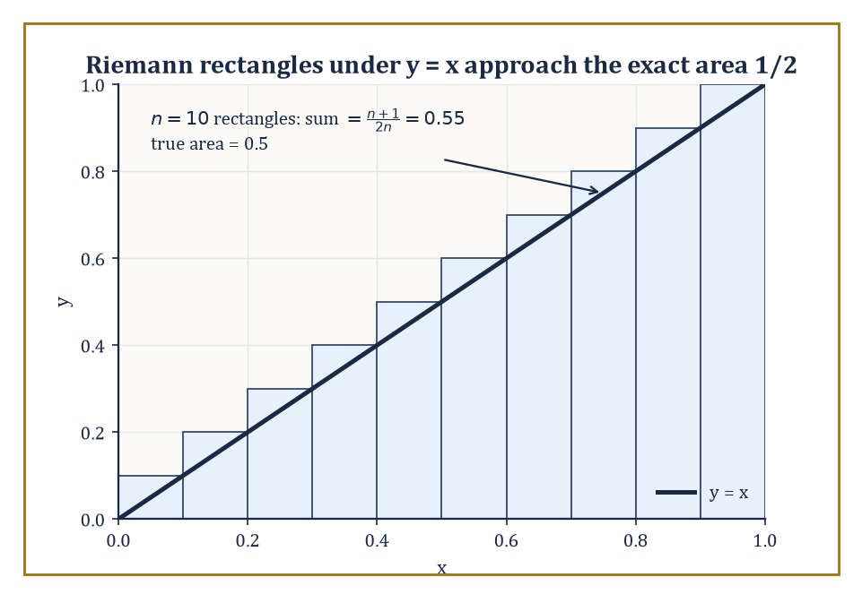
Ten rectangles overshoot the triangle by a little; infinitely many would not overshoot at all — that limit is the integral.
It is, by any reasonable standard, a great deal of machinery to build before it does anything visibly useful — which is exactly the complaint every generation levels at this storey, and exactly the complaint that stops the moment the machinery is finally put to work.
It is a pattern that will repeat throughout the Tower: the storey that teaches the tool is rarely the storey that makes the tool feel necessary, and patience between the two is simply part of the discipline.
That work begins immediately next storey. The derivative — the rate of change of a function at a single instant — is nothing but the limit of a difference quotient, precisely the calculation Room 10.1 previewed with a falling object's velocity.
The definite integral — the exact area under a curve — is the limit of a sum of increasingly many, increasingly thin rectangular slices.
Infinite series are, as Room 10.8 already flagged, limits of their partial sums. Even differential equations, met much further up the Tower, are ultimately statements about limits of difference equations as the step size shrinks to nothing.
Continuity, differentiability, and integrability — the three great regularity properties of the rest of analysis — are all defined, without exception, in the language this storey has just built.
Numeric example — Worked example — the derivative previewed, properly this time. Let f(x) = x³, and estimate the instantaneous rate of change at x = 1 using the difference quotient for shrinking h:
[f(1+h) − f(1)]/h
At h = 0.1:
f(1.1) = 1.331, so [1.331 − 1]/0.1 = 0.331/0.1 = 3.31
At h = 0.01:
f(1.01) = 1.030301, so [1.030301 − 1]/0.01 = 0.030301/0.01 = 3.0301
At h = 0.001:
f(1.001) = 1.003003001, so [1.003003001 − 1]/0.001 = 0.003003001/0.001 = 3.003001
The quotients are converging cleanly on 3. Storey 11 will show this limit always equals 3x² at the point in question — here, 3(1)² = 3 — and will give the whole procedure a name (the derivative) and a systematic set of shortcuts so that nobody ever has to compute a difference quotient by brute numerical force again.
Numeric example — Worked example — the integral previewed. Consider the region under the line y = x, from x = 0 to x = 1 — a right triangle whose area is elementary:
½ · base · height = ½ · 1 · 1 = 0.5
Approximate it instead by n thin rectangles, using the right endpoint of each of the n equal subintervals for the height; the sum is:
(1/n)·Σᵢ₌₁ⁿ (i/n) = (1/n²)·[n(n+1)/2] = (n+1)/(2n)
At n = 4:
5/8 = 0.625
At n = 10:
11/20 = 0.55
At n = 100:
101/200 = 0.505
As n → ∞:
(n+1)/(2n) = (1 + 1/n)/2 → 1/2
This matches the elementary triangle-area answer exactly, confirming both that the rectangle approximation is doing its job and that a limit of finite sums can recover an exact area. This is, in miniature, the entire idea behind the definite integral, which the storey after next develops in full.
One preview is worth making fully explicit, since it uses nothing beyond what this storey has already supplied: the derivative of the sine function, computed directly from the definition and the special limits of Room 10.7.
Numeric example — Worked example — differentiating sine using only this storey's tools. The derivative of f(x) = sin x at a point x is, by definition:
lim_{h→0} [sin(x+h) − sin x]/h
Expand sin(x+h) using the addition formula:
sin(x+h) = sin x cos h + cos x sin h
Substitute:
[sin x cos h + cos x sin h − sin x]/h = sin x·[(cos h − 1)/h] + cos x·[(sin h)/h]
As h → 0, (sin h)/h → 1 (Room 10.7's main special limit), and (cos h − 1)/h → 0 (a rearrangement of the (1 − cos h)/h² limit from Room 10.7), since:
(cos h − 1)/h = −h·[(1 − cos h)/h²]
and −h·(1/2) → 0 as h → 0.
So the whole expression tends to:
sin x·0 + cos x·1 = cos x
Numerical spot check at x = 0, h = 0.001:
[sin(0.001) − sin(0)]/0.001 ≈ 0.00099999983/0.001 ≈ 0.99999983
This is closing in on cos(0) = 1 — exactly as the derivation predicts. Storey 11 will present this same computation as a named rule, applied without re-deriving it every time; here, for once, you get to see the machinery of this entire storey deliver a genuine result of the next one.
The deeper lesson of this storey is not any single formula but a change of philosophical stance.
Everything before this storey trained you to compute exactly, in finitely many steps, and stop. Limits train you to approximate deliberately, track the error, and let the number of steps grow without bound — and to trust the result precisely because the approximation is controlled, not because it merely looks convincing on a graph.
That is the entire difference between calculus practised as a bag of formal tricks and calculus practised as a coherent theory: the limit is what makes the second one possible.
It is also, not coincidentally, a good description of how mathematics itself matures as a discipline: informal insight comes first, precise definition comes second so the insight can be trusted rather than merely admired, and only then does real power accrue.
The scaffolding does not disappear once the derivative and the integral arrive — it simply becomes invisible, buried inside every differentiation rule and every integration technique that follows, doing its quiet structural work without needing to be mentioned by name every time.
We built it carefully in this storey precisely so that later storeys never have to. Every derivative rule, every integration technique, and every convergence test still to come is, at bottom, an ε–δ argument that has been proved once, wrapped in a convenient name, and handed back to you as a tool rather than a chore.
We arrived at the top of Storey Nine with vectors that could point but not move, and we leave the top of Storey Ten having learned, at last, how to talk rigorously about motion, approach, and the infinite — all without ever needing an actual infinity to exist as an object we could hold. That is the quiet triumph of the ε–δ definition: it tames 'arbitrarily close' into something you can prove, not just something you can believe.
Storey Eleven takes this scaffolding and starts building on top of it in earnest: differential calculus, where the limit of a difference quotient becomes the derivative, and where slopes of curves, rates of change, and optimisation problems all turn out to be the same idea answering to different names. You will not need to reprove any ε–δ statements to get there — that work is done, filed away, and trusted from here on — but every rule you learn will, if you trace it back far enough, bottom out in a limit exactly like the ones built in this storey.
We have learned to approach. Next, we learn what happens the instant we get there.

Storey 11: Differential
Rates of Change, Tangents, and the Art of Measuring Instantaneous Change
Storey Ten left us standing very close to a number without ever quite touching it, having spent an entire storey building the scaffolding of rigour around a word — limit — that we had, until then, only ever used the way one uses eventually or probably. We learned to say precisely what it means for a sequence of values to approach a target, to control that approach with an ε and a δ, and to feel, for the first time in this Tower, that we could catch mathematics being honest with itself. It was patient, careful, faintly obsessive work. This storey cashes it in.
Here is the question limits were quietly preparing us to answer: if a quantity is changing — a car accelerating, a population growing, a coastline eroding — how fast is it changing right now, at this exact instant, with no elapsed time to average over? Right now is a slippery phrase; an instant, taken literally, has zero duration, and a rate of change needs both a change and a duration to divide it by. Ask for the speed of a car at 3:04:12 and no seconds more, and you appear to be dividing zero by zero. It is precisely this apparent absurdity that the limit was built to dissolve, and dissolving it is the entire subject of differential calculus.
The object that survives the dissolving is called the derivative, and it is arguably the single most useful idea in the whole Tower — more of applied mathematics runs on the derivative than on any other construction we shall meet, tenure notwithstanding. It is a slope, a velocity, a marginal cost, a sensitivity, a rate — the same idea wearing a different coat depending on which room of science you happen to open. We shall build it from the ground up, as a limit of secant slopes, and then tame it with a small toolkit of rules so that we are never again obliged to return to that limit for every new function we meet.
By the end of this storey you will be able to differentiate almost anything that can be written down, find where a function is largest or smallest without checking a single unnecessary point, and prove — using nothing more than a picture of a tangent line and a great deal of care — some of the deepest structural facts about how functions behave. The storey after this one, on Integral Calculus, will turn the entire process on its head and ask how to recover a function from its rate of change, which turns out to be a rather different and considerably slipperier business. But first, as the previous storey's author put it and this one's cannot resist repeating: let's differentiate.

Room 11.1: What the Derivative Actually Is
In which 'how fast, right now' turns out to be a perfectly respectable question
The derivative of a function f at a point a is the instantaneous rate of change of f at that point — the number that answers the question: how fast is f changing, exactly at a, with no interval left to average over? Geometrically, it is the slope of the tangent line to the graph of f at the point (a, f(a)): not a line that merely brushes the curve, but the line that best matches the curve's direction at that single point, the way a compass needle matches the direction you happen to be facing at the moment you glance at it.
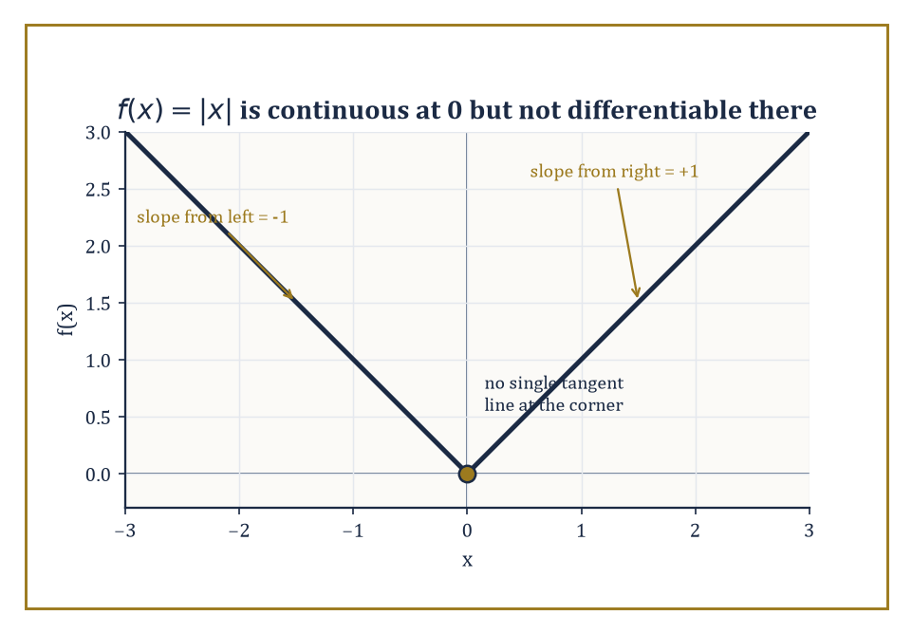
The graph of f(x) = |x|: continuous at the origin, but arriving from the left and leaving to the right at two different slopes, so no single tangent line fits.
Physically, the derivative is whatever the 'instantaneous version' of a quantity means in context: if f(t) is the position of an object at time t, the derivative is its velocity; if f(x) is total cost as a function of quantity produced, the derivative is marginal cost, the cost of the next infinitesimal unit; if f is mass as a function of volume, the derivative is density. One definition, endlessly many coats.
Numeric example — Worked example — the falling ball. Drop a ball from a great height and ignore air resistance; its distance fallen after t seconds is given by the following formula (the constant 4.9 is half of Earth's gravitational acceleration, 9.8 m/s²):
s(t) = 4.9t² metres
What is its velocity at the instant t = 2 seconds? We cannot divide 'distance fallen' by 'time elapsed' over an instant, since both are zero — but we can compute average velocity over shrinking intervals starting at t = 2 and watch where the numbers head.
Algebraically, the average velocity over [2, 2+h] is:
[s(2+h) − s(2)]/h = 4.9[(2+h)² − 4]/h = 4.9(4h + h²)/h = 4.9(4 + h) = 19.6 + 4.9h
Over [2, 2.1] (h = 0.1): average velocity = 19.6 + 0.49 = 20.09 m/s
Over [2, 2.01] (h = 0.01): 19.6 + 0.049 = 19.649 m/s
Over [2, 2.001] (h = 0.001): 19.6 + 0.0049 = 19.6049 m/s
The pattern is unmistakable: as the interval shrinks, the average velocity homes in on 19.6 m/s and shows no sign of heading anywhere else. That limiting value — not any one average, but the number the averages converge to — is the instantaneous velocity at t = 2, soon to be written s′(2).
19.6 = 9.8 × 2
As a sanity check, that's exactly the 'speed equals g times t' formula from physics, reconstructed here from nothing but the definition of position.
The idea is older than its rigorous definition. Fermat computed tangent slopes by a method that is recognisably a difference quotient, long before anyone had a clean theory of limits to justify it. Newton and Leibniz, working independently and famously falling out over priority, each developed a systematic calculus for derivatives and their inverse operation, integrals. The modern limit definition — the one this storey uses — arrived later still, courtesy of Cauchy and Weierstrass, and made the whole subject secure against the objections of anyone tactless enough to ask what an 'infinitesimal' actually was.
A function that possesses a derivative at a is said to be differentiable at a, and differentiability is a considerably more demanding property than mere continuity. Every differentiable function is continuous — if a curve has a well-defined tangent direction at a point, it can hardly be tearing itself apart there — but the converse fails, and it fails at the first sharp corner you draw. A graph can be perfectly continuous, with no gaps, jumps, or holes, and still refuse to have a tangent line at some point, simply because the curve arrives from the left heading in one direction and leaves to the right heading in another, with no way to average the two into a single slope.
Numeric example — Worked example — the kink at the origin. Take f(x) = |x|, continuous everywhere, including at x = 0 (as x approaches 0 from either side, f(x) approaches 0, and f(0) = 0, so there is no jump). Examine the difference quotient at a = 0:
[f(0+h) − f(0)]/h = |h|/h
For h > 0:
|h| = h, so the quotient equals h/h = 1
For h < 0:
|h| = −h, so the quotient equals −h/h = −1
Approaching from the right gives a limit of 1; approaching from the left gives a limit of −1. Since a limit must agree from both sides to exist at all, the limit of the difference quotient does not exist, and f is not differentiable at 0 — despite being perfectly continuous there.
Geometrically this is exactly the V-shaped kink you would draw: no single straight line is tangent to a corner, because a corner has two different directions arriving at the same point, not one.
Because the derivative can, in principle, be computed at every point where f is differentiable, it makes sense to regard 'the derivative' not as a single number but as a new function in its own right — the derived function, written f′, whose value at each point a is the slope of the original graph at that point. Studying the relationship between a function and its derived function — what the shape of one tells you about the other — is one of the great unifying themes of the whole of calculus, and it will occupy us for the rest of this storey and much of the next two.
Numeric example — Worked example — a function and its derived function. Later in this storey (Room 11.2) we shall prove from the definition that:
if f(x) = x², then f′(x) = 2x for every x
Treat that as a preview and see what it means to regard f′ as a function of its own.
f′(−2) = −4
At x = −2 the graph of x² is falling steeply, with slope −4.
f′(0) = 0
At x = 0 the graph is momentarily flat, the bottom of the parabola.
f′(1) = 2
At x = 1 the graph is rising with slope 2.
f′(3) = 6
At x = 3 it is rising three times as steeply as at x = 1.
One formula, x², has generated an entirely new formula, 2x, and that new formula carries genuine information — where the original graph is flat, where it is steep, where it is rising and where falling — that is not obvious from x² alone until you actually compute it.

Room 11.2: The Derivative as a Limit
Secant lines learn to grow up
The formal engine behind everything in Room 11.1 is the difference quotient:
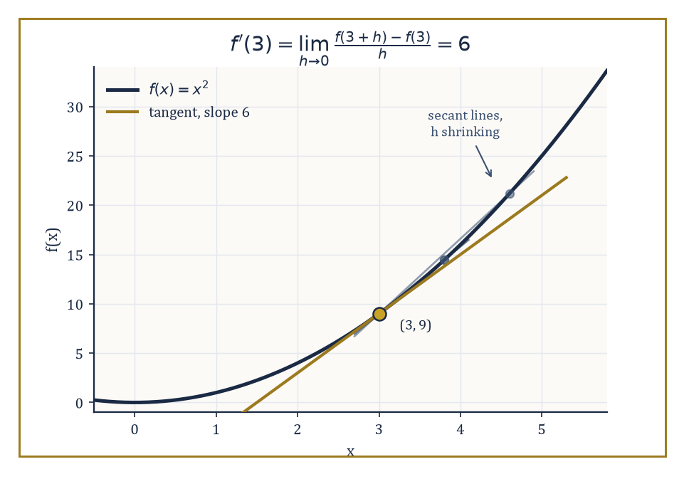
Secant lines through (3, 9) on y = x², pivoting as h shrinks until they settle into the tangent of slope 6.
[f(a + h) − f(a)] / h
Read geometrically, this is the slope of the secant line — the straight line cutting through the graph of f at the two points (a, f(a)) and (a + h, f(a + h)). A secant line is an entirely respectable, entirely computable object: given two points on a curve, 'rise over run' tells you its slope with no limits required. The derivative is what happens to that slope as the second point is dragged back toward the first — formally:
f′(a) = lim_{h→0} [f(a + h) − f(a)] / h
— provided this limit exists. As h shrinks, the secant line pivots around (a, f(a)) and, if the function is well-behaved there, settles into the tangent line: the straight line that grazes the curve at that one point rather than slicing through it at two.
Numeric example — Worked example — differentiating x² at a point, from first principles. Let f(x) = x² and find f′(3) directly from the definition, with no shortcuts.
f(3 + h) − f(3) = (3 + h)² − 3² = (9 + 6h + h²) − 9 = 6h + h²
Divide by h (legitimate since h is never actually 0 during this process, merely heading there):
[f(3+h) − f(3)]/h = (6h + h²)/h = 6 + h
Now let h → 0: 6 + h tends to 6, with no further algebra required, since 6 + h is a perfectly continuous function of h with no division-by-zero problem left in it. So:
f′(3) = 6
Geometrically, the parabola y = x² has a tangent line at the point (3, 9) with slope 6 — steeper than 45°, exactly as you would expect from a curve that is accelerating upward.
An entirely equivalent way to write the same limit replaces the increment h with the second point x itself:
f′(a) = lim_{x→a} [f(x) − f(a)] / (x − a)
The substitution x = a + h converts one form into the other — as x approaches a, the quantity h = x − a approaches 0, and the two difference quotients are identical term for term. The h-form is usually more convenient for algebraic manipulation, since you expand in powers of h and watch terms cancel; the x-form is occasionally more natural when a is fixed and x is thought of as the moving variable. Both say exactly the same thing: the derivative is the limit of secant slopes.
Numeric example — Worked example — the same derivative, written the other way. Repeat the computation for f(x) = x² at a = 3, this time in the x-form.
[f(x) − f(3)] / (x − 3) = (x² − 9)/(x − 3)
Factor the numerator as a difference of squares:
x² − 9 = (x − 3)(x + 3)
So the quotient equals:
(x − 3)(x + 3)/(x − 3) = x + 3
valid for all x ≠ 3 (a restriction that is irrelevant to the limit, which never asks what happens exactly at x = 3). As x → 3:
x + 3 → 6
Same answer, f′(3) = 6, reached by factoring instead of expanding — two different pieces of algebra, one limit, one tangent line.
Every derivative computed directly from the definition follows the same three-step ritual: expand the numerator f(a + h) − f(a), or factor it in the x-form; identify and cancel the common factor of h (or x − a) that is guaranteed to be there, guaranteed because f(a) always cancels the constant terms, leaving every remaining term with at least one factor of h; and then take the limit of what remains, which by this point is usually just a matter of setting h = 0 in a polynomial or similarly tame expression with no division problem left.
The algebra is frequently elementary. The conceptual leap is elsewhere: recognising that this purely algebraic limiting process is computing something geometric — the slope of a line touching the curve at exactly one point — and something physical — an instantaneous rate no stopwatch could ever measure directly.
Numeric example — Worked example — a full derivation for a quadratic. Let f(x) = x² − 3x + 1 and find f′(x) for general x, straight from the definition.
f(x + h) − f(x) = [(x+h)² − 3(x+h) + 1] − [x² − 3x + 1] = [x² + 2xh + h² − 3x − 3h + 1] − [x² − 3x + 1] = 2xh + h² − 3h
Divide by h:
(2xh + h² − 3h)/h = 2x + h − 3
Let h → 0:
2x + h − 3 → 2x − 3
So:
f′(x) = 2x − 3
This holds for every x. Check it against Room 11.3's linearity rule once you reach it: term by term, x² differentiates to 2x, −3x differentiates to −3, and the constant 1 differentiates to 0, giving 2x − 3 — exactly what the definition produced by brute force. The rules to come are not new truths; they are shortcuts that this same limiting argument justifies once and for all, so you never have to expand a difference quotient again.
Not every function is differentiable at every point, and the definition itself is the diagnostic tool that tells you where it fails. A corner — like the kink in |x| at the origin, met in Room 11.1 — produces two different one-sided limits of the difference quotient, so no single limit exists.
A cusp is similar but sharper: the two sides don't merely disagree, they shoot off toward +∞ and −∞ respectively. A vertical tangent produces a difference quotient that diverges to infinity from both sides at once — the 'slope' is trying to be infinite, which is not a real number, so the derivative simply does not exist there, even though the tangent line is a perfectly sensible-looking vertical line on the picture.
In every case the failure is not a flaw in the definition; it is the definition doing exactly its job, pointing out precisely where and why the intuitive notion of 'tangent line' breaks down.
Numeric example — Worked example — a vertical tangent. Let f(x) = x^(1/3), the real cube root, defined for all real x, positive and negative alike, and examine the difference quotient at a = 0.
[f(0+h) − f(0)]/h = h^(1/3)/h = h^(1/3 − 1) = h^(−2/3) = 1/h^(2/3)
Since h^(2/3) = (h²)^(1/3) is positive whether h itself is positive or negative — you are cube-rooting a square — and h^(2/3) → 0⁺ as h → 0 from either side, the quotient 1/h^(2/3) grows without bound: the difference quotient tends to +∞ from both left and right.
The two one-sided 'limits' agree for once, both diverging to the same infinity, but agreeing on infinity is not the same as agreeing on a real number, so f′(0) does not exist as a finite value. The graph of x^(1/3) does have a well-defined tangent line at the origin; it is simply vertical, and a vertical line has no finite slope to report.

Room 11.3: Differentiation Rules: Linearity, Product, Quotient, Chain
Four shortcuts that save you from ever factoring a difference quotient again
Computing every derivative from the definition, as we did twice in Room 11.2, is a perfectly rigorous way to spend an afternoon and an entirely impractical way to spend a career. Real functions are built from simpler ones by addition, multiplication, division, and composition, often several layers deep, and expanding a difference quotient for something like sin(x²)/(1 + eˣ) directly from the definition would be an act of mathematical self-harm.
The differentiation rules solve this once and for all: each rule is proved exactly once, from the definition, using the limit laws established in Storey 10, and thereafter may be applied freely, mechanically, without ever returning to h's and limits again.
Linearity is the gentlest of the rules and states two things at once: the derivative of a sum is the sum of the derivatives, and constants factor straight through.
(f + g)′ = f′ + g′
(c·f)′ = c·f′
Both halves follow directly from the corresponding limit laws — the limit of a sum is the sum of the limits, and a constant factor can always be pulled outside a limit — applied to the difference quotient of f + g or c·f. Together they mean that any polynomial, being a sum of constant multiples of powers of x, can be differentiated term by term with no further thought.
Numeric example — Worked example — differentiating a polynomial term by term. Let f(x) = 4x³ − 2x² + 7x − 5. Differentiating each term separately, using the power rule of Room 11.4 slightly ahead of schedule (it is standard enough to borrow): 4x³ differentiates to 12x²; −2x² differentiates to −4x; 7x differentiates to 7; and the constant −5, having no x in it to change, differentiates to 0.
4x³ → 4·3x² = 12x²
−2x² → −2·2x = −4x
7x → 7
−5 → 0
Adding these by linearity:
f′(x) = 12x² − 4x + 7
Evaluate at x = 2:
f′(2) = 12(4) − 4(2) + 7 = 48 − 8 + 7 = 47
The graph of f is rising steeply at x = 2, with slope 47 — plausible, since f is a cubic dominated for large x by the 4x³ term, and cubics grow fast, so a slope in the dozens by x = 2 is entirely in character.
The product rule handles (fg)′, and it is not, despite what every student's first instinct suggests, simply f′g′.
(fg)′ = f′g + fg′
Differentiate the first factor and multiply by the second untouched, then add the first factor untouched multiplied by the derivative of the second. The proof adds and subtracts a strategic cross term inside the difference quotient for fg, splits it into two quotients that each converge, one to f′g and the other to fg′, and the surprising extra term simply falls out in the wash.
Numeric example — Worked example — the product rule, checked against direct expansion. Let f(x) = x²·(3x + 1). By the product rule, with u = x² (u′ = 2x) and v = 3x + 1 (v′ = 3):
f′(x) = u′v + uv′ = 2x(3x + 1) + x²(3) = 6x² + 2x + 3x² = 9x² + 2x
Check this the honest way, by multiplying out first:
f(x) = x²(3x+1) = 3x³ + x²
which differentiates term by term to 9x² + 2x — exactly matching the product-rule answer. Evaluate at x = 2 by either route:
f′(2) = 9(4) + 2(2) = 36 + 4 = 40
The product rule earns its keep on functions you cannot easily expand, but it is always reassuring, the first few times, to see it agree with brute force on one you can.
The quotient rule handles (f/g)′, valid wherever g is not zero:
(f/g)′ = (f′g − fg′) / g²
It can be derived from the product rule and the chain rule together, by writing f/g as f · g⁻¹ and differentiating that product — a pleasant illustration of how few independent facts calculus actually needs, since most of the machinery is generated from a small core. Note the asymmetry: unlike the product rule, order matters here, and the sign is easy to misremember; a reliable habit is to check the rule against a case you can verify directly.
Numeric example — Worked example — the quotient rule. Let f(x) = (x² + 1)/(x − 1), with u = x² + 1 (u′ = 2x) and v = x − 1 (v′ = 1). By the quotient rule:
f′(x) = (u′v − uv′)/v² = [2x(x−1) − (x²+1)(1)] / (x−1)² = [2x² − 2x − x² − 1] / (x−1)² = (x² − 2x − 1)/(x−1)²
Evaluate at x = 3: numerator = 9 − 6 − 1 = 2; denominator = (3−1)² = 4; so
f′(3) = 2/4 = 0.5
At x = 3, f(3) = (9+1)/(3−1) = 10/2 = 5, and the curve has a modest, gently rising slope there — consistent with a graph that is climbing but not steeply at that point.
The chain rule differentiates a composition (f ∘ g)(x) = f(g(x)):
(f ∘ g)′ = (f′ ∘ g) · g′
or in the more usable Leibniz notation, if y = f(u) and u = g(x), then:
dy/dx = (dy/du)(du/dx)
a formula so suggestively cancellative, with the du's appearing to cancel like fractions, that it is tempting to think that is literally what is happening. It is not quite; du here is not a number you can cancel, and the apparent cancellation is a happy notational coincidence dressed up around a genuine limit argument. The mnemonic is harmless, though, and the rule itself is entirely rigorous.
Numeric example — Worked example — the chain rule, checked against direct expansion. Let f(x) = (2x − 1)³. Treat this as the outer function u³ applied to the inner function u = 2x − 1. The outer derivative, with respect to u, is 3u²; the inner derivative, du/dx, is 2. By the chain rule:
f′(x) = 3u² · 2 = 3(2x−1)² · 2 = 6(2x−1)²
Check by expanding first, using (a−b)³ = a³ − 3a²b + 3ab² − b³ with a = 2x, b = 1:
(2x−1)³ = 8x³ − 12x² + 6x − 1
which differentiates term by term to:
24x² − 24x + 6
Now expand the chain-rule answer:
6(2x−1)² = 6(4x² − 4x + 1) = 24x² − 24x + 6
The two methods agree exactly, as they must.
The chain rule is the most powerful of the four, and not by a small margin. Linearity, the product rule, and the quotient rule each combine two functions that sit side by side; the chain rule is the only one of the four that reaches inside a function and threads through however many layers of composition you care to nest.
It is the reason a function built by composing five elementary pieces is no harder to differentiate than one built from two, provided you apply the rule once per layer, from the outside in, and it is the algebraic engine — quietly, in the background — behind implicit differentiation and related rates, both of which occupy the next room. Mastery of the chain rule is, more than any other single skill, the difference between 'I can differentiate polynomials' and 'I can differentiate anything built from elementary functions by the ordinary operations of algebra.'
Numeric example — Worked example — three layers deep. Let f(x) = [ (x² + 1)³ + 1 ]⁵. This is composition three layers deep: the innermost layer is u = x² + 1; the middle layer is v = u³ + 1; the outer layer is f = v⁵. Differentiate from the outside in, multiplying derivatives as you go:
df/dv = 5v⁴, dv/du = 3u², du/dx = 2x
By the chain rule applied twice:
f′(x) = 5v⁴ · 3u² · 2x = 30x·u²·v⁴, where u = x² + 1 and v = u³ + 1
Evaluate at x = 1: u = 1² + 1 = 2; v = 2³ + 1 = 9; u² = 4; v⁴ = 9⁴ = 6561.
f′(1) = 30 · 1 · 4 · 6561 = 120 · 6561 = 787,320
No sane person expands [(x²+1)³+1]⁵ before differentiating it — it has dozens of terms — yet the chain rule, applied one layer at a time, produces the derivative, evaluated at a point, in four lines of arithmetic. This is the rule earning, with interest, everything it cost to learn.

Room 11.4: Derivatives of the Elementary Functions
The known unknowns
The power rule states that for any real number n, on whatever domain makes both xⁿ and x^(n−1) sensible, the derivative of xⁿ is given by:
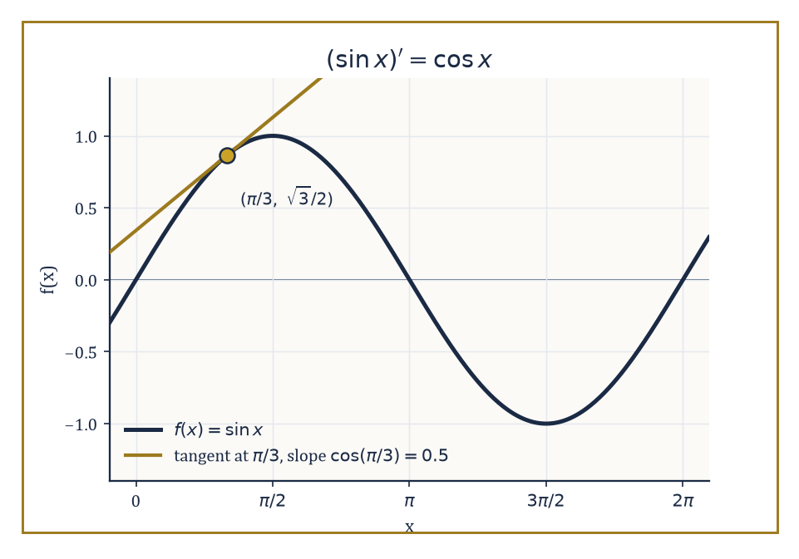
y = sin x with its tangent line at x = π/3, where the slope equals cos(π/3) = 0.5 — the derivative rule made visible.
(xⁿ)′ = n·x^(n−1)
For positive integers it can be proved by expanding (x+h)ⁿ with the binomial theorem — every term except the first two carries a factor of h² or higher, so dividing by h and letting h → 0 leaves only n·x^(n−1) standing.
Or it can be proved by induction using the product rule on the identity
xⁿ = x · x^(n−1)
The rule then extends to negative integers via the quotient rule, and to rational exponents via implicit differentiation on
y = x^(p/q)
meaning
y^q = x^p
Finally it extends to arbitrary real exponents by writing
xⁿ = e^(n ln x)
and applying the chain rule together with the exponential and logarithmic derivatives established later in this room. The statement is uniform; the proof is assembled in stages as the toolkit grows.
Numeric example — Worked example — fractional and negative exponents. Let f(x) = x^(3/2), defined for x ≥ 0. By the power rule:
f′(x) = (3/2)x^(1/2)
Evaluate at x = 4:
f′(4) = 1.5 · √4 = 1.5 · 2 = 3
Now let g(x) = x^(−2) = 1/x², defined for x ≠ 0. By the power rule:
g′(x) = −2x^(−3) = −2/x³
Evaluate at x = 1:
g′(1) = −2/1 = −2
so the graph of 1/x² is falling steeply just to the right of x = 1. Evaluate at x = 2:
g′(2) = −2/8 = −0.25
falling far more gently, since 1/x² is levelling off toward zero as x grows. The single formula n·x^(n−1) handles positive, negative, and fractional exponents without a change of method, which is precisely the uniformity that makes it worth proving once, in general, rather than case by case.
The exponential function eˣ has the almost embarrassingly simple property of being its own derivative:
(eˣ)′ = eˣ
This is not a coincidence dressed up as a theorem; it is essentially the defining property of the number e, which can itself be characterised as the unique base for which this holds.
The natural logarithm, being the inverse of eˣ, has derivative
(ln x)′ = 1/x
provable by implicit differentiation on
e^y = x
The derivatives of a general exponential aˣ and a general logarithm log_b x follow from these two by the change-of-base identities
aˣ = e^(x ln a)
log_b x = ln x / ln b
combined with the chain rule:
(aˣ)′ = aˣ ln a
Numeric example — Worked example — exponentials and logarithms, evaluated. For f(x) = eˣ:
f′(0) = e⁰ = 1
so the graph crosses the y-axis rising at exactly 45°.
f′(1) = e¹ ≈ 2.71828
rising nearly three times as steeply just one unit later — exponential growth accelerating its own rate of growth, forever.
For g(x) = ln x:
g′(2) = 1/2 = 0.5
g′(5) = 1/5 = 0.2
the logarithm's rate of increase shrinking as x grows, exactly why it is the textbook example of growing, but slower and slower.
For h(x) = 2^x: using (aˣ)′ = aˣ ln a with a = 2:
h′(3) = 2³ · ln 2 = 8 × 0.693147 ≈ 5.545
Compare: an unadorned power function x³ has derivative
3x² = 27 at x = 3
whereas 2^x is still climbing at only about 5.5 there — a useful reminder that 'exponential eventually beats every polynomial' is a statement about large x, not small x.
The trigonometric derivatives are:
(sin x)′ = cos x
(cos x)′ = −sin x
The remaining four trigonometric functions, being built from sin and cos by division, follow immediately from the quotient rule.
The proofs of the two basic ones rest on two special limits established back in Storey 10:
lim_{h→0} (sin h)/h = 1
lim_{h→0} (1 − cos h)/h = 0
Both limits look, on first sight, like division-by-zero disasters, and both are in fact perfectly well-behaved once approached correctly — which is rather the whole moral of the previous storey, redeployed here to devastating effect.
Numeric example — Worked example — the special limits, seen numerically. Take h = 0.01 radians, a small angle of roughly 0.57°. Using the small-angle approximations:
sin h ≈ h − h³/6
cos h ≈ 1 − h²/2
Then:
sin(0.01) ≈ 0.01 − 0.0000001667 ≈ 0.0099998
(sin h)/h ≈ 0.0099998/0.01 ≈ 0.99998
already extremely close to 1, with h nowhere near 0 yet.
And:
1 − cos(0.01) ≈ (0.01)²/2 = 0.00005
(1 − cos h)/h ≈ 0.00005/0.01 = 0.005
already close to 0, and shrinking further: at h = 0.001, the same computation gives
(1 − cos h)/h ≈ 0.0005
ten times smaller, exactly as the limit demands.
Numeric example — Worked example — differentiating sine and cosine at a point. Let f(x) = sin x and g(x) = cos x, and evaluate both derivatives at x = π/3 (60°), where:
sin(π/3) = √3/2 ≈ 0.8660
cos(π/3) = 1/2
Then:
f′(π/3) = cos(π/3) = 0.5
the sine curve is rising modestly there, past its steepest point at x = 0 and heading toward its flat peak at x = π/2.
g′(π/3) = −sin(π/3) = −√3/2 ≈ −0.8660
the cosine curve is falling quite steeply there, consistent with cos x heading down toward zero at x = π/2.
The inverse trigonometric functions, despite arising from trigonometry, have derivatives that are purely algebraic — no sines or cosines appear in the answer, only square roots:
(arcsin x)′ = 1/√(1 − x²)
(arccos x)′ = −1/√(1 − x²)
(arctan x)′ = 1/(1 + x²)
and similarly for the remaining three.
These are proved by implicit differentiation, Room 11.5's technique borrowed slightly early: if y = arcsin x then x = sin y; differentiate both sides with respect to x, and solve for dy/dx using the Pythagorean identity to convert cos y back into a function of x.
Hyperbolic functions, when they are introduced, satisfy strikingly similar rules:
(sinh x)′ = cosh x
(cosh x)′ = sinh x
with no inconvenient minus sign this time, a small algebraic souvenir of their direct relationship to eˣ rather than to a circle.
Numeric example — Worked example — an inverse trig derivative. Let f(x) = arcsin x and evaluate f′(0.5). Using:
(arcsin x)′ = 1/√(1 − x²)
Then:
f′(0.5) = 1/√(1 − 0.25) = 1/√0.75 ≈ 1/0.8660 ≈ 1.1547
Sanity check the shape: arcsin x is defined only on [−1, 1] and its graph becomes vertical as x → ±1, matching the vertical-tangent behaviour of Room 11.2, since 1/√(1−x²) → ∞ there.
At x = 0.5, comfortably inside the domain but past the gentle middle, a slope of about 1.15 — somewhat steeper than the slope of 1 at x = 0 — is exactly the trend you would expect on the way to that eventual blow-up.
Together, the power rule, the exponential and logarithmic derivatives, the trigonometric derivatives, the inverse trigonometric derivatives, and the four differentiation rules of Room 11.3, closed under repeated application, let us differentiate any function that can be built by arithmetic operations and composition from this short list of elementary pieces.
This is a genuinely remarkable fact: the collection of functions you can differentiate by hand, using nothing but a page of rules memorised in an afternoon, covers essentially every function that appears in an undergraduate science curriculum.
It will not last forever — later storeys will introduce functions defined by processes too wild for this toolkit — but for now, the toolkit is complete enough to feel, for a while, like it covers everything.

Room 11.5: Implicit Differentiation and Related Rates
Differentiating equations that haven't been solved yet
Every derivative so far has been computed for a function handed to us explicitly, in the form y = f(x).
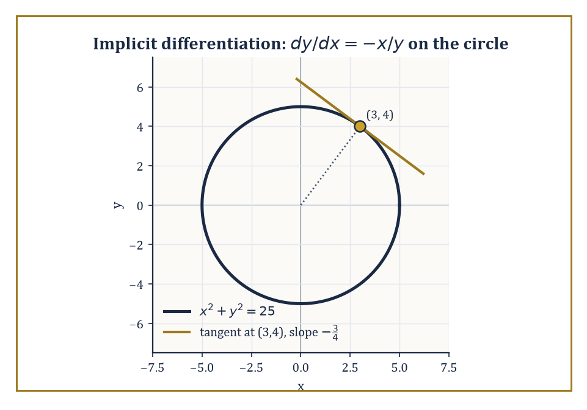
The circle x² + y² = 25 and its tangent at (3, 4), found with dy/dx = −x/y and no equation for y ever written down.
But many relations between x and y are not, and sometimes cannot be, solved for y in closed form — a circle x² + y² = 25, an ellipse, or a more exotic curve like x³ + y³ = 6xy, the folium of Descartes, which no amount of algebra will cleanly untangle into y = something.
Implicit differentiation sidesteps the need to solve for y at all: differentiate both sides of the relation with respect to x, treating y throughout as an unspecified but differentiable function of x, so that the chain rule turns d/dx(y²) into
d/dx(y²) = 2y · dy/dx
since y² is a squaring function applied to the inner function y(x).
Once both sides are differentiated, dy/dx appears, algebraically, as one term among several, and a little rearrangement isolates it.
This matters most exactly when solving explicitly for y is impossible, or would produce several branches that all have to be tracked separately — implicit differentiation finds the slope of whichever branch you happen to be standing on without ever having to name it.
Numeric example — Worked example — the slope of a circle. The circle x² + y² = 25 passes through the point (3, 4), since 3² + 4² = 9 + 16 = 25. Find the slope of the circle at that point without ever solving for y.
Differentiate both sides with respect to x:
d/dx(x²) + d/dx(y²) = d/dx(25)
The left side becomes 2x + 2y·(dy/dx), using the chain rule on y² exactly as described above, and the right side is 0, since 25 is a constant. So:
2x + 2y(dy/dx) = 0
giving:
dy/dx = −x/y
At the point (3, 4):
dy/dx = −3/4 = −0.75
Sanity check geometrically: at (3, 4), in the upper-right of the circle, the curve should be heading down and to the right as x increases — a negative slope — and a magnitude less than 1 is right for a point more than halfway from the circle's top to its rightmost edge. No equation 'y = …' was ever written down; the whole computation stayed implicit throughout.
Related-rates problems are the chain rule's other great party trick: situations in which several quantities are all varying with time, tied together by some fixed geometric or physical relation, and the question asks how fast one of them is changing given the rates of the others.
The method is always the same three steps: write down the relation that holds at every instant, not just the instant in question, since the relation must be an identity, true for all time, or differentiating it tells you nothing; differentiate both sides with respect to time t, using the chain rule to convert, for example, d/dt(x²) into
d/dt(x²) = 2x·(dx/dt)
and finally substitute in the known values and known rates at the particular instant of interest, solving for whichever rate is unknown.
Numeric example — Worked example — the sliding ladder. A 10-foot ladder leans against a vertical wall, its foot on the ground a distance x from the wall and its top a height y up the wall. At every instant, Pythagoras gives the fixed relation
x² + y² = 10² = 100
since the ladder's length never changes, only the triangle's shape. The foot of the ladder is being pulled away from the wall at dx/dt = 2 ft/s. How fast is the top sliding down the wall at the instant the foot is 6 feet from the wall?
First find y at that instant:
6² + y² = 100
y² = 64
y = 8
an old friend, the 6-8-10 right triangle.
Differentiate the relation with respect to time:
2x(dx/dt) + 2y(dy/dt) = 0
dy/dt = −(x/y)(dx/dt)
Substitute x = 6, y = 8, dx/dt = 2:
dy/dt = −(6/8)(2) = −(0.75)(2) = −1.5 ft/s
The negative sign is not a mistake to discard — it is the answer: y is decreasing, so the top of the ladder is sliding down the wall at 1.5 feet per second at that instant.
As a footnote to physical intuition: this rate is not constant, and it grows sharply as the foot nears directly under the top — a genuinely alarming fact for anyone actually standing on the ladder, and a good reason to leave related-rates problems to the page.
Numeric example — Worked example — a second related rate, inflating a balloon. A spherical balloon is being inflated so that its volume increases at a constant rate of 100 cubic centimetres per second:
dV/dt = 100 cm³/s
How fast is the radius increasing at the instant r = 5 cm? The governing relation is
V = (4/3)πr³
holding at every instant regardless of how fast anything is changing. Differentiate with respect to time:
dV/dt = 4πr² · (dr/dt)
the chain rule converting r³ into 3r²·(dr/dt) and the constant (4/3)π·3 simplifying to 4π. Substitute the given volume rate and radius:
100 = 4π(25)(dr/dt) = 100π(dr/dt)
so:
dr/dt = 100/(100π) = 1/π ≈ 0.3183 cm/s
Notice that the radius grows more slowly than a first guess from a constant inflow might suggest: because the balloon's surface area, 4πr², grows as the balloon expands, the same 100 cm³ per second is spread over an ever-larger surface, so the radius's rate of increase actually falls as r grows, even though the volume's rate does not — a fact this same equation reveals instantly if you substitute a larger r.
Both techniques illustrate the same underlying principle, easy to lose sight of amid the algebra: differentiation is a mechanical operation that can be applied directly to an equation, not merely to an expression that has already been solved for the dependent variable.
You do not need y isolated on one side to differentiate a relation involving y; you only need to know that y is, or can be treated as, a differentiable function of x, or of t, and the chain rule does the rest of the work for you, term by term, however tangled the original relation looked.
It is also, quietly, our first genuine glimpse of a habit that will recur throughout the rest of the Tower: treating an equation, rather than an explicit formula, as the primary object of study, and extracting exactly the information you need — here, a rate — without ever solving the equation in full.

Room 11.6: Higher-Order Derivatives and Linear Approximation
Derivatives, all the way down; then straight lines, all the way close
Since the derivative f′ is itself a function, there is nothing to stop us differentiating it again: the derivative of the derivative is the second derivative, written f″ or f^(2), and the process continues recursively — f‴ for the third derivative, and f^(n) for the n-th, whenever each successive derivative happens to exist.
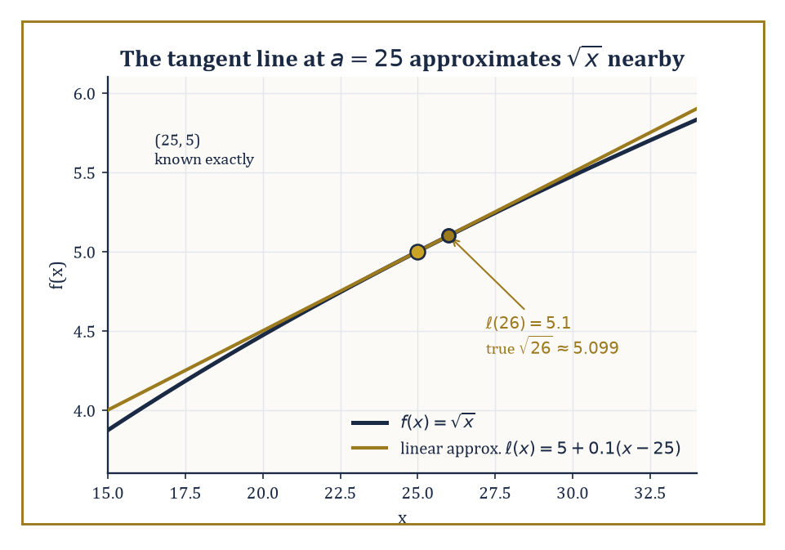
The tangent line to √x at a = 25 stays close enough to the curve to estimate √26 as 5.1, against a true value of 5.099.
Physically, if f(t) is position, then f′(t) is velocity and f″(t) is acceleration, the rate at which velocity itself is changing, which is the quantity you actually feel as a passenger when a car speeds up, slows down, or corners hard.
Geometrically, the second derivative measures concavity: where f″ > 0 the graph curves upward, like the inside of a bowl, and where f″ < 0 it curves downward, like the outside of a dome — information the first derivative alone cannot supply, since f′ only tells you whether the graph is rising or falling, not which way it is bending while it does so.
Go one derivative further, to the third derivative of position, and you reach jerk — the rate of change of acceleration itself, the quantity that makes a smoothly accelerating lift feel comfortable and a jerky one feel exactly as its name suggests; engineers who design lifts, trains, and roller coasters spend a surprising amount of their working lives thinking about third derivatives.
Numeric example — Worked example — three derivatives of a quartic. Let f(x) = x⁴ − 3x² + 2. Differentiate repeatedly:
f′(x) = 4x³ − 6x
f″(x) = 12x² − 6
f‴(x) = 24x
Evaluate all three at x = 1:
f′(1) = 4 − 6 = −2
so the graph is falling at x = 1.
f″(1) = 12 − 6 = 6
This is positive, so the graph is concave up there, curving like a bowl.
f‴(1) = 24
the third derivative, with no standard geometric picture of its own but a perfectly well-defined number nonetheless.
Numeric example — Worked example — velocity and acceleration. A particle's position along a line is given below, with t in seconds:
s(t) = t³ − 6t² + 9t metres
Its velocity and acceleration are:
s′(t) = 3t² − 12t + 9
s″(t) = 6t − 12
At t = 1 second, the velocity is:
v(1) = 3 − 12 + 9 = 0
the particle momentarily at rest, not stopped for good but reversing direction — factoring s′(t) shows exactly when velocity is zero:
s′(t) = 3(t−1)(t−3)
This factoring shows velocity is zero exactly at t = 1 and t = 3, the two instants the particle turns around.
Its acceleration at that same instant is:
a(1) = 6 − 12 = −6 m/s²
This is negative, meaning the net push at t = 1 is in the negative direction — exactly what is slowing the particle to its momentary standstill and then reversing it thereafter.
Differentiate once more for the jerk:
s‴(t) = 6
a constant — this particular motion has the same jerk at every instant, meaning its acceleration always changes at the same steady rate, however fast the particle itself happens to be moving at the time.
The first-order, or linear, approximation to f near the point a is the function ℓ(x), precisely the equation of the tangent line at a, now repurposed as a stand-in for f itself in the immediate vicinity of a:
ℓ(x) = f(a) + f′(a)(x − a)
Since the tangent line matches both the value and the direction of f at a, it tracks f closely for x near a, and the error f(x) − ℓ(x) tends to zero faster than the distance |x − a| itself as x → a.
This 'faster than linear' decay of the error is not an incidental nicety; it is, properly stated, the precise technical meaning of differentiability — a function is differentiable at a exactly when it admits a best linear approximation there, in this strong sense.
This is also why the tangent line is sometimes called the best linear approximation and not merely a linear approximation: any other straight line through (a, f(a)) with a different slope produces an error that shrinks only at the same rate as |x − a|, not faster, so the tangent line is not just convenient but uniquely optimal among every line through that point.
Numeric example — Worked example — estimating √26 without a calculator. Let f(x) = √x, and use a = 25, a nearby point where the value is known exactly:
f(25) = 5
The derivative is f′(x) = 1/(2√x), so:
f′(25) = 1/(2·5) = 0.1
Linear approximation near a = 25:
ℓ(x) = 5 + 0.1(x − 25)
Estimate √26 by setting x = 26:
ℓ(26) = 5 + 0.1(1) = 5.1
The true value is √26 ≈ 5.0990 to four decimal places, so the linear approximation is off by only about 0.001 — a remarkably good estimate for an expression that looks, on the surface, like it demands a calculator, produced instead by one multiplication and one addition.
Linear approximation is also written in differential notation, for the actual change:
Δf ≈ f′(a) Δx
or, as a compact symbolic identity relating the 'infinitesimal' changes df and dx:
df = f′(x) dx
This notation introduces no new mathematics beyond what the previous paragraph already established — it is simply a convenient shorthand, much loved by physicists and engineers, for the same linear approximation, and it is also the first hint of the notation that will dominate integral calculus in the next storey, where dx reappears inside an integral sign.
For now, treat df and dx simply as convenient stand-ins for 'a small change in f' and 'a small change in x' respectively, related by the ordinary derivative — nothing more mysterious is happening, whatever the notation's eighteenth-century reputation for mystery might suggest.
Numeric example — Worked example — estimating a change in volume. A spherical balloon has radius r = 10 cm and is inflated so that r increases to 10.1 cm. Estimate the resulting change in volume using differentials, given:
V(r) = (4/3)πr³, so dV/dr = 4πr²
At r = 10:
dV/dr = 4π(100) = 400π
With dr = 0.1:
dV ≈ 400π × 0.1 = 40π ≈ 125.66 cm³
Compare with the exact change:
V(10.1) − V(10) = (4/3)π(10.1³ − 10³) = (4/3)π(1030.301 − 1000) = (4/3)π(30.301) ≈ 126.93 cm³
The differential estimate, 125.66 cm³, is close to the true value, 126.93 cm³, but not exact — the gap of about 1.27 cm³ is precisely the error term that the previous paragraph promised would vanish faster than Δr as Δr → 0. Here Δr = 0.1 is small but not infinitesimal, so a small residual error is exactly what theory predicts, and exactly what we see.

Room 11.7: The Mean Value Theorem and Its Consequences
Somewhere in between, a tangent finally agrees with the secant
Rolle's theorem is the special case that makes everything else easy to believe: if f is continuous on the closed interval [a, b], differentiable on the open interval (a, b), and f(a) = f(b) — the function starts and ends at the same height — then there is at least one point c strictly between a and b where f′(c) = 0.
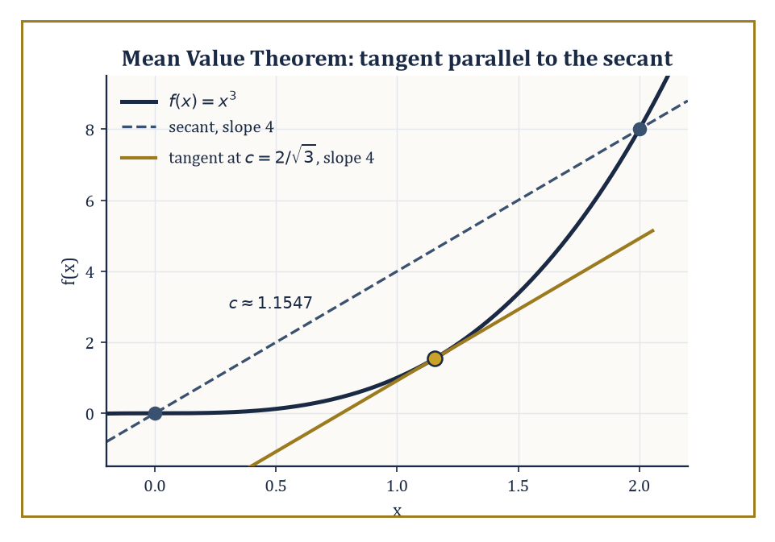
On y = x³ over [0, 2], the tangent at c = 2/√3 runs exactly parallel to the secant — the Mean Value Theorem, drawn.
Intuitively this is unavoidable: if a continuous curve leaves a height and returns to exactly the same height, it must, somewhere in between, stop going up and start coming down, or vice versa, or simply stay flat throughout, and at that turning instant its tangent is horizontal.
The theorem asks for surprisingly little — continuity on the closed interval, differentiability only on the open interval, so the endpoints themselves are allowed to misbehave slightly, and equal heights — and delivers, in return, a guarantee that holds for every function meeting those conditions, however wild the function looks in between.
Numeric example — Worked example — Rolle's theorem in action. Let f(x) = x² − 4x + 3 on the interval [1, 3]. Check the hypotheses: f is a polynomial, hence continuous and differentiable everywhere, so both conditions are automatic. Check the endpoint condition:
f(1) = 1 − 4 + 3 = 0
f(3) = 9 − 12 + 3 = 0
The two endpoint values agree, both zero, so Rolle's theorem applies and guarantees some c in (1, 3) with f′(c) = 0. Find it:
f′(x) = 2x − 4
so f′(c) = 0 gives c = 2, which indeed lies strictly between 1 and 3. The parabola x² − 4x + 3, which factors as (x−1)(x−3), confirming the roots at x = 1 and x = 3, has its vertex, its horizontal tangent, exactly at x = 2, the midpoint, entirely as the symmetric picture of a parabola would lead you to expect.
The Mean Value Theorem drops Rolle's restrictive requirement that f(a) equal f(b) and replaces the conclusion with something more general: under the same continuity and differentiability hypotheses, there is some c in (a, b) where
f′(c) = [f(b) − f(a)] / (b − a)
the instantaneous rate of change at c exactly equals the average rate of change over the whole interval. In geometric language: somewhere between the endpoints, the tangent line is parallel to the secant line joining them. Rolle's theorem is simply the special case where the secant happens to be horizontal.
The proof, in fact, reduces the general case to Rolle's exactly this way: subtract off the secant line itself, forming a new auxiliary function that does start and end at the same height by construction, apply Rolle's theorem to that auxiliary function, and translate the resulting horizontal tangent back into a statement about the original f.
Numeric example — Worked example — the Mean Value Theorem. Let f(x) = x³ on [0, 2]. f(0) = 0, f(2) = 8, so the average rate of change over the interval is
[f(2) − f(0)] / (2 − 0) = 8/2 = 4
the secant line joining (0,0) and (2,8) has slope 4. The Mean Value Theorem guarantees some c in (0, 2) with f′(c) = 4. Find it:
f′(x) = 3x²
3c² = 4
c² = 4/3, c = 2/√3 ≈ 1.1547
which lies strictly between 0 and 2. At that point, the tangent to y = x³ has exactly the same slope, 4, as the secant across the whole interval — the theorem's promise, delivered.
The Mean Value Theorem is the bridge from local information — the value of the derivative at individual points — to global information about the function's overall behaviour, and a remarkable proportion of the qualitative theory of calculus is simply a corollary of it.
If f′(x) = 0 throughout an interval, the theorem forces f to be constant on that interval, since any two points would otherwise force some derivative to be nonzero somewhere between them. If f′(x) > 0 throughout an interval, the same argument forces f to be strictly increasing.
These facts feel obvious from a picture, but the Mean Value Theorem is what turns feels obvious into is provable, and that provability is what eventually underwrites the error bound on linear approximation, the uniqueness of solutions to certain differential equations, and much else besides.
A further consequence worth naming: if f′(x) < g′(x) throughout an interval and f and g agree at the left endpoint, then f(x) < g(x) for every x to the right of it — differentiation of the inequality builds it up, point by point, from a single starting comparison, which is precisely the technique used to prove many of the standard inequalities in analysis.
Abstract example — Worked example — proving a function is one-to-one. Let f(x) = x³ + x. Its derivative is
f′(x) = 3x² + 1
which is at least 1 for every real x, since 3x² ≥ 0 always — so f′(x) > 0 everywhere, with no exceptions. By the Mean Value Theorem's consequence above, f is therefore strictly increasing on the entire real line, and a strictly increasing function can never take the same value twice: if a < b then f(a) < f(b), so f(a) ≠ f(b). This single derivative computation, with no algebra solving f(a) = f(b) required, proves that f is injective (one-to-one) on all of ℝ — a fact that would be considerably more awkward to establish by trying to solve x³ + x = y³ + y directly.
Numeric example — Worked example — same derivative, different function, constant gap. Let f(x) = x² + 3 and g(x) = x² − 1. Differentiate both:
f′(x) = 2x, g′(x) = 2x
identical for every x. The consequence of the Mean Value Theorem stated above, applied to the difference f − g, whose derivative is 2x − 2x = 0 everywhere and so must be constant, predicts that f and g differ by a fixed constant across their entire domains. Check directly:
f(x) − g(x) = (x² + 3) − (x² − 1) = 4
for every x — not approximately 4, not 4 only near some point, but exactly 4, everywhere, as promised. This is the seed of an idea that will blossom in the next storey into the plus-C that follows every indefinite integral: knowing a derivative pins down a function only up to an unknown constant, and the Mean Value Theorem is the precise reason why that constant, and nothing more exotic, is the only ambiguity that remains.

Room 11.8: Optimization and Curve Sketching
Finding the top of the hill without climbing every inch of it
A differentiable function can only achieve a local maximum or minimum at a critical point — a point where f′ = 0, the tangent is horizontal, or where f′ fails to exist, a corner, cusp, or similar irregularity.
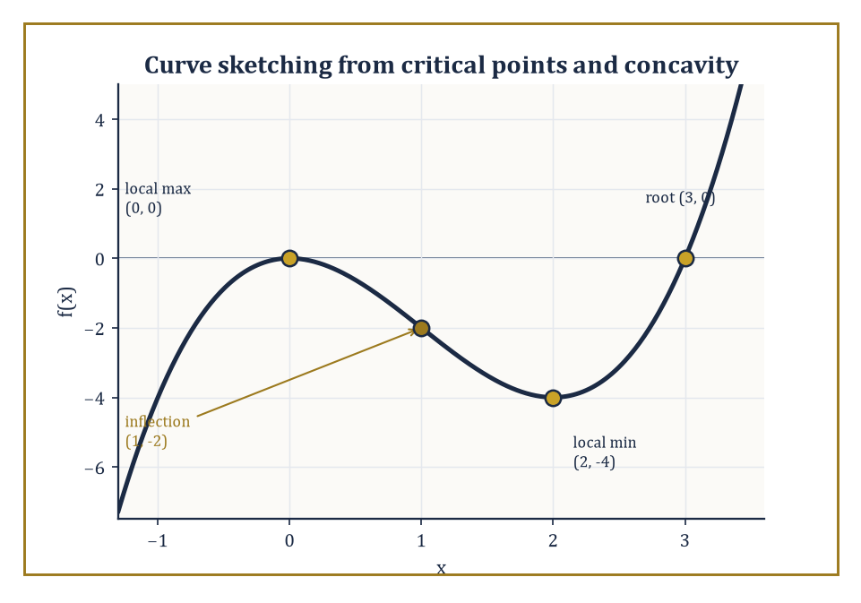
f(x) = x³ − 3x², sketched from four numbers alone: a local max at (0,0), an inflection at (1,−2), a local min at (2,−4), and a root at (3,0).
This is itself a small application of the Mean Value Theorem's ideas from the previous room: at a local peak, the function is increasing just before and decreasing just after, so its derivative cannot be positive there and cannot be negative there, leaving zero as the only option when the derivative exists at all.
The first-derivative test classifies a critical point by checking whether f′ changes from positive to negative (a local max), negative to positive (a local min), or does not change sign at all (neither, typically a flattening).
The second-derivative test offers a shortcut where it applies.
f″(c) < 0
This signals a local max at that critical point, since the graph is concave down there, curving away below the tangent.
f″(c) > 0
This signals a local min.
f″(c) = 0
This case is inconclusive and sends you back to the first-derivative test.
To find the absolute maximum and minimum of a continuous function on a closed interval [a, b], compare the function's values at its critical points inside the interval with its values at the two endpoints.
The largest and smallest of this finite list of candidates are the absolute extrema, guaranteed to exist by the Extreme Value Theorem carried over from Storey 10.
Numeric example — Worked example — finding all extrema on a closed interval. Let f(x) = x³ − 3x + 1 on the closed interval [−2, 2].
Find f′(x), and set it to zero to locate the interior critical points.
f′(x) = 3x² − 3
3x² − 3 = 0
x² = 1
So x = 1 and x = −1, both interior critical points.
Compute f at every candidate, the two critical points and the two endpoints:
f(−2) = −8 + 6 + 1 = −1
f(−1) = −1 + 3 + 1 = 3
f(1) = 1 − 3 + 1 = −1
f(2) = 8 − 6 + 1 = 3
Comparing the four values: the absolute maximum is 3, attained at both x = −1 and x = 2, a genuine tie; the absolute minimum is −1, attained at both x = 1 and x = −2, another tie.
This is exactly why the method insists on checking every candidate rather than stopping at the first critical point found: had we only checked x = −1 and declared it the sole maximum without comparing to the endpoint x = 2, we would have missed that the true maximum value is shared, and a hasty student who forgot endpoints altogether would have missed it being attained there at all.
Optimization problems in the wild rarely arrive as a tidy function of one variable — they arrive as a paragraph of words, and the real work is translating that paragraph into mathematics: choosing which quantity to call x, writing down the objective function to be maximised or minimised in terms of that one variable, eliminating any others using whatever constraints the problem supplies, and determining the domain that the physical or geometric setup actually permits.
Once that translation is complete, the calculus — find critical points, apply a test, compare to any relevant endpoints — is frequently the easiest part of the exercise.
Numeric example — Worked example — maximizing area against a fixed budget of fence. A farmer has 100 metres of fencing and wants to enclose the largest possible rectangular field using a straight barn wall as one side, so fencing is needed on only the other three sides.
Let x be the length of each of the two sides perpendicular to the wall, and y the length of the side parallel to the wall.
The fencing constraint is:
2x + y = 100
y = 100 − 2x
The area to maximise is:
A(x) = x·y = x(100 − 2x) = 100x − 2x²
with domain:
0 < x < 50
Differentiate:
A′(x) = 100 − 4x
Set A′(x) = 0:
x = 25
Check it is a maximum:
A″(x) = −4
This is negative everywhere, so every critical point of A is automatically a maximum, and here, since A is a downward parabola, the global one.
So x = 25, giving:
y = 100 − 50 = 50
A = 25 × 50 = 1250 square metres
Notice the shape at the optimum: the side parallel to the wall, 50 m, is exactly twice each perpendicular side, 25 m — far easier to state after doing the calculus than to guess beforehand.
Curve sketching combines every piece of local and global information the previous rooms have supplied: the sign of f′ tells you where the graph rises and falls and locates the critical points; the sign of f″ tells you where it is concave up or down and locates the inflection points, where concavity switches; limits at infinity and any infinite limits locate horizontal and vertical asymptotes; and the intercepts anchor the picture to specific coordinates.
The goal is not to plot dozens of points and connect the dots — it is to identify the small number of qualitatively significant features, peaks, troughs, inflections, asymptotes, that determine the shape of the whole graph, and sketch a curve that visibly has exactly those features and no others it shouldn't.
Numeric example — Worked example — sketching a cubic from its derivatives. Let f(x) = x³ − 3x², which factors as x²(x − 3).
f(x) = x³ − 3x² = x²(x − 3)
So it crosses the x-axis at x = 0, a double root where the curve touches but does not cross, and at x = 3, a simple root where it crosses.
First derivative:
f′(x) = 3x² − 6x = 3x(x − 2)
This is zero at x = 0 and x = 2.
Second derivative:
f″(x) = 6x − 6
This is zero at x = 1.
Classify x = 0:
f″(0) = −6 < 0
So x = 0 is a local maximum, with value f(0) = 0.
Classify x = 2:
f″(2) = 6 > 0
So x = 2 is a local minimum, with value:
f(2) = 8 − 12 = −4
The inflection point is at x = 1, where concavity switches from down to up.
f(1) = 1 − 3 = −2
Putting it together: the curve rises to a local max of 0 at x = 0, touching the x-axis there, falls all the way to a local min of −4 at x = 2, passing through the inflection point (1, −2) on the way down, then rises again, crossing the x-axis at x = 3 and continuing upward without bound.
Four numbers, 0, 2, 1, 3, and their corresponding heights are enough to draw an entirely accurate qualitative graph, with no point-plotting required beyond those four.

Room 11.9: Looking Ahead: From Derivatives to Integrals and Differential Equations
The view from the top of this particular staircase
We have, over the last eight rooms, acquired the full working vocabulary of differential calculus: the derivative as a limit of difference quotients, the four rules that make computing derivatives mechanical rather than heroic, the derivatives of every elementary function worth naming, implicit differentiation and related rates for equations not yet solved for the dependent variable, higher-order derivatives and the linear approximation they generate, the Mean Value Theorem that connects local slopes to global behaviour, and the optimization and curve-sketching techniques that put all of it to visible use.
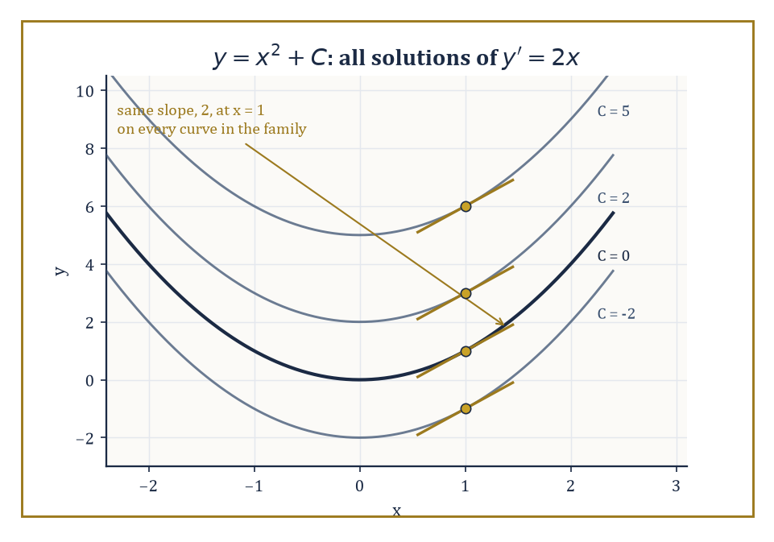
The family y = x² + C: every member shares the same slope, 2, at x = 1 — the plus-C ambiguity of running a derivative backwards, made visible.
That is a great deal of machinery for one storey, and it is worth pausing, briefly, to notice that essentially all of it descends from a single definition — the limit of a difference quotient — met on the second page. It is worth listing them once more, together, if only to admire how much load nine rooms' worth of ideas are quietly carrying, starting with the definition of f′ itself:
f′ as lim_{h→0}[f(a+h)−f(a)]/h
linearity, the product rule, the quotient rule, and the chain rule as its four operational shortcuts; the derivatives of powers, exponentials, logarithms, trigonometric and inverse trigonometric functions as its raw material; implicit differentiation and related rates as its application to equations rather than bare formulas; f″, f‴, and linear approximation as its extension to curvature and estimation; Rolle's theorem and the Mean Value Theorem as its bridge to global statements about a function; and critical points, extrema, and curve sketching as its payoff in genuinely useful problem-solving.
These tools are the foundation for the storeys immediately above this one. Integral Calculus, next, will run the entire process in reverse: instead of starting from a function and finding its rate of change, it starts from a rate of change, or from the shape of a curve, and asks how to recover the accumulated total — an area under a graph, a total distance from a velocity, a total cost from a marginal cost.
The two processes turn out, via the Fundamental Theorem of Calculus, to be inverses of one another in a precise sense, one of the most satisfying payoffs in the whole Tower and well worth the climb to reach it. Differential Equations, further up, will study equations that relate an unknown function to its own derivatives, reversing our usual habit of starting with a known function and computing its derivative, and instead starting with a relationship the derivative must satisfy and hunting for the function that obeys it.
Multivariable Calculus, higher still, will extend the derivative itself to functions of several variables, via partial derivatives and the gradient, generalising 'slope of the tangent line' to 'steepest direction on a tangent plane' and beyond. None of this requires abandoning anything learned here — quite the opposite.
The Fundamental Theorem of Calculus, the centrepiece of the next storey, is stated and proved using derivatives throughout; differential equations are, definitionally, equations built out of derivatives; and the gradient of a multivariable function is nothing more exotic than a vector whose entries are ordinary single-variable derivatives, one for each direction you could choose to move in. Everything above this storey is differential calculus, generalised and redeployed, not replaced.
Numeric example — Worked example — running the derivative backwards. Suppose you are told only that
f′(x) = 2x
and asked to find f. One answer springs to mind immediately, since the power rule of Room 11.4 tells us the derivative of x² is 2x:
f(x) = x²
works. But so does this, since the constant 5 differentiates to 0 and vanishes without trace:
f(x) = x² + 5
so does this:
f(x) = x² − 100
so, in fact, does this, for absolutely any constant C:
f(x) = x² + C
All of these functions have exactly the same derivative, 2x, and Room 11.7's Mean Value Theorem consequence is precisely the guarantee that this plus-C ambiguity is the only ambiguity there is — no other family of functions shares this derivative. Reversing a derivative, it turns out, recovers the original function only up to an unknown constant, and untangling exactly what that constant means, and how to pin it down with extra information, is the first order of business of the next storey.
Abstract example — Worked example — a first taste of a differential equation. Consider the equation
y′ = y
find every function y(x) whose derivative equals the function itself. From Room 11.4 we already know one solution:
y(x) = eˣ
since
(eˣ)′ = eˣ
exactly. But by the same plus-C logic as above, generalised slightly, this works for any constant C:
y(x) = C·eˣ
since
(C·eˣ)′ = C·eˣ = y(x)
again, the constant riding along for free through the linearity rule of Room 11.3. Check a specific instance: if C = 3, then
y(x) = 3eˣ
y′(x) = 3eˣ
which indeed equals y(x). This equation,
y′ = y
is the very first differential equation most students meet, precisely because both sides are built from nothing but the derivative machinery of this storey — and pinning down its full solution required nothing more than remembering which elementary function is its own derivative.
The deeper lesson of this storey, underneath all the rules and worked examples, is that instantaneous rate of change is not a philosophical hand-wave or a convenient fiction physicists invented to make their equations balance — it is a precisely defined mathematical object, computable by an entirely finite and mechanical procedure, that carries geometric information, the tangent line; physical information, velocity, acceleration, marginal cost, density, and a hundred other named rates across the sciences; and analytic information, concavity, monotonicity, the shape of a graph, far beyond anything visible in the original difference quotient it was built from.
That is not a bad note to end a storey on: a single, almost naive question — how fast, right now? — answered so thoroughly that it reorganises how you see every changing quantity you will ever meet again.
Differential calculus is, then, both a computational engine — a set of rules that will differentiate almost anything you can write down, mechanically, without further inspiration required — and a new way of seeing change itself: as something that can be measured at a single instant, not merely averaged over an interval, however short. Few ideas in this Tower do quite so much useful work for quite so modest an initial investment of a single limit.
There is, as ever, a catch, or at least a boundary: everything in this storey assumed the function in question was tame enough to differentiate at all, and plenty of the functions the Tower will meet on its way up — and even one or two you have already met, corners and cusps among them — are not. Differentiability is a genuine achievement for a function, not an automatic entitlement, and the Tower will spend the odd storey later on precisely characterising functions that fail to have it, sometimes spectacularly.
But the next storey has friendlier business. Integral Calculus takes the derivative we have just spent nine rooms constructing and asks the natural following question: if you know how fast something is changing at every instant, can you recover how much it has changed overall? The answer is yes, by a method that looks, on the surface, nothing like differentiation — summing infinitely many infinitesimal slices — and turns out, by one of the great theorems of the subject, to be secretly the same operation run backwards. We shall meet it properly very soon.
The tower continues upward. We have learned to differentiate.

Storey 12: Integral
Accumulation, Area, and the Art of Adding Infinitely Many Pieces
Storey Eleven left us standing at a single point on a curve, magnifying glass in hand, measuring the precise instant at which everything was changing. It was intimate, fussy work — one point, one tangent line, one slope, and an inordinate amount of careful limit-taking to nail it down. This storey asks the opposite question, and it is, appropriately, a much bigger one. Never mind the instant. What happens when you add up every instant there is?
That is the integral: the mathematics of accumulation. Newton and Leibniz, working independently and with a mutual suspicion that later curdled into one of the more undignified priority disputes in the subject's history, both noticed something remarkable — that this business of accumulating and the business of differentiating from the previous storey are mirror images of one another. Undo one and you recover the other. That mirror-image relationship has a name imposing enough to have survived three centuries of undergraduates copying it into notebooks: the Fundamental Theorem of Calculus. It is the load-bearing wall of everything that follows in this storey, and very possibly the single most important sentence in all of undergraduate mathematics.
The plan for the climb ahead: we will define the definite integral properly, as a limit of sums over ever-finer partitions (Room 12.2), state and prove the Fundamental Theorem that ties it to differentiation (Room 12.3), meet the indefinite integral and the standard toolbox for finding antiderivatives (Rooms 12.4 and 12.5), and then spend it — on areas, volumes, arc lengths, and physical work (Room 12.6) — before confronting integrals over infinite intervals and integrals of unbounded functions (Room 12.7), and finally admitting that sometimes you simply cannot find a formula and must approximate instead (Room 12.8).
One small, cheerful confession before the ascent begins. Differentiation, once the rules are memorised, is essentially clerical work: you look at the shape of the expression and the correct mechanical procedure presents itself. Integration is not like that, and never will be. It is an art — pattern recognition, a bag of substitutions, the odd flash of inspiration, and occasionally the mature acceptance that no tidy formula exists at all. This is not a flaw in the subject; it is a symptom of the fact that accumulation is a genuinely richer, more global affair than instantaneous measurement ever was. Sleeves up. Let's integrate.

Room 12.1: What the Integral Actually Is
A Single Symbol Living a Double Life
Every mathematical object worth knowing turns out to be secretly two things wearing one name, and the integral is a particularly shameless example. As a definite integral, it is a number — the signed area trapped between the curve y = f(x) and the x-axis, running from x = a to x = b.
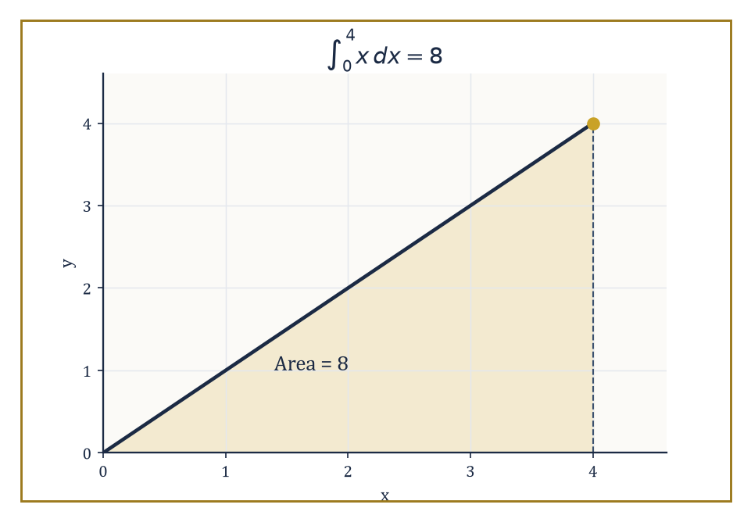
The triangle under y = x from 0 to 4 — schoolroom geometry and the definite integral agreeing, for once, without an argument.
∫_a^b f(x) dx
As an indefinite integral, written with no limits attached, it is not a number at all but an entire family of functions: the antiderivatives of f, meaning every function whose derivative is f.
∫ f(x) dx
Keeping these two senses apart is the single most useful habit you can form in this storey. Whenever somebody says 'the integral', ask yourself: number, or family of functions? The word itself refuses to specify.
Take the number first, since it is the more intuitive of the two and the one your eye can actually check against a picture. Imagine standing at x = a and walking rightward to x = b, and at every instant noting the height of the curve above (or, where the curve dips below the axis, the depth beneath) the horizontal axis. The definite integral totals up all of that height, weighted by how much horizontal distance you covered at each height. For a simple, straight curve this is nothing more exotic than the area of a triangle or rectangle from schoolroom geometry; the machinery built in Rooms 12.2 and 12.3 exists purely to make the same idea work when the curve is too wriggly for a protractor and a ruler.
Numeric example — Worked example — area by eye. Take f(x) = x on the interval [0, 4]. The region under the line y = x, above the x-axis, between x = 0 and x = 4, is a right-angled triangle with base 4 and height 4 (the height at x = 4 is f(4) = 4).
Area = ½ × base × height = ½ × 4 × 4 = 8
No calculus has been used — this is pure schoolroom geometry — but the number 8 is exactly what the definite integral ∫_0^4 x dx will turn out to equal once we define it properly in Room 12.2. Hold onto that number; we are going to recover it twice more before this storey is done, by two entirely different methods, and watch it stubbornly refuse to change.
A word on the notation, since it looks more mysterious than it is. In ∫_a^b f(x) dx, the function f is called the integrand, a and b are the limits of integration (the ends of the interval), and dx names the variable being integrated over — it also carries a faint memory of 'an infinitesimally thin slice of width dx', which is exactly the intuition Room 12.2 will make rigorous. The letter x itself is what mathematicians call a dummy variable, or bound variable: it exists only inside the integral sign and means nothing outside it, so it may be renamed freely without changing the value of the integral.
Numeric example — Worked example — renaming the dummy. The following are all the same number, 8, computed the same way — the label on the horizontal axis is bookkeeping, not mathematics.
∫_0^4 x dx = ∫_0^4 t dt = ∫_0^4 u du = 8
Contrast this with a and b, which are emphatically not dummy variables: change the upper limit from 4 to 5 and the triangle grows a wedge-shaped sliver, giving
½ × 5 × 5 = 12.5
instead. The limits of integration matter enormously; the name of the integration variable does not matter at all.
Now the other face. An antiderivative of f is any function F with F′ = f — that is, any function which, when you differentiate it (the operation the previous storey spent its whole length teaching you), hands you back f. Antiderivatives are never unique: if F is one antiderivative of f, then so is F + C for any constant C whatsoever, because the derivative of a constant is zero and differentiation is blind to it. The indefinite integral ∫ f(x) dx denotes this entire family at once, conventionally written F(x) + C.
The Fundamental Theorem of Calculus, the centrepiece of Room 12.3, asserts — almost unbelievably, the first time you meet it — that these two faces of the integral are the same underlying fact seen from different angles: the definite integral of f from a to b equals F(b) − F(a) for any antiderivative F you care to choose, the arbitrary constant C cancelling neatly in the subtraction.
∫_a^b f(x) dx = F(b) − F(a)
Numeric example — Worked example — the same 8, the second way. Continue with f(x) = x. An antiderivative is F(x) = x²/2, since differentiating gives
F′(x) = x = f(x)
exactly (the power rule from the previous storey, run in reverse — more on that reversal in Room 12.4). Now evaluate F at the two endpoints of the same interval as before:
F(4) − F(0) = (4²/2) − (0²/2) = 16/2 − 0 = 8
That is precisely the triangle's area from the earlier example, obtained this time with no picture at all — purely by finding a function whose slope is x, and subtracting its values at the ends. This is not a coincidence, and by the end of Room 12.3 you will know exactly why it cannot be one.
That agreement — geometry on one side, antiderivatives on the other, arriving at the same number — is the whole engine of integral calculus. It means areas can be computed by finding antiderivatives, which is usually far easier than slicing a region into infinitely many strips by hand, and, running the logic the other way, new antiderivatives can be discovered by reasoning about areas. The two directions of thought will spend the rest of this storey leaning on each other. It is worth admitting now, before the honeymoon ends, that finding the antiderivative is very often the hard part. We will spend Room 12.5 learning why, and what to do about it.

Room 12.2: Riemann Sums and the Definite Integral
Death by a Thousand Rectangles (Then a Limit)
To make 'signed area' into something you could defend in front of a hostile examiner, you need a procedure, not a picture. Here it is. A partition of the interval [a, b] chops it into finitely many subintervals using points
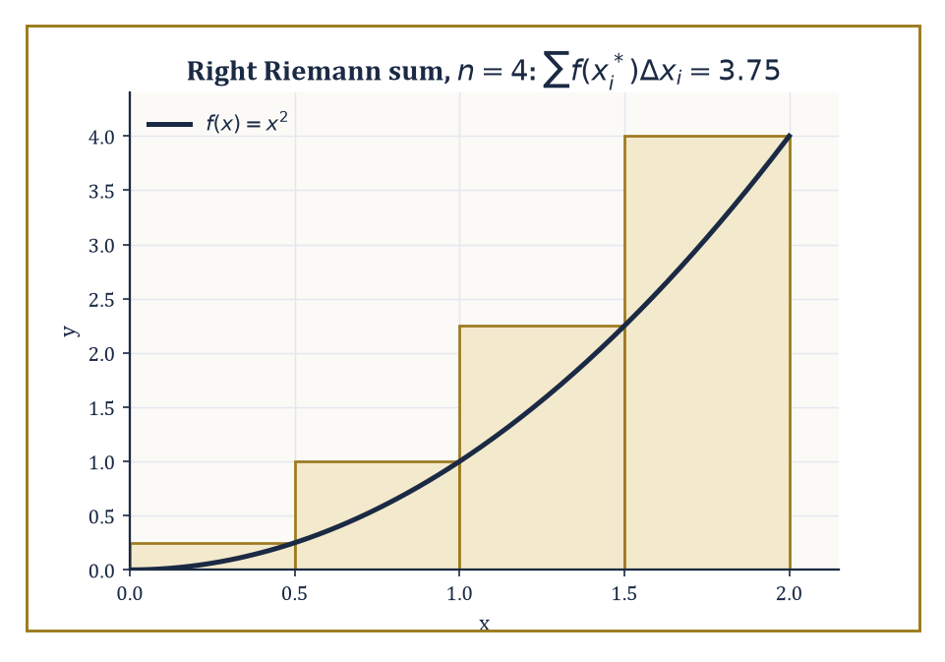
Four right-hand rectangles overshooting the true area under y = x², each one a little too tall by exactly the amount the curve rose within its strip.
a = x₀ < x₁ < x₂ < … < xₙ = b
On each subinterval [x_(i−1), x_i] you choose a sample point x_i*, anywhere in that subinterval — the left end, the right end, the middle, wherever your conscience allows — and form the product f(x_i*) × Δx_i, where Δx_i = x_i − x_(i−1) is the width of that subinterval. This product is the area of a thin rectangle standing on the subinterval, with height borrowed from the function at the sample point. Add up all n of these rectangles, and you have a Riemann sum, summed over i from 1 to n:
Σ f(x_i*) Δx_i
A Riemann sum is only ever an approximation, built from flat-topped rectangles pretending to trace a curved boundary. The genius of the definition is what happens next: as the partition is refined — more subintervals, each one narrower, the mesh (the width of the widest subinterval) shrinking toward zero — the rectangles hug the curve ever more closely. If the Riemann sums approach one common limiting number as the mesh tends to zero, and that limit does not depend on how the sample points were chosen, the function f is said to be Riemann integrable on [a, b], and the limit itself is defined to be the definite integral ∫_a^b f(x) dx. This is the rigorous version of the vague sentence 'add up infinitely many infinitely thin slices' — it survives contact with a determined skeptic because the definition never actually adds up infinitely many anythings. It takes a limit of finite sums, which is a completely respectable operation storey after storey has already trained you to trust.
Numeric example — Worked example — squeezing the truth out of rectangles. Let f(x) = x² on [0, 2], and partition into n = 4 equal subintervals of width Δx = 0.5, at nodes x₀ = 0, x₁ = 0.5, x₂ = 1, x₃ = 1.5, x₄ = 2. Using right-hand sample points (x₁ through x₄): f-values are 0.25, 1, 2.25, 4, summing to 7.5, so the right Riemann sum is
7.5 × 0.5 = 3.75
Using left-hand sample points (x₀ through x₃) instead: f-values are 0, 0.25, 1, 2.25, summing to 3.5, giving a left Riemann sum of
3.5 × 0.5 = 1.75
The true value — which Room 12.3 will let us find exactly via an antiderivative — is
∫_0^2 x² dx = [x³/3]_0^2 = 8/3 ≈ 2.6667
Notice that the right sum (3.75) overshoots and the left sum (1.75) undershoots, which is exactly what must happen for an increasing function: the right-hand rectangles are always a little too tall, the left-hand ones a little too short. As n grows and Δx shrinks, both sums squeeze in on 8/3 from either side, which is the mesh-tending-to-zero limit in miniature.
Which functions are actually well-behaved enough for this limit to exist? Continuous functions on closed intervals always are — no jumps, no gaps, nothing for the rectangles to trip over. Rather more surprisingly, functions with only finitely many jump discontinuities are integrable too: a single honest jump does no lasting damage, because it affects a negligible sliver of total width as the mesh shrinks. What genuinely breaks the definition is an infinite discontinuity (the function shoots off to infinity somewhere in the interval) or infinitely wild oscillation packed into a finite stretch — in those cases the Riemann sums can be made to disagree wildly depending on the sample points chosen, and no common limit exists. The definition is, pleasingly, self-diagnosing: it does not need a separate rulebook for which functions are allowed, because ill-behaved functions simply fail the limit test on their own.
Numeric example — Worked example — a jump that does no damage. Let g(x) = 2 for 0 ≤ x < 1 and g(x) = 5 for 1 ≤ x ≤ 3 — a single jump discontinuity at x = 1. This is integrable despite the jump, and the value splits sensibly across the break point:
∫_0^3 g(x) dx = ∫_0^1 2 dx + ∫_1^3 5 dx = (2 × 1) + (5 × 2) = 2 + 10 = 12
Geometrically this is just two rectangles, one of height 2 and width 1, one of height 5 and width 2, stacked side by side — and the additivity property mentioned below is precisely what licenses splitting the integral at the jump like this.
The geometric meaning is signed area, and the word signed is doing real work. Regions where the curve sits above the x-axis contribute a positive amount to the sum, since f(x_i*) is positive there; regions where the curve dips below contribute negatively, since f(x_i*) is negative. The definite integral therefore measures net accumulation, not total ink spilled on the page — a curve that spends equal time above and below the axis can integrate to zero even though there is visibly plenty of area on the picture.
Numeric example — Worked example — area that cancels itself into nothing. Take f(x) = x again, now on the symmetric interval [−1, 1].
∫_(−1)^1 x dx = [x²/2]_(−1)^1 = (1/2) − (1/2) = 0
The net integral is exactly zero. Yet there is visibly a triangle of area ½ × 1 × 1 = 0.5 sitting below the axis on [−1, 0], and an equal triangle of area 0.5 sitting above the axis on [0, 1] — a total unsigned geometric area of 0.5 + 0.5 = 1. The definite integral reports the net figure, 0, having let the positive and negative contributions cancel; if you wanted the total geometric area you would have needed to integrate |f(x)| instead, or split the interval at the sign change and add absolute values by hand.
Finally, three formal properties fall straight out of the fact that a Riemann sum is, underneath everything, just a sum, and limits of sums behave predictably. Linearity: scaling and adding functions scales and adds their integrals, for any constants c and d.
∫_a^b [c·f(x) + d·g(x)] dx = c∫_a^b f(x) dx + d∫_a^b g(x) dx
Additivity over intervals, for any c between a and b, as the jump-function example above already exploited:
∫_a^b f dx = ∫_a^c f dx + ∫_c^b f dx
And comparison — a smaller function cannot out-accumulate a bigger one: if f(x) ≤ g(x) throughout [a, b], then
∫_a^b f dx ≤ ∫_a^b g dx
None of these facts is deep once you believe the definition; all three will be invoked constantly, usually without comment, from this point onward.
Numeric example — Worked example — linearity without knowing the functions. Suppose you are told, without ever seeing formulas for f and g, that ∫_0^1 f(x) dx = 4 and ∫_0^1 g(x) dx = −1. Linearity alone determines:
∫_0^1 [2f(x) − 5g(x)] dx = 2 × 4 − 5 × (−1) = 8 + 5 = 13
with no further information about f or g required. This is precisely the sort of shortcut linearity is for — arithmetic with the integrals, rather than fresh partitioning-and-summing work every time a combination of functions appears.

Room 12.3: The Fundamental Theorem of Calculus
Where Storey Eleven and This One Turn Out to Be the Same Building
Everything up to this point has been groundwork; here is the payoff. The Fundamental Theorem of Calculus comes in two parts, and the first is the more startling. It says: if f is continuous on [a, b], and F is defined by F(x) as the running accumulated area from the fixed point a up to the moving point x —
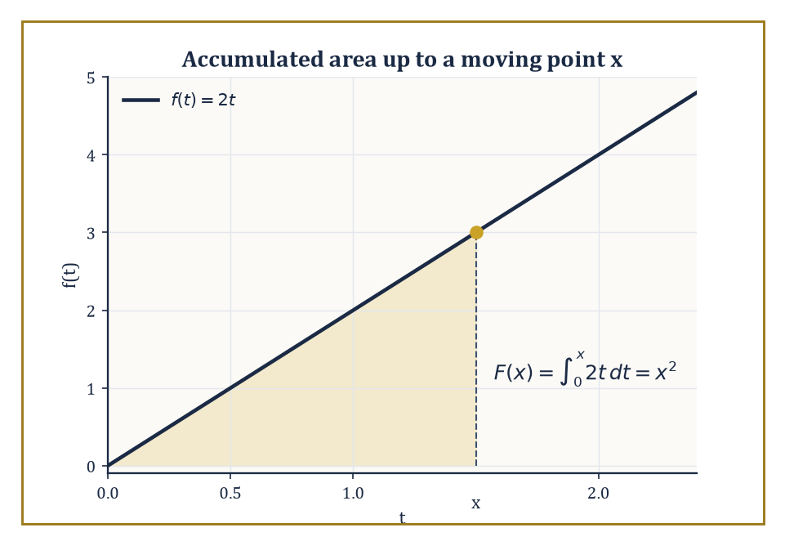
F(x) is the area swept out so far under f(t) = 2t — nudge x forward and the area grows by roughly f(x) times a sliver of width, which is Part One in one picture.
F(x) = ∫_a^x f(t) dt
— then F is differentiable, and
F′(x) = f(x)
In words: the integral, viewed as a function of its own upper limit, is an antiderivative of the thing being integrated. Differentiating an accumulation undoes the accumulation and hands back the original rate. This is the precise sense in which integration and differentiation are inverse operations, and it is genuinely remarkable that a limit of ever-finer rectangle sums, differentiated, collapses back down to the single function you started with.
Numeric example — Worked example — Part One in action. Let f(t) = 2t, and define F(x) = ∫_0^x 2t dt. An antiderivative of 2t is t² (check: d/dt(t²) = 2t), so
F(x) = [t²]_0^x = x² − 0² = x²
Now differentiate F directly:
F′(x) = d/dx(x²) = 2x
And indeed F′(x) = 2x = f(x) exactly, just as Part One promises — differentiating the accumulated area recovers the original integrand, with no trace of the accumulation process left visible.
Why should Part One be true intuitively, and not merely as a symbol-pushing coincidence? Picture F(x) as the area swept out so far, reading left to right from a. Nudge x forward by a small amount h: the newly accumulated area F(x + h) exceeds the old area F(x) by roughly one thin vertical strip, of width h and height approximately f(x), since a continuous curve barely moves over such a short horizontal stretch. So
F(x + h) − F(x) ≈ f(x) · h
and dividing by h and letting h shrink toward zero — the ordinary difference-quotient definition of a derivative from the previous storey — gives exactly F′(x) = f(x). Continuity of f is precisely what licenses the phrase 'barely moves over such a short stretch'; strip it away, at a genuine jump, and Part One can fail at that single point even while holding everywhere else.
Numeric example — Worked example — watching the rate converge. Reuse F(x) = x² and f(x) = 2x from above, and check the difference-quotient argument with real numbers at x = 1, where f(1) = 2. Take h = 0.1:
F(1.1) − F(1) = 1.21 − 1 = 0.21, so 0.21/0.1 = 2.1
already close to 2. Shrink h to 0.01:
F(1.01) − F(1) = 1.0201 − 1 = 0.0201, so 0.0201/0.01 = 2.01
closer still. As h keeps shrinking the average rate keeps closing in on exactly 2 = f(1), which is Part One's abstract argument made visible in decimals: the rate at which accumulated area grows, at a point, equals the height of the curve at that point, no more and no less.
The second part is the one you will actually use to compute numbers, and it is the one that turns the whole subject from a theoretical curiosity into a calculational engine. It says: if F is any antiderivative of f (not necessarily the specific running-accumulation F from Part One — any antiderivative at all), then
∫_a^b f(x) dx = F(b) − F(a)
This licenses a spectacular shortcut: instead of grinding through the limit-of-Riemann-sums definition every time a definite integral needs evaluating, you may instead search for any function whose derivative is f, plug in the two endpoints, and subtract. The arbitrary constant C that always tags along with an antiderivative cancels automatically in the subtraction, which is why Part Two is allowed to say 'any antiderivative' rather than insisting on a particular one.
Numeric example — Worked example — Part Two doing the heavy lifting. Evaluate ∫_1^3 (3x² − 2x + 1) dx. An antiderivative is F(x) = x³ − x² + x (check termwise: d/dx(x³) = 3x², d/dx(−x²) = −2x, d/dx(x) = 1, and these sum to exactly the integrand). Then F(3) = 27 − 9 + 3 = 21, and F(1) = 1 − 1 + 1 = 1. By Part Two:
∫_1^3 (3x² − 2x + 1) dx = F(3) − F(1) = 21 − 1 = 20
a definite integral evaluated by pure algebra, no rectangles required at any stage.
Put the two parts together and calculus stops being two subjects wearing a shared name and becomes one. Differentiation undoes integration, up to the harmless ambiguity of a constant (Part One); integration undoes differentiation exactly, once the limits are fixed and the constant is cancelled by subtraction (Part Two). This is why tables of standard integrals exist at all — every entry is simply a differentiation rule from the previous storey, read backwards — and why symbolic algebra software can evaluate huge numbers of definite integrals by purely mechanical, closed-form means rather than by numerically approximating rectangles. It is also, not incidentally, why this storey exists as the natural sequel to the last one rather than as an unrelated topic sharing a textbook cover.
Numeric example — Worked example — the round trip, with trigonometry along for the ride. Let f(x) = cos x. By Part One, F(x) = ∫_0^x cos t dt should be an antiderivative of cos x; indeed an antiderivative of cos t is sin t, so
F(x) = [sin t]_0^x = sin x − sin 0 = sin x
Differentiating back confirms Part One immediately: d/dx(sin x) = cos x = f(x), the loop closing exactly as promised. Now apply Part Two to the same function over a specific interval:
∫_0^(π/2) cos x dx = [sin x]_0^(π/2) = sin(π/2) − sin(0) = 1 − 0 = 1
A quarter-turn of cosine, accumulated, comes to precisely 1 — a fact you could in principle verify by patient rectangle-counting, and which the Fundamental Theorem instead hands you in two lines.

Room 12.4: Antiderivatives and Indefinite Integrals
Guessing Backwards, Professionally
An antiderivative of a function f is, as Rooms 12.1 and 12.3 have already used without much ceremony, any function F satisfying F′ = f. The key structural fact, mentioned briefly earlier and worth stating in full now, is that antiderivatives are never lonely: if F is one antiderivative of f, then every antiderivative of f has the form F + C for some constant C, and no other functions qualify. This is a genuine theorem, not a convention — it follows from the Mean Value Theorem of the previous storey, since two functions with the same derivative everywhere on an interval can only differ by a constant. The indefinite integral ∫ f(x) dx is notation for this entire family at once, written F(x) + C, with the understanding that C ranges over all real numbers.
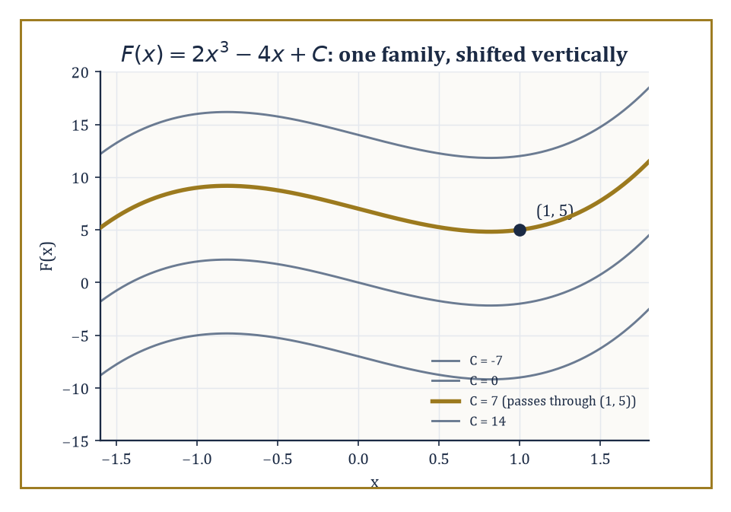
One photograph singled out from an infinite roll of identical negatives — the whole family F(x) = 2x³ − 4x + C, with the single curve pinned down by F(1) = 5 picked out in gold.
Because the indefinite integral is differentiation run in reverse, every differentiation rule from Storey Eleven yields a corresponding integration rule, read backwards. The power rule is the workhorse, valid for any exponent n except n = −1:
∫ xⁿ dx = x^(n+1)/(n+1) + C
(where the formula would divide by zero — that missing case turns out to have its own, entirely different, answer, since d/dx(ln|x|) = 1/x):
∫ x^(−1) dx = ∫ (1/x) dx = ln|x| + C
The exponential and trigonometric derivatives reverse similarly into standard entries — really just the previous storey's derivative table read from right to left:
∫ e^x dx = e^x + C, ∫ sin x dx = −cos x + C, ∫ cos x dx = sin x + C
Numeric example — Worked example — the power rule in reverse. Apply the power rule:
∫ x³ dx = x^(3+1)/(3+1) + C = x⁴/4 + C
Check: d/dx(x⁴/4) = 4x³/4 = x³, matching the integrand exactly. As a definite integral this gives:
∫_1^2 x³ dx = [x⁴/4]_1^2 = 16/4 − 1/4 = 4 − 0.25 = 3.75
a number obtainable in seconds once the antiderivative is in hand, versus the considerably more tedious business of building and refining Riemann sums by hand.
Linearity carries over from definite to indefinite integrals exactly as expected, so any polynomial can be integrated term by term:
∫ [c₁f(x) + c₂g(x)] dx = c₁∫ f(x) dx + c₂∫ g(x) dx
What indefinite integrals add, that definite ones do not need, is the arbitrary constant — and that constant is not always a nuisance to be waved away. Given extra information (an initial condition, a known value of F at one point), the constant can be pinned down exactly, turning the family of antiderivatives into one specific function. This move — find the general antiderivative, then use a known data point to solve for C — is the single most common calculation in elementary differential equations, previewed properly in Room 12.9 and treated at length several storeys from now.
Numeric example — Worked example — pinning down the constant. Find the function F satisfying F′(x) = 6x² − 4 and F(1) = 5. Integrate term by term:
F(x) = 2x³ − 4x + C
(check: d/dx(2x³ − 4x) = 6x² − 4, correct). Now use the data point:
F(1) = 2(1)³ − 4(1) + C = −2 + C = 5, so C = 7
The specific function is therefore F(x) = 2x³ − 4x + 7 — one exact function, singled out from the infinite family of antiderivatives by a single known value, the way one photograph is singled out from an infinite roll of identical negatives shifted up or down by different amounts.
Here comes the craft, and the honest limitation promised at the start of this storey. Differentiating any elementary function — one built from polynomials, exponentials, logarithms, trigonometric functions, and their combinations — always produces another elementary function; the chain rule and product rule guarantee it mechanically. Integrating does not enjoy this guarantee. Functions such as e^(−x²), sin(x)/x, and 1/ln(x) are perfectly respectable, continuous, differentiable-everywhere functions, and yet none of them possesses an antiderivative that can be written down using the standard elementary toolkit — a fact provable rigorously (it is a consequence of Liouville's theorem on elementary functions, well outside this storey's scope) rather than merely a sign of insufficient cleverness. Recognising which integrals will yield to technique and which will not is, itself, a large part of the professional skill Room 12.5 exists to build.
Abstract example — Abstract example — naming the problem instead of solving it. Since e^(−x²) has no elementary antiderivative, mathematicians did the next best thing: they gave the integral itself a name and treated it as a new function in its own right. The error function is defined by:
erf(x) = (2/√π) ∫_0^x e^(−t²) dt
It cannot be simplified into elementary terms, but it can still be differentiated (by Part One of the Fundamental Theorem, its derivative is simply (2/√π)e^(−x²), no integration required), tabulated numerically, and manipulated in formulas — it is, for instance, exactly the function needed to compute probabilities under the normal distribution in statistics. This is the standard escape route whenever an integral resists elementary evaluation: stop looking for a formula, and instead define a new function to be the integral, then study that function on its own terms.

Room 12.5: Techniques of Integration
A Toolbox, Not an Algorithm
Differentiation, as established repeatedly by now, is a procedure: apply the right rule to the right piece of the expression and the answer falls out, every time, guaranteed. Integration has no such guarantee, but it does have a well-stocked toolbox, and the rest of this room is a tour of its principal drawers. Each technique is really a differentiation rule from the previous storey, worn backwards like a jacket turned inside out, and the skill lies entirely in recognising which drawer a given integral belongs in before you start rummaging.
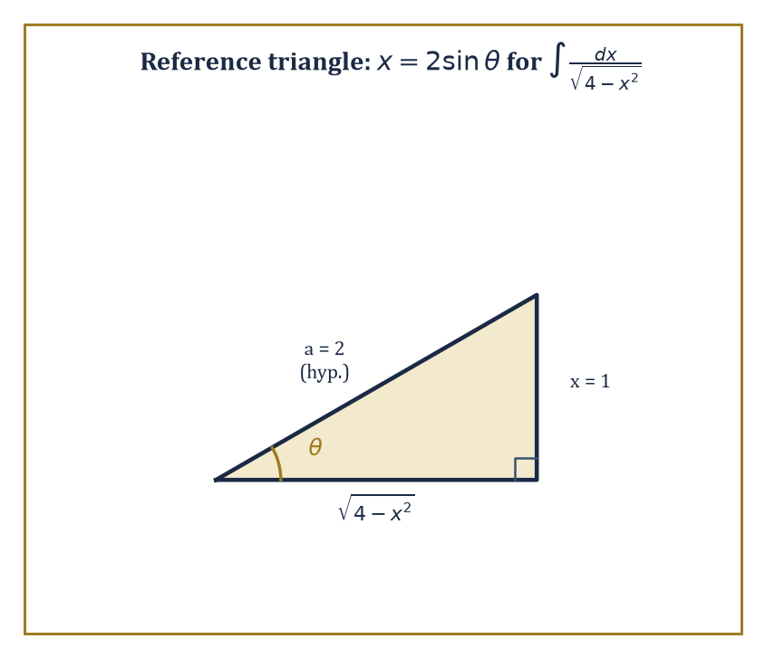
The reference triangle behind x = 2 sinθ — the whole trick of trigonometric substitution drawn as one right triangle with the radical sitting quietly on the bottom leg.
Substitution — often called u-substitution — is the chain rule in reverse. If the integrand contains some inner function g(x) together with its own derivative g′(x) sitting alongside it (up to a constant multiple), set u = g(x), so that du = g′(x) dx. Rewrite the entire integral in terms of u alone, integrate the now-simpler expression, and substitute g(x) back in for u at the end. The method works precisely because differentiating the eventual answer, by the chain rule, regenerates the factor of g′(x) that substitution allowed you to absorb into du in the first place.
Numeric example — Worked example — substitution. Evaluate ∫ 2x(x² + 1)³ dx. Notice that 2x is exactly the derivative of x² + 1, sitting right there in the integrand — the signature of a substitution problem. Set u = x² + 1, so du = 2x dx, and the integral becomes:
∫ u³ du = u⁴/4 + C
Substituting back:
∫ 2x(x² + 1)³ dx = (x² + 1)⁴/4 + C
Check by the chain rule: d/dx[(x² + 1)⁴/4] = 4(x² + 1)³ · 2x / 4 = 2x(x² + 1)³, matching the original integrand. For the definite version, convert the limits along with the variable: when x = 0, u = 1; when x = 1, u = 2. So the integral becomes:
∫_0^1 2x(x² + 1)³ dx = ∫_1^2 u³ du = [u⁴/4]_1^2 = 16/4 − 1/4 = 3.75
with no need to substitute back to x at all.
Integration by parts is the product rule in reverse, and its formula is worth memorising as a single line:
∫ u dv = uv − ∫ v du
Given a product of two factors inside an integral, one is designated u (to be differentiated) and the other dv (to be integrated); the art — and it is genuinely an art, with no universal recipe, though the mnemonic LIATE (Logarithmic, Inverse trig, Algebraic, Trigonometric, Exponential, in roughly that priority order for choosing u) helps more often than not — lies in choosing the split so that the resulting integral ∫ v du is strictly simpler than the one you started with, rather than equally hard or worse.
Numeric example — Worked example — integration by parts. Evaluate ∫ x eˣ dx. Following LIATE, the algebraic factor x should be differentiated and the exponential integrated: let u = x and dv = eˣ dx, so du = dx and v = eˣ. Then:
∫ x eˣ dx = x eˣ − ∫ eˣ dx = x eˣ − eˣ + C = eˣ(x − 1) + C
Check: d/dx[eˣ(x − 1)] = eˣ(x − 1) + eˣ(1) = x eˣ, matching the integrand exactly. As a definite integral:
∫_0^1 x eˣ dx = [eˣ(x − 1)]_0^1 = e¹(0) − e⁰(−1) = 0 + 1 = 1
a clean answer of exactly 1 from an integrand that looked considerably less friendly at the outset.
Trigonometric integrals — powers and products of sine and cosine — are tamed with identities that trade high powers for lower ones dressed up in multiple angles. The double-angle identities are the workhorses here, converting an awkward squared trig function into something linear in a new angle, which integrates immediately:
sin²x = (1 − cos 2x)/2, cos²x = (1 + cos 2x)/2
For rational combinations of sine and cosine that resist identities altogether, the Weierstrass substitution t = tan(x/2) converts the entire integral into an ordinary rational function of t, which partial fractions (below) can then finish off.
Numeric example — Worked example — a trigonometric identity clearing the path. Evaluate ∫ sin²x dx. Using sin²x = (1 − cos 2x)/2, the integral becomes:
∫ (1/2 − cos(2x)/2) dx = x/2 − sin(2x)/4 + C
Check: d/dx[x/2 − sin(2x)/4] = 1/2 − cos(2x)/2 = (1 − cos 2x)/2 = sin²x, correct. As a definite integral over a full half-period:
∫_0^π sin²x dx = [x/2 − sin(2x)/4]_0^π = π/2 − 0 = π/2
since sin(2π) = 0; the average height of sin²x over a half-period works out to exactly 1/2, and π × 1/2 = π/2 confirms the answer by a second route.
Trigonometric substitution handles integrals built around the three telltale radical patterns √(a² − x²), √(a² + x²), and √(x² − a²), by substituting x = a sinθ, x = a tanθ, or x = a secθ respectively, chosen precisely so that the Pythagorean identities collapse the radical into a single trigonometric factor. What looked like an intractable square root becomes, after substitution, an ordinary trigonometric integral of the kind just covered.
Numeric example — Worked example — trigonometric substitution. Evaluate ∫ dx/√(4 − x²). This matches the a² − x² pattern with a = 2, so set x = 2 sinθ, giving dx = 2 cosθ dθ and √(4 − x²) = 2cosθ (taking cosθ ≥ 0 on the relevant range). Substituting:
∫ (2cosθ dθ)/(2cosθ) = ∫ dθ = θ + C
Since x = 2sinθ means θ = arcsin(x/2), the answer is arcsin(x/2) + C. Check by direct differentiation:
d/dx[arcsin(x/2)] = (1/2) / √(1 − x²/4) = 1/√(4 − x²)
matching the original integrand precisely.
Finally, partial-fraction decomposition tackles rational functions — one polynomial divided by another — by first factoring the denominator and then rewriting the whole fraction as a sum of simpler fractions, each with one of those factors underneath. Simple linear factors integrate to logarithms; irreducible quadratic factors integrate to arctangents (or logarithms, depending on the numerator). The technique converts a single hard rational integral into several easy standard ones, at the cost of a short exercise in algebra to find the numerators of the pieces.
Numeric example — Worked example — partial fractions. Evaluate ∫ dx/(x² − 1). Factor the denominator: x² − 1 = (x − 1)(x + 1), and seek constants A, B with:
1/((x − 1)(x + 1)) = A/(x − 1) + B/(x + 1)
Clearing denominators: 1 = A(x + 1) + B(x − 1). Setting x = 1 gives 1 = 2A, so A = 1/2; setting x = −1 gives 1 = −2B, so B = −1/2. Hence:
∫ dx/(x² − 1) = (1/2)ln|x − 1| − (1/2)ln|x + 1| + C = (1/2)ln|(x − 1)/(x + 1)| + C
As a definite integral, ∫_2^3 dx/(x² − 1) = [(1/2)ln|(x − 1)/(x + 1)|]_2^3. At x = 3:
(1/2)ln(2/4) = (1/2)ln(0.5) ≈ (1/2)(−0.693147) = −0.346574
At x = 2:
(1/2)ln(1/3) ≈ (1/2)(−1.098612) = −0.549306
Subtracting: −0.346574 − (−0.549306) = 0.202732, a small positive number, exactly as expected since 1/(x² − 1) is positive (though shrinking) all across [2, 3].
And when none of these techniques, nor any combination of them, produces an elementary closed form — because, as Room 12.4 already warned, elementary closed forms sometimes genuinely do not exist — the honest options are three: leave the answer as a definite integral and evaluate it numerically (Room 12.8 supplies the machinery), express it in terms of a named special function like the error function met earlier, or accept a numerical approximation as the final answer outright. None of these is a failure of technique; all three are standard, respectable endpoints in applied mathematics.

Room 12.6: Applications: Area, Volume, Arc Length, Work
Calculus Finally Earns Its Keep
It is time to spend all this machinery. The most immediate application is the area trapped between two curves: if f(x) ≥ g(x) throughout [a, b], the area of the region squeezed between them is found by subtracting the lower boundary from the upper one, at every x, and integrating the resulting height.
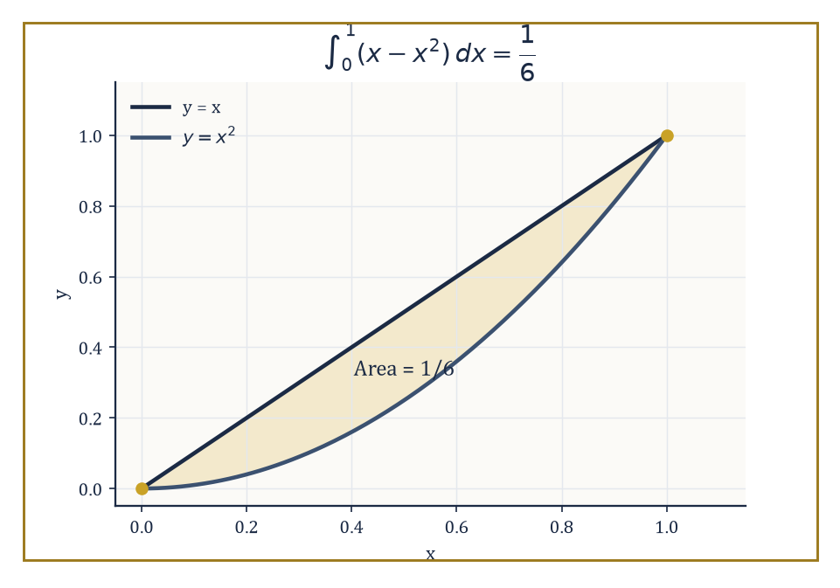
The lens-shaped sliver trapped between y = x and y = x² on [0, 1] — a straight line and a parabola agreeing to meet only at the two endpoints.
Area = ∫_a^b [f(x) − g(x)] dx
This is nothing more than the single-curve area idea from Room 12.1, generalised so that the 'floor' of the region is another curve instead of the x-axis.
Numeric example — Worked example — area between two curves. Find the area between y = x and y = x² on [0, 1]. On this interval x ≥ x² (check at x = 0.5: 0.5 ≥ 0.25, correct), so the upper curve is y = x and the lower is y = x². Area:
∫_0^1 (x − x²) dx = [x²/2 − x³/3]_0^1 = (1/2 − 1/3) − 0 = 1/6
The two curves — a straight line and a parabola — meet at x = 0 and x = 1 (where x = x² has its only solutions in this range), bounding a lens-shaped sliver of area exactly 1/6.
Rotate a region about an axis, and the same slicing idea, run in three dimensions, gives volume instead of area. In the disk method, each thin vertical strip of the original region, when swept around the axis, sweeps out a thin disk of radius f(x) and thickness dx, contributing volume π[f(x)]² dx; summing (integrating) over the interval gives:
V = π ∫_a^b [f(x)]² dx
Where the region does not touch the axis of rotation, each strip instead sweeps out a washer — a disk with a hole in it — and the method is named accordingly; a third approach, cylindrical shells, slices the original region into thin vertical strips and rotates each one into a thin cylindrical tube rather than a disk. All three are Riemann-sum arguments in disguise, differing only in the shape of the infinitesimal piece being summed.
Numeric example — Worked example — volume by disks. The region under y = x² on [0, 1], between the curve and the x-axis, is rotated about the x-axis. Each disk has radius x² and thickness dx, so:
V = π ∫_0^1 (x²)² dx = π ∫_0^1 x⁴ dx = π [x⁵/5]_0^1 = π/5
The resulting solid — a bowl-shaped horn tapering from radius 1 down to a point — has volume exactly π/5, or roughly 0.628 cubic units, considerably less than the cylinder of radius 1 and length 1 (volume π) that would contain it, which is exactly the shrinking-toward-zero shape of y = x² making itself felt in three dimensions.
Arc length asks a more delicate question: not how much area or volume a curve encloses, but how long the curve itself is. Chop the curve into tiny straight segments, and by Pythagoras each segment has length √(dx² + dy²) = √(1 + (dy/dx)²) dx; summing (integrating) these infinitesimal lengths over the interval gives the arc length formula:
L = ∫_a^b √(1 + [f′(x)]²) dx
Surface area of a solid of revolution follows an almost identical pattern, weighting each infinitesimal arc-length piece by the circumference it sweeps out.
Numeric example — Worked example — a sanity check via a straight line. Apply the arc length formula to the straight line y = x from x = 0 to x = 3, where the answer is already known by the ordinary distance formula, as a check that the machinery has not gone mad. Here f′(x) = 1 for all x, so the integrand is √(1 + 1²) = √2, a constant, and:
L = ∫_0^3 √2 dx = 3√2 ≈ 4.2426
Compare this against the straight-line distance formula directly: the distance from (0, 0) to (3, 3) is
√(3² + 3²) = √18 = √(9 × 2) = 3√2
exactly the same number. The calculus machinery, applied to the one case simple enough to check by an entirely independent method, returns precisely the expected answer, which is reassuring evidence that the formula is trustworthy on curves too twisted for any shortcut to check.
Beyond geometry, the same accumulation pattern drives a good deal of elementary physics. Work, when a variable force F(x) acts along a straight line, is force accumulated over distance, generalising the schoolbook formula 'work equals force times distance' to forces that change as the object moves:
W = ∫_a^b F(x) dx
Centre of mass and moments of a region are ratios of integrals; hydrostatic force against a submerged surface is the integral of pressure times the width of the surface at each depth (not depth on its own — the pressure term already carries the depth, courtesy of ρgh); and a probability density function integrates to exactly 1 over its whole domain, since 'probability of something happening' is a certainty.
Numeric example — Worked example — stretching a spring. By Hooke's law, the force needed to stretch a spring by a distance x is F(x) = kx, where k is the spring constant. Take k = 200 newtons per metre, and find the work done stretching the spring from its natural length (x = 0) to an extension of 0.5 metres.
W = ∫_0^0.5 200x dx = 200 [x²/2]_0^0.5 = 200 × 0.125 = 25 joules
Notice the force itself grows the whole time you are stretching — at full extension it is 200 × 0.5 = 100 newtons — so the naive shortcut 'force times distance' using the final force alone would badly overestimate the work; the integral correctly accounts for the fact that most of the stretching happened while the force was still comparatively gentle.
Notice the pattern repeating, unmistakably, across every single example in this room: a quantity is approximated by chopping it into many small contributions, each contribution is recognised as one term of a Riemann sum, and the limit of that sum is written down as an integral. Once that recognition is made, evaluating the integral is a matter of technique — Room 12.5's toolbox, mostly. The genuinely hard step, every time, is the first one: correctly setting up the integral in the first place, deciding what the thin slice looks like and what it contributes. That skill is earned by practice, not by formula, and no amount of fluency with substitution and parts will substitute for it.

Room 12.7: Improper Integrals
How to Have Infinite Length and Finite Area, and Other Party Tricks
Everything so far has quietly assumed a finite interval and a bounded integrand — the Riemann sum machinery of Room 12.2 genuinely requires both. An integral is called improper when either assumption fails: the interval stretches to infinity in one or both directions, or the integrand itself blows up to infinity somewhere on (or at the edge of) the interval. Such integrals are defined not by any new machinery, but by a limit of the perfectly ordinary, proper integrals already in hand: replace the offending infinite bound (or the point of blow-up) with a finite variable, compute the resulting proper integral as a function of that variable, and then take the limit as the variable approaches the true, troublesome value. If that limit exists and is finite, the improper integral is said to converge, and its value is the limit; if the limit is infinite or fails to exist at all, the improper integral diverges, and no value is assigned.
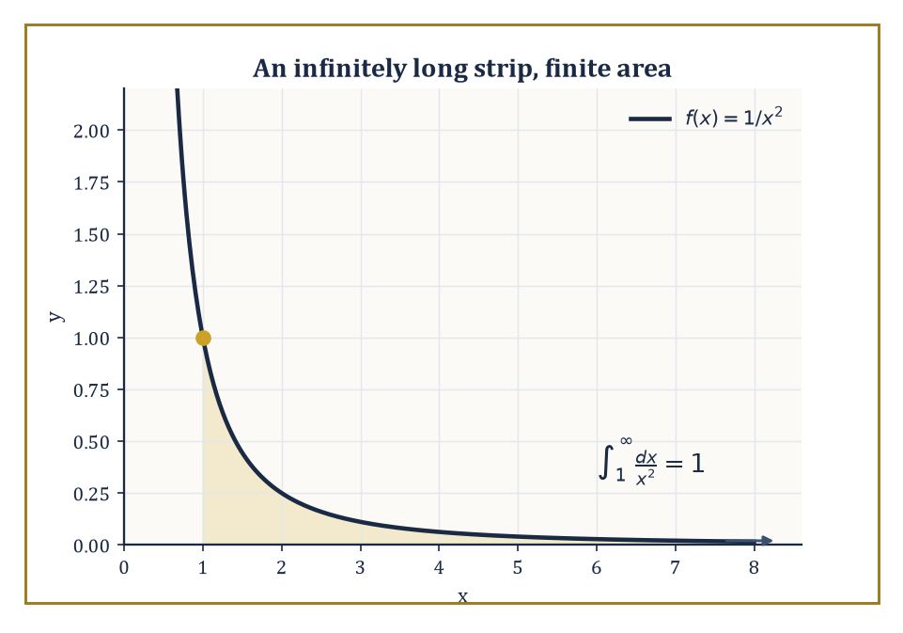
A strip with no end in sight, tapering fast enough under 1/x² to enclose exactly one finite unit of area.
Numeric example — Worked example — an infinite strip with finite area. Evaluate ∫_1^∞ dx/x². Replace the infinite upper limit with a finite b and compute the proper integral:
∫_1^b dx/x² = [−1/x]_1^b = 1 − 1/b
Now let b → ∞: the term 1/b shrinks to 0, leaving the limit 1 − 0 = 1. So:
∫_1^∞ dx/x² = 1
an infinitely long strip, stretching out to x = ∞ with no end in sight, nonetheless encloses exactly one unit of area. This is one of the genuine surprises early in the subject — infinite extent does not force infinite area, provided the curve shrinks toward the axis fast enough as it goes.
How fast is fast enough? The p-integral ∫_1^∞ dx/x^p is the standard yardstick against which other integrals of this type get measured, via comparison tests (if 0 ≤ f(x) ≤ g(x) and ∫g converges, then ∫f converges too; if f(x) ≥ g(x) ≥ 0 and ∫g diverges, then ∫f diverges too) or limit-comparison tests (comparing the ratio f(x)/g(x) as x → ∞ instead of comparing the functions directly, useful when a direct inequality is awkward to establish). The p-integral itself converges precisely when p > 1, and diverges for every p ≤ 1 — a single sharp threshold worth memorising, since a great many other improper integrals are ultimately judged by how they measure up against it.
Numeric example — Worked example — the threshold, both sides. The previous example used p = 2, safely above the threshold, and converged to 1. Now try p = 1 exactly: ∫_1^∞ dx/x. As before:
∫_1^b dx/x = [ln x]_1^b = ln b − 0 = ln b
But ln b grows without bound as b → ∞ (however slowly), so the limit does not exist as a finite number, and ∫_1^∞ dx/x diverges. The difference between p = 1 and p = 2 looks tiny on a graph — both curves creep toward the x-axis — but the p = 1 curve creeps too slowly, accumulating unboundedly, while p = 2 creeps just fast enough to total a finite sum. This is exactly the kind of razor's-edge behaviour the p > 1 threshold is designed to capture.
The second variety of improper integral involves not an infinite interval but an unbounded integrand: the function shoots off to infinity at some point within, or at the boundary of, an otherwise finite interval. The same fix applies — replace the offending point with a finite variable set a small distance ε away, evaluate the proper integral, and let ε shrink to zero (or the variable approach the troublesome point from whichever side is relevant).
Numeric example — Worked example — infinite height, finite area. Evaluate ∫_0^1 dx/√x. The integrand blows up as x → 0⁺, so replace the lower limit 0 with a small ε > 0 and take the limit afterward:
∫_ε^1 x^(−1/2) dx = [2√x]_ε^1 = 2 − 2√ε
As ε → 0⁺, √ε → 0, so the limit is 2 − 0 = 2. So:
∫_0^1 dx/√x = 2
a curve that rockets off to infinite height right at the edge of the interval still encloses only two finite units of area beneath it. Compare this with ∫_0^1 dx/x (the same kind of blow-up, but with exponent p = 1 rather than 1/2):
∫_ε^1 dx/x = [ln x]_ε^1 = ln 1 − ln ε = −ln ε
which tends to +∞ as ε → 0⁺ (since ln ε → −∞). That integral diverges — the same threshold behaviour met above for infinite intervals reappears, in mirror image, for unbounded integrands.
Improper integrals are, in a precise and useful sense, the continuous cousins of infinite series — a topic waiting a few storeys further up the Tower, where sums of infinitely many discrete terms are studied by exactly the same convergent-or-divergent lens applied here to continuous accumulation. They also turn up constantly in applications with genuinely infinite or singular domains: the normal and exponential probability distributions of statistics are defined by integrals over infinite intervals that must converge to make sense as probabilities, and physics regularly asks about escape velocities, potential energy at infinite separation, and other quantities defined only by an improper integral's limiting value. The lesson to take away, ahead of everything downstream that will lean on it: unbounded does not mean infinite. An infinite strip, or an infinitely tall spike, can still enclose a perfectly ordinary, finite number — you simply have to ask the question as a limit, rather than as a sum, to find out which.

Room 12.8: Numerical Integration and Approximation
When You Can't Find the Antiderivative, Cheat Tastefully
Room 12.4 already confessed that some integrands — e^(−x²) chief among them — have no elementary antiderivative at all, and in applied work one frequently faces an even worse situation: the integrand is known only through measured data points, with no formula to differentiate or integrate in the first place. In either case, exact evaluation via the Fundamental Theorem is off the table, and the honest response is to approximate the definite integral numerically instead. The trapezoidal rule and Simpson's rule are the two standard, systematic recipes: both choose a set of sample points across the interval, evaluate the function there, and combine the values into a weighted sum designed to approximate the true area far more accurately than a crude Riemann sum of the same size would.
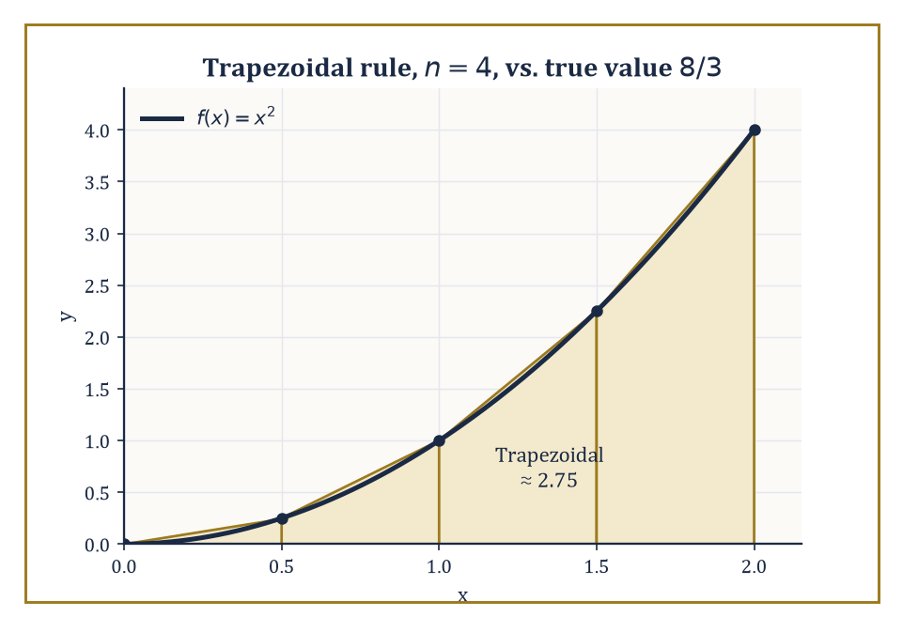
Four trapezoids tracking y = x² closely enough that the straight chords are barely distinguishable from the curve — and closely enough to beat either plain Riemann sum from Room 12.2.
The trapezoidal rule replaces each flat-topped Riemann rectangle with a trapezoid instead, connecting consecutive function values with a straight line rather than a flat top — since a straight-topped trapezoid tracks a smoothly curving function noticeably better than a flat rectangle does. For a partition into n equal subintervals of width h, the rule reads — every interior sample point counted twice, since it forms the shared edge of two neighbouring trapezoids, and the two endpoints counted once each:
Trapezoidal ≈ (h/2)[f(x₀) + 2f(x₁) + 2f(x₂) + … + 2f(x_(n−1)) + f(xₙ)]
Numeric example — Worked example — trapezoidal rule. Approximate ∫_0^2 x² dx using the trapezoidal rule with the same n = 4 partition used back in Room 12.2: h = 0.5, nodes 0, 0.5, 1, 1.5, 2, with f-values 0, 0.25, 1, 2.25, 4.
Trapezoidal ≈ (0.5/2)[0 + 0.5 + 2 + 4.5 + 4] = 0.25 × 11 = 2.75
The true value, recall, is 8/3 ≈ 2.6667, so the trapezoidal estimate overshoots by about 0.083 — a considerably smaller error than either the plain left sum (1.75, off by nearly 1) or right sum (3.75, off by more than 1) computed for the very same partition in Room 12.2. Averaging left and right, in effect, is exactly what a trapezoid does, and averaging cancels much of each one's individual error.
Simpson's rule goes one step further, fitting a short parabola through each consecutive triple of sample points instead of a straight line, and it requires an even number of subintervals so that the points pair up into triples correctly. Its formula, for n even and h = (b − a)/n, weights endpoints once, odd-indexed interior points four, and even-indexed interior points two — an alternating pattern that looks arbitrary until you see where it comes from (integrating the interpolating parabola through each triple exactly):
Simpson's ≈ (h/3)[f(x₀) + 4f(x₁) + 2f(x₂) + 4f(x₃) + 2f(x₄) + … + 4f(x_(n−1)) + f(xₙ)]
A remarkable side effect of fitting parabolas is that Simpson's rule integrates any polynomial of degree three or lower exactly, with zero error — the error term for the rule involves the fourth derivative of the integrand, which vanishes identically for cubics and anything simpler.
Numeric example — Worked example — Simpson's rule, exactly. Approximate the same integral, ∫_0^2 x² dx, using Simpson's rule with the same n = 4 data (h = 0.5, f-values 0, 0.25, 1, 2.25, 4 at nodes 0, 0.5, 1, 1.5, 2).
Simpson's ≈ (0.5/3)[0 + 1 + 2 + 9 + 4] = (1/6) × 16 = 8/3
That is exactly 8/3, matching the true value to every decimal place, with none of the small overshoot the trapezoidal rule left behind. This is not a lucky coincidence: x² is a polynomial of degree two, comfortably within the degree-three ceiling below which Simpson's rule carries zero error, so the parabola the method fits through each triple of points is not merely a good approximation to the curve — for this particular integrand, it is the curve.
Error bounds for both rules can be derived rigorously from the Mean Value Theorem or from Taylor expansion (both tools from the previous storey, still earning their keep), and in general terms: higher-order rules like Simpson's converge to the true value faster than lower-order ones like the trapezoidal rule, for the same number of sample points, provided the integrand is smooth enough for the relevant derivative bound to be small. Gauss quadrature pushes the same idea further still, choosing both the sample points and the weights simultaneously (rather than fixing equally spaced points and only choosing weights) to extract maximum accuracy from a given number of function evaluations, and adaptive methods refine the partition automatically, concentrating extra sample points precisely where the integrand is changing most rapidly and leaving smoother stretches coarsely sampled.
None of this numerical machinery is a substitute for exact methods when an exact antiderivative genuinely exists — Room 12.5's toolbox should always be tried first, since an exact answer is an exact answer and a numerical one is only ever an approximation, however good. But when the antiderivative does not exist, or the integrand is known only as a finite table of measurements from an experiment, numerical integration stops being a fallback and becomes the only tool available at all. In applied science and engineering, it is entirely routine for the numerical answer to be the only answer anyone will ever obtain — and, given how close a well-chosen Simpson's rule can land, as the previous example just demonstrated rather emphatically, that is far less of a compromise than it might first sound.

Room 12.9: Looking Ahead: From Integrals to Series, Multivariable Calculus, and Differential Equations
The Scaffolding Comes Down, Three New Corridors Open
Stocktaking, before the climb resumes. This storey has assembled a genuinely substantial vocabulary: the definite integral as a limit of Riemann sums (Room 12.2); the Fundamental Theorem of Calculus, tying that limit to the antiderivatives of Room 12.1 and Room 12.4 (Room 12.3); the standard techniques — substitution, parts, trigonometric methods, partial fractions — for actually finding those antiderivatives by hand (Room 12.5); the geometric and physical payoff in areas, volumes, arc lengths, and work (Room 12.6); the extension to infinite intervals and unbounded integrands via improper integrals (Room 12.7); and the fallback of numerical approximation when no exact method applies (Room 12.8). That is a full toolkit by any reasonable standard, and every floor built from here upward in the Tower will, sooner or later, reach back down and borrow a piece of it.
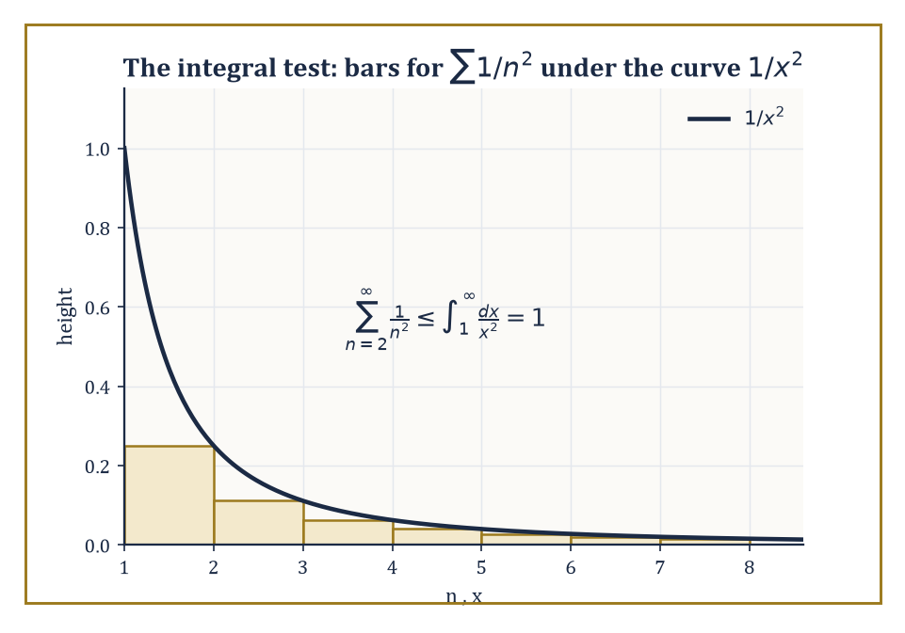
Each bar of the series Σ 1/n² tucked neatly under the curve 1/x² — the integral test, in one picture, capping the sum without ever finding its exact total.
The nearest reach-back will come from infinite series, a topic waiting a few storeys further up the Tower. A series is what you get by summing infinitely many discrete terms rather than integrating a continuously varying function — the discrete cousin of everything built in this storey, studied by defining its value as the limit of its partial sums, in exact structural parallel to how the definite integral was defined as the limit of Riemann sums back in Room 12.2. The two theories turn out to be so closely related that one of the standard tests for whether an infinite series converges — the integral test — works by comparing the series directly against an improper integral of the kind met in Room 12.7.
Numeric example — Worked example — a series tamed by an integral. Consider the series Σ 1/n², summed over all positive integers n. Its first five partial sums build as:
1, 1.25, 1.3611, 1.4236, 1.4636
creeping upward, but by ever-smaller increments. Does it keep creeping forever, or level off at some finite total? The integral test answers this using precisely the p = 2 result proved in Room 12.7: since 1/n² is a decreasing positive function, the tail of the series from n = 2 onward is bounded above by:
∫_1^∞ dx/x² = 1
(each rectangle of the series sits below the corresponding strip of the smooth curve 1/x²). So the whole series is bounded above by 1 (the first term) plus 1 (the tail bound), giving 2 as a guaranteed ceiling — and the series is thereby proved to converge, without ever computing its exact total. For the curious: the exact total, a genuinely famous result first found by Euler, is π²/6 ≈ 1.6449, comfortably inside the ceiling of 2 that the integral test predicted using nothing more than a single improper integral already in hand.
The very next storey reaches back in a different direction: multivariable calculus, extending every idea built here from functions of a single variable to functions of several variables at once — surfaces instead of curves, regions in the plane or in space instead of intervals on a line. Where this storey integrated a single function over an interval, that one will integrate a function of two or three variables over a region in the plane or in space, via iterated integrals (integrate with respect to one variable at a time, holding the others fixed, nesting the single-variable machinery of this storey inside itself) and via changes of variables that generalise the substitution technique of Room 12.5 to more than one dimension simultaneously. Every technique for finding an antiderivative learned in this storey will be needed again there, now applied one variable at a time inside a larger, multidimensional calculation.
A third corridor, reached further up still, is differential equations: equations that relate an unknown function to its own derivatives, rather than pinning the function down directly by a formula. The very simplest such equations — those of the form dy/dx = f(x), with no y on the right-hand side at all — are solved by nothing more than finding an antiderivative of f, exactly the skill built across Rooms 12.4 and 12.5. More elaborate differential equations demand more elaborate machinery, but integration remains the principal engine for solving the simplest and most common cases throughout that entire subsequent storey, which is as clear a sign as any that the work done here was never merely a self-contained exercise.
The deeper lesson underneath all three previews is worth stating plainly, since it is easy to lose sight of amid rectangles and antiderivatives: the accumulation of infinitely many infinitesimally small contributions can be given an entirely precise, rigorous mathematical meaning — not a hand-wave, not a metaphor, but a genuine limit, defensible to the most hostile examiner imaginable — and the resulting total is very often computable by the strikingly indirect route of reversing differentiation instead of summing anything directly. Integral calculus is therefore two things at once, just as the integral itself was two things at once back in Room 12.1: a formidable computational engine, and a wholly new way of seeing total change, rather than instantaneous change, as a mathematical object in its own right.
We have learned to accumulate. Every rectangle summed, every antiderivative guessed at and verified, every improper integral coaxed into surrendering a finite answer despite its infinite pretensions — all of it in service of one central fact, proved properly in Room 12.3, that accumulating and differentiating are the same coin viewed from its two faces.
The Tower continues upward, and it takes an immediate and sensible turn: Storey Thirteen keeps every tool built here, but stops confining itself to a single variable. Curves become surfaces, intervals become regions, and the single integral sign learned in this storey multiplies discreetly into two or three, nested inside itself, still meaning exactly what it always meant — add up the small pieces, and take the limit.
Mind the step. The floor gets considerably more dimensional from here.

